**E&S International Enterprises Inc (Valley View) SOP**

Version 1.0 by Kevin Nguyen

Biller: Luke Darang

**NOTE:** Billing cycle for handling is bimonthly (1-15, 16-EOM).

The below SOP describes how to create a discrepancy report on a bimonthly basis (1-15, 16-EOM) for E&S International Enterprises Inc (Valley View) using their invoice(s) from BNP and activity report from WISE.

**Section 1: Creating Discrepancy Sheet**

1. Create a new Excel sheet
2. Save as **[AccountName]-[Valley Viewility]-[Billing Cycle]**
   1. Example: E&SInternationalEnterprisesInc-ValleyView-Bimonthly
3. This Excel sheet will be used as the discrepancy report during this process. (Hereby referred to as “**Discrepancy Report**”)

**Section 2: Getting BNP Quantities**

1. Navigate to <http://bnp.unisco.com/> and enter log-in credentials.

1. Hover over **Modules** on the top left and select **Sales Module** on the drop-down menu.

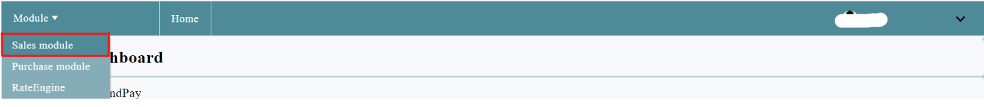

1. Hover over **Invoice** on top and select **Invoice Management** on the drop-down menu.

1. Input the following information into the corresponding fields:
   1. Bill To: E&S International Enterprises Inc
   2. Valley Viewility: Fac
   3. Invoice Status: CheckAll
   4. Period Start: 08/01/22
   5. Period End: 08/15/22

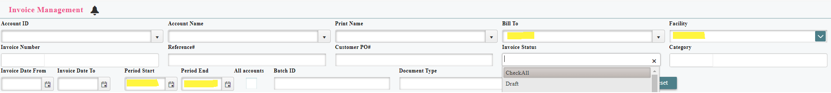

1. Select **Detail** on any with a category **Handling** and a new tab should appear with the Invoice Details.



1. On the new Invoice Details page, select **Export**.

1. Open the downloaded Excel file and select the **Item Summary** tab on the bottom.

1. Highlight the **Header Billing Period Start** and **Header Billing Period End** columns and cut them.
2. Insert the cut cells in front of the **Category** column.

1. Highlight the **Category** column, cut it, and insert the cut cell in front of the **InvoiceNumber**.
   1. Delete the cells (“Billing…”) in the **Category** column.
   2. Relabel rows with the **ItemName** of **HANDLING IN** to **Inbound** and **HANDLING OUT** to **Outbound.**
2. Highlight and delete the **Amount, Adjustment,** and **Active** columns at the end.
3. Rename the **Qty** column to **BNP Qty.**
4. Label the two columns following **BNP Qty** to **WISE Qty** and **CSR Qty**.

(It should look like this so far)



1. Select the whole excel with CTRL+A and copy all content to the **Discrepancy Report**.
2. Close the Invoice Details page.

**Section 3: Filling in WISE Activity Report Quantities**

1. Navigate to <https://wise.logisticsteam.com/v2/#/login> and input log-in credentials.

1. Hover over the Valley Viewility on the top right and select facility (ex: **Fac**)

1. Hover over the **Home Menu** at the top left and select **Report Center** on the drop-down menu.

1. On the left side, select **Billing > Activity Report V2**.

1. Input the following information in the appropriate fields below and **Export** to view the activity report

**Section 4: Calculation Process**

**Part 1 – Handling**

**Part 2 – Accessorial**

**NOTE:** Not Applicable for this facility

**Part 3 – Storage**

#### Recurring Storage (Monthly Invoice)

**NOTE:** Biller says: “These are manually added into BNP.” **CSR** needs to update.

### **Discrepancy Report Result**

**NOTE:** BNP different than WISE for the following –

1. This is how the **Discrepancy report** should look so far:

## Section 5: Email Discrepancy Report to CSR

1. Save the **Discrepancy Report**
2. Attach the **Discrepancy Report** and WISE **Activity Report**, and enter the **Valley Viewility CSR** in the **To:** section of the email and cc **Biller** by email
3. In the email body, please have the following:

“Please fill in the CSR Qty column and Unit Price in the Discrepancy Report and send it back to us at your earliest convenience.”

1. Hit send.