15 Best Photo Spots in Hanoi: A Local Photographer's Field Guide (2026)
By TravelFrame Photography Team · Updated September 2026 · 11 min read

Introduction: Why Hanoi is a Photographer's Dream
Few cities in Southeast Asia possess the raw visual layers of Hanoi. Here, textured ochre-yellow French facades peel back to reveal ancient Chinese roof tiles, crisscrossing overhead utility wires frame neon signage, and soft golden light filters through centuries-old banyan canopies.
Whether you are carrying a professional mirrorless camera, a vintage 35mm film body, or simply shooting on the latest smartphone, Hanoi offers an astonishing variety of backdrops.
As local documentary photographers who walk these streets every single day, we put together this **curated guide to the 15 best photo spots in Hanoi**. Beyond just giving you GPS coordinates, we share the exact times to shoot, how to handle tricky natural lighting, and most importantly: how to photograph local life with warmth and cultural respect.

Part 1: Old Quarter Atmospheric Locations (5 Spots)

1. Phung Hung Mural Street & Railway Arches
- What makes it special Built beneath the historic stone viaduct supporting the north-south railway, this street features 17 hand-painted trompe-l'œil murals depicting traditional Hanoi life (street vendors, Lunar New Year markets, ancient schoolgirls in white *áo dài*). The stone arches themselves create stunning leading lines.
- Best time to shoot 7:30 AM – 9:00 AM. The morning light cuts diagonally through the trees, casting long shadows across the arches before tourist crowds arrive.
- Camera tip Use a 35mm or 50mm prime lens at f/2.8 to blur the background while keeping the stone texture sharp.
- Cultural note (V-09) Local residents often park bicycles along the walls. If an elder is sitting nearby reading a morning newspaper, a warm smile and a polite nod (*"Cháu chào bác"*) before taking a shot will always be welcomed.

2. Hang Ma Street (The Lantern & Color Capital)
- What makes it special The epicenter of festival craft culture in Hanoi. Depending on the season, Hang Ma transforms into an explosion of color: glowing paper lanterns and lion heads for the Mid-Autumn Festival (August–September), or red envelopes and gold calligraphy for Tết (January–February).
- Best time to shoot Blue hour (5:45 PM – 6:45 PM) when the shop lanterns illuminate, creating rich contrast against the deep twilight sky.
- Camera tip Set your white balance to Daylight (~5500K) to keep the warm red and gold lanterns looking vibrant without washing out skin tones.

3. Ta Hien & Luong Ngoc Quyen Corner (Morning vs. Night)
- What makes it special Known at night as "Beer Street", this iconic intersection reveals an entirely different personality at sunrise. Weathered shutters, classic 1920s merchant shophouse architecture, and quiet flagstone streets make it feel like 1950s Indochina.
- Best time to shoot 6:15 AM – 7:30 AM. After 5:00 PM, it becomes packed with plastic stools and nightlife crowds (great for high-ISO night street photography).
- Camera tip Shoot low to the ground to emphasize the cobblestone texture and the narrow perspective of the ancient alleys.

4. Dong Xuan Market Morning Alleys (*Ngõ Đồng Xuân*)
- What makes it special A bustling pedestrian food lane adjacent to Hanoi’s largest covered market. Giant aluminum pots steam with herbal broths, smoke billows from mini charcoal grills, and sunbeams pierce through overhead tarps.
- Best time to shoot 6:30 AM – 8:00 AM during peak breakfast rush.
- Camera tip Keep your shutter speed at 1/250s or faster to freeze moving steam and market activity.

5. Hang Bac (Silver Street) Ancient Shophouses
- What makes it special Hang Bac is one of the oldest streets in Hanoi, dating back over 800 years. Look for house #47 (an ancient communal temple tucked behind a modern storefront) and preserved narrow "tube houses" with narrow wooden balconies draped in potted ferns.
- Best time to shoot 9:00 AM – 10:30 AM when direct sunlight hits the upper balconies.

Part 2: Iconic Heritage Landmarks (4 Spots)

6. Temple of Literature (Văn Miếu)
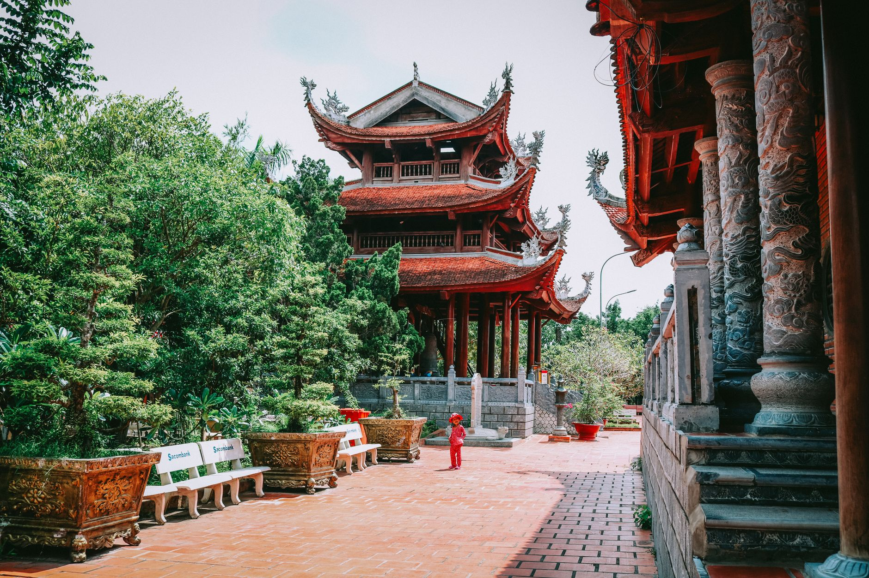
Figure: Classic Vietnamese pagoda pavilion surrounded by water and greenery, showcasing traditional architectural symmetry. | Photo: Loifotos / Pexels
- What makes it special Vietnam's first national university, founded in 1070. Five symmetrical courtyards featuring ancient lotus ponds (Well of Heavenly Clarity), giant stone turtles bearing doctorate stelae, and deep crimson timber pavilions.
- Best time to shoot 8:00 AM right at opening, or 3:30 PM – 4:45 PM when late-afternoon sun illuminates the red lacquer pillars.
- Camera tip The Khue Van Cac pavilion is the symbol of Hanoi. Frame your subject walking along the central stone pathway with the pavilion centered in the background.

7. St. Joseph’s Cathedral (Nhà Thờ Lớn)
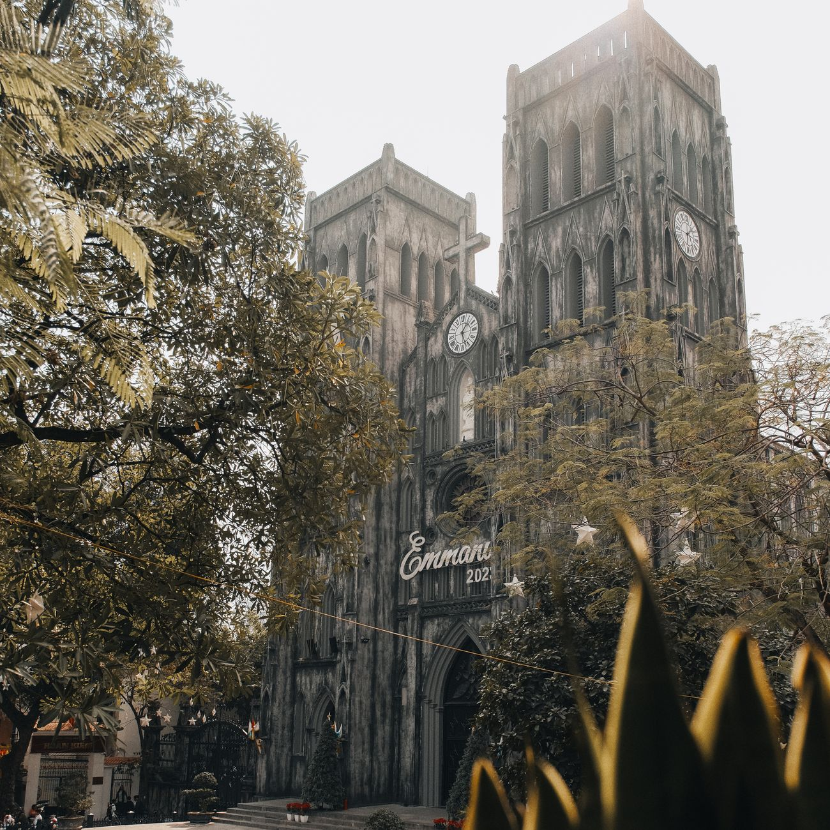
Figure: Gothic architecture and weathered stone facade of St. Joseph's Cathedral framed by green trees. | Photo: Nguyen Duc Toan / Pexels
- What makes it special A dramatic 19th-century neo-Gothic cathedral with heavily weathered, soot-blackened stone walls that look reminiscent of Notre-Dame de Paris, set against leafy tropical sidewalk cafes.
- Best time to shoot 3:00 PM – 5:00 PM for front-facade illumination, or grab a balcony seat at an opposite cafe (like *Cộng Cà Phê*) for an elevated vantage point.

8. Long Bien Bridge (Cầu Long Biên)
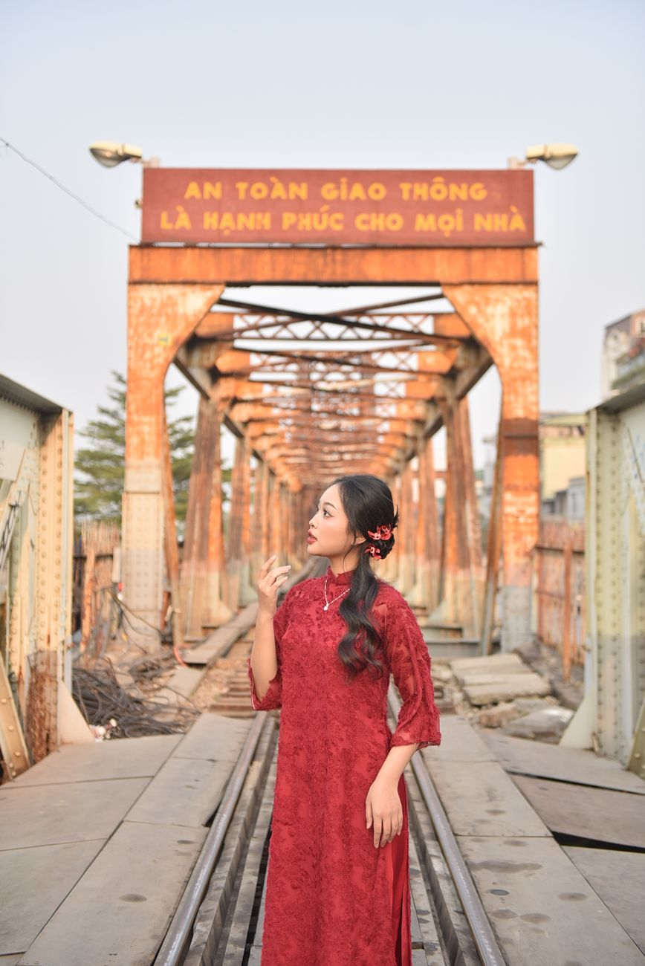
Figure: Woman in red Ao Dai standing on the historic century-old steel cantilever spans of Long Bien Bridge. | Photo: Felix Young / Pexels
- What makes it special Designed by Daydé & Pillé and opened in 1902, this century-old steel cantilever bridge spans the Red River. Its rusty iron girders, wooden pedestrian walkways, and passing commuter trains make it one of the most cinematic photo locations in northern Vietnam.
- Best time to shoot Sunrise (5:30 AM – 6:30 AM) looking east over the banana plantations of the Red River sandbars, or Golden Hour (4:45 PM – 5:45 PM).
- Safety tip Stay strictly within the pedestrian sidewalk; never walk onto the center train tracks.

9. Hanoi Opera House (Nhà Hát Lớn) & French Quarter Boulevards
- What makes it special Modeled after the Palais Garnier in Paris, this yellow neoclassical landmark anchors the elegant French Quarter. Surrounding streets like Trang Tien and Ly Thai To feature wide sidewalks, colonial colonnades, and tall mahogany trees.
- Best time to shoot 7:00 AM – 8:30 AM on weekends when traffic is light.

Part 3: Secret Local Gems Known to Insiders (3 Spots)

10. The Balcony at Café Đinh (Hidden Heritage Cafe)
- What makes it special Located on the second floor through a nondescript, dimly lit alleyway at #13 Dinh Tien Hoang. Step out onto the tiny iron balcony for the single best eye-level view of Hoan Kiem Lake, framed by hanging cables, wooden window frames, and steaming cups of traditional egg coffee.
- Best time to shoot 8:00 AM – 9:30 AM.

11. Chu Van An High School French Villa Campus
- What makes it special Tucked right along the shores of West Lake, this century-old school campus boasts some of the best-preserved French colonial villa architecture in Hanoi, complete with grand stone staircases, octagonal towers, and towering banyan trees.
- Best time to shoot Late afternoon (outside school hours or from the lakeside perimeter).

12. Hanoi Train Street (Safe Upper-Floor Vantage Points)
- What makes it special While trackside access on ground level is subject to safety regulations, local cafes with 2nd and 3rd-floor balconies (such as along Tran Phu or Phung Hung) allow you to safely photograph the curve of the tracks slicing between residential homes with laundry hanging from balconies.

Part 4: Light & Timing Masterclass for Hanoi
Window | Light Quality | Best Hanoi Locations | Photography Style
**Golden Morning**<br>(6:00 AM – 7:30 AM) | Soft, warm, low angle. Long golden shadows. Minimal crowds. | Hoan Kiem Lake, Long Bien Bridge, Old Quarter alleys. | Candid portraits, street documentary, atmospheric wide shots.
**Midday Diffused**<br>(11:00 AM – 2:00 PM) | Harsh overhead sun outdoors; beautiful soft light indoors. | Heritage cafes (*Café Giảng, Loading T*), temple courtyards. | Food & coffee details, quiet indoor portraits, architectural details.
**Late Afternoon**<br>(4:00 PM – 5:30 PM) | Rich amber hues reflecting off yellow colonial walls. | French Quarter boulevards, Temple of Literature, West Lake promenade. | Romantic couple portraits, golden street flares.
**Blue Hour & Night**<br>(6:00 PM – 7:30 PM) | Deep cobalt sky contrasting with warm neon & red lanterns. | Hang Ma, Ta Hien, St. Joseph's Cathedral square. | High-contrast night portraits, light trails from scooters.

Part 5: What to Wear & Photography Etiquette in Hanoi

Styling Tips for Great Travel Photos
1. Choose Complementary Colors: Hanoi’s urban palette consists heavily of weathered yellow ochre, deep moss greens, and warm red brick. Colors that pop beautifully:
- Crisp white linen, cream, or pastel tones.
- Sky blue or terracotta.
- Traditional Vietnamese *Áo dài* (silk tunics) create timeless, elegant silhouettes in temple courtyards.
2. Avoid Busy Loud Patterns: Large commercial logos or heavy neon patterns will clash with Hanoi's intricate street textures. Keep outfits simple, breathable, and comfortable for walking.

Photography Etiquette: The Golden Rule (V-09)
The people of Hanoi are famously warm and hospitable, but respect goes both ways:
- Always ask before taking close-up portraits A simple gesture pointing to your camera with a friendly smile and saying *"Excuse me, may I?"* or *"Cháu chụp một kiểu được không ạ?"* is polite and almost always met with a proud smile.
- Temple Etiquette At the Temple of Literature, Ngoc Son Temple, or pagodas: cover your shoulders and knees. Never turn your back disrespectfully to altars during prayers.

Capture Hanoi Without the Camera Stress: TravelFrame Private Photo Tours
You can spend half your holiday fiddling with tripods, wrestling with selfie sticks, and stressing over whether you're standing in the right light. Or, you can walk through Hanoi like a local insider with a dedicated photographer friend.
At **TravelFrame**, we lead **private, walking photo experiences** designed specifically for international solo travelers, couples, and creators.
- We Know the Angles We guide you away from tourist traps straight to the hidden courtyards, photogenic alleys, and quiet temple corners featured in this guide.
- Candid, Natural, Unposed No rigid studio posing. We chat, explore, grab a local coffee, and capture authentic, genuine moments as you fall in love with Hanoi.
- Fast 24-Hour Delivery You receive your high-resolution, professionally color-graded photo gallery within 24 hours of wrapping your walk.
👉 **Book your private session:** [Explore TravelFrame Photo Tours](https://travelframe.vn/)
👉 **Planning your days?** Grab our free [24-Hour Hanoi Itinerary](file:///Users/macbook/Codex%20GPT/travelframe.vn/Marketing-Growth/Content/Drafts/Lead-Magnet-24h-Hanoi.md) with walking maps and verified food stops.

