The Honest Hanoi Street Food Guide 2026: What to Eat, Where to Sit, and How to Eat Like a Local
By TravelFrame Food & Culture Team · Updated September 2026 · 12 min read

Introduction: Why Hanoi is Southeast Asia’s Street Food Capital
In Hanoi, the best food in the city does not hide behind white linen tablecloths or Michelin plaques. It lives on low blue plastic stools scattered across cracked sidewalks, bubbling in giant aluminum stockpots heated by charcoal embers, and served by grandmothers (*bà cụ*) who have cooked a single recipe with clockwork perfection for forty years.
Hanoi food is markedly different from the fiery heat of central Vietnam or the sweet richness of the south. Northern Vietnamese cuisine is restrained, aromatic, and deeply balanced: prioritizing clean meat broths simmered overnight, subtle herbal layers (perilla, Vietnamese coriander, garlic vinegar), and delicate textures.
If the thought of crouching on a tiny stool on a scooter-packed street makes you slightly nervous, don't worry. This **Honest Hanoi Street Food Guide 2026** breaks down the 8 essential dishes, realistic local price ranges, food safety guidelines, and street etiquette so you can eat with absolute confidence.

Part 1: The 8 Non-Negotiable Dishes to Try

1. Traditional Hanoi Beef Pho (*Phở Bò*)
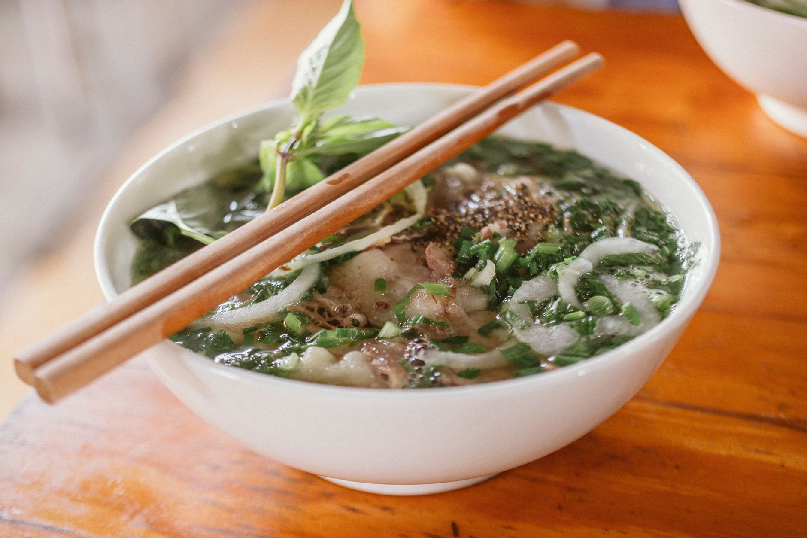
Figure: Steaming bowl of authentic Hanoi beef pho with scallions, fresh herbs, and rich bone broth. | Photo: Nam Phong Bùi / Pexels
- What it is Hanoi's culinary crown jewel. Tender flat rice noodles served in a fragrant broth simmered for 12 to 14 hours with charred ginger, star anise, cinnamon, and beef marrow bones, topped with sliced scallions and your choice of beef (rare *tái*, well-done brisket *chín*, or flank *nạm*).
- Hanoi style Clearer and more savory than southern pho. Do not ask for hoisin sauce or bean sprouts - Hanoi locals season their broth strictly with fresh lime juice, fresh bird's eye chili, and homemade pickled garlic vinegar (*dấm tỏi*). Pair it with crispy fried dough sticks (*quẩy*) dipped directly into the soup.
- Typical price 45,000–65,000 VND ($1.80–$2.60 USD).
- Where to try *Phở Gia Truyền Bát Đàn* (49 Bat Dan) or *Phở 10 Lý Quốc Sư* (10 Ly Quoc Su).

2. Charcoal-Grilled Pork with Rice Noodles (*Bún Chả*)
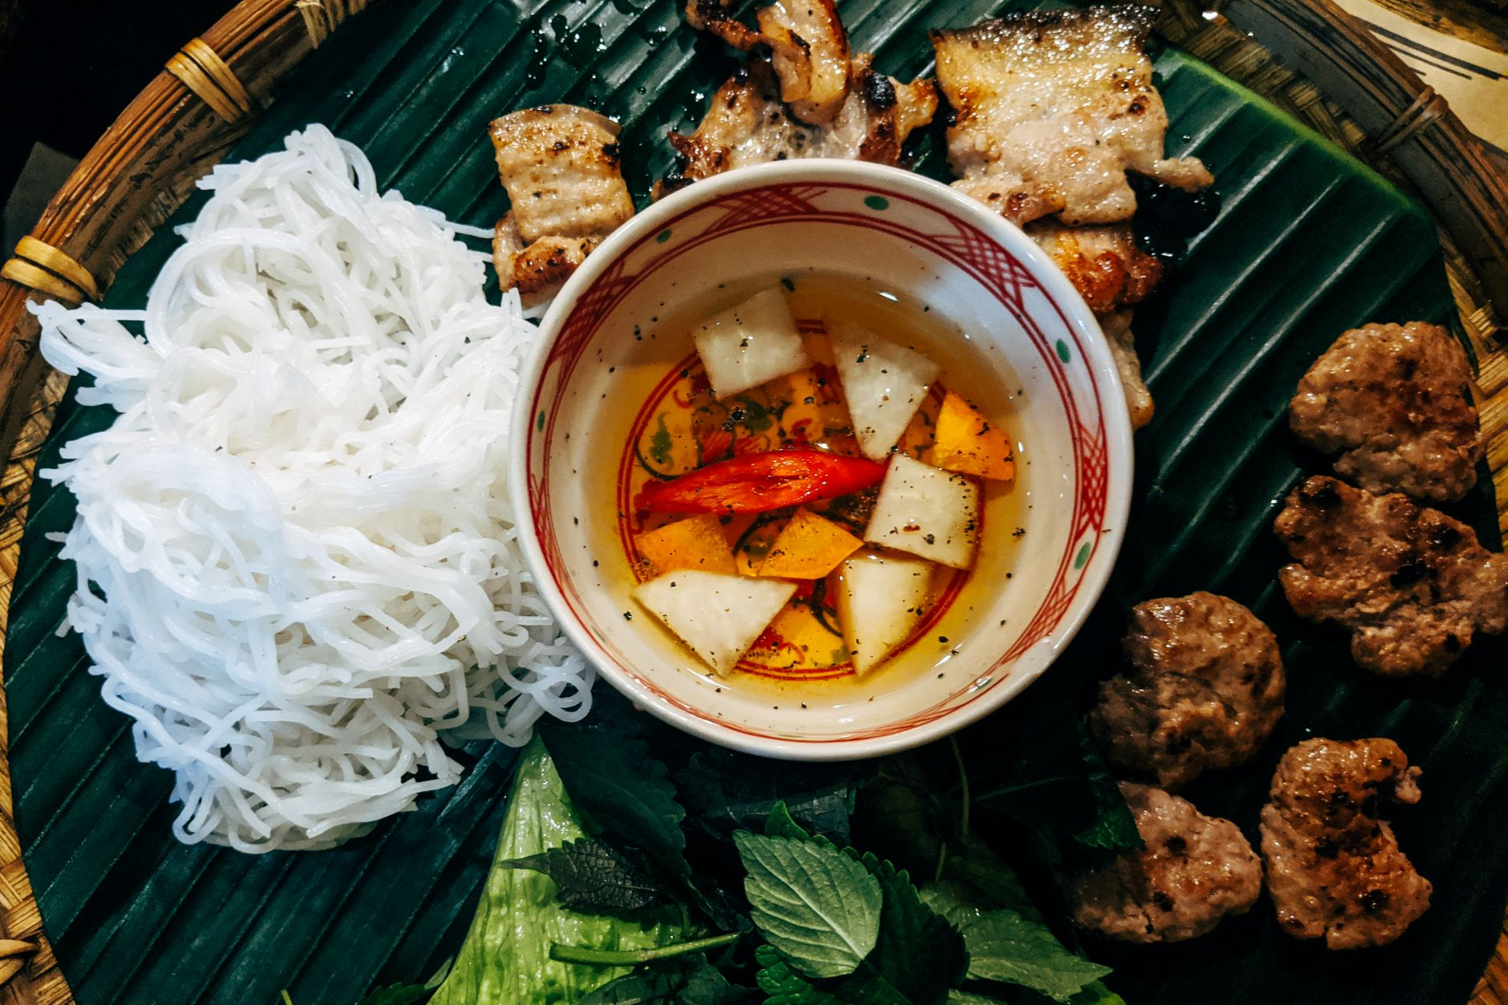
Figure: Hanoi Bun Cha served with charcoal grilled pork patties, fresh rice vermicelli, and aromatic herbs. | Photo: Markus Winkler / Pexels
- What it is The dish that Anthony Bourdain shared with President Barack Obama in Hanoi. Seasoned minced pork patties and pork belly slices grilled over smoking charcoal, served swimming in a warm bowl of balanced fish sauce broth (nuoc cham) infused with green papaya and carrot slices.
- How to eat Take a small bundle of cold rice vermicelli noodles (*bún*) and fresh herbs (mint, perilla, lettuce), dip them into the warm broth, and eat in one delicious, smoky bite.
- Typical price 50,000–70,000 VND ($2.00–$2.80 USD). Add a crispy crab spring roll (*nem cua bể*) for 15,000–20,000 VND.
- Where to try *Bún Chả Đắc Kim* (1 Hang Manh) or *Bún Chả Hương Liên* (24 Le Van Huu: the Obama stall).

3. Steamed Fermented Rice Rolls (*Bánh Cuốn*)
- What it is A masterclass in culinary dexterity. Rice batter fermented to silky perfection is steamed on a taut cotton cloth over boiling water, scraped off with a thin bamboo stick, stuffed with minced pork and wood-ear mushrooms, rolled, and showered in crispy fried shallots.
- How to eat Dip into warm sweet-sour fish sauce, often served with steamed pork roll (*chả lụa*) or grilled cinnamon sausage (*chả quế*).
- Typical price 35,000–50,000 VND ($1.40–$2.00 USD).
- Where to try *Bánh Cuốn Gia An* or *Bánh Cuốn Bà Hoành* (66 To Hien Thanh).

4. The Crispy Hanoi Baguette (*Bánh Mì*)
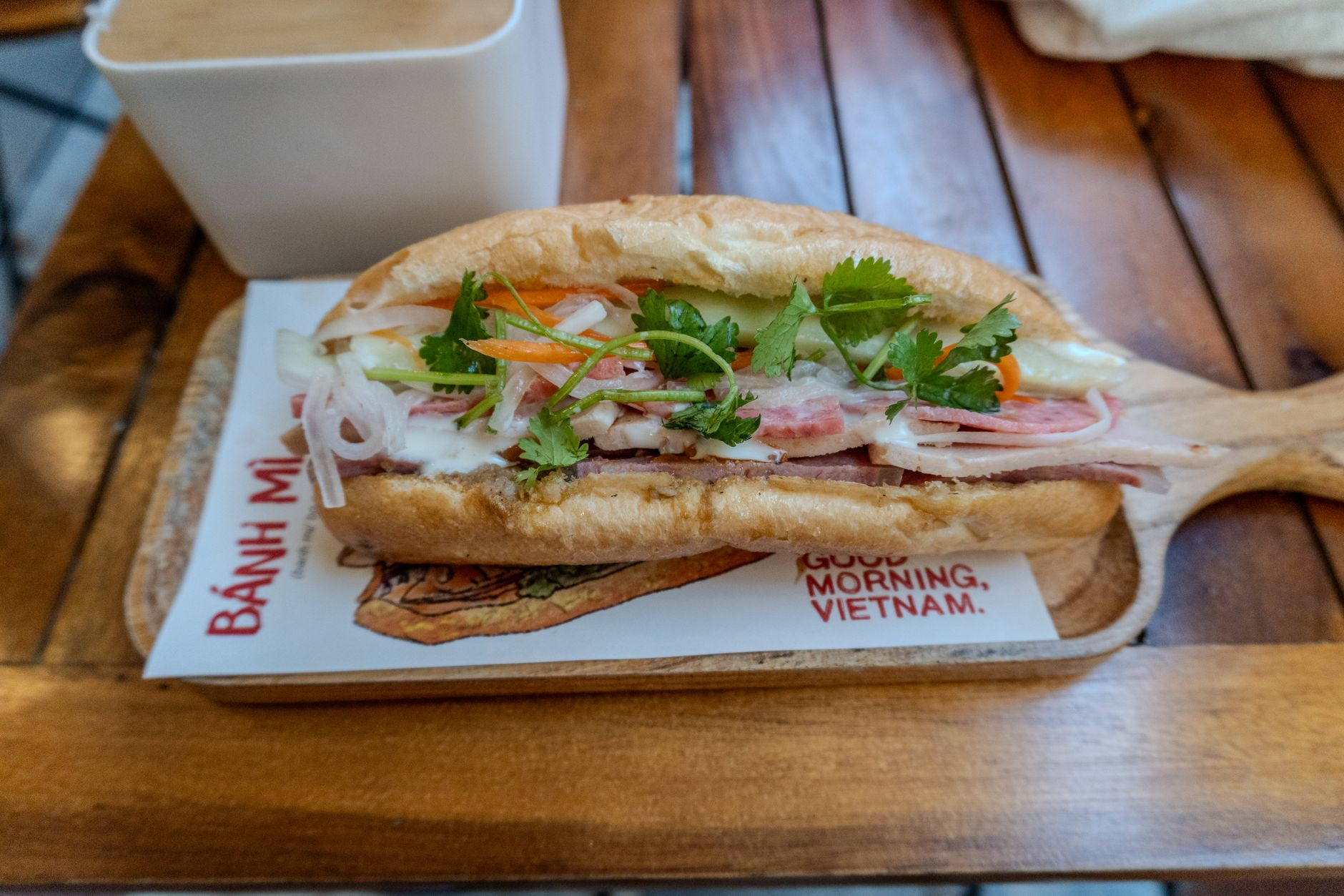
Figure: Crisp Vietnamese Banh Mi sandwich freshly assembled with rich pate and crisp cucumbers. | Photo: Jordan Coleman / Pexels
- What it is While Saigon is famous for towering bánh mì stuffed with dozens of cold cuts, Hanoi bánh mì is simpler, toasted extra crispy, and emphasizes rich duck/pork liver pâté, warm pork floss, cucumber, chili paste, and cilantro.
- Typical price 25,000–40,000 VND ($1.00–$1.60 USD).
- Where to try *Bánh Mì 25* (25 Hang Ca) or *Bánh Mì Phố Cổ* (38 Dinh Liet).

5. Authentic Hanoi Egg Coffee (*Cà Phê Trứng*)
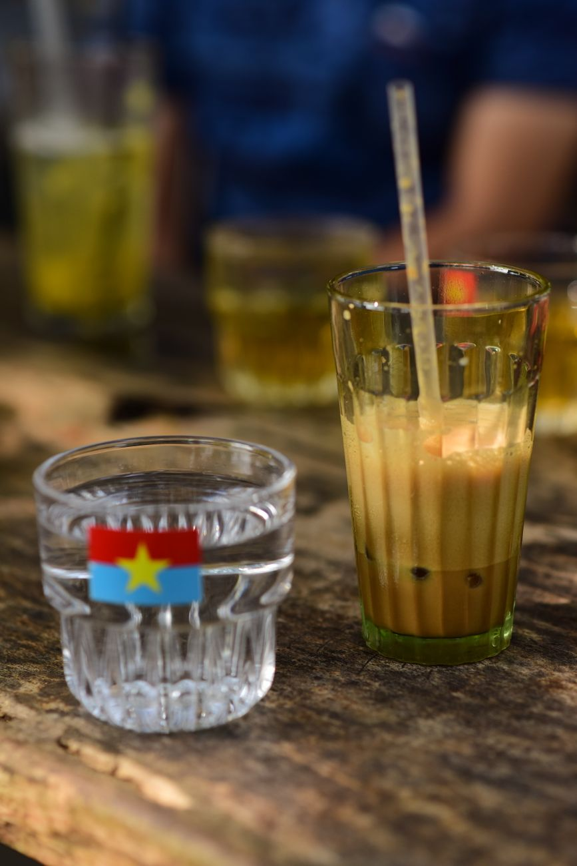
Figure: Traditional Vietnamese iced coffee on a sidewalk table, a daily staple of Hanoi street life. | Photo: Sóc Năng Động / Pexels
- What it is Created in 1946 during the First Indochina War when fresh milk was scarce, Mr. Nguyen Van Giang whisked egg yolks with sweetened condensed milk and sugar to create a luxurious foam that floats atop strong dark robusta drip coffee.
- The flavor profile Tastes like warm liquid tiramisu or rich custard cream balanced by deep, bittersweet coffee.
- Typical price 35,000–45,000 VND ($1.40–$1.80 USD).
- Where to try *Café Giảng* (39 Nguyen Huu Huan: original heritage shop) or *Café Đinh* (13 Dinh Tien Hoang).

6. Snail Noodle Soup (*Bún Ốc*)
- What it is For adventurous eaters, this is Hanoi's most authentic street flavor. Plump freshwater snails (*ốc*) cooked in a tangy, tomato-based broth enriched with fermented rice wine vinegar (*giấm bỗng*), fried tofu, and heaps of purple perilla leaves.
- Typical price 40,000–55,000 VND ($1.60–$2.20 USD).
- Where to try Alleys around Dong Xuan Market (*Ngõ Đồng Xuân*).

7. Turmeric Grilled Fish with Dill (*Chả Cá Lã Vọng*)
- What it is Hanoi's signature celebration meal. Chunks of tender river fish marinated in turmeric and galangal are brought to your table in a sizzling skillet with mountains of fresh dill and spring onions.
- How to eat Combine rice noodles, fresh herbs, roasted peanuts, and a dash of chili fish sauce (or pungent fermented shrimp paste *mắm tôm* for the brave) in your bowl, then top with the sizzling fish.
- Typical price 140,000–180,000 VND ($5.50–$7.20 USD) per serving.
- Where to try *Chả Cá Thăng Long* (21 Duong Thanh).

8. Crispy Crab Spring Rolls (*Nem Cua Bể*)
- What it is Square-shaped spring rolls wrapped in delicate rice paper, packed with fresh Gulf of Tonkin crab meat, ground pork, glass noodles, and shiitake mushrooms, fried to a golden, blistered crunch.
- Typical price 40,000–60,000 VND ($1.60–$2.40 USD) for 2 large rolls.

Part 2: How to Eat Like a Hanoi Local

The 4 Golden Rules of Sidewalk Dining
1. Always Confirm Prices Before Sitting Down (V-07 Rule): While 95% of vendors are completely honest, tourist-heavy areas occasionally have stalls that charge a "foreigner markup" if prices aren't posted. Simply point at the pot and ask *"Bao nhiêu một bát?"* (How much for a bowl?) or check for a printed wall menu (*Bảng Giá*).
2. Follow the Plastic Stool Crowd: The single best quality indicator is a sidewalk stall packed with local office workers or families sitting on low stools with scooters parked haphazardly outside. High turnover means the meat and broth are guaranteed fresh.
3. Master the Table Condiments:
- Pickled garlic slices in vinegar (*dấm tỏi*): Add 2–3 slices and a spoonful of garlic vinegar to your pho broth.
- Chili sauce (*tương ớt*): Traditional Hanoi chili sauce is thin, savory, and fermented - not sweet like commercial ketchup.
- Lime wedges (*chanh*): Squeeze into broths for bright acidity.
4. Use Lime Wedges for Your Chopsticks: You will often see locals take a discarded lime rind and rub it across the tips of their bamboo chopsticks before wiping them with a dry tissue. It's a quick, natural sanitizing ritual that also adds a subtle citrus aroma!

Part 3: Food Safety & Avoiding "Hanoi Belly"
Getting sick from food in Hanoi is actually far less common than in many other travel hubs, provided you follow basic precautions:
- Water Safety Never drink tap water. Drink bottled or boiled water. Good hotels provide complimentary sealed bottles daily.
- The Truth About Ice (Trà Đá) 99% of cafes and sidewalk stalls use commercially manufactured cylindrical tube ice with a hollow hole in the center (*đá ống*). This ice is made in certified food-grade water filtration plants and is perfectly safe to consume. Only avoid crushed, cloudy block ice shaved by hand from large ice blocks.
- Cooked-to-Order Rule Stick to hot, freshly prepared foods. If meat or noodles have been sitting pre-cooked at ambient temperature on an unshaded counter, choose another stall.

Part 4: Hanoi's Greatest Food Streets to Explore on Foot
Street / Alley | Primary Culinary Specialty | Best Time to Visit
**Ngõ Đồng Xuân** (Dong Xuan Alley) | High-density street breakfast: *Bún ốc, Bún chả, Bánh cuốn* | 7:00 AM – 10:30 AM
**Ngõ Trạm & Đường Thành** | *Phở bò, Bánh mì, Chả cá* | 11:30 AM – 2:00 PM (Lunch)
**Tống Duy Tân** (Food Street) | 24/7 dining: Steamed chicken soup (*Gà tần*), fried rice, stir-fried noodles | 6:00 PM – 2:00 AM (Late night)
**Tạ Hiện** (Beer Corner) | Fresh draught beer (*Bia hơi* at 12,000–15,000 VND/glass), grilled quail, crispy cheese sticks | 6:00 PM – 11:30 PM

Discover Hanoi’s Flavors with a Local Storyteller: TravelFrame Experience
Navigating narrow residential alleys in search of multi-generational street food gems can feel intimidating if you don't speak Vietnamese.
At **TravelFrame**, we blend **authentic culinary exploration with candid documentary photography**. Walk alongside a bilingual local friend who orders the best secret dishes, explains the cultural folklore behind every flavor, and captures beautiful, unposed photos of you laughing, tasting, and living like a local in Hanoi.
👉 **Book a private photo & food walk:** [Discover TravelFrame Sessions](https://travelframe.vn/)
👉 **Need a complete 1-day walking plan?** Download our free [24-Hour Hanoi Itinerary](file:///Users/macbook/Codex%20GPT/travelframe.vn/Marketing-Growth/Content/Drafts/Lead-Magnet-24h-Hanoi.md).
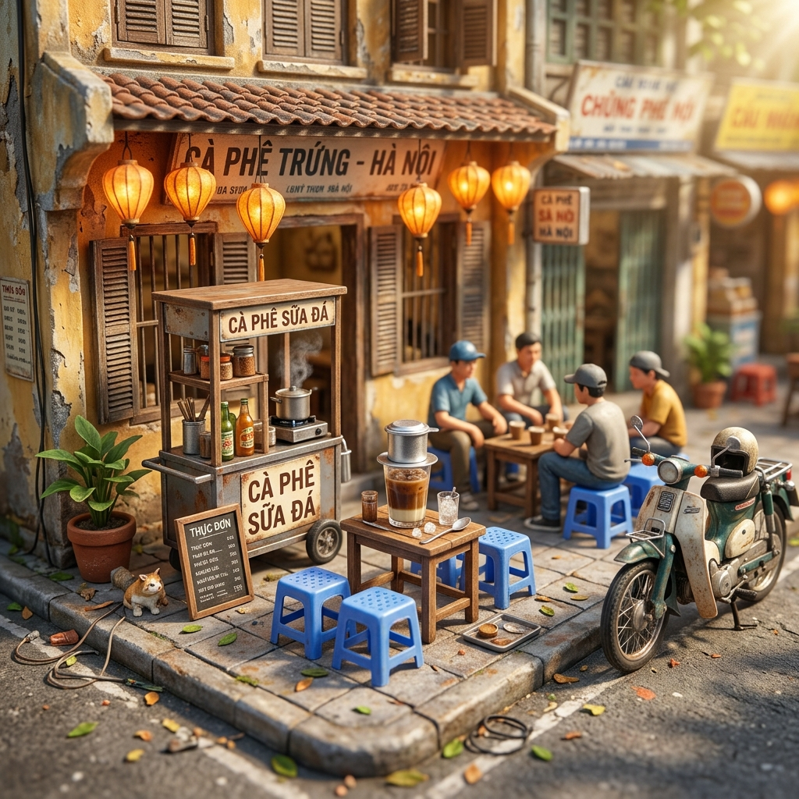
Figure: Visual concept: 3D miniature diorama of a classic Hanoi sidewalk cafe. | AI Concept by Nano Banana for TravelFrame

