Hiring a private photographer in Hanoi: what to expect, costs, and locations (2026 guide)
By TravelFrame Editorial Team · Updated September 2026
Hiring a local photographer in Hanoi has become one of the most common requests from solo travelers and couples visiting Vietnam. The reasons are practical: selfies in crowded markets end up crooked, carrying a heavy tripod on uneven sidewalks is exhausting, and asking strangers on the street usually leaves you with cut-off heads and tilted horizons.
This guide explains how private photo walks work in Hanoi, what standard rates look like in 2026, which neighborhoods produce the best pictures, and what to look for before reserving a session.

How private photo walks work
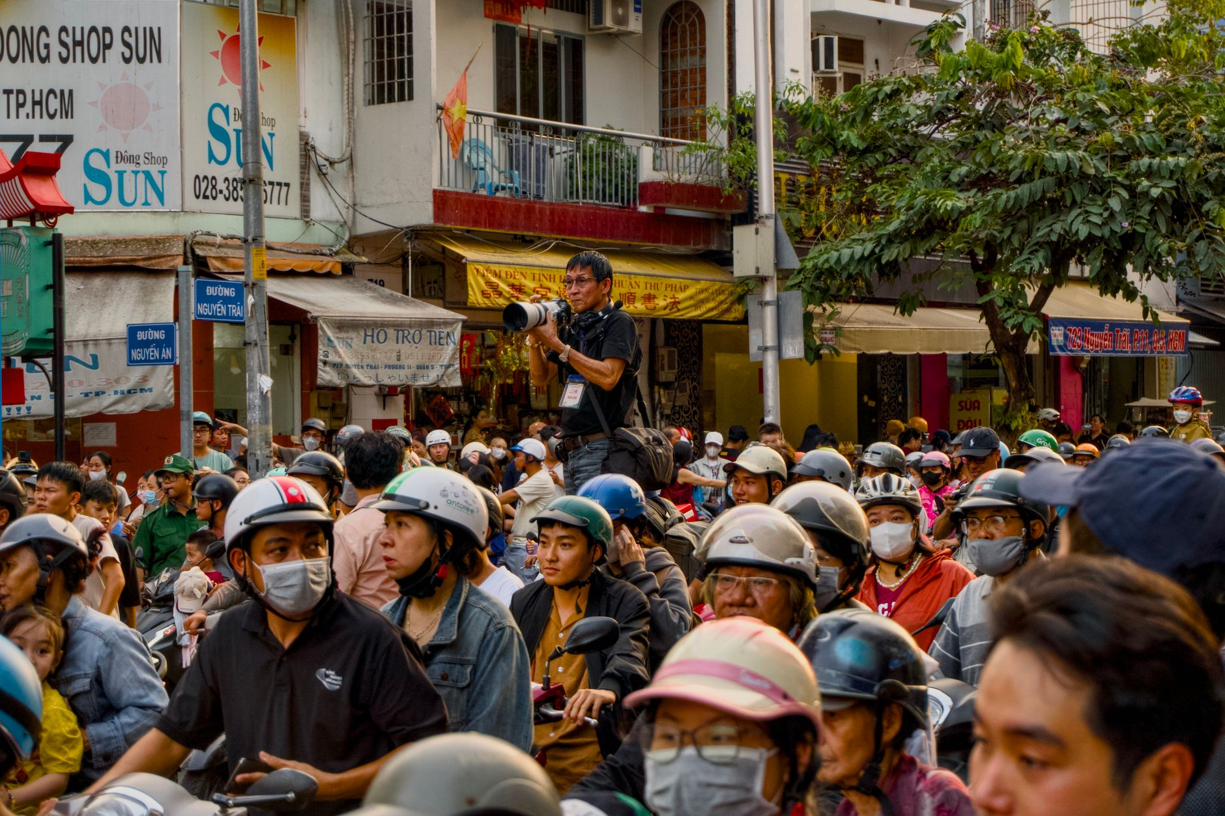
Figure: Personal photographer capturing candid travel moments in the bustling streets of Hanoi. | Photo: Tuan Vy / Pexels
A private photo walk is different from an indoor studio session or a rigid wedding shoot. You meet your photographer in the Old Quarter, usually between 7:00 and 8:30 in the morning when the light is soft and the sidewalks are less congested.
Over the next 90 to 120 minutes, you walk a planned route through traditional craft streets, narrow residential alleys, and lakeside paths.
Your photographer gives gentle direction so you feel comfortable, but the focus stays on natural movement:
- Walking along weathered yellow colonial walls
- Stopping at a quiet sidewalk cafe for an egg coffee or iced tea
- Exploring ancient temple courtyards
- Watching morning street life without holding stiff poses
Most private photographers in Hanoi deliver a private gallery of 35 to 50 edited digital photos within 24 to 48 hours.

How much does a photographer in Hanoi cost?
Prices in Hanoi vary depending on whether you book through international platforms like Airbnb Experiences, hire a high-end commercial fashion studio, or book directly with an independent local photo guide.
Here is what typical rates look like in 2026:
Service type | Duration | Typical price range | Best suited for
Large group photo walk (4-8 people) | 2 hours | $35 to $50 per person | Budget travelers who do not mind sharing shooting time
Private solo session | 1.5 hours | $70 to $90 total | Solo travelers wanting natural portraits and personalized guidance
Private couple session | 2 hours | $120 to $150 total | Couples wanting vacation photos and engagement shoots
Full-day commercial shoot | 6-8 hours | $300 to $500 total | Fashion brands or creators needing multiple wardrobe changes

At TravelFrame, we charge $75 for a private 1.5-hour solo walk and $130 for a 2-hour couple walk, with all photos color-graded and delivered within 24 hours.

Best neighborhoods for photos in Hanoi
Hanoi has four distinct visual areas. Your photographer will usually recommend one based on the time of day and the style you want.

1. The Old Quarter (Hoan Kiem)
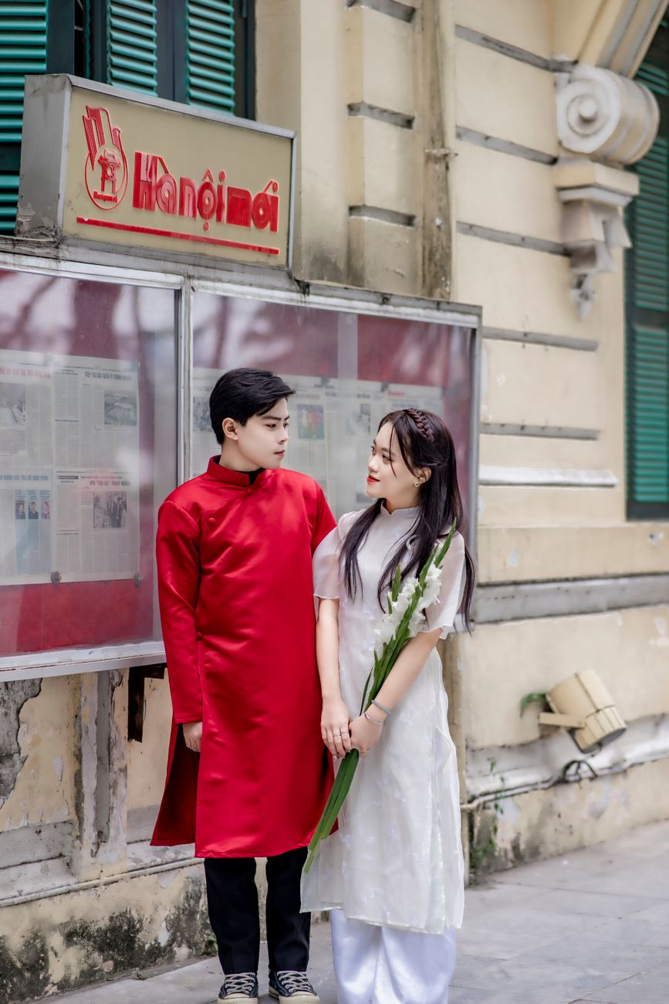
Figure: Couple photoshoot in traditional Vietnamese dress on historic Hanoi streets. | Photo: Toàn Văn / Pexels
The Old Quarter offers the most authentic street texture in northern Vietnam. Narrow shophouses, dark green timber shutters, leafy banyan branches, and low plastic stools create an immediate sense of place. The best spots include Hang Bac, Hang Ma, and the quiet alleys behind Dong Xuan market.
Best time: 7:00 AM to 8:30 AM before traffic builds up.

2. The French Quarter (Ba Dinh & South Hoan Kiem)
If you prefer wide pavements, neoclassical yellow architecture, and grand colonnades, head south toward the Hanoi Opera House, Trang Tien street, and the perimeter of the Metropole Hotel.
Best time: 8:30 AM to 10:00 AM or late afternoon.

3. Temple of Literature (Van Mieu)
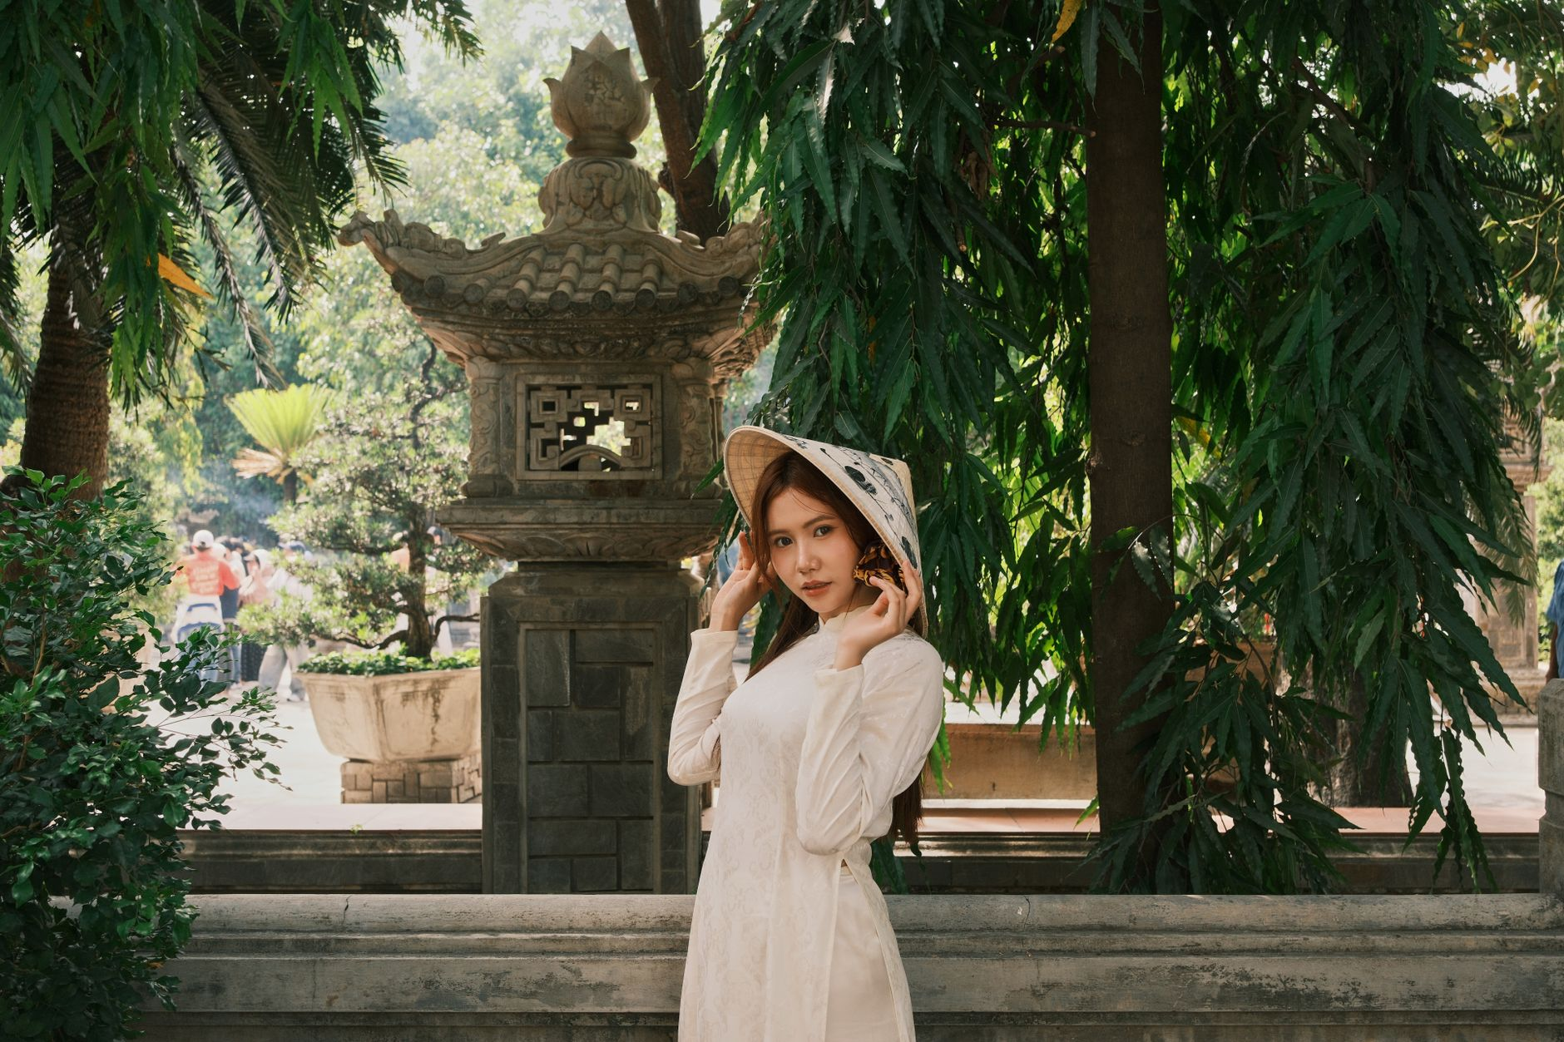
Figure: Solo travel portrait capturing serene expressions in an ancient temple courtyard. | Photo: quang vinh / Pexels
Founded in 1070, this historic complex features red lacquer pavilions, ancient stone stelae on turtle statues, and quiet lotus ponds. It is ideal for traditional Vietnamese Ao Dai portraits.
Best time: 8:00 AM right at opening to avoid tour groups.

4. Long Bien Bridge
Built over a century ago across the Red River, the rusty iron girders and pedestrian boardwalk give photos an industrial, vintage mood.
Best time: Sunrise (5:30 AM to 6:30 AM) or golden hour before sunset.

What to wear for your session
Choosing the right clothes makes a noticeable difference in how your photos turn out:
- Solid neutral colors work best: white linen, cream, beige, soft blue, and terracotta contrast well with Hanoi's yellow walls and green shutters.
- Avoid loud commercial logos or busy neon prints that distract from the background.
- Wear comfortable walking shoes. Hanoi sidewalks have high curbs, broken tiles, and parked scooters. You can pack a pair of dressier shoes in a tote bag to slip on during specific shots.
- If visiting temples, ensure your clothing covers your knees and shoulders to respect local customs.

4 questions to ask before booking
Before sending a deposit to any photographer in Hanoi, check these four points:
1. Delivery time: Will you get your photos before leaving Hanoi? If you are traveling to Sapa or Halong Bay two days later, confirm that delivery happens within 24 to 48 hours.
2. What is included: How many final edited images do you receive? Are raw files available upon request?
3. Rescheduling policy: Rain happens in Hanoi, especially in summer. Does the photographer offer flexible rescheduling or indoor heritage cafe alternatives?
4. Communication: Can you contact the photographer directly via WhatsApp or Instagram before the shoot to discuss locations?

Book your Hanoi photo walk with TravelFrame
TravelFrame connects travelers with friendly, English-speaking local photographers who know Hanoi's quietest corners and best morning light.
- Strictly private sessions with no strangers joining your group
- Natural, unposed documentary style
- 24-hour delivery guaranteed
- Transparent flat pricing with no hidden charges
Check available dates and view our recent guest gallery at [travelframe.vn](https://travelframe.vn/).

