TravelFrame.vn · Bộ Ấn Phẩm Nội Dung & Visuals 2026
Tuyển tập 4 bài viết trụ cột SEO & Chuyển đổi kèm bộ hình ảnh minh họa chất lượng cao
Đơn vị phát hành: TravelFrame Vietnam (travelframe.vn)
Ngày hoàn thiện: 15/09/2026
Quy chuẩn nội dung: Humanizer Engine (Giọng văn chân thật, gãy gọn, loại bỏ khuôn mẫu AI)
Hệ thống hình ảnh: Curated Stock qua Pexels API & Nano Banana 3D Visual Pipeline
Tổng số hình ảnh tích hợp: 14 ảnh có bản quyền & credit chi tiết

Mục Lục Các Bài Viết Trong Tập Tài Liệu
Số thứ tự | Tên bài viết | Bộ hình ảnh tích hợp
Phần 1 | The Complete Hanoi Travel Guide 2026 | 3 ảnh minh họa (Phố cổ, Hồ Gươm, Train Street)
Phần 2 | 15 Best Photo Spots in Hanoi (Field Guide) | 3 ảnh minh họa (Cầu Long Biên, Nhà Thờ Lớn, Chùa Trấn Quốc)
Phần 3 | The Honest Hanoi Street Food Guide 2026 | 5 ảnh minh họa (Phở bò, Bún chả, Bánh mì, Cà phê, 3D Diorama)
Phần 4 | Hiring a Private Photographer in Hanoi | 3 ảnh minh họa (Nhiếp ảnh gia đường phố, Chụp đôi, Chụp chùa cổ)

PHẦN 1: THE COMPLETE HANOI TRAVEL GUIDE 2026
The Complete Hanoi Travel Guide 2026: What to Do, Eat, and Know Before You Arrive
By TravelFrame Editorial Team · Updated September 2026 · 14 min read

Introduction: The City That Demands All Five Senses
Hanoi is not a destination where you passively check off landmarks from a sightseeing checklist. It is a living, breathing sensory kaleidoscope where centuries-old banyan trees drape over French-colonial villas, motorized scooters move in fluid harmony through labyrinthine alleys, and the unmistakable aroma of star anise and roasted robusta coffee drifts through every doorway.
Whether you are stepping foot in Vietnam for the very first time or returning to explore its hidden courtyards, Hanoi can feel delightfully overwhelming on day one.
This comprehensive **Hanoi Travel Guide 2026** is written from the ground up by local insiders to give you everything you need: authentic neighborhood breakdowns, verified local transport costs, honest safety tips, must-try food spots, and practical photography advice to help you capture memories that do justice to this unforgettable capital.

1. When to Visit Hanoi: Weather & Seasons Explained
Hanoi experiences four distinct seasons, unlike the perpetually warm tropical climate of southern Vietnam:
- Autumn (September to November): The Golden Window Universally celebrated as the best time to visit Hanoi. Daytime temperatures hover between 22°C and 28°C (71°F–82°F) with low humidity, clear skies, and a crisp morning breeze. Streets like Phan Dinh Phung and Hoang Dieu are blanketed with golden leaves, and the fragrant scent of milk flowers (*hoa sữa*) fills the night air.
- Winter (December to February) Crisp, cool, and overcast. Temperatures can drop to 10°C–14°C (50°F–57°F) with high humidity, making it feel cooler than the thermometer suggests. Pack lightweight layers, a warm fleece or jacket, and enjoy steaming bowls of street noodle soup.
- Spring (March to April) Mild temperatures (20°C–26°C), but accompanied by occasional drizzle and fog (*mưa phùn*). It gives the Old Quarter an atmospheric, moody charm that street photographers love.
- Summer (May to August) Hot and humid, with temperatures frequently exceeding 35°C (95°F) and dramatic afternoon downpours. Best for early risers who want to explore between 6:00 AM and 9:00 AM before retreating to air-conditioned heritage cafes during the midday heat.

2. Getting There & Essential Logistics

Vietnam E-Visa
As of 2026, Vietnam offers a 90-day multiple-entry e-visa for citizens of all countries and territories. Apply exclusively through the official Vietnam Government Immigration portal (`evisa.xuatnhapcanh.gov.vn`) at least 7–10 days before your travel date. The standard processing fee is $25 USD for single-entry and $50 USD for multiple-entry. Avoid third-party commercial visa agencies that charge exorbitant markup fees.

Currency & Money Tips
The local currency is the Vietnamese Dong (VND). As an indicative reference, $1 USD is approximately 25,000–25,600 VND *(re-check current rates before major transactions)*.
- Cash is King While upscale hotels, restaurants, and convenience stores readily accept Visa and Mastercard, street food vendors, traditional market stalls, and local taxis operate strictly on cash.
- ATM Tips Major international bank ATMs (such as HSBC, Standard Chartered) or local banks with high withdrawal limits (VPBank, TPBank) offer the best rates with minimal transaction fees.
- Note Confusion Warning The 20,000 VND (blue polymer) note looks strikingly similar to the 500,000 VND (cyan polymer) note under dim street lighting. Double-check the zeros before handing over payment!

Getting From Noi Bai International Airport (HAN) to the City Center
Noi Bai Airport is situated approximately 30 km (18 miles) north of downtown Hanoi:
1. Ride-Hailing (Grab): The most reliable option. Download the Grab app upon arrival using the airport's free Wi-Fi or a local eSIM. A standard ride to the Old Quarter costs between 280,000 VND and 380,000 VND ($11–$15 USD), including highway toll fees. Pick-up is at the designated ride-hailing lanes outside Terminal 2 (International).
2. Airport Express Bus #86: Runs every 30–45 minutes directly from Terminal 1 & 2 to Hanoi Central Railway Station via the Old Quarter (stops near Hoan Kiem Lake). Highly comfortable, air-conditioned, and costs just 45,000 VND (~$1.80 USD) per person.
3. Airport Taxis: Stick strictly to reputable branded taxi counters (Mai Linh, Taxi Group) located right at the arrival terminal. Always confirm that the driver uses the meter.

3. Where to Stay: Neighborhood Guide
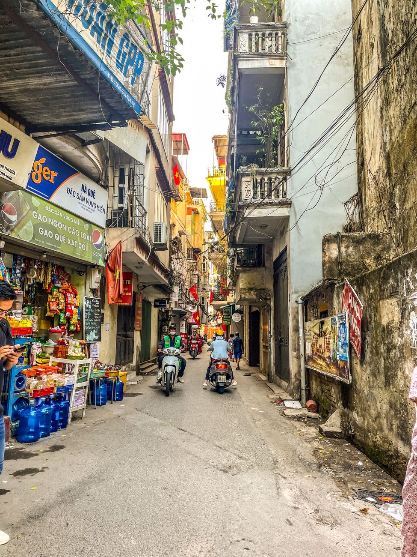
Figure: Morning sunlight illuminating the traditional street life and cyclos of the Hanoi Old Quarter. | Photo: Warren Yip / Pexels

The Old Quarter (Hoan Kiem District): Best for First-Timers & Walkability
The beating heart of Hanoi, consisting of 36 ancient guild streets named after the goods historically traded there (Silk Street, Silver Street, Bamboo Street).
- Vibe Bustling, energetic, historic, endlessly walkable.
- Best for Travelers who want to step straight from their hotel lobby into street food alleys, cafes, and vibrant nightlife.
- Note Street noise can start as early as 6:30 AM; request a room facing an internal courtyard if you are a light sleeper.

The French Quarter (South of Hoan Kiem): Best for Luxury & Heritage
Characterized by wide, tree-shaded boulevards, grand yellow neoclassical facades, art galleries, and the magnificent Hanoi Opera House.
- Vibe Sophisticated, peaceful, and elegant.
- Best for Couples, honeymooners, and travelers seeking boutique luxury hotels (such as the historic Sofitel Legend Metropole).

West Lake (Tay Ho District): Best for Extended Stays & Cafes
A breezy, expansive residential district surrounding Hanoi's largest freshwater lake.
- Vibe Relaxed, international, bohemian, dotted with rooftop cocktail bars, lakeside coffee shops, and wellness studios.
- Best for Digital nomads, repeat visitors, and anyone wanting a quiet sanctuary away from scooter horns.

4. Top Things to Do & Hidden Corners

1. Sunrise Stroll Around Hoan Kiem Lake (6:00 AM – 7:30 AM)
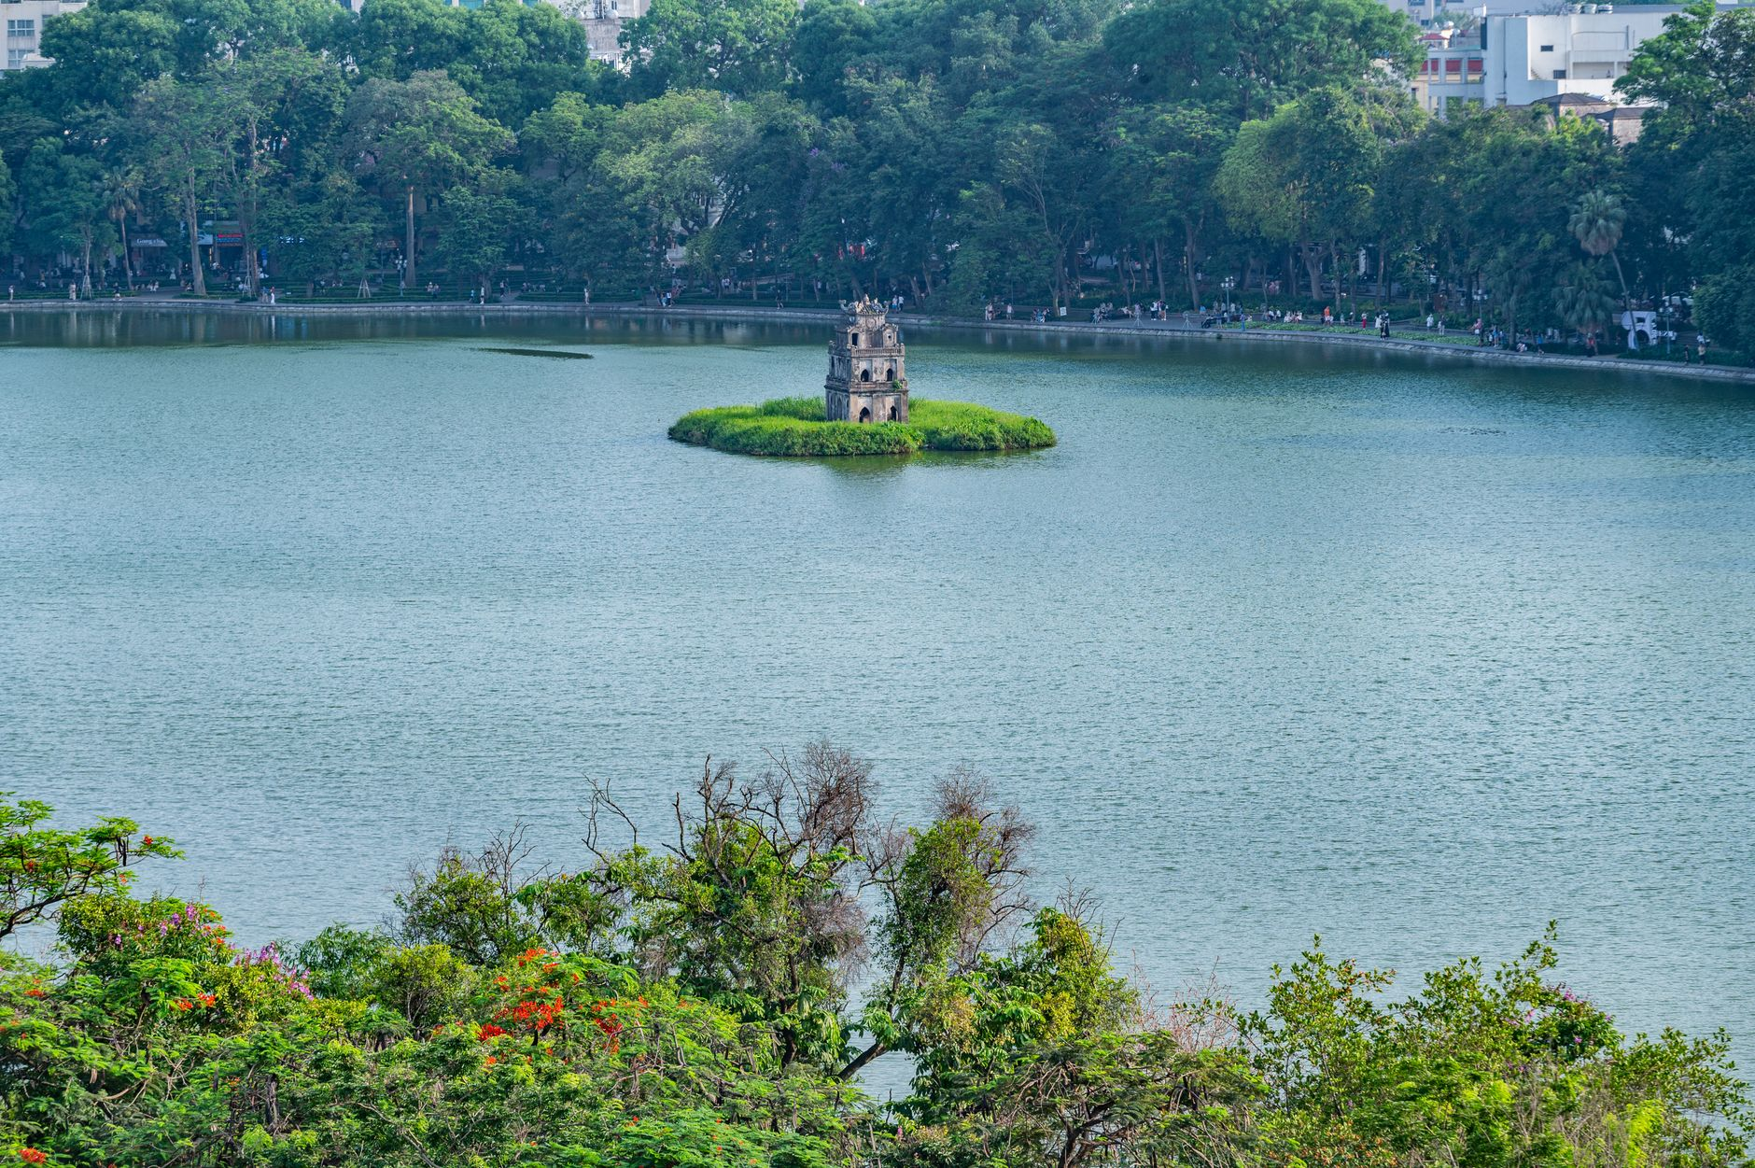
Figure: Turtle Tower standing serenely amidst morning mist on Hoan Kiem Lake. | Photo: Nguyen Ngoc Tien / Pexels
Before the city awakens to its legendary traffic rush, Hoan Kiem Lake belongs to the locals. Watch seniors practice Tai Chi and ballroom dancing along the mist-draped shore, while runners loop around Ngoc Son Temple. The morning light filtering through the lakeside willow trees offers one of the most serene sights in all of Vietnam.

2. Discovering the Secrets of Dong Xuan Alleys
While the main Dong Xuan Market building can feel overwhelming with wholesale textiles, the surrounding alleys (specifically *Ngõ Đồng Xuân*) hide the city's highest concentration of culinary heritage. Here, multi-generational street vendors dish out piping hot bowls of snail noodle soup (*Bún ốc*) and grilled pork patties on charcoal braziers.

3. Exploring the Temple of Literature (Văn Miếu)
Founded in 1070 as Vietnam's first national university, this exquisitely preserved specimen of traditional Vietnamese architecture is dedicated to Confucius. Walk through five manicured courtyards, gaze at the ancient stone stelae resting on giant stone turtles, and soak in the scholar culture that has shaped Vietnamese history for a millennium.

4. Experiencing Hanoi Train Street (Respectfully & Safely)
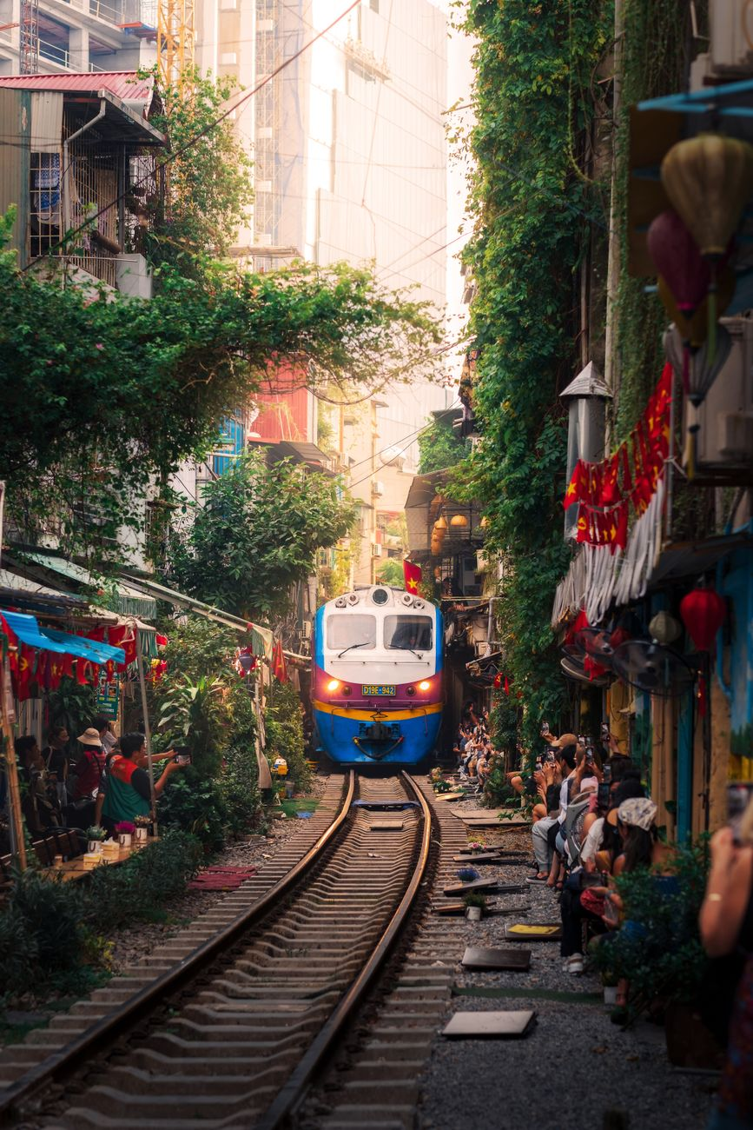
Figure: Local train passing through the residential corridor of Hanoi Train Street. | Photo: Hòa Lê Đình / Pexels
The iconic railway slicing through narrow residential houses is a fascinating visual spectacle. While authorities have periodically regulated access for safety reasons, authorized local cafes along the tracks welcome visitors to sit safely behind safety barriers with an iced egg coffee while the train rumbles past inches away.

5. Hidden Courtyards & Heritage Coffee Houses
Escape the street commotion by slipping down unassuming residential passageways (*ngõ*). Behind crumbling facades lie tranquil French-colonial courtyards, independent bookshops, and vintage cafes like *Café Đinh* overlooking the lake or *Nhà Sàn Art Cafe*.

5. What to Eat: A Culinary Masterclass
Hanoi food is celebrated for its subtle balance, fresh herbal aromatics, and clean, savory broths. Here are four foundational dishes you cannot leave without tasting:
Dish | Vietnamese Name | What Makes It Special | Typical Local Price
**Hanoi Traditional Pho** | *Phở Bò / Phở Gà* | Fragrant 12-hour simmered bone broth with fresh flat rice noodles, sliced beef/chicken, lime, and chili garlic vinegar. Simpler and less sweet than southern-style pho. | 40,000–60,000 VND ($1.60–$2.40 USD)
**Grilled Pork with Vermicelli** | *Bún Chả* | Smoky grilled pork slices and meatballs served in a warm bowl of sweet-savory fish sauce broth, paired with rice vermicelli and heaps of fresh herbs. (Made famous globally by Anthony Bourdain and Barack Obama). | 50,000–70,000 VND ($2.00–$2.80 USD)
**Crispy Hanoi Baguette** | *Bánh Mì* | French baguette baked light and crispy, spread with pate, pork charcuterie, cucumber, pickled carrots and daikon, cilantro, and chili sauce. | 25,000–40,000 VND ($1.00–$1.60 USD)
**Hanoi Egg Coffee** | *Cà Phê Trứng* | Robust Vietnamese dark drip coffee crowned with a velvety, whipped egg yolk, condensed milk, and honey custard foam. Tastes like liquid tiramisu. | 35,000–50,000 VND ($1.40–$2.00 USD)

6. Staying Safe & Scam-Free in Hanoi
Hanoi is statistically one of the safest capital cities in Asia, with very low rates of violent crime. However, petty tourist scams can happen if you are unprepared:
1. The Cyclo Fare Misunderstanding: Cyclos (three-wheeled rickshaws) are a charming way to tour the Old Quarter. However, **always agree on the exact price beforehand**, and explicitly confirm whether the quoted price is *per person* or *for both passengers*, and whether it covers *the entire trip* or *per hour*. Write the agreed amount on your phone screen to avoid misunderstandings at the destination.
2. The "Free" Fruit Basket Photo Trap: Women carrying traditional conical hats and bamboo shoulder baskets (*đòn gánh*) of pineapples or bananas may smile and place the basket across your shoulders for a photo. Once you take a picture, they will insist you purchase their fruit at 5 to 10 times the market price. Politely shake your head and say *"Không, cảm ơn"* (No, thank you) before they place the basket.
3. Shoe Shiners on Foot: Someone may crouch down and point at a scuff on your sneakers, applying glue or cleaner without asking, then demand 200,000–400,000 VND. A firm and immediate *"No, thank you"* with a wave of your hand will prevent this.
4. Crossing the Street with Confidence: The legendary Hanoi traffic looks terrifying to newcomers, but there is a rhythm to the scooter flow. When crossing at an intersection or crosswalk: walk at a steady, predictable, slow pace. Do not make sudden stops or sprint backwards. Scooter riders calculate your path and smoothly steer behind or around you.

7. Turn Your Hanoi Journey Into Lifetime Memories: The Private Photo Walk Experience
You can explore Hanoi on your own with a phone camera, but selfie sticks and tripod setups come with undeniable friction: you either end up with unflattering chin-angle selfies, awkward posed expressions, or you spend half your precious morning worrying about camera angles rather than living in the moment.
That is why **TravelFrame** was born.
We host **private, relaxed walking photo tours** led by passionate local photographers who know every hidden doorway, sunlit courtyard, and heritage alley in the Old Quarter.
- No Stiff Posing We don't make you stand awkwardly in front of crowded tourist monuments. We guide you through quiet, picturesque street corners while sharing authentic stories about local life, capturing natural, candid documentary portraits as you genuinely enjoy your walk.
- Perfect for Solo Travelers & Couples If you are traveling solo, you finally get magazine-worthy travel portraits without asking strangers. If you are a couple, you both get to be in the frame together.
- High Quality Delivered Within 24 Hours We know you want to share your travel highlights with family and followers while you're still on your trip. You receive your professionally edited gallery within 24 hours of finishing your tour.
👉 **Ready to explore Hanoi with a local photographer friend?** [Discover TravelFrame Private Photo Tours](https://travelframe.vn/) or grab our free [24-Hour Hanoi Itinerary Lead Magnet](file:///Users/macbook/Codex%20GPT/travelframe.vn/Marketing-Growth/Content/Drafts/Lead-Magnet-24h-Hanoi.md) to kickstart your trip planning.

Frequently Asked Questions (FAQ)

Is Hanoi safe for solo female travelers?
Yes, Hanoi is widely considered one of the safest travel destinations in Southeast Asia for solo women. Street harassment is rare, and violent crime against tourists is extremely low. Standard precautions apply: avoid unlit alleys late at night, watch your bag near busy traffic, and book transportation through official apps like Grab.

How many days should I spend in Hanoi?
We recommend spending at least **3 full days** in Hanoi to properly explore the Old Quarter, savor the street food culture, visit key cultural landmarks (Temple of Literature, Ho Chi Minh Complex), and enjoy a leisurely afternoon around West Lake before heading to Halong Bay or Ninh Binh.

What is the best way to get mobile internet (SIM/eSIM) in Hanoi?
The easiest method is purchasing a travel eSIM online prior to departure (providers like Airalo or Viettel/Vinaphone tourist eSIMs). If your phone does not support eSIM, buy a physical SIM card directly at official telecom counters at Noi Bai Airport (expect to pay 200,000–350,000 VND / $8–$14 USD for generous 4G data packages).
```json
{
"@context": "https://schema.org",
"@type": "FAQPage",
"mainEntity": [
{
"@type": "Question",
"name": "Is Hanoi safe for solo female travelers?",
"acceptedAnswer": {
"@type": "Answer",
"text": "Yes, Hanoi is widely considered one of the safest travel destinations in Southeast Asia for solo women. Street harassment is rare, and violent crime against tourists is extremely low. Standard precautions like watching your belongings and booking rides via Grab apply."
}
},
{
"@type": "Question",
"name": "How many days should I spend in Hanoi?",
"acceptedAnswer": {
"@type": "Answer",
"text": "We recommend spending at least 3 full days in Hanoi to properly explore the Old Quarter, savor street food, visit cultural heritage sites, and take in the cafe culture before departing for regional excursions."
}
},
{
"@type": "Question",
"name": "What is the best way to get mobile internet (SIM/eSIM) in Hanoi?",
"acceptedAnswer": {
"@type": "Answer",
"text": "The easiest method is purchasing a travel eSIM online prior to departure. Alternatively, physical SIM cards can be purchased at official telecom counters inside Noi Bai International Airport for approximately 200,000–350,000 VND ($8–$14 USD)."
}
}
]
}
```

PHẦN 2: 15 BEST PHOTO SPOTS IN HANOI: FIELD GUIDE
15 Best Photo Spots in Hanoi: A Local Photographer's Field Guide (2026)
By TravelFrame Photography Team · Updated September 2026 · 11 min read

Introduction: Why Hanoi is a Photographer's Dream
Few cities in Southeast Asia possess the raw visual layers of Hanoi. Here, textured ochre-yellow French facades peel back to reveal ancient Chinese roof tiles, crisscrossing overhead utility wires frame neon signage, and soft golden light filters through centuries-old banyan canopies.
Whether you are carrying a professional mirrorless camera, a vintage 35mm film body, or simply shooting on the latest smartphone, Hanoi offers an astonishing variety of backdrops.
As local documentary photographers who walk these streets every single day, we put together this **curated guide to the 15 best photo spots in Hanoi**. Beyond just giving you GPS coordinates, we share the exact times to shoot, how to handle tricky natural lighting, and most importantly: how to photograph local life with warmth and cultural respect.

Part 1: Old Quarter Atmospheric Locations (5 Spots)

1. Phung Hung Mural Street & Railway Arches
- What makes it special Built beneath the historic stone viaduct supporting the north-south railway, this street features 17 hand-painted trompe-l'œil murals depicting traditional Hanoi life (street vendors, Lunar New Year markets, ancient schoolgirls in white *áo dài*). The stone arches themselves create stunning leading lines.
- Best time to shoot 7:30 AM – 9:00 AM. The morning light cuts diagonally through the trees, casting long shadows across the arches before tourist crowds arrive.
- Camera tip Use a 35mm or 50mm prime lens at f/2.8 to blur the background while keeping the stone texture sharp.
- Cultural note (V-09) Local residents often park bicycles along the walls. If an elder is sitting nearby reading a morning newspaper, a warm smile and a polite nod (*"Cháu chào bác"*) before taking a shot will always be welcomed.

2. Hang Ma Street (The Lantern & Color Capital)
- What makes it special The epicenter of festival craft culture in Hanoi. Depending on the season, Hang Ma transforms into an explosion of color: glowing paper lanterns and lion heads for the Mid-Autumn Festival (August–September), or red envelopes and gold calligraphy for Tết (January–February).
- Best time to shoot Blue hour (5:45 PM – 6:45 PM) when the shop lanterns illuminate, creating rich contrast against the deep twilight sky.
- Camera tip Set your white balance to Daylight (~5500K) to keep the warm red and gold lanterns looking vibrant without washing out skin tones.

3. Ta Hien & Luong Ngoc Quyen Corner (Morning vs. Night)
- What makes it special Known at night as "Beer Street", this iconic intersection reveals an entirely different personality at sunrise. Weathered shutters, classic 1920s merchant shophouse architecture, and quiet flagstone streets make it feel like 1950s Indochina.
- Best time to shoot 6:15 AM – 7:30 AM. After 5:00 PM, it becomes packed with plastic stools and nightlife crowds (great for high-ISO night street photography).
- Camera tip Shoot low to the ground to emphasize the cobblestone texture and the narrow perspective of the ancient alleys.

4. Dong Xuan Market Morning Alleys (*Ngõ Đồng Xuân*)
- What makes it special A bustling pedestrian food lane adjacent to Hanoi’s largest covered market. Giant aluminum pots steam with herbal broths, smoke billows from mini charcoal grills, and sunbeams pierce through overhead tarps.
- Best time to shoot 6:30 AM – 8:00 AM during peak breakfast rush.
- Camera tip Keep your shutter speed at 1/250s or faster to freeze moving steam and market activity.

5. Hang Bac (Silver Street) Ancient Shophouses
- What makes it special Hang Bac is one of the oldest streets in Hanoi, dating back over 800 years. Look for house #47 (an ancient communal temple tucked behind a modern storefront) and preserved narrow "tube houses" with narrow wooden balconies draped in potted ferns.
- Best time to shoot 9:00 AM – 10:30 AM when direct sunlight hits the upper balconies.

Part 2: Iconic Heritage Landmarks (4 Spots)

6. Temple of Literature (Văn Miếu)
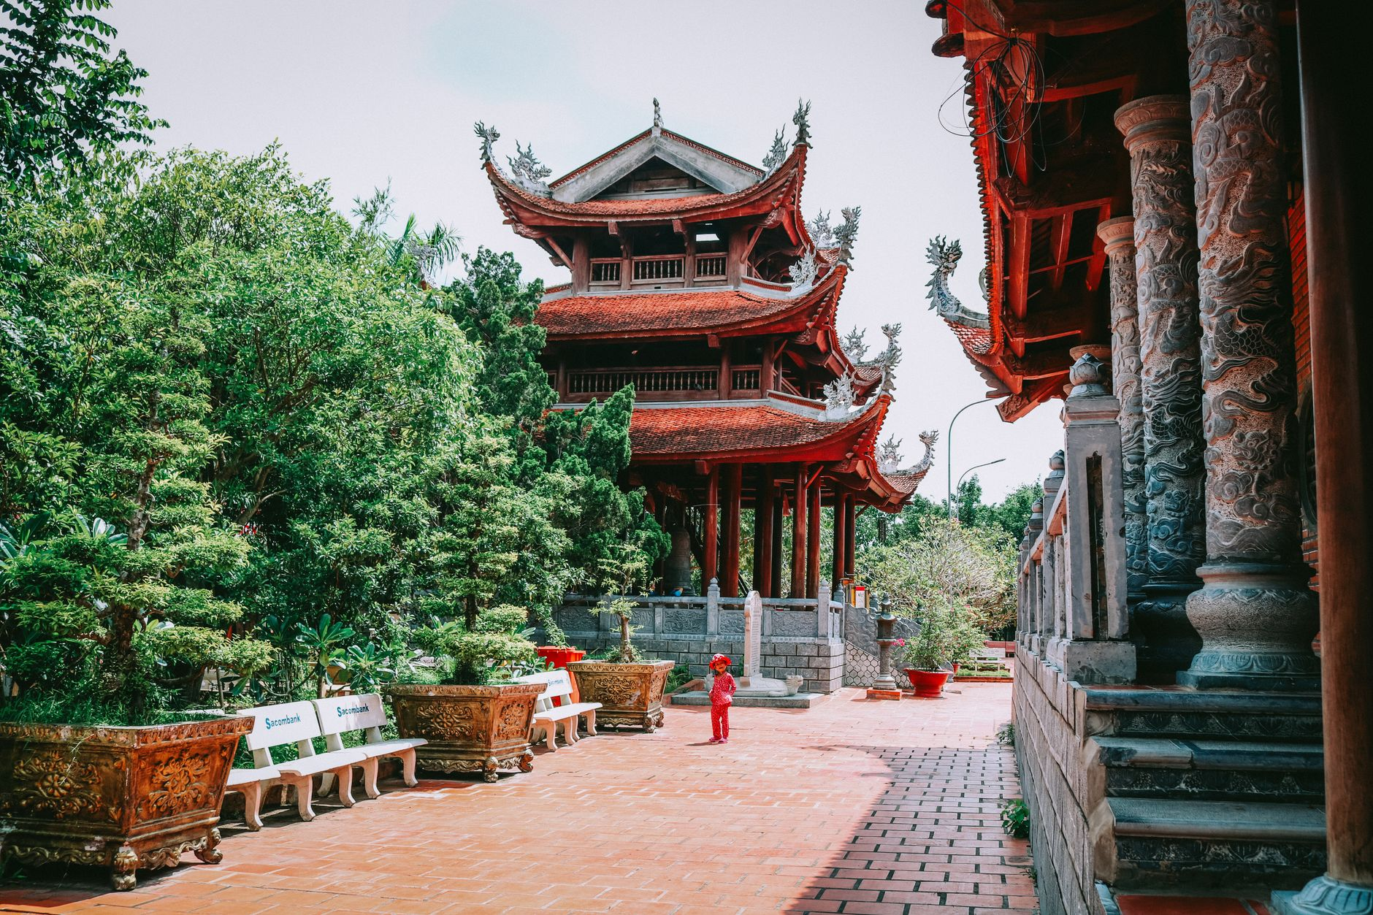
Figure: Classic Vietnamese pagoda pavilion surrounded by water and greenery, showcasing traditional architectural symmetry. | Photo: Loifotos / Pexels
- What makes it special Vietnam's first national university, founded in 1070. Five symmetrical courtyards featuring ancient lotus ponds (Well of Heavenly Clarity), giant stone turtles bearing doctorate stelae, and deep crimson timber pavilions.
- Best time to shoot 8:00 AM right at opening, or 3:30 PM – 4:45 PM when late-afternoon sun illuminates the red lacquer pillars.
- Camera tip The Khue Van Cac pavilion is the symbol of Hanoi. Frame your subject walking along the central stone pathway with the pavilion centered in the background.

7. St. Joseph’s Cathedral (Nhà Thờ Lớn)
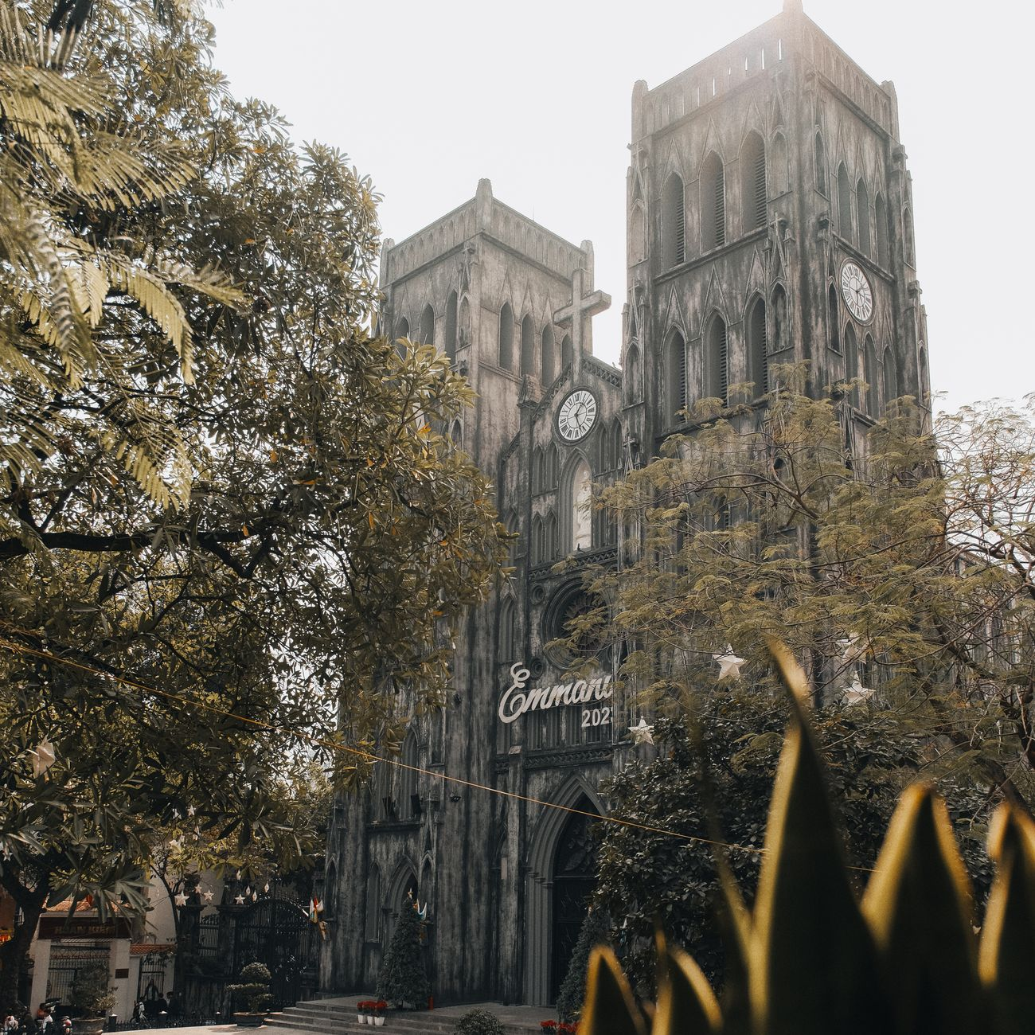
Figure: Gothic architecture and weathered stone facade of St. Joseph's Cathedral framed by green trees. | Photo: Nguyen Duc Toan / Pexels
- What makes it special A dramatic 19th-century neo-Gothic cathedral with heavily weathered, soot-blackened stone walls that look reminiscent of Notre-Dame de Paris, set against leafy tropical sidewalk cafes.
- Best time to shoot 3:00 PM – 5:00 PM for front-facade illumination, or grab a balcony seat at an opposite cafe (like *Cộng Cà Phê*) for an elevated vantage point.

8. Long Bien Bridge (Cầu Long Biên)
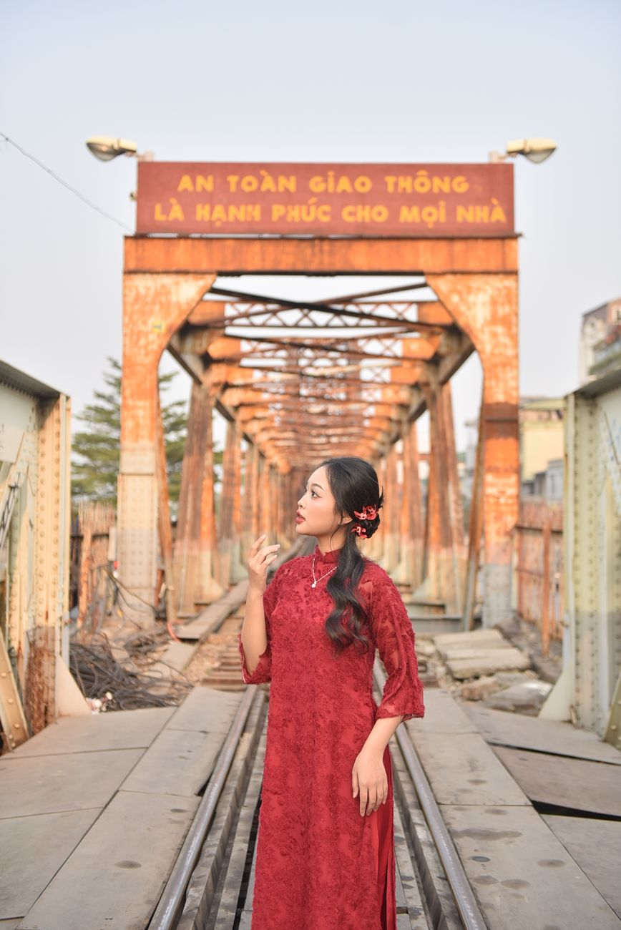
Figure: Woman in red Ao Dai standing on the historic century-old steel cantilever spans of Long Bien Bridge. | Photo: Felix Young / Pexels
- What makes it special Designed by Daydé & Pillé and opened in 1902, this century-old steel cantilever bridge spans the Red River. Its rusty iron girders, wooden pedestrian walkways, and passing commuter trains make it one of the most cinematic photo locations in northern Vietnam.
- Best time to shoot Sunrise (5:30 AM – 6:30 AM) looking east over the banana plantations of the Red River sandbars, or Golden Hour (4:45 PM – 5:45 PM).
- Safety tip Stay strictly within the pedestrian sidewalk; never walk onto the center train tracks.

9. Hanoi Opera House (Nhà Hát Lớn) & French Quarter Boulevards
- What makes it special Modeled after the Palais Garnier in Paris, this yellow neoclassical landmark anchors the elegant French Quarter. Surrounding streets like Trang Tien and Ly Thai To feature wide sidewalks, colonial colonnades, and tall mahogany trees.
- Best time to shoot 7:00 AM – 8:30 AM on weekends when traffic is light.

Part 3: Secret Local Gems Known to Insiders (3 Spots)

10. The Balcony at Café Đinh (Hidden Heritage Cafe)
- What makes it special Located on the second floor through a nondescript, dimly lit alleyway at #13 Dinh Tien Hoang. Step out onto the tiny iron balcony for the single best eye-level view of Hoan Kiem Lake, framed by hanging cables, wooden window frames, and steaming cups of traditional egg coffee.
- Best time to shoot 8:00 AM – 9:30 AM.

11. Chu Van An High School French Villa Campus
- What makes it special Tucked right along the shores of West Lake, this century-old school campus boasts some of the best-preserved French colonial villa architecture in Hanoi, complete with grand stone staircases, octagonal towers, and towering banyan trees.
- Best time to shoot Late afternoon (outside school hours or from the lakeside perimeter).

12. Hanoi Train Street (Safe Upper-Floor Vantage Points)
- What makes it special While trackside access on ground level is subject to safety regulations, local cafes with 2nd and 3rd-floor balconies (such as along Tran Phu or Phung Hung) allow you to safely photograph the curve of the tracks slicing between residential homes with laundry hanging from balconies.

Part 4: Light & Timing Masterclass for Hanoi
Window | Light Quality | Best Hanoi Locations | Photography Style
**Golden Morning**<br>(6:00 AM – 7:30 AM) | Soft, warm, low angle. Long golden shadows. Minimal crowds. | Hoan Kiem Lake, Long Bien Bridge, Old Quarter alleys. | Candid portraits, street documentary, atmospheric wide shots.
**Midday Diffused**<br>(11:00 AM – 2:00 PM) | Harsh overhead sun outdoors; beautiful soft light indoors. | Heritage cafes (*Café Giảng, Loading T*), temple courtyards. | Food & coffee details, quiet indoor portraits, architectural details.
**Late Afternoon**<br>(4:00 PM – 5:30 PM) | Rich amber hues reflecting off yellow colonial walls. | French Quarter boulevards, Temple of Literature, West Lake promenade. | Romantic couple portraits, golden street flares.
**Blue Hour & Night**<br>(6:00 PM – 7:30 PM) | Deep cobalt sky contrasting with warm neon & red lanterns. | Hang Ma, Ta Hien, St. Joseph's Cathedral square. | High-contrast night portraits, light trails from scooters.

Part 5: What to Wear & Photography Etiquette in Hanoi

Styling Tips for Great Travel Photos
1. Choose Complementary Colors: Hanoi’s urban palette consists heavily of weathered yellow ochre, deep moss greens, and warm red brick. Colors that pop beautifully:
- Crisp white linen, cream, or pastel tones.
- Sky blue or terracotta.
- Traditional Vietnamese *Áo dài* (silk tunics) create timeless, elegant silhouettes in temple courtyards.
2. Avoid Busy Loud Patterns: Large commercial logos or heavy neon patterns will clash with Hanoi's intricate street textures. Keep outfits simple, breathable, and comfortable for walking.

Photography Etiquette: The Golden Rule (V-09)
The people of Hanoi are famously warm and hospitable, but respect goes both ways:
- Always ask before taking close-up portraits A simple gesture pointing to your camera with a friendly smile and saying *"Excuse me, may I?"* or *"Cháu chụp một kiểu được không ạ?"* is polite and almost always met with a proud smile.
- Temple Etiquette At the Temple of Literature, Ngoc Son Temple, or pagodas: cover your shoulders and knees. Never turn your back disrespectfully to altars during prayers.

Capture Hanoi Without the Camera Stress: TravelFrame Private Photo Tours
You can spend half your holiday fiddling with tripods, wrestling with selfie sticks, and stressing over whether you're standing in the right light. Or, you can walk through Hanoi like a local insider with a dedicated photographer friend.
At **TravelFrame**, we lead **private, walking photo experiences** designed specifically for international solo travelers, couples, and creators.
- We Know the Angles We guide you away from tourist traps straight to the hidden courtyards, photogenic alleys, and quiet temple corners featured in this guide.
- Candid, Natural, Unposed No rigid studio posing. We chat, explore, grab a local coffee, and capture authentic, genuine moments as you fall in love with Hanoi.
- Fast 24-Hour Delivery You receive your high-resolution, professionally color-graded photo gallery within 24 hours of wrapping your walk.
👉 **Book your private session:** [Explore TravelFrame Photo Tours](https://travelframe.vn/)
👉 **Planning your days?** Grab our free [24-Hour Hanoi Itinerary](file:///Users/macbook/Codex%20GPT/travelframe.vn/Marketing-Growth/Content/Drafts/Lead-Magnet-24h-Hanoi.md) with walking maps and verified food stops.

PHẦN 3: THE HONEST HANOI STREET FOOD GUIDE 2026
The Honest Hanoi Street Food Guide 2026: What to Eat, Where to Sit, and How to Eat Like a Local
By TravelFrame Food & Culture Team · Updated September 2026 · 12 min read

Introduction: Why Hanoi is Southeast Asia’s Street Food Capital
In Hanoi, the best food in the city does not hide behind white linen tablecloths or Michelin plaques. It lives on low blue plastic stools scattered across cracked sidewalks, bubbling in giant aluminum stockpots heated by charcoal embers, and served by grandmothers (*bà cụ*) who have cooked a single recipe with clockwork perfection for forty years.
Hanoi food is markedly different from the fiery heat of central Vietnam or the sweet richness of the south. Northern Vietnamese cuisine is restrained, aromatic, and deeply balanced: prioritizing clean meat broths simmered overnight, subtle herbal layers (perilla, Vietnamese coriander, garlic vinegar), and delicate textures.
If the thought of crouching on a tiny stool on a scooter-packed street makes you slightly nervous, don't worry. This **Honest Hanoi Street Food Guide 2026** breaks down the 8 essential dishes, realistic local price ranges, food safety guidelines, and street etiquette so you can eat with absolute confidence.

Part 1: The 8 Non-Negotiable Dishes to Try

1. Traditional Hanoi Beef Pho (*Phở Bò*)
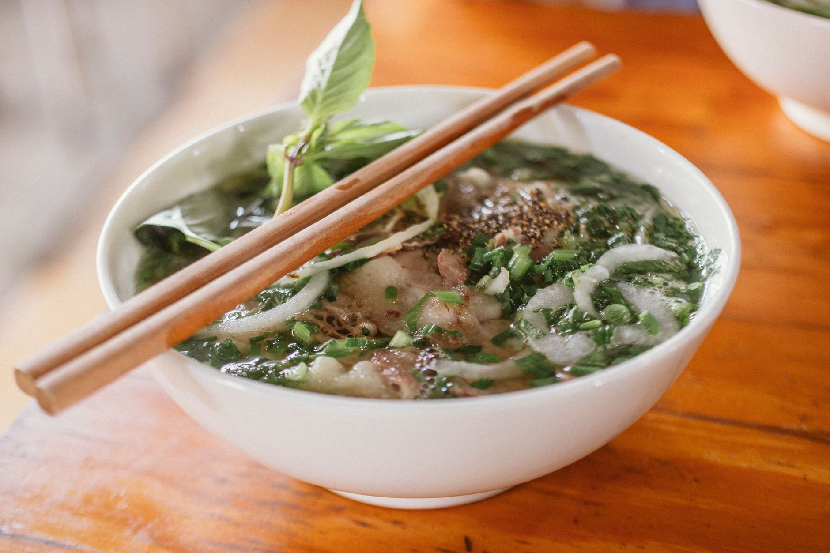
Figure: Steaming bowl of authentic Hanoi beef pho with scallions, fresh herbs, and rich bone broth. | Photo: Nam Phong Bùi / Pexels
- What it is Hanoi's culinary crown jewel. Tender flat rice noodles served in a fragrant broth simmered for 12 to 14 hours with charred ginger, star anise, cinnamon, and beef marrow bones, topped with sliced scallions and your choice of beef (rare *tái*, well-done brisket *chín*, or flank *nạm*).
- Hanoi style Clearer and more savory than southern pho. Do not ask for hoisin sauce or bean sprouts - Hanoi locals season their broth strictly with fresh lime juice, fresh bird's eye chili, and homemade pickled garlic vinegar (*dấm tỏi*). Pair it with crispy fried dough sticks (*quẩy*) dipped directly into the soup.
- Typical price 45,000–65,000 VND ($1.80–$2.60 USD).
- Where to try *Phở Gia Truyền Bát Đàn* (49 Bat Dan) or *Phở 10 Lý Quốc Sư* (10 Ly Quoc Su).

2. Charcoal-Grilled Pork with Rice Noodles (*Bún Chả*)
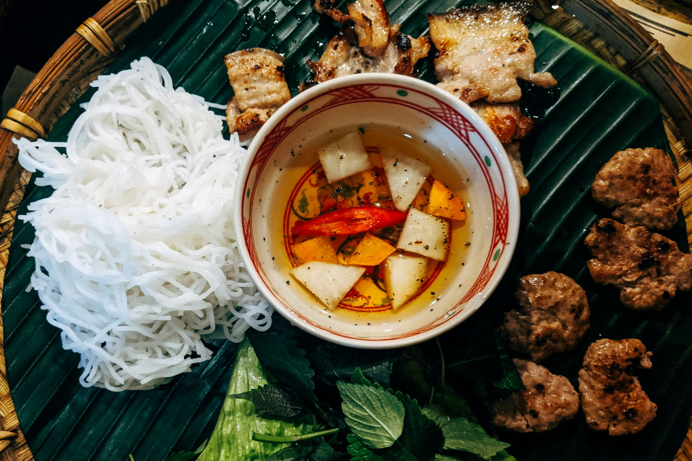
Figure: Hanoi Bun Cha served with charcoal grilled pork patties, fresh rice vermicelli, and aromatic herbs. | Photo: Markus Winkler / Pexels
- What it is The dish that Anthony Bourdain shared with President Barack Obama in Hanoi. Seasoned minced pork patties and pork belly slices grilled over smoking charcoal, served swimming in a warm bowl of balanced fish sauce broth (nuoc cham) infused with green papaya and carrot slices.
- How to eat Take a small bundle of cold rice vermicelli noodles (*bún*) and fresh herbs (mint, perilla, lettuce), dip them into the warm broth, and eat in one delicious, smoky bite.
- Typical price 50,000–70,000 VND ($2.00–$2.80 USD). Add a crispy crab spring roll (*nem cua bể*) for 15,000–20,000 VND.
- Where to try *Bún Chả Đắc Kim* (1 Hang Manh) or *Bún Chả Hương Liên* (24 Le Van Huu: the Obama stall).

3. Steamed Fermented Rice Rolls (*Bánh Cuốn*)
- What it is A masterclass in culinary dexterity. Rice batter fermented to silky perfection is steamed on a taut cotton cloth over boiling water, scraped off with a thin bamboo stick, stuffed with minced pork and wood-ear mushrooms, rolled, and showered in crispy fried shallots.
- How to eat Dip into warm sweet-sour fish sauce, often served with steamed pork roll (*chả lụa*) or grilled cinnamon sausage (*chả quế*).
- Typical price 35,000–50,000 VND ($1.40–$2.00 USD).
- Where to try *Bánh Cuốn Gia An* or *Bánh Cuốn Bà Hoành* (66 To Hien Thanh).

4. The Crispy Hanoi Baguette (*Bánh Mì*)
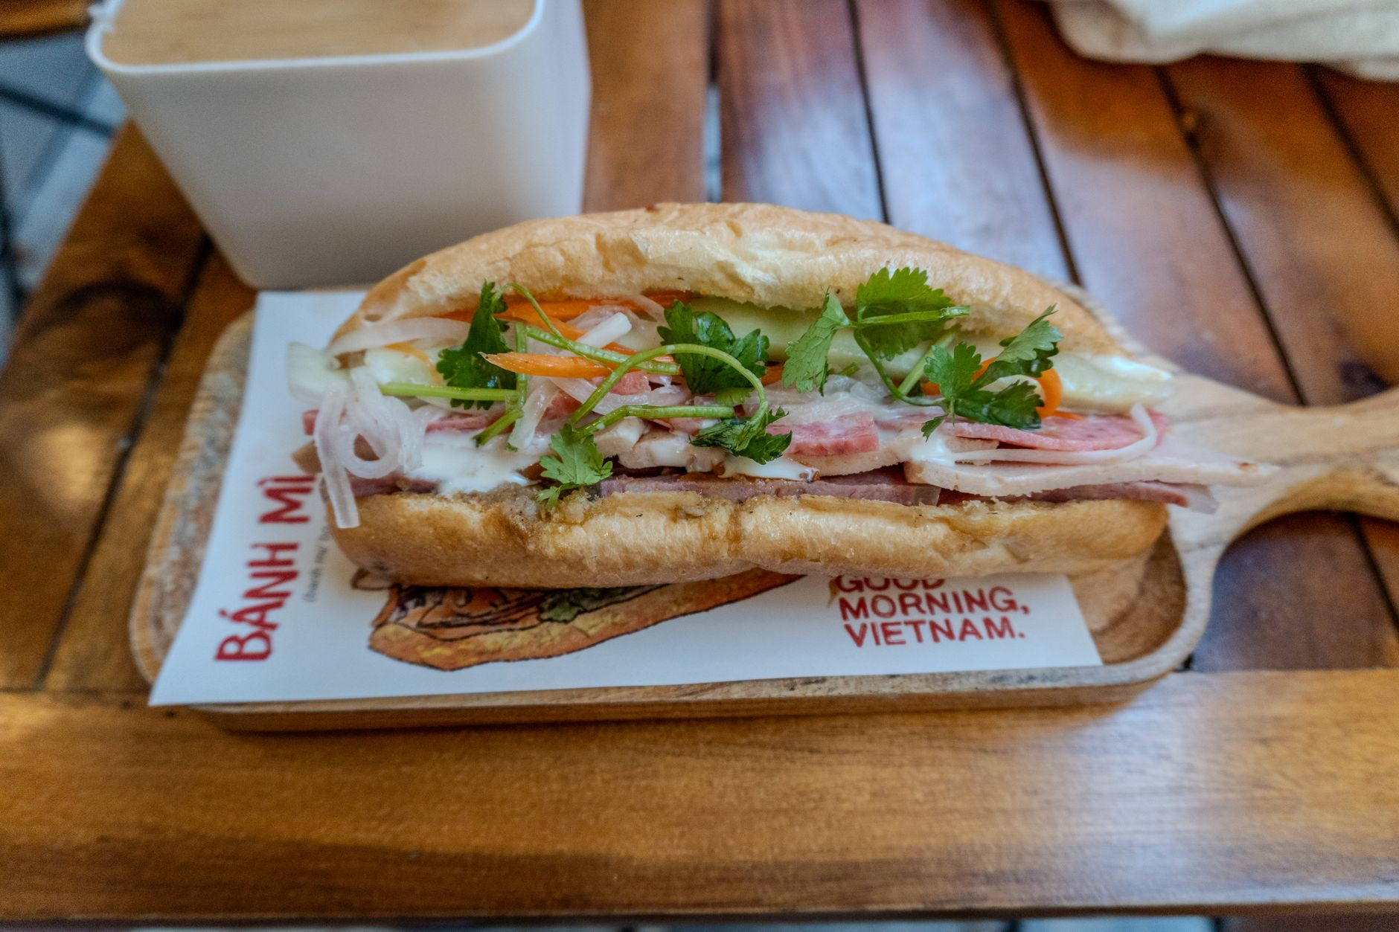
Figure: Crisp Vietnamese Banh Mi sandwich freshly assembled with rich pate and crisp cucumbers. | Photo: Jordan Coleman / Pexels
- What it is While Saigon is famous for towering bánh mì stuffed with dozens of cold cuts, Hanoi bánh mì is simpler, toasted extra crispy, and emphasizes rich duck/pork liver pâté, warm pork floss, cucumber, chili paste, and cilantro.
- Typical price 25,000–40,000 VND ($1.00–$1.60 USD).
- Where to try *Bánh Mì 25* (25 Hang Ca) or *Bánh Mì Phố Cổ* (38 Dinh Liet).

5. Authentic Hanoi Egg Coffee (*Cà Phê Trứng*)
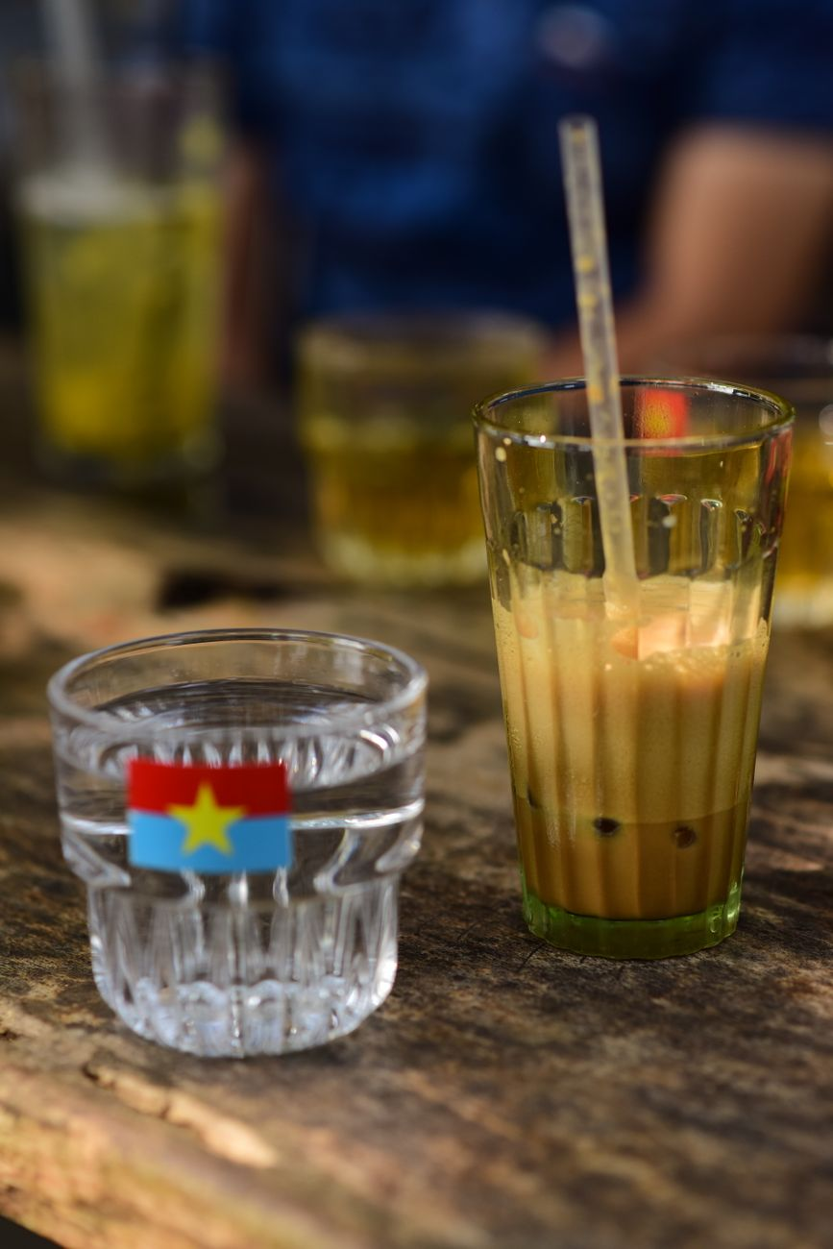
Figure: Traditional Vietnamese iced coffee on a sidewalk table, a daily staple of Hanoi street life. | Photo: Sóc Năng Động / Pexels
- What it is Created in 1946 during the First Indochina War when fresh milk was scarce, Mr. Nguyen Van Giang whisked egg yolks with sweetened condensed milk and sugar to create a luxurious foam that floats atop strong dark robusta drip coffee.
- The flavor profile Tastes like warm liquid tiramisu or rich custard cream balanced by deep, bittersweet coffee.
- Typical price 35,000–45,000 VND ($1.40–$1.80 USD).
- Where to try *Café Giảng* (39 Nguyen Huu Huan: original heritage shop) or *Café Đinh* (13 Dinh Tien Hoang).

6. Snail Noodle Soup (*Bún Ốc*)
- What it is For adventurous eaters, this is Hanoi's most authentic street flavor. Plump freshwater snails (*ốc*) cooked in a tangy, tomato-based broth enriched with fermented rice wine vinegar (*giấm bỗng*), fried tofu, and heaps of purple perilla leaves.
- Typical price 40,000–55,000 VND ($1.60–$2.20 USD).
- Where to try Alleys around Dong Xuan Market (*Ngõ Đồng Xuân*).

7. Turmeric Grilled Fish with Dill (*Chả Cá Lã Vọng*)
- What it is Hanoi's signature celebration meal. Chunks of tender river fish marinated in turmeric and galangal are brought to your table in a sizzling skillet with mountains of fresh dill and spring onions.
- How to eat Combine rice noodles, fresh herbs, roasted peanuts, and a dash of chili fish sauce (or pungent fermented shrimp paste *mắm tôm* for the brave) in your bowl, then top with the sizzling fish.
- Typical price 140,000–180,000 VND ($5.50–$7.20 USD) per serving.
- Where to try *Chả Cá Thăng Long* (21 Duong Thanh).

8. Crispy Crab Spring Rolls (*Nem Cua Bể*)
- What it is Square-shaped spring rolls wrapped in delicate rice paper, packed with fresh Gulf of Tonkin crab meat, ground pork, glass noodles, and shiitake mushrooms, fried to a golden, blistered crunch.
- Typical price 40,000–60,000 VND ($1.60–$2.40 USD) for 2 large rolls.

Part 2: How to Eat Like a Hanoi Local

The 4 Golden Rules of Sidewalk Dining
1. Always Confirm Prices Before Sitting Down (V-07 Rule): While 95% of vendors are completely honest, tourist-heavy areas occasionally have stalls that charge a "foreigner markup" if prices aren't posted. Simply point at the pot and ask *"Bao nhiêu một bát?"* (How much for a bowl?) or check for a printed wall menu (*Bảng Giá*).
2. Follow the Plastic Stool Crowd: The single best quality indicator is a sidewalk stall packed with local office workers or families sitting on low stools with scooters parked haphazardly outside. High turnover means the meat and broth are guaranteed fresh.
3. Master the Table Condiments:
- Pickled garlic slices in vinegar (*dấm tỏi*): Add 2–3 slices and a spoonful of garlic vinegar to your pho broth.
- Chili sauce (*tương ớt*): Traditional Hanoi chili sauce is thin, savory, and fermented - not sweet like commercial ketchup.
- Lime wedges (*chanh*): Squeeze into broths for bright acidity.
4. Use Lime Wedges for Your Chopsticks: You will often see locals take a discarded lime rind and rub it across the tips of their bamboo chopsticks before wiping them with a dry tissue. It's a quick, natural sanitizing ritual that also adds a subtle citrus aroma!

Part 3: Food Safety & Avoiding "Hanoi Belly"
Getting sick from food in Hanoi is actually far less common than in many other travel hubs, provided you follow basic precautions:
- Water Safety Never drink tap water. Drink bottled or boiled water. Good hotels provide complimentary sealed bottles daily.
- The Truth About Ice (Trà Đá) 99% of cafes and sidewalk stalls use commercially manufactured cylindrical tube ice with a hollow hole in the center (*đá ống*). This ice is made in certified food-grade water filtration plants and is perfectly safe to consume. Only avoid crushed, cloudy block ice shaved by hand from large ice blocks.
- Cooked-to-Order Rule Stick to hot, freshly prepared foods. If meat or noodles have been sitting pre-cooked at ambient temperature on an unshaded counter, choose another stall.

Part 4: Hanoi's Greatest Food Streets to Explore on Foot
Street / Alley | Primary Culinary Specialty | Best Time to Visit
**Ngõ Đồng Xuân** (Dong Xuan Alley) | High-density street breakfast: *Bún ốc, Bún chả, Bánh cuốn* | 7:00 AM – 10:30 AM
**Ngõ Trạm & Đường Thành** | *Phở bò, Bánh mì, Chả cá* | 11:30 AM – 2:00 PM (Lunch)
**Tống Duy Tân** (Food Street) | 24/7 dining: Steamed chicken soup (*Gà tần*), fried rice, stir-fried noodles | 6:00 PM – 2:00 AM (Late night)
**Tạ Hiện** (Beer Corner) | Fresh draught beer (*Bia hơi* at 12,000–15,000 VND/glass), grilled quail, crispy cheese sticks | 6:00 PM – 11:30 PM

Discover Hanoi’s Flavors with a Local Storyteller: TravelFrame Experience
Navigating narrow residential alleys in search of multi-generational street food gems can feel intimidating if you don't speak Vietnamese.
At **TravelFrame**, we blend **authentic culinary exploration with candid documentary photography**. Walk alongside a bilingual local friend who orders the best secret dishes, explains the cultural folklore behind every flavor, and captures beautiful, unposed photos of you laughing, tasting, and living like a local in Hanoi.
👉 **Book a private photo & food walk:** [Discover TravelFrame Sessions](https://travelframe.vn/)
👉 **Need a complete 1-day walking plan?** Download our free [24-Hour Hanoi Itinerary](file:///Users/macbook/Codex%20GPT/travelframe.vn/Marketing-Growth/Content/Drafts/Lead-Magnet-24h-Hanoi.md).
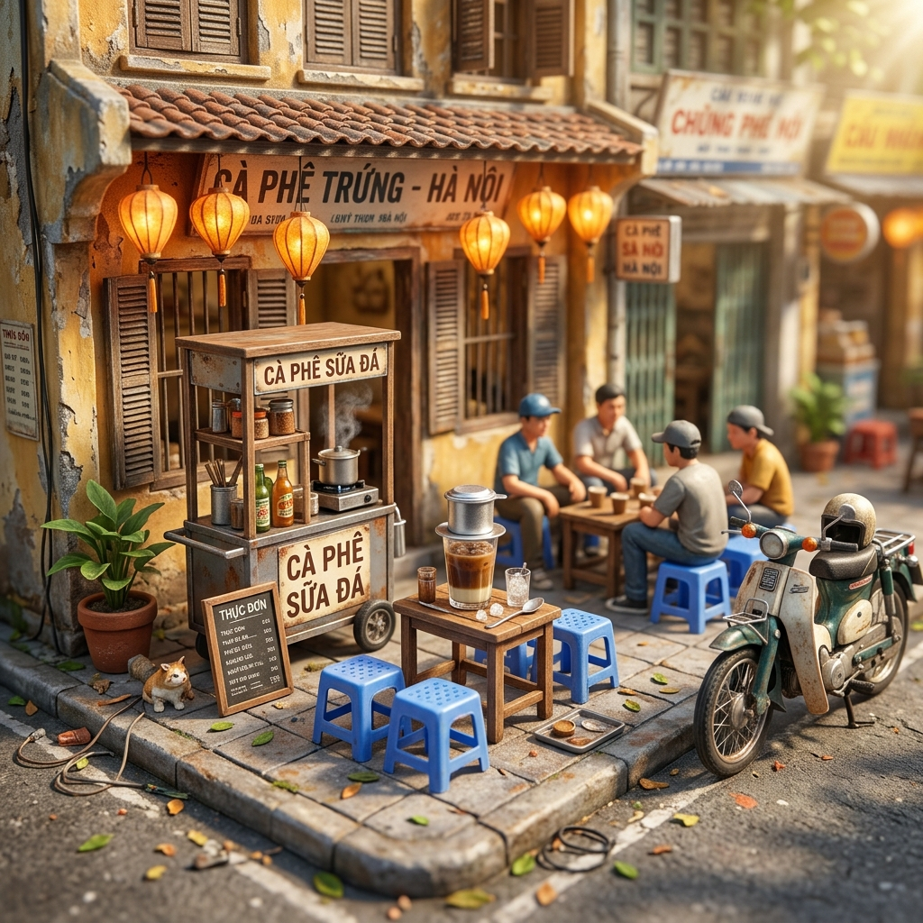
Figure: Visual concept: 3D miniature diorama of a classic Hanoi sidewalk cafe. | AI Concept by Nano Banana for TravelFrame

PHẦN 4: HIRING A PRIVATE PHOTOGRAPHER IN HANOI: 2026 GUIDE
Hiring a private photographer in Hanoi: what to expect, costs, and locations (2026 guide)
By TravelFrame Editorial Team · Updated September 2026
Hiring a local photographer in Hanoi has become one of the most common requests from solo travelers and couples visiting Vietnam. The reasons are practical: selfies in crowded markets end up crooked, carrying a heavy tripod on uneven sidewalks is exhausting, and asking strangers on the street usually leaves you with cut-off heads and tilted horizons.
This guide explains how private photo walks work in Hanoi, what standard rates look like in 2026, which neighborhoods produce the best pictures, and what to look for before reserving a session.

How private photo walks work
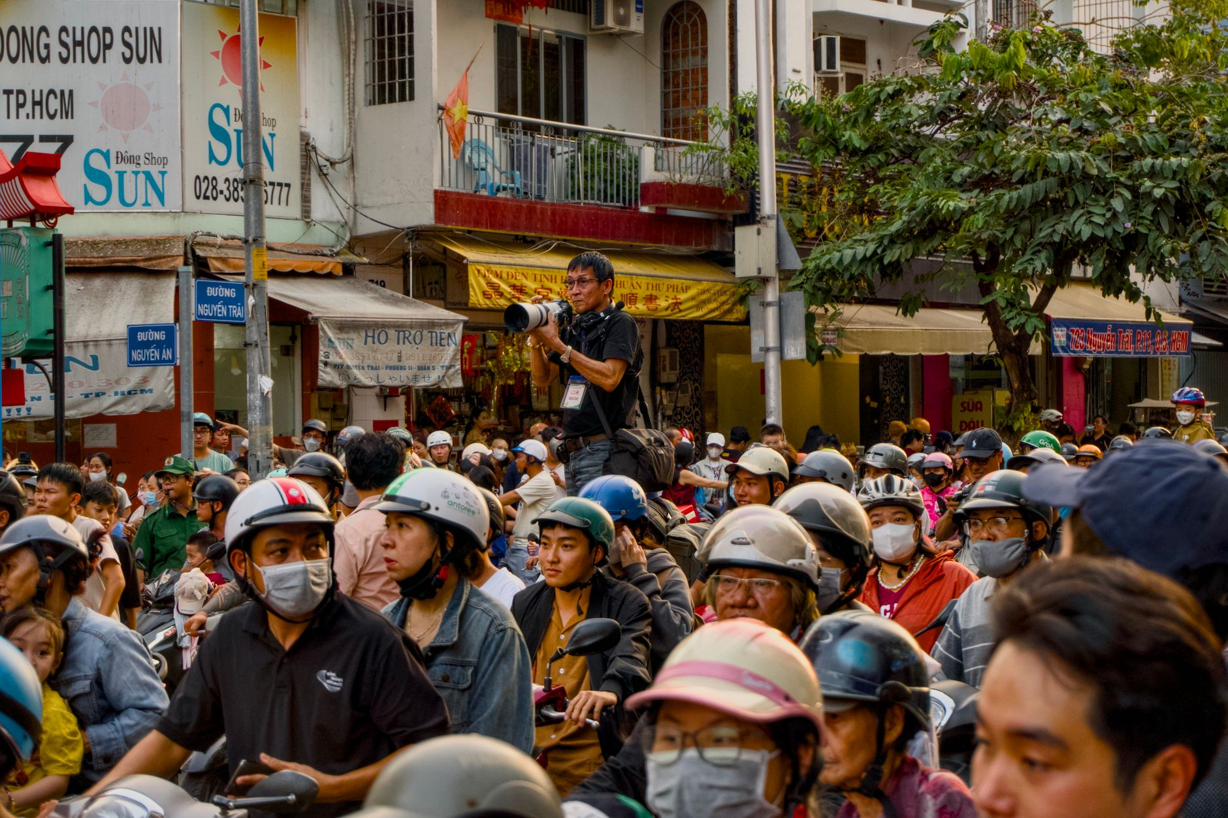
Figure: Personal photographer capturing candid travel moments in the bustling streets of Hanoi. | Photo: Tuan Vy / Pexels
A private photo walk is different from an indoor studio session or a rigid wedding shoot. You meet your photographer in the Old Quarter, usually between 7:00 and 8:30 in the morning when the light is soft and the sidewalks are less congested.
Over the next 90 to 120 minutes, you walk a planned route through traditional craft streets, narrow residential alleys, and lakeside paths.
Your photographer gives gentle direction so you feel comfortable, but the focus stays on natural movement:
- Walking along weathered yellow colonial walls
- Stopping at a quiet sidewalk cafe for an egg coffee or iced tea
- Exploring ancient temple courtyards
- Watching morning street life without holding stiff poses
Most private photographers in Hanoi deliver a private gallery of 35 to 50 edited digital photos within 24 to 48 hours.

How much does a photographer in Hanoi cost?
Prices in Hanoi vary depending on whether you book through international platforms like Airbnb Experiences, hire a high-end commercial fashion studio, or book directly with an independent local photo guide.
Here is what typical rates look like in 2026:
Service type | Duration | Typical price range | Best suited for
Large group photo walk (4-8 people) | 2 hours | $35 to $50 per person | Budget travelers who do not mind sharing shooting time
Private solo session | 1.5 hours | $70 to $90 total | Solo travelers wanting natural portraits and personalized guidance
Private couple session | 2 hours | $120 to $150 total | Couples wanting vacation photos and engagement shoots
Full-day commercial shoot | 6-8 hours | $300 to $500 total | Fashion brands or creators needing multiple wardrobe changes

At TravelFrame, we charge $75 for a private 1.5-hour solo walk and $130 for a 2-hour couple walk, with all photos color-graded and delivered within 24 hours.

Best neighborhoods for photos in Hanoi
Hanoi has four distinct visual areas. Your photographer will usually recommend one based on the time of day and the style you want.

1. The Old Quarter (Hoan Kiem)
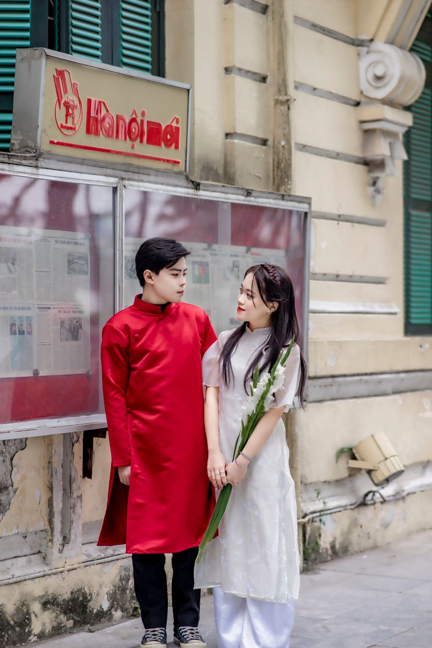
Figure: Couple photoshoot in traditional Vietnamese dress on historic Hanoi streets. | Photo: Toàn Văn / Pexels
The Old Quarter offers the most authentic street texture in northern Vietnam. Narrow shophouses, dark green timber shutters, leafy banyan branches, and low plastic stools create an immediate sense of place. The best spots include Hang Bac, Hang Ma, and the quiet alleys behind Dong Xuan market.
Best time: 7:00 AM to 8:30 AM before traffic builds up.

2. The French Quarter (Ba Dinh & South Hoan Kiem)
If you prefer wide pavements, neoclassical yellow architecture, and grand colonnades, head south toward the Hanoi Opera House, Trang Tien street, and the perimeter of the Metropole Hotel.
Best time: 8:30 AM to 10:00 AM or late afternoon.

3. Temple of Literature (Van Mieu)
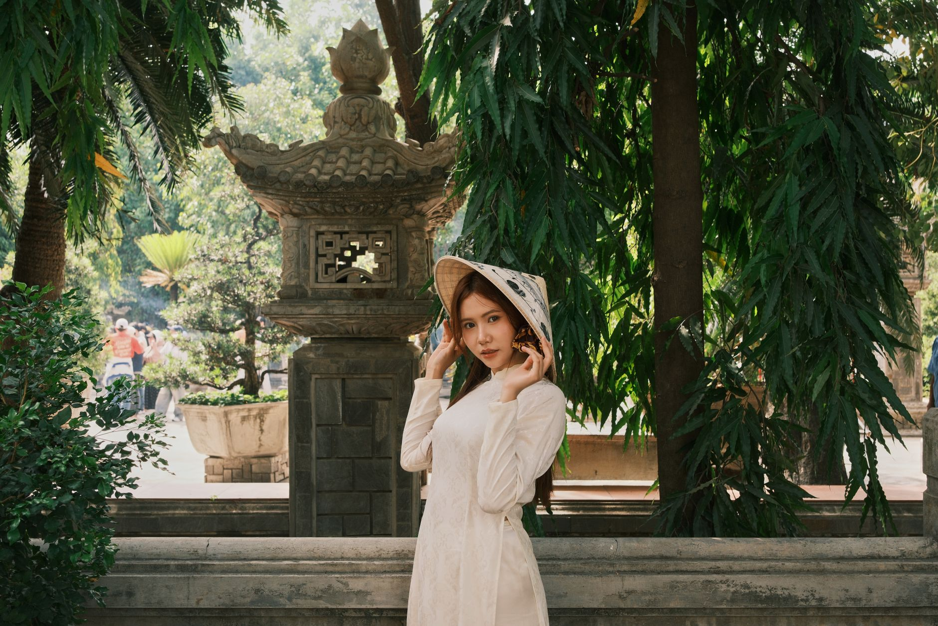
Figure: Solo travel portrait capturing serene expressions in an ancient temple courtyard. | Photo: quang vinh / Pexels
Founded in 1070, this historic complex features red lacquer pavilions, ancient stone stelae on turtle statues, and quiet lotus ponds. It is ideal for traditional Vietnamese Ao Dai portraits.
Best time: 8:00 AM right at opening to avoid tour groups.

4. Long Bien Bridge
Built over a century ago across the Red River, the rusty iron girders and pedestrian boardwalk give photos an industrial, vintage mood.
Best time: Sunrise (5:30 AM to 6:30 AM) or golden hour before sunset.

What to wear for your session
Choosing the right clothes makes a noticeable difference in how your photos turn out:
- Solid neutral colors work best: white linen, cream, beige, soft blue, and terracotta contrast well with Hanoi's yellow walls and green shutters.
- Avoid loud commercial logos or busy neon prints that distract from the background.
- Wear comfortable walking shoes. Hanoi sidewalks have high curbs, broken tiles, and parked scooters. You can pack a pair of dressier shoes in a tote bag to slip on during specific shots.
- If visiting temples, ensure your clothing covers your knees and shoulders to respect local customs.

4 questions to ask before booking
Before sending a deposit to any photographer in Hanoi, check these four points:
1. Delivery time: Will you get your photos before leaving Hanoi? If you are traveling to Sapa or Halong Bay two days later, confirm that delivery happens within 24 to 48 hours.
2. What is included: How many final edited images do you receive? Are raw files available upon request?
3. Rescheduling policy: Rain happens in Hanoi, especially in summer. Does the photographer offer flexible rescheduling or indoor heritage cafe alternatives?
4. Communication: Can you contact the photographer directly via WhatsApp or Instagram before the shoot to discuss locations?

Book your Hanoi photo walk with TravelFrame
TravelFrame connects travelers with friendly, English-speaking local photographers who know Hanoi's quietest corners and best morning light.
- Strictly private sessions with no strangers joining your group
- Natural, unposed documentary style
- 24-hour delivery guaranteed
- Transparent flat pricing with no hidden charges
Check available dates and view our recent guest gallery at [travelframe.vn](https://travelframe.vn/).

