Hiring a Private Photographer in Hanoi: Rates, Routes, and What to Expect (2026 Guide)
By TravelFrame Editorial Team · Official Website SEO Release (2026)
TRAVELFRAME SEO METADATA SPECIFICATION
• URL Slug: /news/hiring-private-photographer-in-hanoi
• Primary Keyword: private photographer in hanoi
• Secondary Keywords: hire photographer hanoi, hanoi vacation photographer, hanoi photo tour, candid photoshoot hanoi old quarter
• Meta Title (<60 chars): Private Photographer in Hanoi: Rates, Routes & 2026 Guide
• Meta Description: Planning a trip to Hanoi? Here is what a private photo walk costs in 2026, the best morning routes in the Old Quarter, and how to get natural, candid vacation photos.
• Target Funnel Stage: BoFu (Commercial / Conversion)
• Target Audience: Solo travelers, couples, and culture-focused visitors wanting genuine vacation portraits without stiff poses

By TravelFrame Editorial Team · Updated September 2026
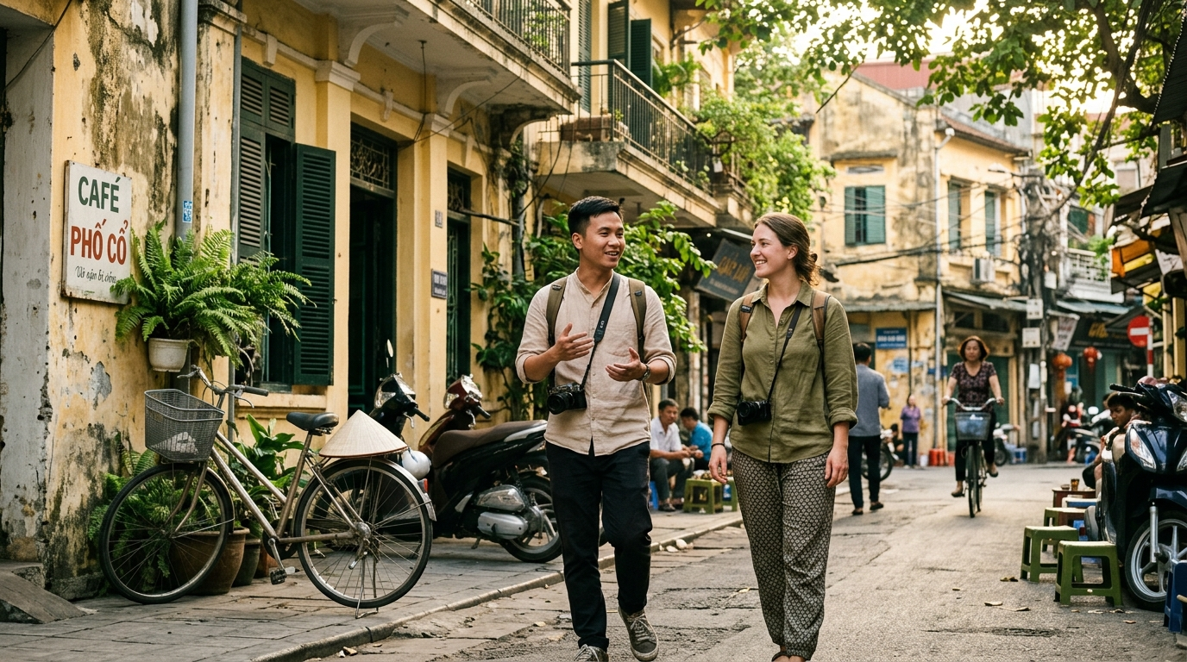
Figure: Local photo guide and traveler walking through historic Old Quarter alley in Hanoi morning light
If you have spent even ten minutes scrolling through travel forums about Vietnam, you will notice a common dilemma: travelers love Hanoi's cinematic atmosphere, but getting decent photos of themselves here is surprisingly difficult.
Selfie sticks struggle with narrow alleyways and overhead power cables. Carrying a heavy tripod across cracked curbs and busy scooter traffic feels like a chore. And handing your smartphone to a well-meaning stranger usually results in cut-off feet, tilted horizons, or a rushed, blurry snap.
In recent years, booking a private walking photographer has become one of the most practical investments travelers make in Hanoi. It combines a relaxed neighborhood walk with a local companion who knows the light, understands the culture, and quietly captures documentary-style portraits while you explore.
This guide outlines realistic rates for 2026, how a private session actually runs, the best street routes for natural light, and the practical details to check before booking.
1. How a Private Photo Walk Actually Works
A private photo walk is fundamentally different from a studio session or a traditional wedding shoot. There are no portable reflectors, no costume racks, and nobody asking you to freeze in an unnatural pose for twenty seconds.
Instead, think of it as spending a calm morning with an English-speaking local friend who happens to carry a professional camera.
The Typical Morning Rhythm
Most sessions start early—typically between 7:00 AM and 8:00 AM.
At this hour, the Old Quarter is just waking up. Street sweepers are finishing their rounds, women are setting out baskets of morning lotus flowers and herbs, and steam is rising from sidewalk noodle pots. The light is soft and angled low across the pale yellow French-colonial plaster.
During a 90- to 120-minute walk, you will cover roughly 1.5 to 2 kilometers at a relaxed pace. Your guide navigates through historic craft quarters, pauses in quiet residential courtyards, and stops for coffee at a hidden second-floor balcony.
7:00 AM — Meet guide at designated cafe or hotel lobby
7:15 AM — Walk through quiet craft streets (Hang Bac, Hang Be)
7:45 AM — Street portrait moments along textured colonial walls
8:15 AM — Break for traditional egg coffee at an open balcony
8:45 AM — Final candid portraits around Hoan Kiem Lake perimeter
9:00 AM — Review camera previews, wrap up session

Throughout the walk, the photographer gives simple, natural direction: "Walk toward that archway," "Look over at that fruit vendor," or "Take a sip of your coffee and look out over the street." You stay focused on experiencing the city, while the photographer captures genuine, unforced moments.
Pro Move (Morning Light Window): The direct sun turns harsh in Hanoi by 9:30 AM in the hotter months. If you want warm, flattering skin tones and empty street backgrounds, never start later than 8:00 AM.

2. Typical Rates for Photographers in Hanoi (2026 Price Benchmark)
Photography pricing in Hanoi varies widely depending on whether you book a mass-market group tour, hire an independent freelance creator, or book a dedicated boutique photo walk service.
Here is a realistic market overview for 2026:
Service Category | Typical Duration | Approximate Price (USD) | What You Receive | Best Suited For
Group Photo Tour (Airbnb Experiences) | 2 hours | $35 – $55 per person | 15–20 shared photos, 4–8 people in group | Solo backpackers on a tight budget who don't mind sharing camera time
Private Solo Photo Walk | 1.5 hours | $75 – $95 total | 35–45 color-graded high-res photos | Solo travelers wanting dedicated attention and relaxed guidance
Private Couple / Honeymoon Session | 2 hours | $125 – $160 total | 50–70 color-graded high-res photos | Couples seeking timeless, candid vacation portraits
Commercial Studio / Pre-Wedding Shoot | Half-day (4–5 hrs) | $350 – $600+ | Full hair/makeup, gown rentals, heavy retouching | Formal pre-wedding couples wanting elaborate editorial setups

How TravelFrame Packages Work
At TravelFrame, we operate on a private, transparent model. We do not herd strangers into groups, and we do not tack on surprise fees for image downloads:
- Private Solo Companion Walk: 90 minutes, 35+ professionally color-graded photos delivered in high resolution within 24 hours.
- Private Couple & Family Walk: 120 minutes, 50+ edited photos, custom pacing, and short video clips for social memories.
All packages include your English-speaking guide, route curation, professional color grading, and private cloud gallery access. You can see confirmed live availability and exact seasonal pricing directly in our Booking Configurator.
3. The 4 Best Photography Neighborhoods in Hanoi
Hanoi is not a uniform city. Different quarters offer completely different textures, color palettes, and lighting conditions. Your photographer will usually recommend one of these four areas:
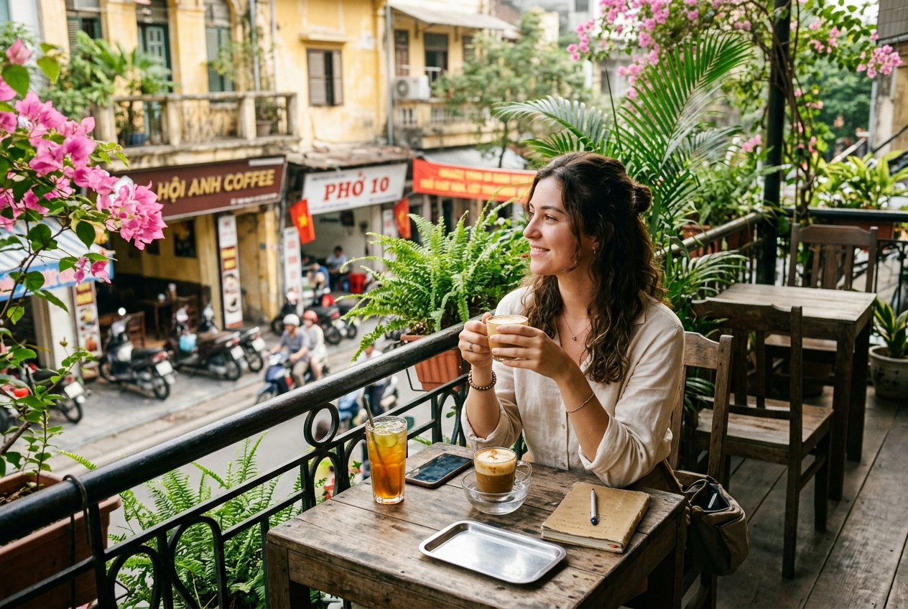
Figure: Traveler enjoying authentic egg coffee on French colonial balcony overlooking Hanoi Old Quarter
1. The Historic Old Quarter (Hoan Kiem)
Best for: Street culture, vintage architecture, dynamic lifestyle shots
The 36 Guild Streets represent the visual heartbeat of Hanoi. The architecture is characterized by "tube houses"—narrow street fronts with deep interiors, weathered mustard-yellow facades, and forest-green timber shutters.
- Top photo spots: Hang Bac (silver jewelry street), Hang Ma (lanterns and paper craft), and the narrow residential passageways off Hang Buom.
- Recommended timing: 7:00 AM – 8:30 AM.
- Related walking route: Check our Early Bird Sunrise & Local Markets Tour.
2. The French Quarter (Trang Tien & Metropole Perimeter)
Best for: Elegant portraits, clean architectural lines, sophisticated European charm
South and east of Hoan Kiem Lake, the streets widen significantly. Here you will find grand neoclassical buildings, wide tree-lined sidewalks, wrought-iron balconies, and grand cream-colored facades.
- Top photo spots: The perimeter of the Sofitel Legend Metropole, Hanoi Opera House plaza, and Trang Tien book street.
- Recommended timing: 8:00 AM – 9:30 AM or 4:00 PM – 5:30 PM.
- Related walking route: Explore our French Colonial Historical Footsteps Tour.
3. West Lake & Ancient Pagodas (Tay Ho & Ba Dinh)
Best for: Calm atmosphere, water reflections, traditional Vietnamese heritage
If you prefer open water, ancient banyan trees, and tranquil Buddhist architecture over energetic street markets, West Lake (Hồ Tây) is the natural choice.
- Top photo spots: Tran Quoc Pagoda causeway, the lotus ponds (in summer), and quiet lakeside residential paths near Tu Hoa street.
- Recommended timing: 6:30 AM sunrise or 5:00 PM golden hour.
- Related walking route: See our Spiritual & West Lake Breeze Tour.
4. Long Bien Bridge & Morning Wholesale Markets
Best for: Raw industrial texture, gritty documentary portraits, dramatic morning skies
Constructed between 1899 and 1902, the historic cantilever Long Bien Bridge crosses the Red River with rusted iron spans and wooden rail ties. Below it sits the bustling Long Bien wholesale produce market.
- Top photo spots: The pedestrian walking span facing east, the iron girder corridors, and the footpaths overlooking the banana island greenery below.
- Recommended timing: 5:45 AM – 7:00 AM (early sunrise only).
4. What to Wear: Wardrobe Guidelines That Work
One of the most frequent questions guests ask before a shoot is what clothes look best in Hanoi's street environment.
The background of Hanoi is visually rich: aged yellow walls, dark green shutters, grey asphalt, green banyan leaves, and red lanterns. To stand out naturally without clashing with the environment, follow these principles:
RECOMMENDED PALETTE:
✓ Warm neutrals: Cream, oatmeal, ivory, sand, beige
✓ Earth tones: Terracotta, warm rust, soft sage green, clay
✓ Fabric choice: Breathable linen, cotton voile, textured weave

COLORS TO AVOID:
✗ Neon greens, hot pinks, or highlighter yellows (clash with heritage walls)
✗ Heavy black outfits (absorb humidity and create flat silhouettes in bright sun)
✗ Large commercial brand logos across chest

Pro Move (Footwear): Hanoi sidewalks are notoriously uneven, with tree roots lifting concrete slabs and motorbikes parked everywhere. Wear comfortable flat sandals, stylish sneakers, or loafers. High heels are genuinely hazardous in the Old Quarter.

5. Important Questions to Ask Before You Book
Before sending a deposit or locking in a session with any photographer in Vietnam, clarify these five practical points:
- What is the exact turnaround time?
Many travelers leave Hanoi for Ha Long Bay, Ninh Binh, or Da Nang within 48 hours. If a photographer quotes a 2- to 3-week delivery, you won't be able to review your photos while still traveling in Vietnam. At TravelFrame, our standard delivery is within 24 hours.
- Are the photos delivered in full resolution?
Some budget platforms charge an extra fee per photo or only provide compressed, low-resolution files suitable for small phone screens. Make sure your agreement includes full-resolution digital downloads suitable for printing.
- What is the rain policy?
Hanoi weather can change quickly, especially during transitional seasonal months. Confirm whether the photographer offers free rescheduling for heavy rain or has curated covered routes (such as historic colonnades and atmospheric indoor cafes).
- Will they give posing direction?
If you feel shy or awkward in front of a camera (as 90% of our guests do), ensure your photographer is experienced in giving gentle, candid cues rather than expecting you to be a professional model.
- Is the photographer also your cultural guide?
A great street photo session isn't just about shutter clicks. It's about learning why Hang Bac street is named after silver, discovering where locals actually drink their morning brew, and having someone help you cross the bustling scooter traffic with confidence.
6. Frequently Asked Questions (FAQ)
I'm traveling solo. Won't a private photoshoot feel awkward?
Not at all. In fact, more than 60% of TravelFrame's bookings come from solo travelers—particularly solo female travelers. Because our hosts are friendly, English-speaking locals, the session feels like exploring a neighborhood with a knowledgeable friend. We focus on walking, observing, and drinking coffee, not posing stiffly on command.
How many edited photos do I get?
For a standard 90-minute session, you will receive 35 to 45 individually color-graded, high-resolution JPEG photos. We curate the best moments so you don't have to sift through hundreds of duplicate test shots.
Can I book on short notice?
We recommend reserving at least 3 to 5 days in advance, especially during the peak travel months from October through April. However, we do our best to accommodate last-minute bookings if a guide is available.
Do I get the raw, unedited camera files?
We deliver professionally finished, color-graded photos adjusted for exposure, contrast, and color harmony. RAW camera files are unprocessed digital negatives that require specialized software to view, so standard packages include the final high-res JPEGs.
7. Ready to Walk Hanoi With a Local Photographer?
You don't need modeling experience, expensive designer clothes, or hours of stiff posing to take home unforgettable photos from Vietnam. You just need a quiet morning, an open curiosity, and a local guide who knows where the light falls best.
If you are visiting Hanoi and want authentic, documentary-style memories of your journey:
👉 [Explore TravelFrame's Walking Photo Tours](https://travelframe.vn/tours)
👉 [Check Live Date Availability in Our Booking Configurator](https://travelframe.vn/booking)
👉 Have a specific question? Message our team directly on WhatsApp at +84 945 555 162 or on Instagram at [@travelframe.vn](https://www.instagram.com/travelframe.vn/).

