15 Best Photo Spots in Hanoi: A Local Guide to Light, Timing, and Uncrowded Angles (2026)
By TravelFrame Editorial Team · Official Website SEO Release (2026)
TRAVELFRAME SEO METADATA SPECIFICATION
• URL Slug: /news/best-photo-spots-hanoi
• Primary Keyword: best photo spots hanoi
• Secondary Keywords: hanoi instagram spots, hanoi photography locations, where to take photos in hanoi, hanoi photo walk spots
• Meta Title (<60 chars): 15 Best Photo Spots in Hanoi: Secret Angles & Timing (2026)
• Meta Description: Discover the 15 best photo spots in Hanoi. Local timing tips, golden hour lighting windows, exact street coordinates, and uncrowded architectural angles.
• Target Funnel Stage: MoFu (Visual Guide & Brand Bridge)
• Target Audience: Independent travelers, couples, and photography lovers looking for authentic, uncrowded photo locations in Hanoi

By TravelFrame Editorial Team · Updated September 2026
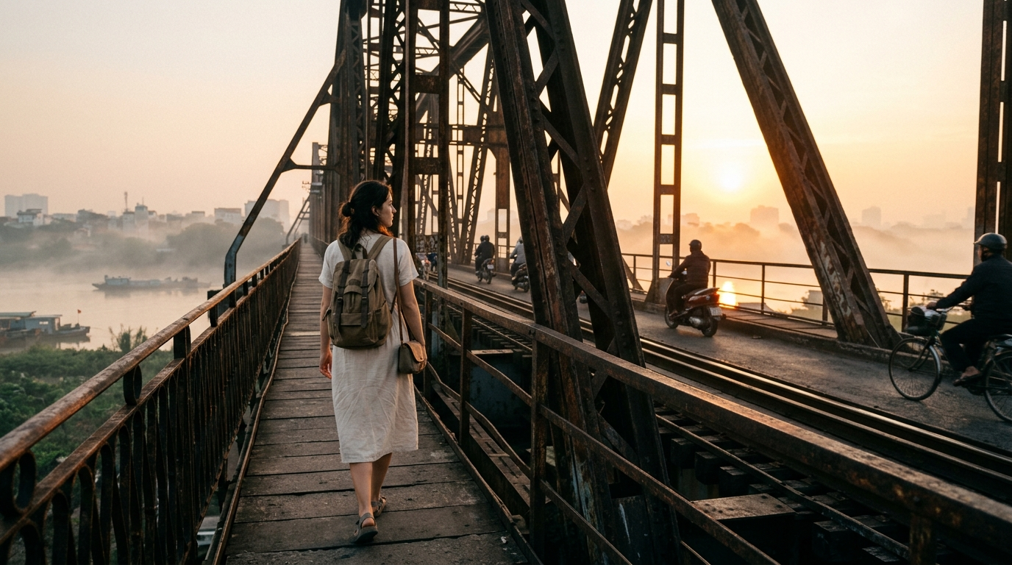
Figure: Traveler walking along Long Bien Bridge pedestrian footpath in Hanoi at sunrise
Hanoi is one of Southeast Asia's most visually rewarding cities, but photographing it well requires patience and local understanding.
Between midday sun reflecting off white concrete, thousands of scooters parked on narrow pavements, and tangled bundles of overhead wiring, finding clean backgrounds can feel overwhelming. Many travelers end up with identical, crowded shots at the same three tourist landmarks.
To help you capture genuine, evocative photos of the capital, our team of local photo guides put together this curated list of 15 exceptional photography spots in Hanoi.
We have organized them by neighborhood, with exact lighting recommendations, crowd avoidance tips, and composition notes so you know when and where to press the shutter.
Part 1: The Historic Old Quarter (Heritage & Street Life)
The 36 Guild Streets offer centuries-old texture: weathered ochre plaster, deep green French louvered shutters, and lively sidewalk commerce. The key here is early morning light before the delivery trucks arrive.
1. Hang Bac Street (The Silver Guild)
Best for: Classic Old Quarter architectural framing and heritage storefronts
Hang Bac is one of the oldest preserved streets in Hanoi, dating back to the 13th century when silver artisans migrated here to mint royal coin bars. The street is lined with narrow communal houses, gold-leaf shop signs, and vintage two-story facades.
- Best Time: 6:45 AM – 8:00 AM.
- Recommended Lens: 35mm or 50mm prime.
- The Angle: Stand on the northern side of the street near the intersection with Ta Hien, shooting down the curve of the road toward Dinh Kim Ngan (Silver Communal House). At 7:15 AM, morning sun cuts between the rooftops, creating dramatic shafts of golden light.
- Pro Move: Look for small family-run silver jewelry workshops where elderly jewelers sit behind glass display cases under tungsten desk lamps.
2. Ngo Huyen & Nha Chung (St. Joseph's Cathedral Alleyways)
Best for: European neo-Gothic texture combined with street cafes
While the front plaza of St. Joseph's Cathedral is usually packed with tour groups and selfie crowds, the perimeter alleyways—especially Ngo Huyen and Au Trieu—offer much calmer compositions.
- Best Time: 7:30 AM – 8:30 AM or 4:30 PM (golden hour).
- The Angle: Walk down Ngo Huyen and shoot back toward the cathedral towers through the gap between modern cafes and ancient banyan trees. You capture the Gothic stone towers framed by vibrant green leaves and low coffee stools.
3. Hang Ma Street (Seasonal Colors & Paper Lanterns)
Best for: Rich background colors and seasonal market atmosphere
Hang Ma is Hanoi's traditional paper and ceremonial street. Depending on the month, it overflows with red silk lanterns, mid-autumn star lanterns, or festive ornaments.
- Best Time: 8:00 AM – 9:00 AM (avoid evening crowds).
- The Angle: Position your subject walking slowly past the hanging lantern stalls. Use a wide aperture (f/1.8 to f/2.8) to blur the bustling background into a soft, glowing palette of red, gold, and magenta.
4. Dong Xuan Morning Market Perimeter (Cau Dong & Hang Khoai)
Best for: Raw documentary portraits and street texture
Inside the covered market, light is dim and chaotic. The photographic gold lies around the perimeter alleys—Cau Dong and Hang Khoai—where wholesale vegetable sellers and flower merchants trade off bicycle racks.
- Best Time: 6:00 AM – 7:15 AM (the earlier, the better).
- Related walking route: Included in our Early Bird Sunrise & Local Markets Tour.
5. O Quan Chuong (Old East Gate)
Best for: Ancient brickwork and historical continuity
Built in 1749 and rebuilt in 1817, O Quan Chuong is the only intact city gate surviving from the ancient Thang Long citadel. Its arched brick passageway still carries daily pedestrian and bicycle traffic.
- Best Time: 7:00 AM – 7:45 AM.
- The Angle: Frame your subject walking through the central brick archway, using the deep stone tunnel as a natural frame while morning sunlight illuminates the street beyond.
Part 2: The French Quarter (Colonial Charm & Grand Avenues)
Wide boulevards, neoclassical facades, and quiet tree-lined avenues define the area south of Hoan Kiem Lake. The visual language here is calm, elegant, and distinctly Indochinese.
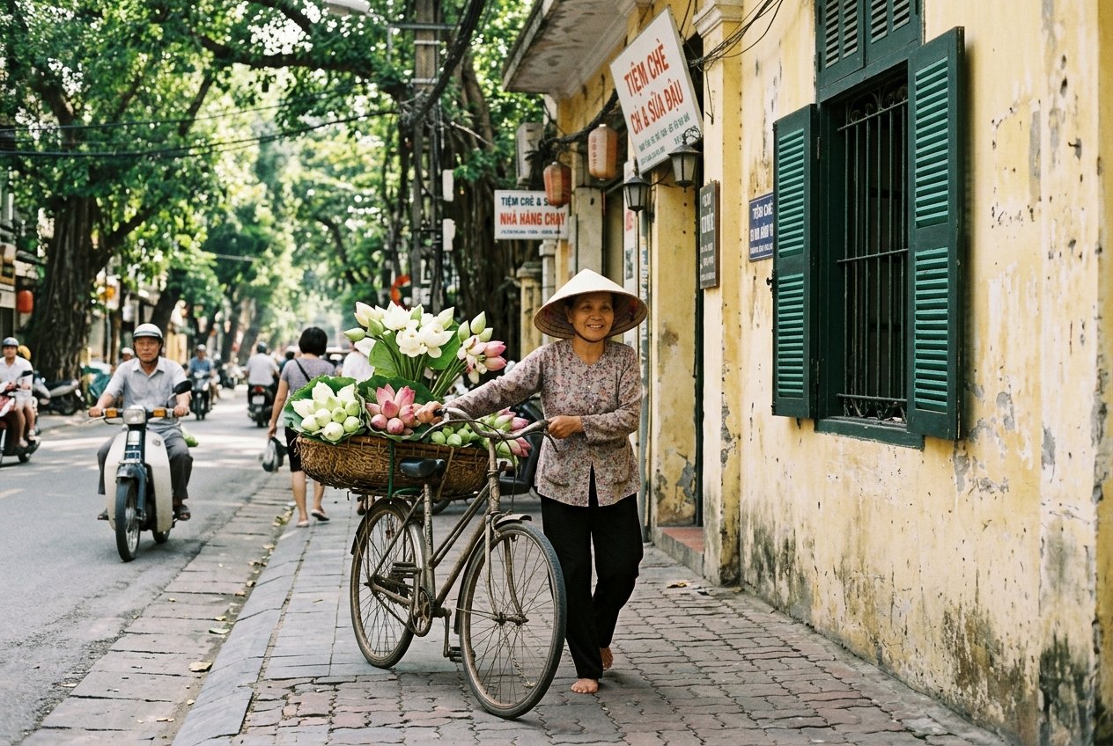
Figure: Hanoi street vendor with vintage bicycle laden with fresh lotus flowers along yellow colonial wall
6. Sofitel Legend Metropole Perimeter (Ngo Quyen & Le Phung Hieu)
Best for: Timeless colonial architecture, white vintage cars, and wrought iron
Opened in 1901, the Metropole is Hanoi’s grand dame hotel. Its white-and-green exterior, classical awnings, and vintage Citroën cars parked on the perimeter provide an effortlessly sophisticated backdrop.
- Best Time: 8:00 AM – 9:30 AM.
- The Angle: The corner of Le Phung Hieu and Ngo Quyen offers clean sidewalk lines, polished wooden louvered doors, and soft shaded light throughout the morning.
- Related walking route: Featured on our French Colonial Historical Footsteps Tour.
7. Hanoi Opera House Plaza (Nha Hat Lon)
Best for: Symmetrical grandeur and evening warm glow
Modeled after the Palais Garnier in Paris, this 1911 landmark sits prominently at the head of Trang Tien street with its pale yellow columns, slate roof, and broad stone steps.
- Best Time: 7:00 AM – 8:00 AM (for empty steps) or 5:30 PM (blue hour when building floodlights switch on).
- The Angle: Shoot from the base of the wide stone steps looking up, or stand across the roundabout near the Hilton gardens using passing vintage Vespa scooters as foreground interest.
8. Trang Tien Walkway & Vintage Book Street
Best for: Nostalgic yellow colonnades and deep shadows
Trang Tien connects Hoan Kiem Lake directly to the Opera House. The north side of the street features covered sidewalk colonnades that create dramatic alternating bands of light and shadow on bright mornings.
- Best Time: 8:30 AM – 10:00 AM.
- The Angle: Shoot down the covered pedestrian colonnade. The long vanishing line of pale yellow pillars and deep shaded ceilings naturally draws the viewer's eye straight toward your subject.
9. Cua Bac Church (Nha Tho Cua Bac)
Best for: Unique Art Deco & French-Vietnamese architectural synthesis
Located on Phan Dinh Phung street, Cua Bac Church was designed by French architect Ernest Hébrard in 1932. Unlike St. Joseph's European Gothic look, Cua Bac combines traditional Vietnamese curved roof tiles with Art Deco bell towers and ochre-yellow stucco.
- Best Time: 8:00 AM – 9:30 AM.
- The Angle: The church courtyard is rarely crowded. Stand beneath the towering sưa trees and shoot upward toward the asymmetrical bell tower against a blue morning sky.
10. Phan Dinh Phung Street (The Golden Tree Canopy)
Best for: Dappled sunlight, leaf-covered sidewalks, and flower bicycles
Phan Dinh Phung is widely considered Hanoi’s most poetic avenue. Four rows of century-old Dracontomelon (cây sấu) trees create an uninterrupted green cathedral over the road.
- Best Time: 7:30 AM – 9:00 AM (when morning rays pierce through the canopy).
- Iconic Element: Local women vendors pushing vintage bicycles laden with seasonal blossoms—lotus in summer, daisies in autumn, and white peach blossoms in spring.
- Pro Move: If you take a photo with a flower vendor, it is polite to purchase a bouquet (typically 50,000 to 80,000 VND / $2–$3) as a warm gesture of appreciation.
Part 3: Cultural, Waterside & Secret Viewpoints
Beyond the Old and French Quarters lie ancient lakeside causeways, historic railway bridges, and second-floor balconies that capture Hanoi from a completely different perspective.
11. Long Bien Bridge Pedestrian Footpath
Best for: Dramatic sunrise silhouettes, Red River mist, and historic iron trusses
Built by Daydé & Pillé between 1899 and 1902, this 2.4-kilometer cantilever steel bridge is a living museum. It survived multiple aerial bombings and remains in daily use by trains, motorbikes, and pedestrians.
- Best Time: 5:30 AM – 6:45 AM (sunrise).
- The Angle: Walk roughly 300 meters along the pedestrian footpath starting from the Long Bien station ramp. Frame your subject walking along the wooden planks with the rusted steel trusses repeating toward the rising sun over the Red River.
- Safety Note: Motorbikes move quickly along the center track. Always remain within the dedicated wooden pedestrian walkway on the outer side.
12. Tran Quoc Pagoda Causeway (West Lake / Ho Tay)
Best for: Water reflections, lotus fragrance, and spiritual tranquility
Perched on a small island on West Lake, Tran Quoc Pagoda is the oldest Buddhist shrine in Hanoi, established in the 6th century. The causeway leading to the temple entrance is shaded by banyan trees and bordered by calm water.
- Best Time: 6:30 AM – 7:30 AM or 5:00 PM sunset.
- The Angle: Stand on Thanh Nien street looking across the water toward the 11-story terracotta pagoda tower (bảo tháp). At sunset, the golden sky reflects directly off West Lake.
- Related walking route: Featured on our Spiritual & West Lake Breeze Tour.
13. Temple of Literature (Van Mieu - Quoc Tu Giam)
Best for: Ancient red lacquer pavilions, stone turtle stelae, and lotus ponds
Founded in 1070 as Vietnam's first national university, the complex consists of five serene courtyards. The traditional timber architecture, grey stone slabs, and manicured topiary trees provide an authentically Vietnamese heritage aesthetic.
- Best Time: 8:00 AM sharp (doors open) before tour buses arrive at 9:00 AM.
- The Angle: The Khue Van Cac (Pavilion of the Constellation of Literature) framed over the Well of Heavenly Clarity (Thien Quang Tinh).
- Dress Code: Because this is a revered academic and Confucian shrine, shoulders and knees must be respectfully covered.
14. Phung Hung Street Railway Archways
Best for: Stone viaduct arches, urban murals, and vintage street lamps
Beneath the elevated train tracks running south from Long Bien station sits Phung Hung street. The 131 stone railway arches have been preserved, with several converted into public art murals celebrating old Hanoi street life.
- Best Time: 8:00 AM – 9:30 AM.
- The Angle: Walk down the pedestrian promenade between Hang Cot and Hang Luoc. The massive granite blocks of the 120-year-old French viaduct offer clean geometric repeating arches for full-body portraits.
15. A Second-Floor Heritage Balcony Cafe (Old Quarter)
Best for: Intimate candid moments, egg coffee, and street-level vantage points
Some of Hanoi’s best photos are taken from above, looking down into the flow of bicycles, street vendors, and heritage roof tiles. Hidden cafes nestled on the second and third floors of French colonial apartments offer open wooden balconies.
- Recommended Cafes: Ban Cong Cafe (Dinh Liet street), Cafe Dinh (second floor overlooking Hoan Kiem Lake), or Loading T (Chan Cam street).
- Best Time: 8:30 AM – 10:00 AM.
- The Angle: Seat your subject at a small wooden table with a glass of warm egg coffee, shooting through hanging bougainvillea plants with the morning street scene softly blurred below.
Lighting Summary: When to Shoot in Hanoi
Time Window | Light Quality | Crowd Level | Best Locations
5:30 AM – 6:45 AM | Soft pastel dawn, sunrise mist | Zero crowds | Long Bien Bridge, Hoan Kiem shoreline, flower markets
7:00 AM – 8:30 AM | Warm directional golden hour | Quiet streets, opening stalls | Old Quarter craft streets, French Quarter boulevards
8:30 AM – 10:00 AM | Bright, angled morning light | Normal street activity | Heritage balcony cafes, Phan Dinh Phung tree avenue
10:30 AM – 3:30 PM | Harsh, vertical overhead sun | Heavy traffic | Shaded temple courtyards, indoor cafes (avoid open streets)
4:30 PM – 5:45 PM | Warm sunset glow & blue hour | Peak rush hour | West Lake causeway, Opera House exterior

3 Practical Street Photography Tips for Travelers
- Travel Light (Ditch the Tripod):
Sidewalks in Hanoi are narrow and motorbikes weave through every alley. Setting up a three-legged tripod will slow you down, block pedestrian flow, and draw unnecessary attention. A fast prime lens (35mm or 50mm) on a lightweight camera body gives you all the speed and mobility you need.
- Always Watch the Overhead Cables:
Hanoi's black utility cables are part of its street character, but a stray wire slicing across someone's face ruins an otherwise gorgeous portrait. Before pressing the shutter, take one second to check the top third of your frame and adjust your angle by taking two steps forward or crouching slightly.
- Interact With Respect:
Street vendors and locals are generally welcoming, but always greet them with a polite smile ("Xin chào") before pointing your camera directly at their face. If someone gestures no, lower your camera and move on with a nod of thanks.
Want to Explore These Spots Without Camera Stress?
Finding the exact street corners, knowing which vendor is open, and trying to take candid photos of yourself while dodging scooters can take the joy out of your morning.
When you book a [Private Walking Photo Tour with TravelFrame](https://travelframe.vn/tours), you don't have to worry about angles, selfie sticks, or crowded backgrounds.
Your host is an English-speaking local who guides you through these exact quiet corners, shares genuine cultural stories, and captures 35 to 50 beautiful, color-graded candid portraits delivered within 24 hours.
👉 [Browse Our Hanoi Photo Tour Itineraries](https://travelframe.vn/tours)
👉 [Read Our Complete Guide to Hiring a Photographer in Hanoi](https://travelframe.vn/news/hiring-private-photographer-in-hanoi)
👉 [Check Live Availability in Our Booking Configurator](https://travelframe.vn/booking)

