Couple & Honeymoon Photoshoot in Hanoi: A Relaxed, Candid Guide (2026)
By TravelFrame Editorial Team · Official Website SEO Release (2026)
TRAVELFRAME SEO METADATA SPECIFICATION
• URL Slug: /news/couple-photoshoot-hanoi-old-quarter
• Primary Keyword: couple photoshoot hanoi
• Secondary Keywords: hanoi honeymoon photography, vacation photoshoot couple hanoi, romantic photo walk hanoi, pre wedding photo shoot hanoi old quarter
• Meta Title (<60 chars): Couple Photoshoot in Hanoi: Natural & Candid Guide (2026)
• Meta Description: Planning vacation or honeymoon photos in Hanoi? Here is how to get authentic, unposed couple portraits without the stress of stiff wedding studios.
• Target Funnel Stage: MoFu / BoFu (Commercial Couple Niche)
• Target Audience: Traveling couples, honeymooners, and partners looking for natural, unposed vacation photography in Hanoi

By TravelFrame Editorial Team · Updated September 2026
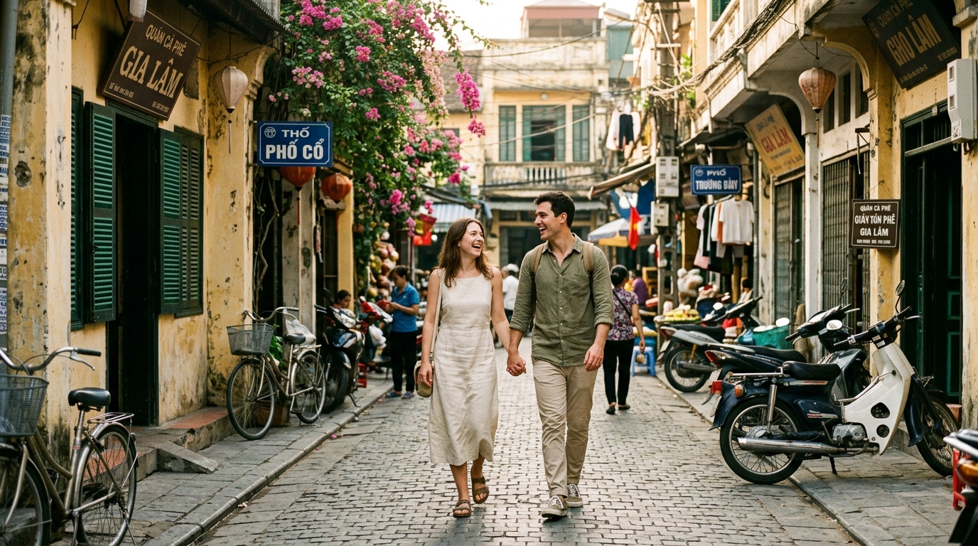
Figure: Affectionate couple walking hand in hand down historic alleyway in Hanoi Old Quarter
Most couples traveling through Vietnam want high-quality photos together, but dread the process of getting them.
The traditional options in Hanoi tend to sit at two extremes: either you take awkward selfie-arm portraits where half the background is blocked, or you hire a commercial wedding studio that dresses you in matching synthetic suits, cakes on heavy makeup, and spends three hours barking instructions like "Tilt your head 15 degrees and gaze passionately into each other's eyes."
Neither captures what it actually feels like to explore Hanoi as partners: laughing over a shared cup of warm egg coffee on a hidden balcony, dodging motorbikes together, or strolling down quiet morning alleys smelling of fresh coriander and woodsmoke.
A private walking couple photoshoot takes a completely different approach. It is structured around natural exploration, genuine conversation, and documentary-style photography.
Here is everything you need to know about planning a relaxed couple or honeymoon session in Hanoi, from route pacing and wardrobe coordination to candid posing cues.
1. Why Documentary Photo Walks Beat Traditional Studio Shoots
If one of you is naturally camera-shy—which is true in roughly 80% of the couples we host—a traditional photoshoot feels like a chore. The pressure to "perform" for a lens creates stiff shoulders, forced smiles, and awkward body language.
A documentary walking session removes that pressure because the camera is secondary to the walk:
- Continuous Movement: You are walking, observing street vendors, and pointing out interesting roof tiles, not frozen on an empty studio set.
- Natural Interaction: The photographer captures you talking to each other, laughing at an unexpected scooter horn, or sharing an iced tea.
- Genuine City Context: Instead of generic flower arches or artificial backdrops, your photos feature authentic Hanoi texture: weathered mustard-yellow plaster, wrought-iron French balconies, and dappled banyan shade.
- Zero Heavy Props: No reflectors, no light umbrellas, and no large crew trailing behind you drawing unwanted attention from crowds.
2. The Ideal 2-Hour Couple Route in Hanoi
Two hours is the sweet spot for a couple shoot: long enough to visit three distinct visual environments without exhausting yourselves or overheating in the tropical humidity.
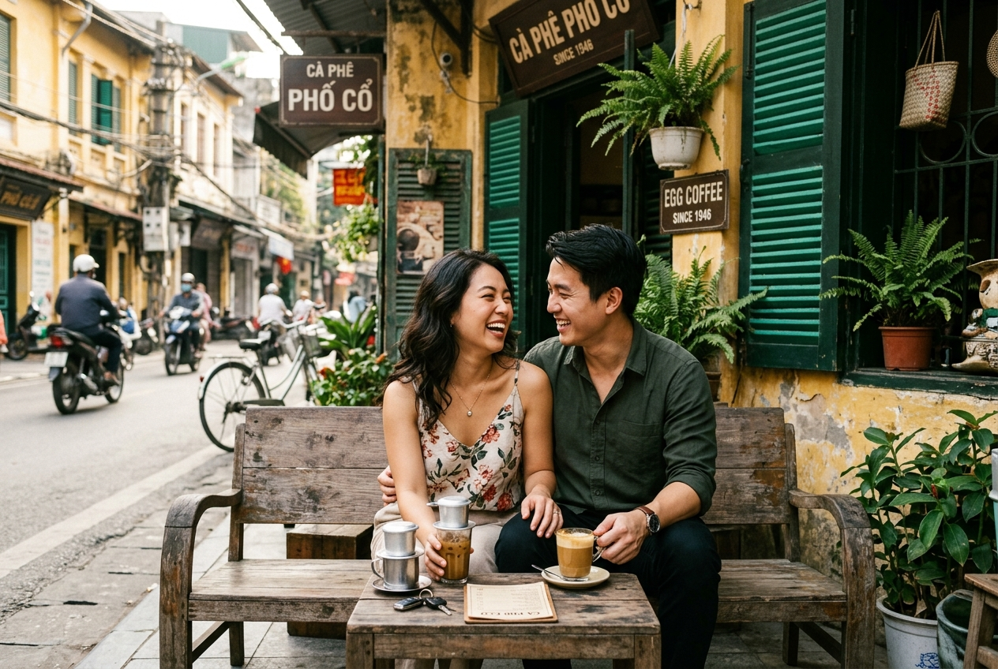
Figure: Couple laughing warmly together on a wooden bench outside a traditional Hanoi street cafe
Phase 1: The Quiet Morning Alleys (7:00 AM – 7:45 AM)
Location: Hang Bac, Hang Be, and residential courtyards
Start early while the morning air is cool and the Old Quarter is just stirring. The low morning light cuts between narrow shophouse roofs, illuminating small courtyards and ancient communal temples.
- The Mood: Quiet, intimate, and contemplative.
- The Shots: Walking hand-in-hand down empty cobblestone corridors, pausing by vintage green wooden shutters, and looking at handwritten street signs.
Phase 2: The Sidewalk Coffee Pause (7:45 AM – 8:15 AM)
Location: Traditional second-floor cafe balcony or rustic street bench
Hanoi coffee culture is world-renowned. Stopping for a glass of traditional egg coffee (cà phê trứng) or drip iced coffee (cà phê sữa đá) provides a natural rest break and produces some of the most intimate photographs of the entire morning.
- The Mood: Relaxed, playful, and genuine.
- The Shots: Sitting close on low wooden stools, clinking glasses, and laughing across a small cafe table while looking down at the street awakening below.
Phase 3: French Quarter Architectural Elegance (8:15 AM – 8:45 AM)
Location: Metropole Hotel perimeter, Le Phung Hieu, and Trang Tien
Cross south into the French Quarter, where streets broaden into tree-lined boulevards with white neoclassical facades, wrought-iron lamps, and polished colonnades.
- The Mood: Sophisticated, timeless, and clean.
- The Shots: Wide-angle full-body portraits walking along the shaded colonnade, framed by vintage shutters and grand cream-colored archways.
- Related walking route: Featured on our French Colonial Historical Footsteps Tour.
Phase 4: Hoan Kiem Lakeside Finale (8:45 AM – 9:00 AM)
Location: East shore near Dinh Tien Hoang weeping willows
Finish the session along the edge of Hoan Kiem Lake, where century-old weeping willows dip their green branches directly toward the water.
- The Mood: Scenic, breezy, and affectionate.
- The Shots: Leaning together against the lakeside stone balustrade, watching morning tai chi practitioners across the water as the session wraps up.
3. Posing Without "Posing": 5 Prompts for Camera-Shy Couples
You do not need modeling experience. A skilled photo guide uses gentle prompts rather than rigid poses:
PROMPT 1: The Stroll & Whisper
Instruction: "Walk slowly down that alleyway toward me. While walking, whisper the funniest
thing that happened to you since arriving in Vietnam."
Why it works: Distracts your mind from the camera, resulting in genuine smiles and laughter.

PROMPT 2: The Crosswalk Handhold
Instruction: "Hold hands, look at the oncoming scooters together, and cross at a steady pace."
Why it works: Naturally draws you close together while generating dynamic motion blur around you.

PROMPT 3: The Shared Balcony Look
Instruction: "Sit together on the balcony bench. Point out the strangest cargo you see tied to a motorbike."
Why it works: Creates natural eye lines and relaxed body posture without staring into the lens.

PROMPT 4: The Shoulder Lean
Instruction: "Stand shoulder-to-shoulder against that yellow wall, look down the street, and take a deep breath."
Why it works: Relaxes tense shoulders and creates an intimate, calm profile shot.

PROMPT 5: The Forehead Bump
Instruction: "Bring your foreheads close together and close your eyes for three seconds."
Why it works: Blocks out the surrounding city noise and produces a quiet, tender portrait.

4. Wardrobe Coordination: How to Complement Without Matching
One of the biggest mistakes couples make is wearing identical matching outfits (like matching white polo shirts and khaki shorts). Identical matching looks like a corporate uniform on camera.
Instead, aim for complementary color harmony:
Recommended Color Combinations
- Option A (Warm Heritage): Her in a cream or oatmeal linen dress; him in an olive green or sage button-down with stone chinos.
- Option B (Earthy Contrast): Her in a soft terracotta sundress; him in an off-white cotton linen shirt with light beige trousers.
- Option C (Minimalist Neutral): Both in varying shades of sand, ivory, and soft grey, using different textures (linen weave, breathable cotton) to create visual depth.
What to Avoid
- Pure Stark White & Jet Black: High contrast extremes confuse digital camera sensors in bright morning light. Choose soft off-white or cream instead of bleaching white.
- Bold Graphic T-shirts: Brand logos, sports jerseys, or loud graphic prints draw the viewer's eye straight to your chest instead of your faces.
- Uncomfortable Footwear: Hanoi sidewalks are uneven and cracked. Choose broken-in loafers, flat leather sandals, or clean sneakers. High heels will slow you down and risk a twisted ankle.
5. Typical Rates & Package Details (2026 Overview)
In Hanoi, couple sessions generally run between $125 and $160 USD for an independent, high-end private walk.
Here is what TravelFrame’s dedicated Couple & Honeymoon Walk includes:
Feature | TravelFrame Couple Package | Standard Wedding Studio
Duration | 120 minutes (relaxed walking pace) | 4–6 hours (heavy waiting time)
Locations | 3–4 authentic Old Quarter & French Quarter neighborhoods | 1 indoor artificial studio set
Photo Delivery | 50+ color-graded high-resolution photos | 15–20 heavily retouched prints
Turnaround Time | Within 24 hours (via private cloud gallery) | 2–4 weeks (after you leave Vietnam)
Atmosphere | Intimate morning walk with local English-speaking friend | Stiff crew with lights, makeup artists, and reflectors
Short Social Clips | Included (candid vertical 4K video clips) | Extra surcharge

You can check exact seasonal rates and real-time calendar availability directly in our Booking Configurator.
6. Frequently Asked Questions
What if my partner hates having their picture taken?
This is our specialty. Tell your photographer at the start of the walk. Our hosts treat the session as a relaxed neighborhood stroll first and a photoshoot second. We never force eye contact with the camera, we avoid counting "1, 2, 3, smile," and we keep the rhythm fast and conversational. Most camera-shy partners tell us afterward: "That was actually really fun."
What if it rains on the morning of our session?
Hanoi's tropical weather can be unpredictable. If light drizzle occurs, we provide clear umbrellas that look gorgeous on camera against wet, reflective heritage asphalt. If severe downpours hit, we offer free rescheduling to another morning during your stay or transition to beautiful covered French colonial colonnades and historic indoor cafes.
Can we bring an outfit change?
For a 2-hour walk, we recommend wearing one comfortable, versatile outfit. Changing clothes in the Old Quarter requires hunting down public restrooms and wastes 20 to 30 minutes of your prime morning light. A simple layer change (like adding a light linen scarf or removing a lightweight overshirt) gives you visual variety without the hassle.
Capture Your Hanoi Story Together
Your vacation in Vietnam is more than landmarks on a map—it is the inside jokes, the morning coffee breaks, and the shared glances while navigating an ancient, bustling city.
Don't leave Hanoi with only crooked arm-length selfies and phone snaps taken by strangers.
Spend a quiet morning exploring the city's most romantic streets with a local friend who captures the genuine feeling of your trip.
👉 [Explore TravelFrame's Couple & Honeymoon Walking Tours](https://travelframe.vn/tours)
👉 [Read: 15 Best Photography Spots in Hanoi](https://travelframe.vn/news/best-photo-spots-hanoi)
👉 [Read: How to Cross the Street in Hanoi Safely](https://travelframe.vn/news/how-to-cross-the-street-in-hanoi)
👉 [Check Live Date Availability in Our Booking Configurator](https://travelframe.vn/booking)

