Hanoi Sunrise Photography Walk: Long Bien Bridge, Flower Markets, and Morning Light (2026)
By TravelFrame Editorial Team · Official Website SEO Release (2026)
TRAVELFRAME SEO METADATA SPECIFICATION
• URL Slug: /news/hanoi-sunrise-photography-walk
• Primary Keyword: long bien bridge sunrise
• Secondary Keywords: hanoi sunrise photo walk, hanoi morning photography, quang ba flower market photography, hanoi early morning walk
• Meta Title (<60 chars): Hanoi Sunrise Photo Walk: Long Bien Bridge & Markets (2026)
• Meta Description: Experience Hanoi at dawn. A local photographer's guide to Long Bien Bridge sunrise, Quang Ba flower market, and uncrowded morning street life.
• Target Funnel Stage: ToFu / MoFu (Cultural Experience & Tour Discovery)
• Target Audience: Enthusiastic photographers, dawn walkers, creators, and travelers seeking Hanoi's most atmospheric early hours

By TravelFrame Editorial Team · Updated September 2026
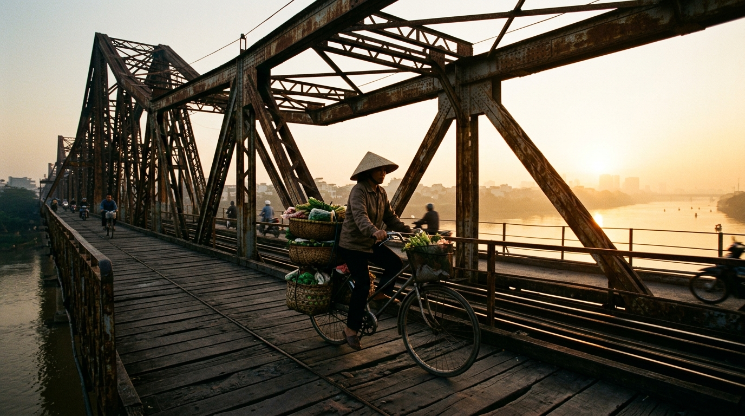
Figure: Local commuter cycling across Long Bien Bridge in Hanoi during golden sunrise mist
If you only explore Hanoi between 10:00 AM and 8:00 PM, you will see a frantic, crowded metropolis. The sidewalks are lined with parked motorbikes, tour buses block narrow alleys, and the humidity softens into a dense haze.
Set your alarm for 4:45 AM, however, and the city reveals a completely different character.
Before dawn, Hanoi belongs to its early risers. Commuters ride vintage bicycles across historic steel bridges carrying produce grown on river sandbars. Thousands of fresh lotus blossoms change hands under hanging lightbulbs at roadside wholesale markets. Along the lakes, elderly residents practice silent tai chi under weeping willows while sidewalk noodle pots simmer in clouds of aromatic steam.
For photographers, this 3-hour dawn window—from 5:00 AM to 8:00 AM—offers the best directional light, cleanest street backgrounds, and most authentic documentary storytelling in northern Vietnam.
Here is the complete field guide to photographing Hanoi at sunrise, including an unhurried morning route, technical lighting advice, and local etiquette.
1. The Dawn Itinerary: 5:00 AM to 8:30 AM
To capture the transition from indigo blue hour to warm morning gold, your morning route needs to move chronologically with the city's waking rhythm.
5:00 AM — Quang Ba Wholesale Flower Market (Blue hour & hanging tungsten lights)
5:45 AM — Long Bien Bridge Pedestrian Span (Sunrise silhouettes over Red River)
6:45 AM — Long Bien Wholesale Produce Market (Rivet shadows & street textures)
7:30 AM — Hoan Kiem Lake Promenade (Morning exercises, gentle mist, willow reflections)
8:15 AM — Historic Sidewalk Pho & First Drip Iced Coffee

Stop 1: Quang Ba Night Flower Market (5:00 AM – 5:35 AM)
Visual Focus: Blue hour mood, rich botanical color, and night market trade
Located along the dike road in Tay Ho district, Quang Ba operates all night, receiving truckloads of flowers freshly cut from Da Lat, Me Linh, and the Red River delta.
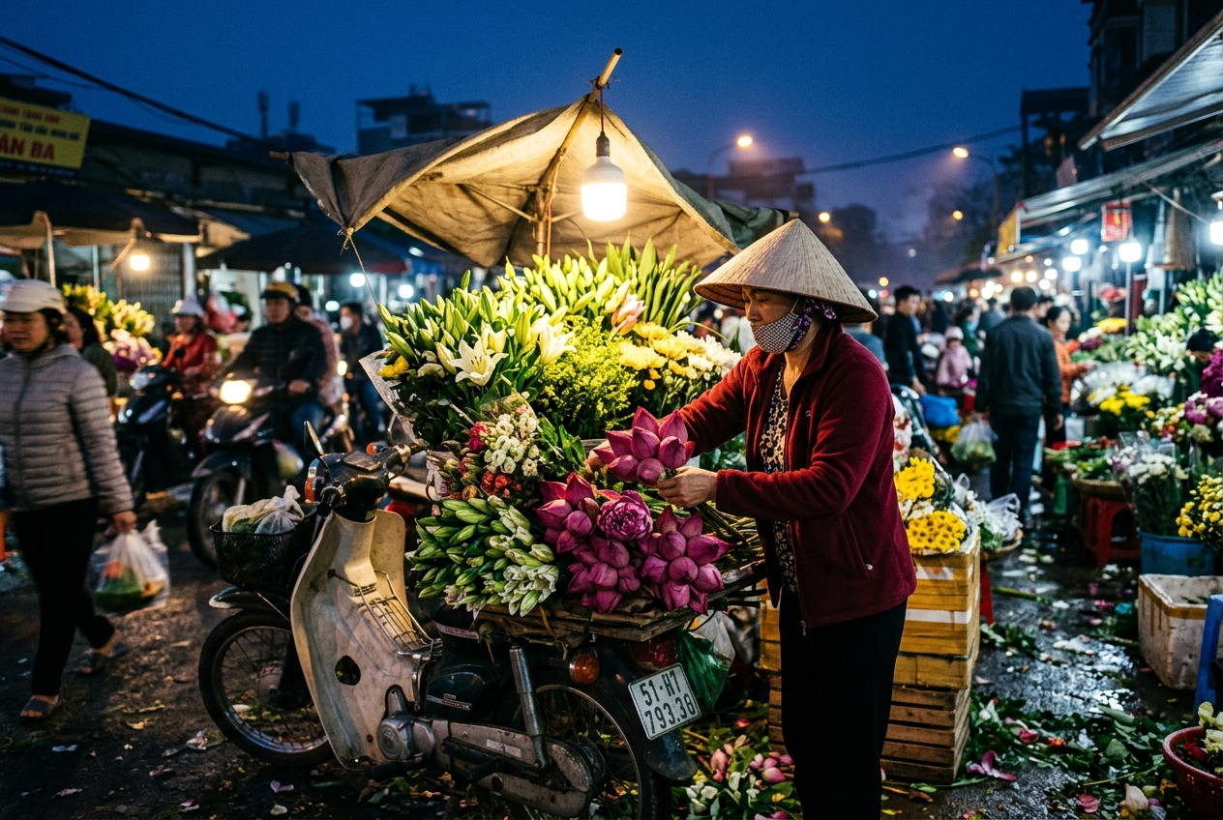
Figure: Quang Ba flower market in Hanoi before dawn illuminated by hanging bulbs and fresh lotus blooms
By 5:00 AM, the market reaches its peak retail energy before packing down at sunrise.
- The Scene: Women in conical hats balance giant mounds of pink lotus blossoms, white lilies, and yellow chrysanthemums on the pillion racks of vintage Honda Super Cubs.
- The Light: Bare overhead lightbulbs create warm pools of tungsten light against the deep indigo twilight sky.
- Composition Tip: Set your camera to a wide aperture (f/2.0 or f/2.8) and an ISO between 800 and 1600. Focus on hands carefully peeling back lotus petals or arranging flower stems in wet woven bamboo baskets.
Stop 2: Long Bien Bridge Sunrise (5:45 AM – 6:40 AM)
Visual Focus: Industrial silhouettes, river mist, and golden dawn glow
Completed in 1902 by the French firm Daydé & Pillé, this 2.4-kilometer cantilever steel bridge crosses the Red River with twenty massive spans. Because it survived multiple air strikes during the war, its rusted iron girders carry deep historical resonance.
- The Scene: As the sun breaks over the eastern horizon behind Gia Lam, golden light reflects off the river surface. Commuters from rural outposts pedal bicycles loaded with herbs and greens toward city markets.
- The Angle: Walk roughly 250 meters out onto the dedicated wooden pedestrian walkway on the south side. Frame passing cyclists against the rising sun using the repeating crisscross iron trusses as leading lines.
- Camera Settings: Stop your lens down to f/5.6 or f/8 for sharp edge-to-edge detail across the iron rivets, and shoot slightly underexposed to turn passing figures into crisp morning silhouettes against the amber sky.
Pro Move (Footing on the Bridge): The pedestrian footpath is made of weathered wooden railway planks. Some boards have small gaps showing the river far below. Wear closed-toe shoes with good grip, watch your step, and never lean your heavy camera body out over the rusted outer railing.

Stop 3: Long Bien Market Under the Viaduct (6:45 AM – 7:25 AM)
Visual Focus: High-energy documentary portraits and market movement
Directly beneath the western ramp of Long Bien Bridge sits Hanoi’s largest wholesale agricultural market. While the main wholesale trucks disperse around 6:00 AM, the retail lanes beneath the massive stone viaduct stay intensely active until 7:30 AM.
- The Scene: Wooden handcarts loaded with watermelons, dragon fruit, and mountain herbs wheel past granite arches built over a century ago.
- Composition Tip: Switch to a 35mm prime lens to capture human scale within the architectural arches. Look for diagonal sunbeams cutting through the market awnings as dust and ice vapor catch the morning rays.
Stop 4: Hoan Kiem Lake Lakeside Rituals (7:30 AM – 8:15 AM)
Visual Focus: Serenity, lakeside reflections, and local morning lifestyle
Head ten minutes south into the heart of the capital. While the Old Quarter streets around the lake are closed to vehicles on weekend mornings, even weekday mornings offer a peaceful public space.
- The Scene: Generations of Hanoians gathering for sunrise movement: groups practicing fan dancing and tai chi, retirees playing traditional Chinese chess (cờ tướng) on stone benches, and joggers circling the water under weeping willows.
- The Angle: Stand on the eastern shore near the statue of King Ly Thai To, looking across toward Turtle Tower (Tháp Rùa). The water is often glass-calm at this hour, providing clean reflections of morning clouds and heritage trees.
Stop 5: The Street Breakfast Reward (8:15 AM)
Visual Focus: Culinary storytelling, steam, and morning conversation
No sunrise walk in Hanoi is complete without the sensory reward of an authentic street breakfast.
Pull up a blue plastic stool at a neighborhood stall near Hang Bac or Bat Dan.
- The Shot: Capture the chef slicing tender beef onto fresh rice noodles, ladling boiling broth from a 50-liter aluminum pot, with backlit morning steam curling into the sunlight.
- Pairing: Follow your hot bowl of pho with a slow-drip iced coffee with condensed milk (cà phê sữa đá) at a shaded sidewalk cafe, reviewing your morning photo captures while the city reaches full morning pace.
Camera Settings & Equipment Recommendations
Photographing Hanoi at dawn requires moving quickly in changing light conditions:
Gear / Setting | Recommendation | Why It Matters
Lens Choice | 35mm or 28mm–70mm zoom | Allows you to switch quickly from wide bridge landscapes to intimate market portraits
Aperture | f/1.8 – f/2.8 (Markets) / f/5.6 – f/8 (Bridge) | Wide open for dark dawn markets; stopped down for bridge structural sharpness
Shutter Speed | Minimum 1/250s for moving cyclists | Prevents blurry handlebars and moving bicycle spokes in low light
ISO Strategy | Auto-ISO with maximum cap at 3200 | Lets you focus on framing without fumbling dials while walking along narrow paths
Bag Choice | Cross-body sling or small backpack | Avoid large rolling camera cases that cannot navigate cracked sidewalks or mud

3 Essential Etiquette Rules for Morning Photographers
- Never Block Active Market Pathways:
Quang Ba and Long Bien are working wholesale commercial hubs, not tourist theme parks. Porters carrying 50-kilogram crates of vegetables have right-of-way. Always stand with your back against a wall or pillar, and never stand in the middle of an alleyway adjusting your lens.
- Always Ask Before Close-Up Vendor Portraits:
A simple smile, eye contact, and a polite gesture toward your camera ("Cháu chụp ảnh nhé?") goes a long way. If a vendor waves their hand no, smile, nod thank you, and move on immediately.
- Buy Something Small:
If you spend five minutes photographing a flower stall or tea vendor, spend 20,000 to 50,000 VND ($1–$2) on a small bottle of water, a glass of green tea, or a small flower bunch. It demonstrates mutual respect and supports local livelihoods.
Want an Expert Companion on Your Morning Walk?
Waking up at 5:00 AM in an unfamiliar foreign city, navigating unlit alleys, and finding the exact pedestrian ramps on Long Bien Bridge can be intimidating on your own.
On TravelFrame’s dedicated [Early Bird Sunrise & Local Markets Tour](https://travelframe.vn/tour/hanoi-early-bird-sunrise-local-markets), you walk alongside an experienced, English-speaking local photographer who:
- Knows the exact minute-by-minute sunrise angles
- Guides you safely through wholesale markets and historic bridges
- Shares genuine cultural context behind morning street rituals
- Takes 35 to 50 documentary-style, color-graded photos of you delivered within 24 hours
👉 [Discover the Early Bird Sunrise Photo Tour](https://travelframe.vn/tour/hanoi-early-bird-sunrise-local-markets)
👉 [Read: Hiring a Private Photographer in Hanoi — Rates & Guide](https://travelframe.vn/news/hiring-private-photographer-in-hanoi)
👉 [Read: 15 Best Photo Spots in Hanoi](https://travelframe.vn/news/best-photo-spots-hanoi)
👉 [Check Live Calendar Dates in Our Booking Configurator](https://travelframe.vn/booking)

