TravelFrame SEO Content Trio
Three English SEO article drafts with visual assets and source notes
Article | Primary intent | Visuals
Hanoi Train Street 2026 | Safety and access | 1 Codex illustration + 2 Pexels photos
Solo Female Travel in Hanoi | Photo guidance and consideration | 1 Codex illustration + 2 Pexels photos
Slow Hanoi 48-Hour Itinerary | Two-day travel planning | 1 Codex illustration + 3 Pexels photos
Commercial claims: Prices, delivery promises, image counts and testimonials were omitted because they are not approved commercial truth.

Hanoi Train Street 2026: A Safety-First Guide and Better Railway Photo Spots
SEO article draft with curated Pexels photography and clearly disclosed AI editorial illustration.
SEO slug  /blog/train-street-hanoi-safety-guide-2026 | Primary keyword  train street hanoi
Status  Draft | Audience  International travelers planning Hanoi
Meta title  Hanoi Train Street 2026: Safety, Access and Photo Guide | Meta description  Is Hanoi Train Street open in 2026? Read a safety-first local guide to changing access rules, train times, barriers and calmer railway photo spots.

By TravelFrame Editorial Team · Fact-checked September 25, 2026
Hanoi Train Street is one of the city's most searched locations. It is also an active railway corridor running through a residential neighborhood.
That distinction matters.
Online posts often describe Train Street as either fully open or completely closed. The reality is less convenient: access and enforcement can change, barriers must be respected, and a cafe invitation does not override instructions from railway staff or local authorities.
This guide explains how to approach the area responsibly, why static train timetables are unreliable, and where to find railway atmosphere without standing on the tracks.
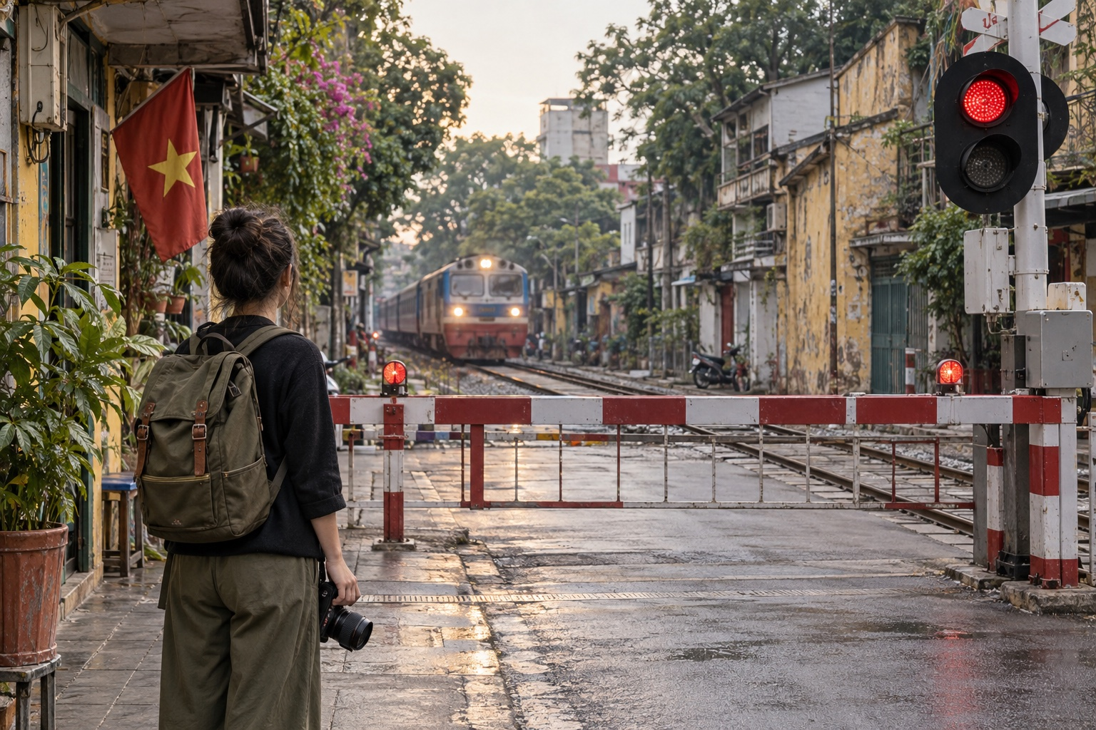
Editorial illustration generated with Codex for TravelFrame. AI-generated image; do not treat it as evidence of current access conditions.

Is Hanoi Train Street Open in 2026?
The safest answer is: do not assume access is available.
Hanoi authorities have repeatedly increased enforcement around the railway corridor. Official city reporting in March 2025 described inspections and penalties for people entering the railway safety area to take photos. In April 2026, local authorities around the Khâm Thiên and Lê Duẩn section announced tighter monitoring, including cameras, and reiterated that tourism businesses must not occupy the railway safety corridor.
Conditions can differ by entrance and can change without notice. A route that appeared open in a recent social post may be closed when you arrive.
Use these rules:
- Stop at every barrier or checkpoint.
- Follow railway staff, police and local security immediately.
- Never climb around a barrier or follow someone through a residential entrance.
- Never stand, sit or place a tripod on the rails.
- Do not treat a drink purchase as permission to ignore an official restriction.
Pro move: plan Train Street as an optional observation stop, not the anchor of your Hanoi day.

Why We Do Not Publish a Fixed Train Street Schedule
Search results are full of minute-by-minute Train Street timetables. Many are copied from older blogs, cafe boards or social posts.
That creates false confidence.
Passenger and freight operations can change because of delays, maintenance and operational decisions. The time printed on a rail ticket or booking page is not a guarantee of the exact minute a train will pass a specific city crossing.
Before going:
- Check current passenger train information through Vietnam Railways or an official ticketing channel.
- Ask your hotel or accommodation to verify local access on the same day.
- Treat any cafe timetable as an estimate.
- Leave if authorities close the area.
If seeing a train is essential to your trip, use a normal public level crossing and remain behind the closed barrier. You may not get the viral close-up angle, but you will get a truthful view of Hanoi's working railway.
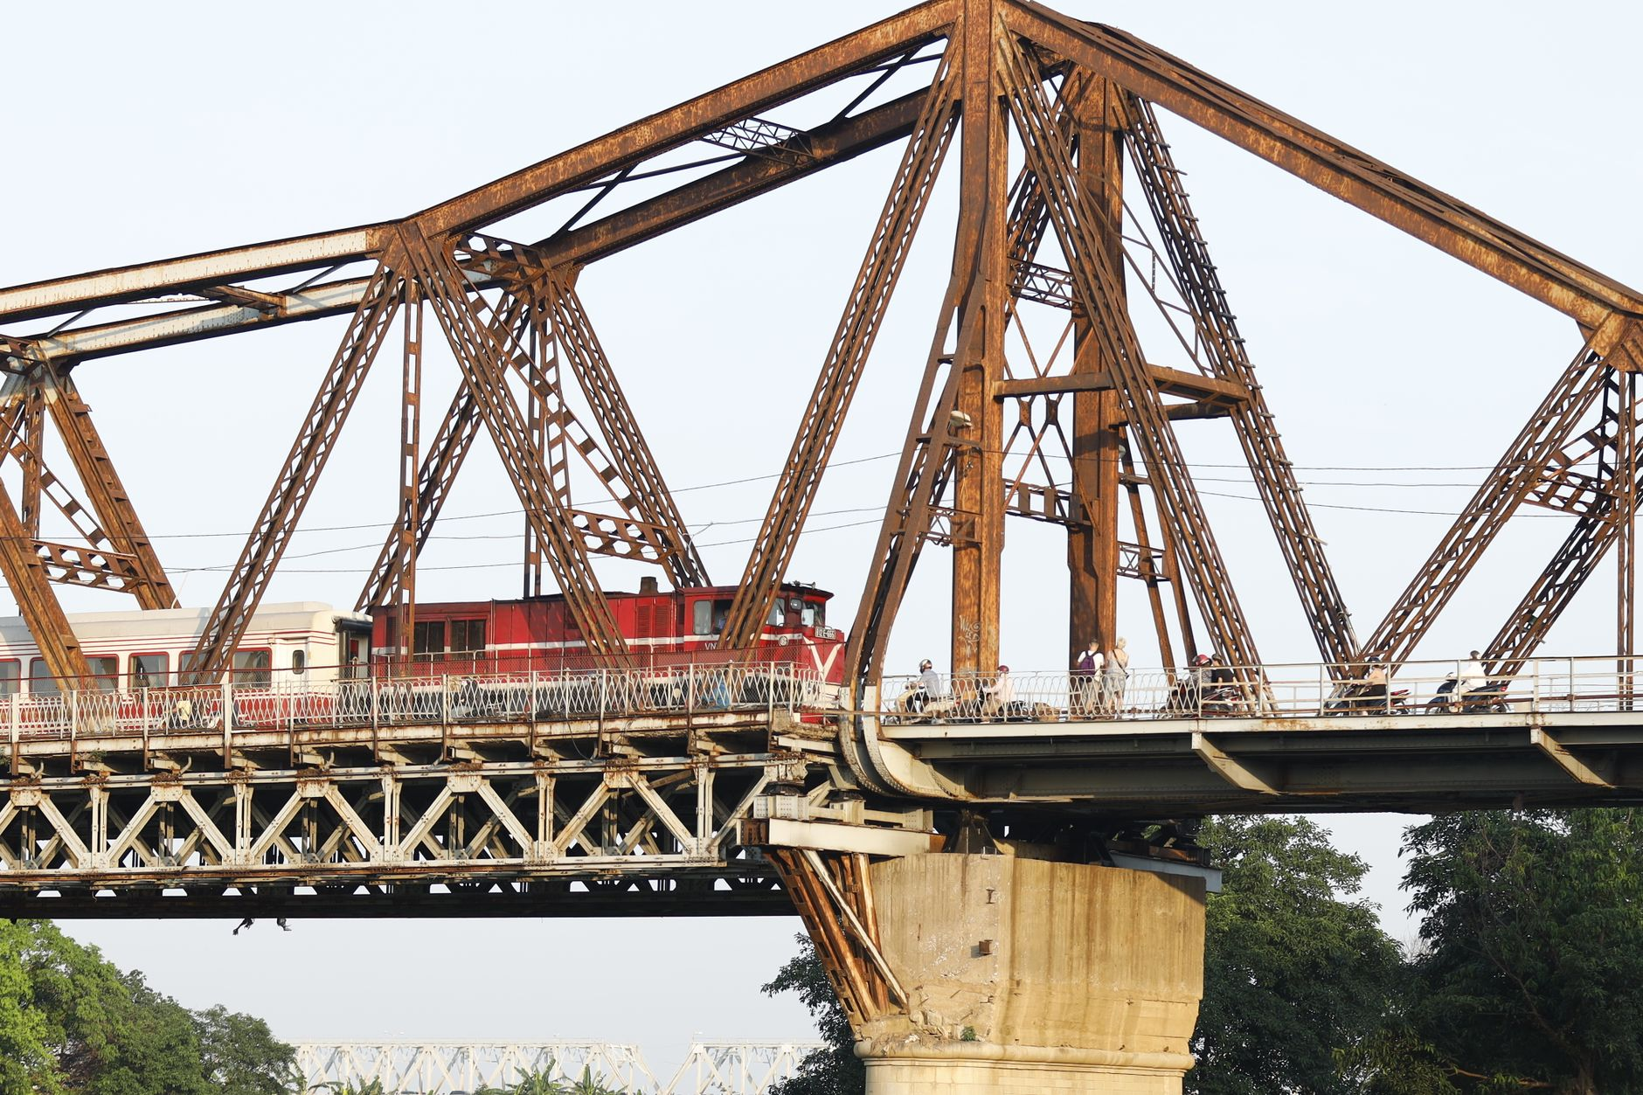
Photo: Nguyễn Hưng / Pexels.

Essential Safety Rules

Stay Outside the Railway Corridor
The rail line is transport infrastructure, not a pedestrian street. Keep your body, phone, camera straps and luggage behind the barrier or marked safety boundary.

Do Not Copy Social Media Behavior
A video may have been filmed before restrictions changed. It may also show unsafe or unauthorized behavior. The fact that someone captured a shot does not make the shot legal or repeatable.

Keep Children Beside You
Children should remain directly supervised and well away from the track. If the area becomes crowded, leave rather than trying to hold your position.

Respect the Neighborhood
People live beside the railway. Keep voices low, do not photograph residents through windows, and ask before taking a close portrait of a person or business.

Leave When Asked
Do not negotiate for one more photo. Do not argue that another visitor was allowed through. A calm exit protects you and reduces pressure on the community.

Three Calmer Ways to Photograph Hanoi's Railway Heritage
These ideas still require normal street awareness. They are alternatives to entering the narrow residential rail corridor, not promises of unrestricted access.

1. Phùng Hưng Mural Street and the Railway Arches
Phùng Hưng offers old masonry, murals and layered streetscape details near the elevated railway. Work from the public pavement and frame the arches, trees and neighborhood activity.
Best approach: arrive in the morning, keep the composition wide and ask before including a vendor or resident as the main subject.

2. Long Biên Bridge Approaches
Long Biên Bridge is one of Hanoi's strongest visual symbols. The iron structure, Red River landscape and nearby market activity create more photographic variety than a single viral alley.
Use designated pedestrian areas and stay separated from the railway line. Conditions on the bridge can be windy and busy, so secure loose clothing and camera straps.
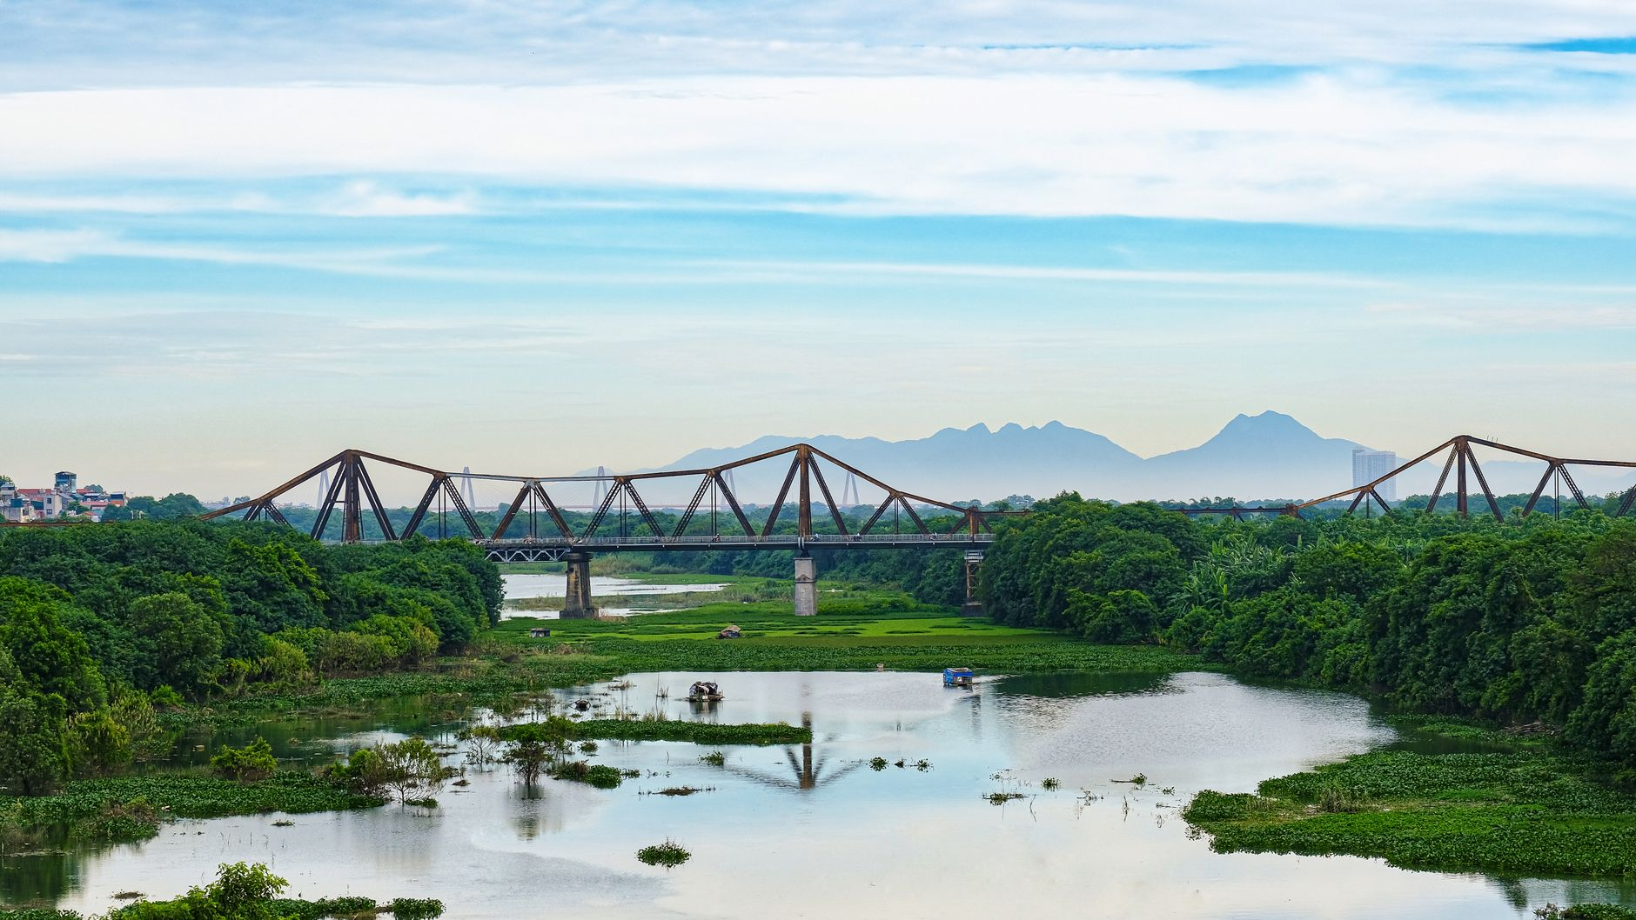
Photo: tu nguyen / Pexels.

3. A Public Level Crossing
A normal public crossing can show the rhythm of Hanoi's railway without requiring anyone to enter the track area. Stand on the pavement behind the barrier and photograph the wider scene: waiting scooters, the warning light and the train moving through the city.
This angle tells a more honest story. It shows how the railway is part of daily Hanoi, not a stage built for visitors.

A Better Hanoi Photo Plan
If Train Street is closed, your day is not ruined. Hanoi has hundreds of visual layers within a short walk:
- Weathered facades and craft streets in the Old Quarter.
- Morning life around Hoàn Kiếm Lake.
- French-era architecture around the Opera House.
- Temple courtyards, with respectful dress and photography.
- Long Biên's iron structure and river landscape.
TravelFrame's working approach is simple: build a flexible walking route around the light, the guest's pace and current local conditions. We do not guarantee Train Street access or place it in a fixed route.
For help planning a private, photo-friendly Hanoi walk, visit TravelFrame (https://travelframe.vn/) or message PHOTO to @travelframe.vn (https://instagram.com/travelframe.vn). Exact routes, inclusions and delivery details are confirmed in writing before booking.

Frequently Asked Questions

Can I enter if a cafe owner invites me?
An invitation does not override a barrier or instruction from authorities. Follow the restriction you see on the day.

Where can I find the current train time?
Check Vietnam Railways or an official rail ticketing channel, then treat the passage time at any particular crossing as approximate. Do not rely only on a blog timetable.

Can I take photos from behind a barrier?
Yes, when you remain in a public area and follow staff instructions. Keep equipment out of the railway corridor and avoid blocking traffic.

Is Train Street included in TravelFrame routes?
No fixed route guarantees Train Street. Any route is adjusted to current access, safety and the guest's confirmed priorities.

Editorial Sources
- Hanoi city report on Train Street enforcement, March 25, 2025: https://cmshn.hanoi.gov.vn/tin-so-nganh/tang-cuong-xu-phat-tuyen-truyen-bao-dam-an-toan-giao-thong-khu-vuc-ca-phe-duong-tau-4250325161459344.htm
- Văn Miếu ward report on railway safety monitoring, April 13, 2026: https://vanmieuquoctugiam.hanoi.gov.vn/linh-vuc-kinh-te-ha-tang-va-do-thi-67678/se-lap-camera-quan-ly-tai-khu-vuc-ca-phe-duong-tau-tren-tuyen-kham-thien-le-duan-2813260415105532541.htm
- TravelFrame canonical safety rules: 06-Safety-And-Verified-Travel-Facts.md

Solo Female Travel in Hanoi: How to Get Natural Photos Without Awkward Posing
SEO article draft with curated Pexels photography and clearly disclosed AI editorial illustration.
SEO slug  /blog/solo-female-traveler-hanoi-photoshoot | Primary keyword  solo female traveler photo tour hanoi
Status  Draft | Audience  International solo female traveler, age 23-40
Meta title  Solo Female Travel Hanoi: Natural Photos Without Awkward Poses | Meta description  A practical Hanoi photo guide for solo female travelers: morning light, comfortable outfits, natural movement prompts, street awareness and local support.

By TravelFrame Editorial Team · Updated September 25, 2026
Traveling solo gives you freedom. Your camera roll does not always reflect it.
You may return from a full day in Hanoi with hundreds of street photos, food photos and screenshots, but only two rushed pictures of yourself. One is a wide-angle selfie. The other was taken by a kind stranger who accidentally cropped out the street.
The answer is not to turn your trip into a fashion shoot. It is to make photography part of the walk.
This guide covers the best light, practical outfits, natural movement prompts and simple safety habits for getting photographs that still feel like you.
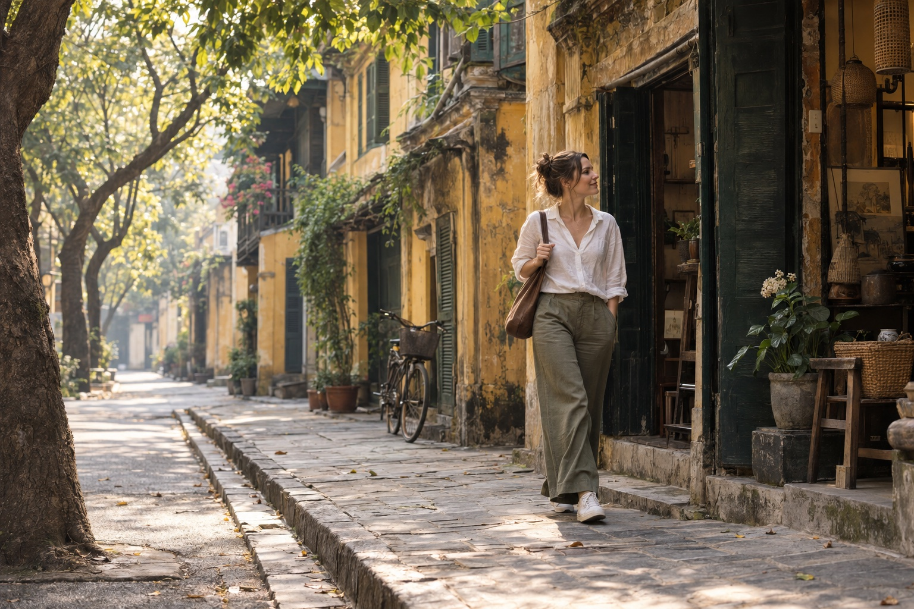
Editorial illustration generated with Codex for TravelFrame. AI-generated image.

Start Early, but Do Not Obsess Over One Exact Time
Early morning is useful because the light is softer and many streets feel less compressed. Hanoi is already awake: people exercise by the lake, breakfast stalls prepare their first bowls, and shops begin opening their shutters.
The best window changes with season and weather. Instead of treating 7:00 AM as a rule, plan to begin around sunrise and adjust for cloud cover, heat and your location.
Morning helps in three ways:
- Softer light: skin tones and textured walls photograph more gently.
- More room: you can move without blocking a busy pavement.
- Less performance pressure: a quieter street makes natural expressions easier.
Pro move: spend the first ten minutes walking and talking without trying to create a perfect frame.

Choose an Outfit You Can Actually Walk In
Hanoi rewards comfortable clothes. Pavements can be uneven, curbs can be high, and scooters may occupy part of the walkway.

Colors That Work Well
Hanoi backdrop | Outfit direction | Why it works
Yellow walls and green shutters | White, ivory, olive or soft blue | Clear contrast without looking staged
Temple courtyards | Modest linen layers and muted colors | Respectful and visually calm
Long Biên Bridge | Cream, navy, rust or denim | Holds detail against iron and open sky
Street cafes | Simple solid colors | Keeps attention on expression and context

Avoid carrying an outfit that requires constant adjustment. A dress that catches on steps or shoes you cannot walk in will change your posture and your mood.
Bring one small accessory, such as a scarf or light overshirt, if you want variety without losing time.

Stop Posing and Start Doing
Most people feel awkward because they are asked to freeze. Movement gives your body a reason to relax.

The Slow Walk
Walk toward the photographer, then pass slightly to one side. Keep your pace steady and look at the street rather than the lens.

The Cafe Pause
Sit where you would genuinely stop. Order something you want to drink. Hold the cup, watch the pavement and continue the conversation.

The Shopfront Look
Pause at a bookstore, flower stall or craft shop. Let your attention rest on a real detail. Ask the owner before photographing inside or making a person the focus of the frame.

The Turn Back
Walk away, then look back after hearing your name. The movement creates a natural shoulder line and expression.

The Quiet Portrait
Not every image needs motion. Stand in open shade, angle your body slightly away from the camera, breathe out and let your hands rest naturally.
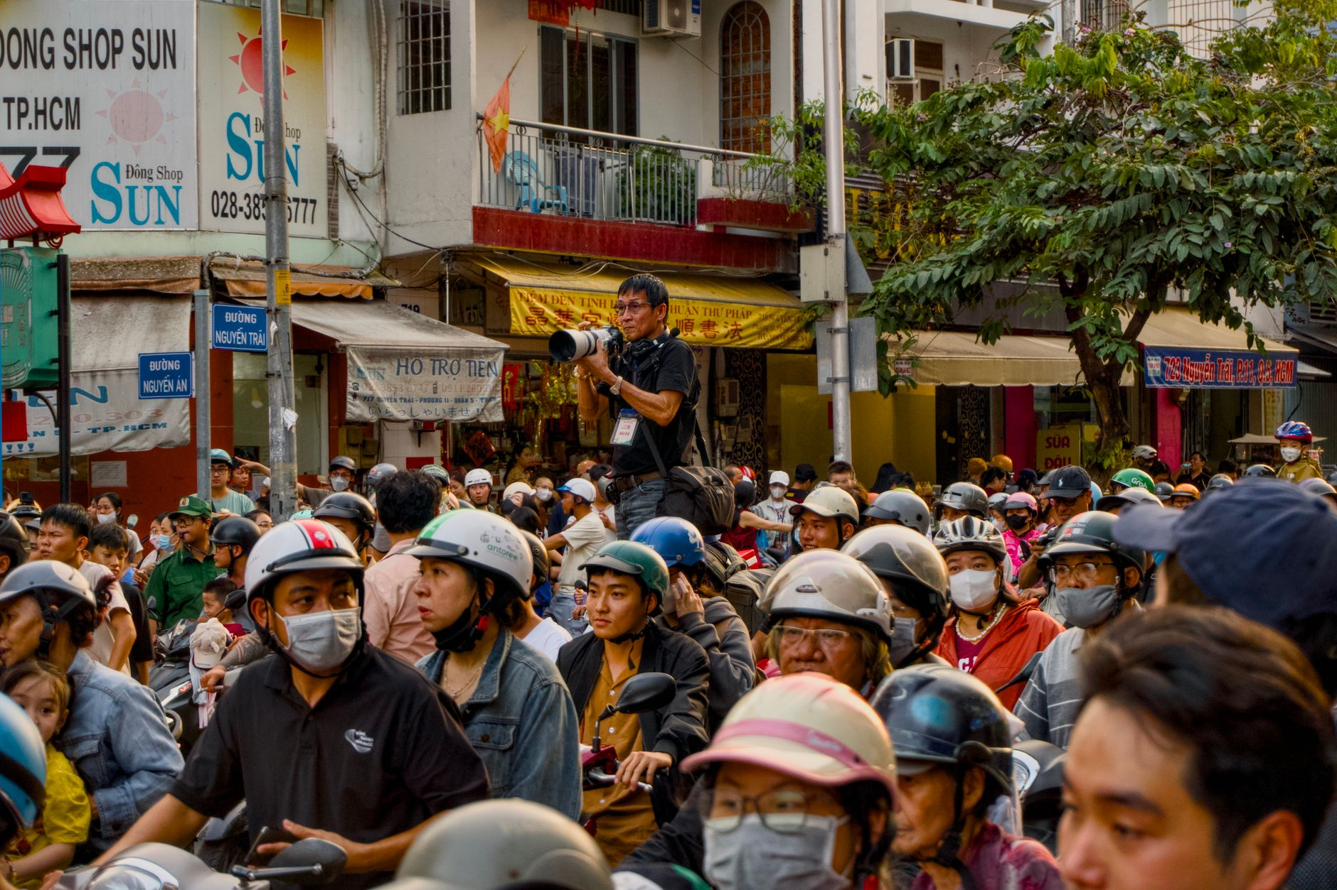
Photo: Tuan Vy / Pexels.

Plan Locations as a Walk, Not a Checklist
Three nearby scenes usually produce a better set of photographs than six locations reached by car.
A simple morning route could combine:
- A quiet Old Quarter street with layered facades.
- A public cafe or courtyard break.
- A wider architectural setting in the French Quarter.
Another route might stay around the Temple of Literature and nearby streets. Dress respectfully, check current visitor rules and avoid blocking entrances or ceremonies.
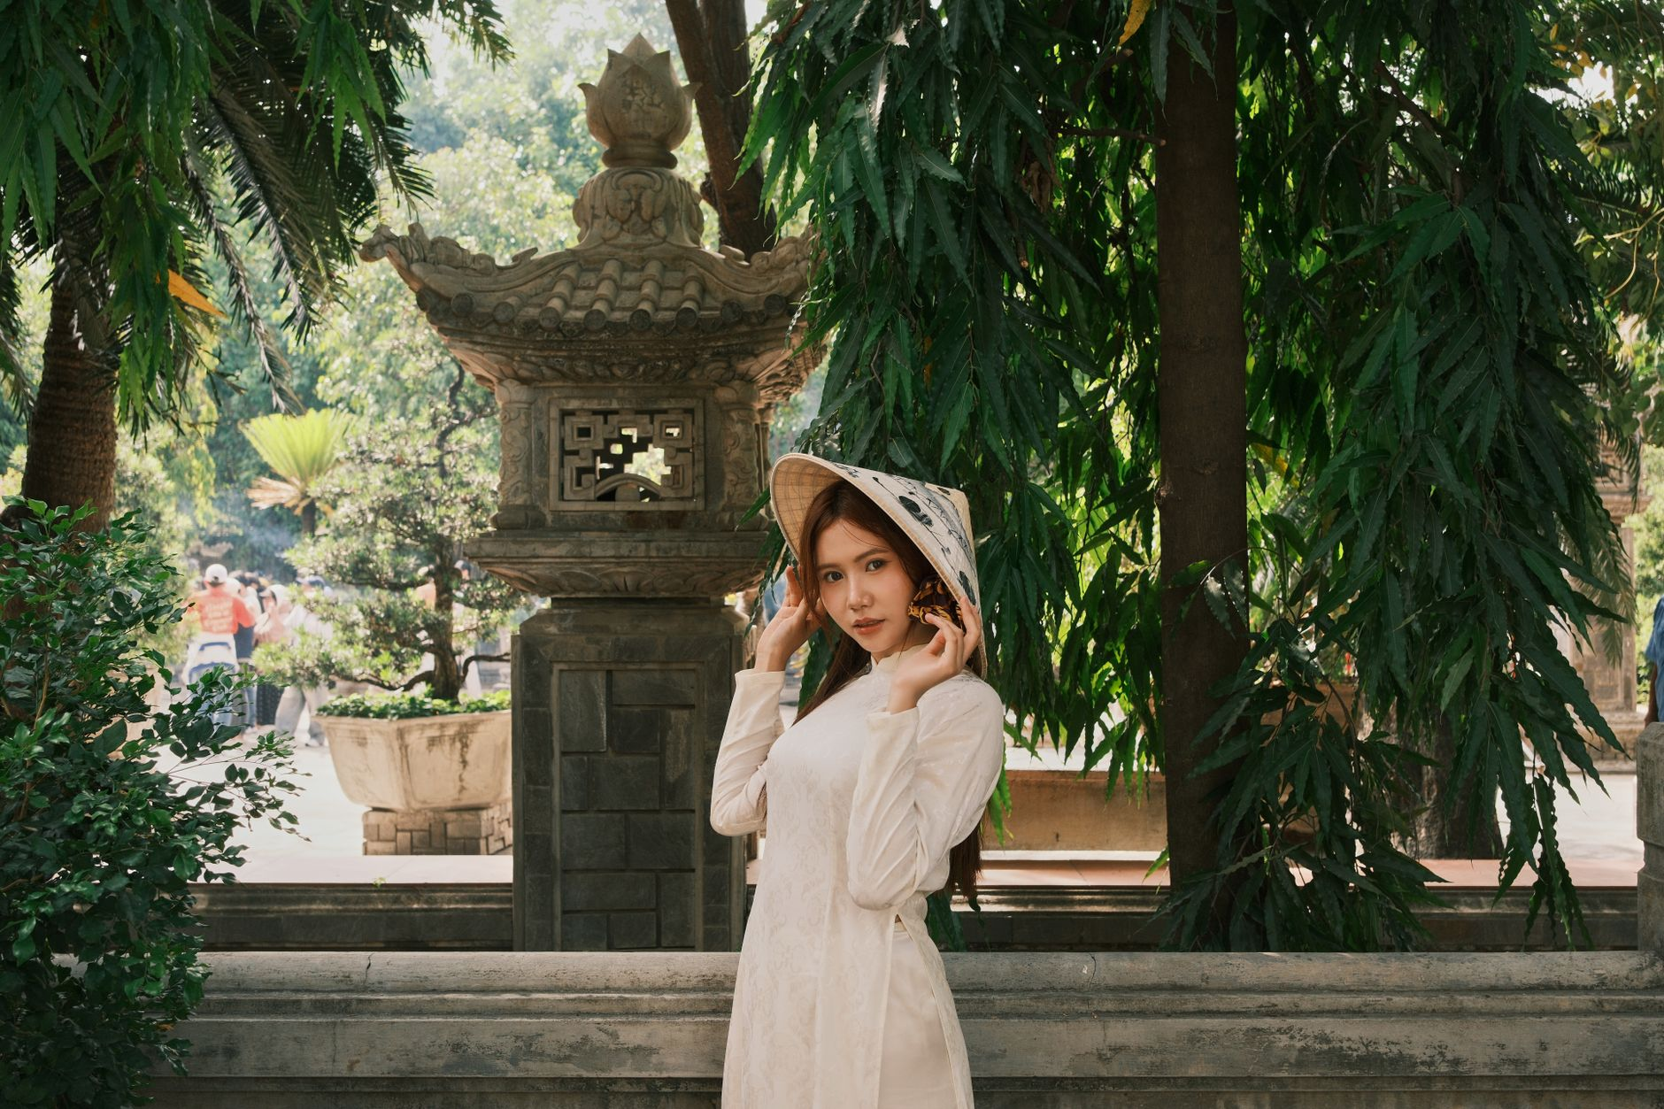
Photo: quang vinh / Pexels. Confirm photography rules at each site before shooting.

Street Awareness for Solo Travelers
Hanoi can feel intense before its traffic patterns become familiar. Use the same practical habits you would use in any large city:
- Keep your phone secure near the road edge.
- Use a zipped crossbody bag.
- Book rides through the app and confirm the vehicle details.
- Avoid placing a tripod where it blocks pedestrians.
- Ask before photographing a vendor, artisan or resident closely.
- Leave a location if the interaction or crowd feels uncomfortable.
When crossing a street, use a marked crossing where available. Move predictably, keep watching traffic and do not step out only because another person waves you forward.
Avoid absolute safety claims. Conditions vary by street, time and individual experience. A local companion can reduce navigation friction, but no guide can guarantee that every environment is risk-free.

When a Local Photo Companion Helps
A private photo walk is useful when you want to remain present instead of managing a tripod, checking every frame and researching each route alone.
TravelFrame's working concept combines:
- A local walking companion.
- Route planning around mood and current conditions.
- Gentle movement and posing guidance.
- Photography as part of the experience.
Package names, duration, price, image count and delivery time are confirmed in writing before booking. We do not publish a promise that has not been operationally approved.
To discuss a solo Hanoi walk, visit TravelFrame (https://travelframe.vn/) or message PHOTO to @travelframe.vn (https://instagram.com/travelframe.vn).

Frequently Asked Questions

What if I always look stiff in photos?
Begin with actions instead of poses. Walking, browsing and holding a drink give your hands and eyes something real to do.

Should I bring a change of clothes?
One comfortable outfit with a light layer is usually more practical for a walking session. Confirm changing options before bringing a second outfit.

What happens if it rains?
Light rain can create reflections and softer light, but the route should follow current weather and safety conditions. Rescheduling or route changes must be agreed for the specific booking.

How do I book a TravelFrame photo walk?
Message PHOTO to @travelframe.vn. The team will confirm the date, route, package, inclusions, delivery terms and image-use permissions in writing.

Editorial Notes
- Tone and content follow TravelFrame's current operating ICP: international solo female travelers seeking local support, confidence and natural visual memories.
- No price, duration, image count, testimonial or delivery SLA is presented as approved commercial truth.
- Pexels photographs include creator attribution. The hero is an AI-generated editorial illustration.

The Slow Hanoi 48-Hour Itinerary: A Calm Two-Day Walking Guide
SEO article draft with curated Pexels photography and clearly disclosed AI editorial illustration.
SEO slug  /blog/slow-hanoi-48-hour-itinerary | Primary keyword  hanoi 2 day itinerary
Status  Draft | Audience  Solo travelers, couples and first-time Hanoi visitors
Meta title  Slow Hanoi 48-Hour Itinerary: A Calm Two-Day Guide | Meta description  A slow Hanoi two-day itinerary with morning walks, Old Quarter craft streets, French Quarter architecture, West Lake and time to pause.

By TravelFrame Editorial Team · Updated September 25, 2026
Many two-day Hanoi itineraries read like a race. They ask you to cross the city repeatedly, eat on command and spend more time checking the clock than noticing where you are.
Hanoi works better in clusters.
Choose one part of the city for each half-day. Walk when the streets invite you to walk. Pause when a cafe, courtyard or conversation becomes more interesting than the next pin on your map.
This 48-hour plan is intentionally spacious. Opening hours, weather and venue access can change, so verify key stops before your visit.
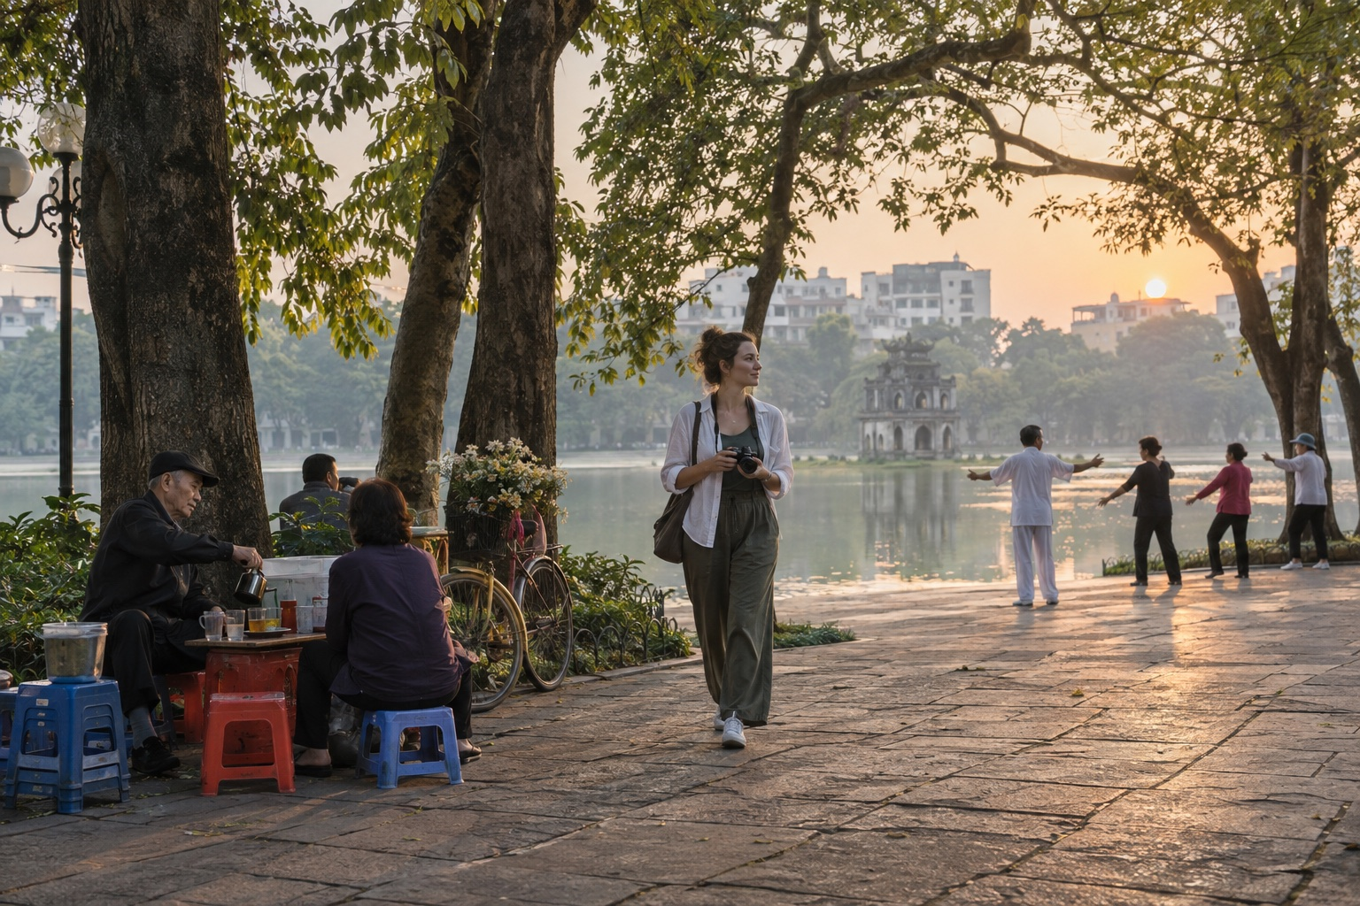
Editorial illustration generated with Codex for TravelFrame. AI-generated image.

Before You Start
Use this itinerary as a rhythm, not a reservation sheet.
- Group nearby places together.
- Keep one rest period each afternoon.
- Check official opening hours for ticketed sites.
- Ask before photographing people closely.
- Use app-based rides when walking between distant clusters.
- Keep sacred spaces quiet and dress respectfully.

Day 1 Morning: Hoàn Kiếm Lake and the Old Quarter

6:45 AM: Begin at Hoàn Kiếm Lake
Walk one gentle loop or choose a quiet section under the trees. You will see exercise groups, breakfast deliveries and the city shifting from dawn into working hours.
Do not rush to photograph everything. Spend ten minutes observing the direction of the light and the flow of pedestrians.
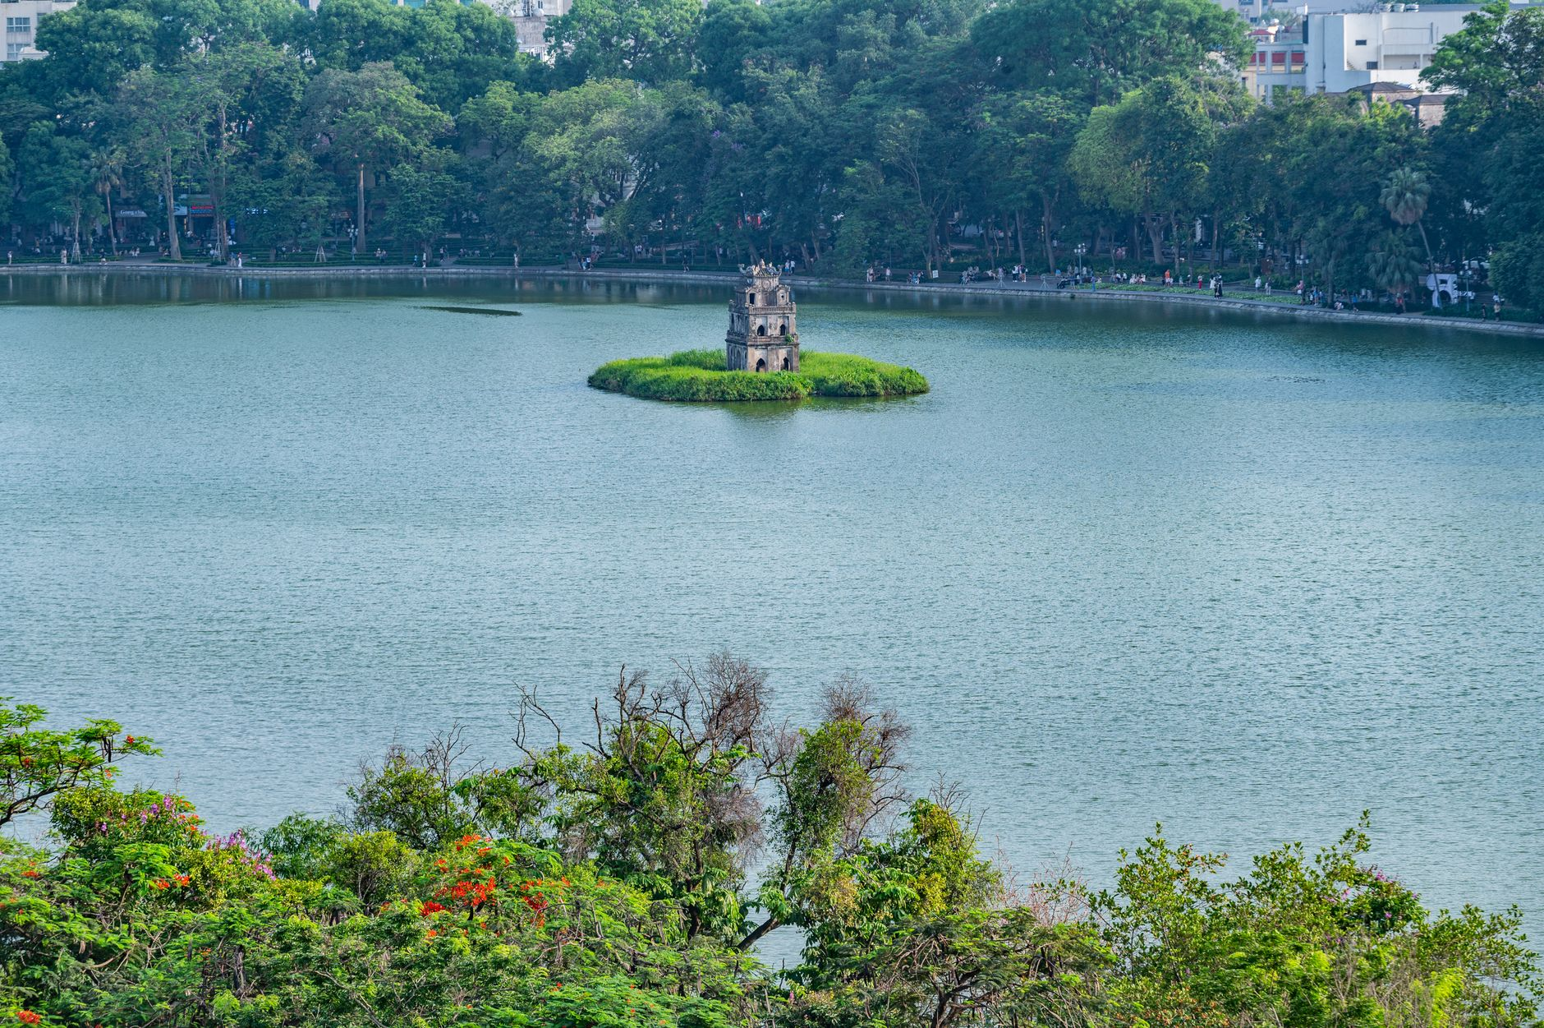
Photo: Nguyen Ngoc Tien / Pexels.

7:45 AM: Eat a Local Breakfast
Choose a busy, clean stall or restaurant near your route. Phở is an obvious choice, but bánh cuốn, xôi and bún riêu can be equally good morning options.
Ask for the price before ordering when a menu is not displayed. TravelFrame's last canonical snapshot listed street phở at an indicative 40,000-65,000 VND on September 6, 2026. Treat that range as dated guidance, not a tariff.
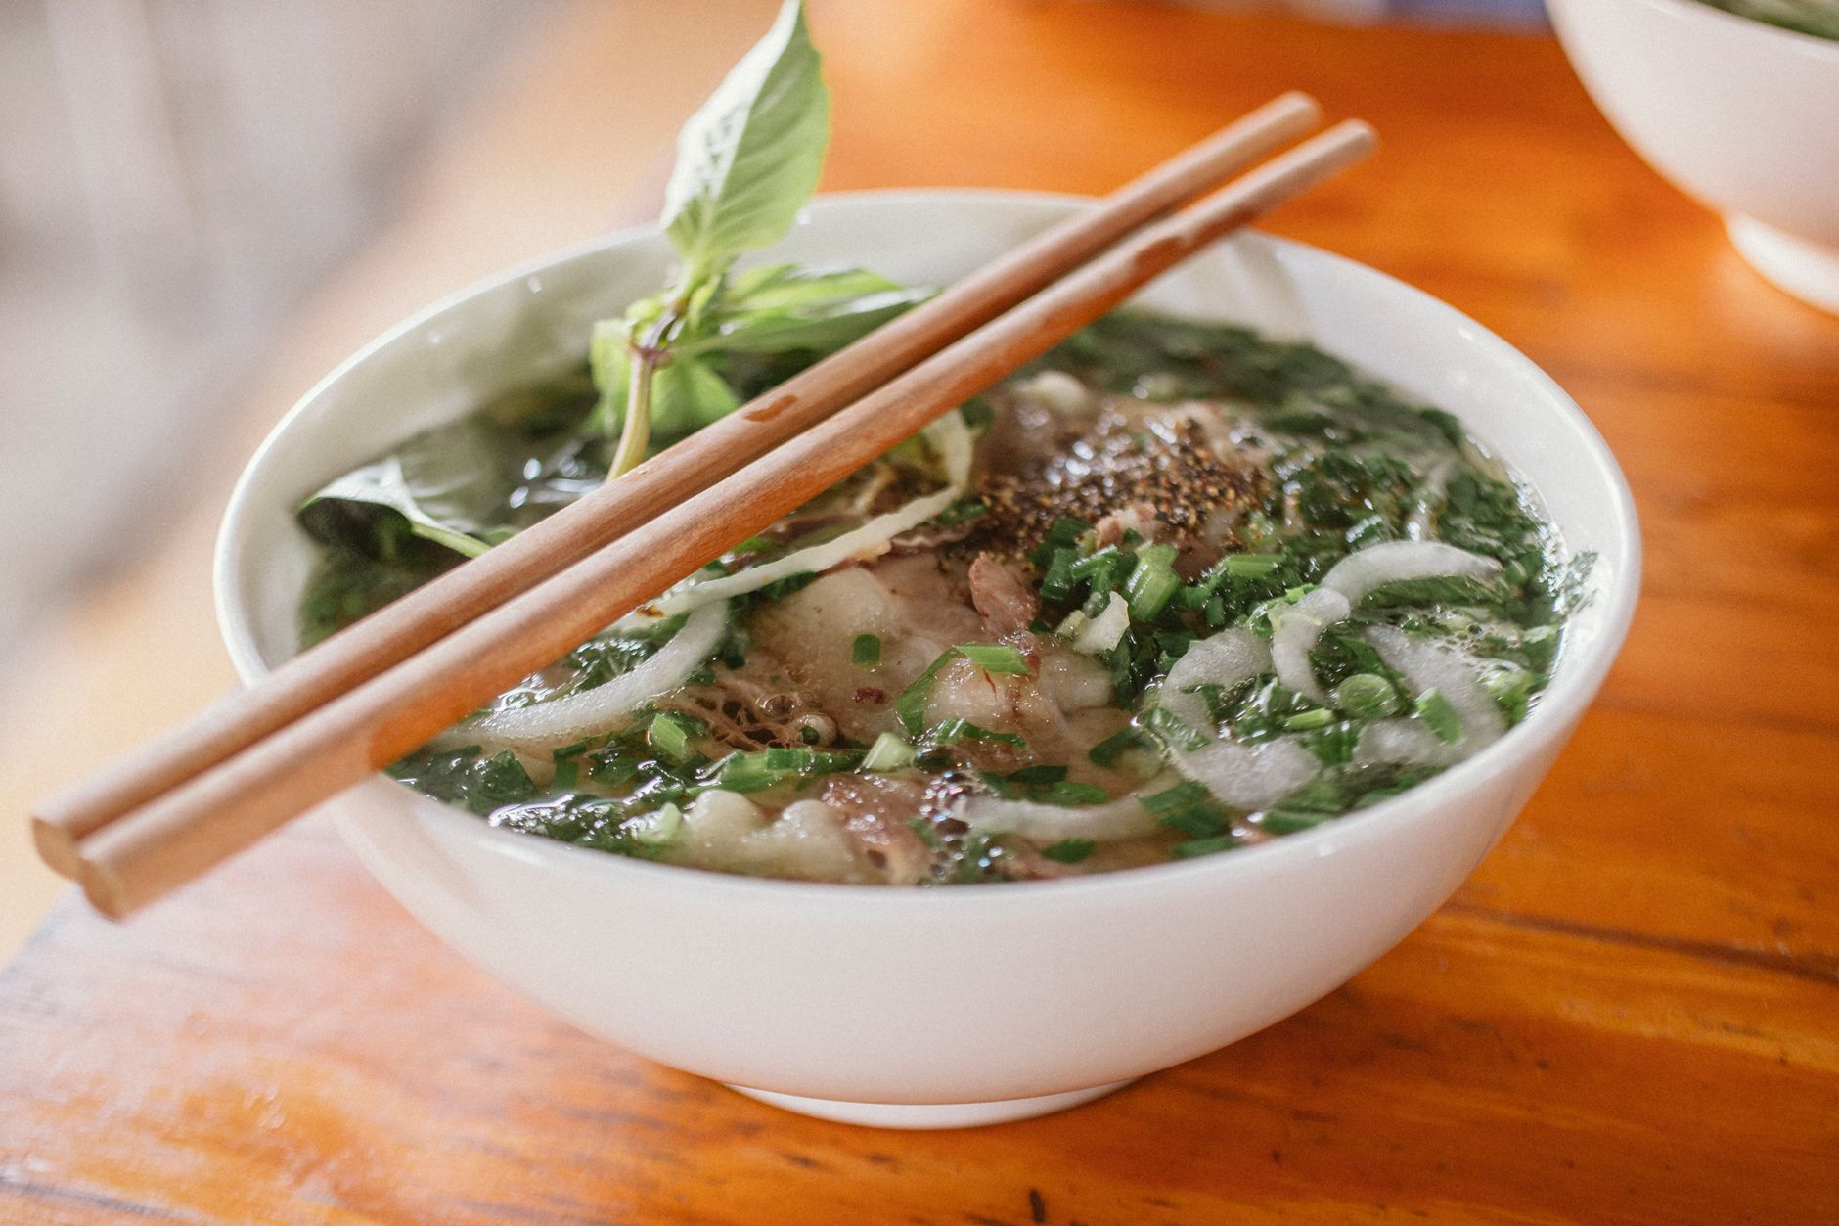
Photo: Nam Phong Bùi / Pexels.

9:00 AM: Walk the Craft Streets
Move through two or three streets rather than trying to cover the entire Old Quarter.
Look for silverwork around Hàng Bạc, woven goods, paper products, old shop signs and the narrow rhythm of tube-house facades. Many businesses are active workplaces. Ask before stepping inside with a camera.

11:00 AM: Take a Cafe Pause
Choose a cafe because it feels comfortable, not because it appears on every list. A balcony gives you a wider street view. A ground-floor shop gives you closer contact with the neighborhood rhythm.

Day 1 Afternoon: French Quarter at a Slower Pace

2:30 PM: Start Near the Opera House
The French Quarter offers wider pavements and more open compositions than the Old Quarter. Walk around the Opera House, nearby gardens and public streets with preserved facades.
Some buildings are hotels, offices or diplomatic properties. Photograph from public space and respect security signs.

4:30 PM: Rest
Return to your accommodation. Shower, back up your photos and stop making decisions for an hour.
This pause is part of the itinerary. Hanoi's heat, humidity and traffic can make a full day feel longer than the map suggests.

6:30 PM: Dinner Within One Neighborhood
Choose a dinner area you can explore on foot after eating. Bún chả, bánh cuốn and chả cá are strong Hanoi options. Confirm ingredients if you have allergies or dietary restrictions.
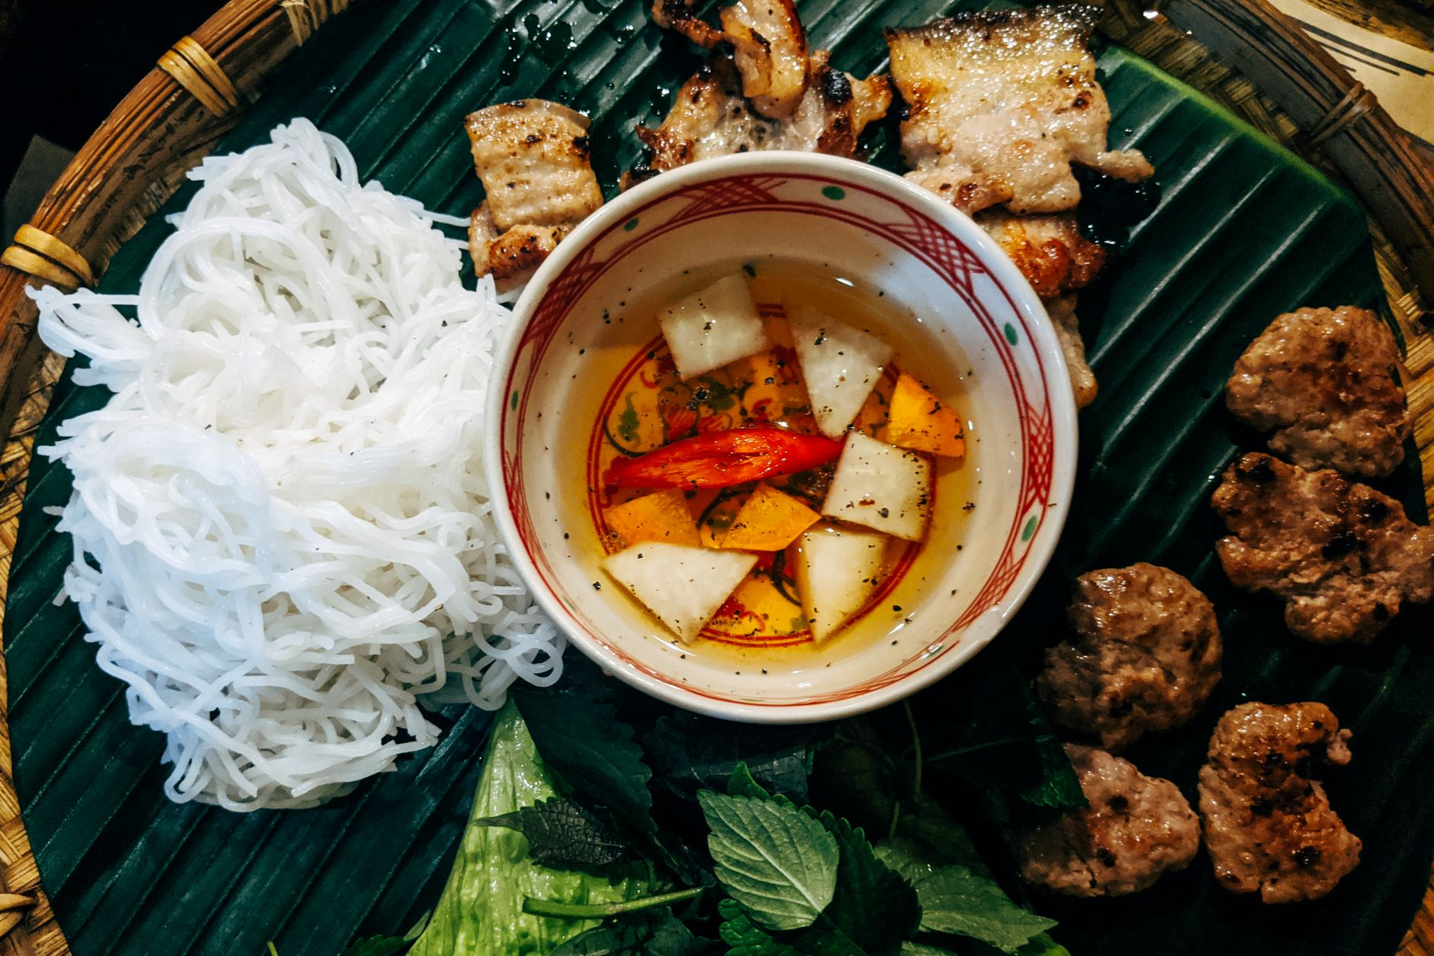
Photo: Markus Winkler / Pexels.

Day 2 Morning: West Lake and a Sacred-Space Visit

7:00 AM: Walk a Short West Lake Section
West Lake is large. Do not try to walk the full perimeter during a two-day visit.
Choose one section and enjoy the open air, water and neighborhood cafes. Use a ride-hailing app to reach the area and confirm the vehicle before boarding.

8:00 AM: Visit Trấn Quốc Pagoda Respectfully
Check current access before leaving your hotel. Cover shoulders and knees, lower your voice, and avoid photographing worshippers closely.
The purpose of the stop is not to collect a perfect temple portrait. Give the place time before taking out your camera.

9:30 AM: Tea or a Quiet Breakfast
Lotus tea is associated with West Lake, but product quality and seasonality vary. Choose a reputable tea house and ask what is being served rather than assuming every cup is locally scented lotus tea.

Day 2 Afternoon: Temple of Literature and Long Biên

2:00 PM: Temple of Literature
The Temple of Literature gives you a slower sequence of gates, courtyards and garden spaces. The official visitor website should be checked for current hours, ticket information and special events before you go.
Move through the site quietly. Keep pathways open and avoid directing a long portrait session in a crowded ceremonial area.

4:30 PM: Choose Your Final Scene
Pick one of these options based on weather and energy:
- Long Biên approaches: iron structure, river landscape and late-day light.
- Phùng Hưng area: railway arches, murals and neighborhood textures.
- Hoàn Kiếm return: an easy final loop with dinner nearby.
On Long Biên Bridge, use designated pedestrian space, secure loose items and remain separated from the railway.

How to Keep the Itinerary Flexible

Rain
Move the architecture walk under covered arcades or into a cafe. Do not force a bridge or lakeside plan during unsafe weather.

Heat
Begin earlier, carry water and protect the afternoon rest period.

Crowds
Skip the photograph rather than blocking an entrance or turning a worship space into a set.

Low Energy
Remove one cluster. A slow itinerary only works when you are willing to see less.

Add Photography Without Turning the Trip Into a Shoot
The easiest place for a private photo walk is Day 1 morning, when the route already moves through varied Old Quarter and French Quarter textures.
TravelFrame's working experience combines a local companion, route planning, gentle posing support and photography. Exact package, duration, delivery and price are confirmed in writing.
Visit TravelFrame (https://travelframe.vn/) or message PHOTO to @travelframe.vn (https://instagram.com/travelframe.vn) to discuss current options.

Frequently Asked Questions

Is 48 hours enough for Hanoi?
It is enough for a thoughtful introduction to the historic center and one wider neighborhood cluster. It is not enough to see every major attraction.

How should I travel between the Old Quarter and West Lake?
An app-based car is often the simplest option. Check the estimated fare in the app, confirm the vehicle and allow extra time for traffic.

What should I book in advance?
Confirm accommodation and any essential ticketed experience. Re-check official hours for museums, heritage sites and performances near the visit date.

Is this itinerary suitable for solo female travelers?
The route uses central, well-known areas and leaves daylight for most walking. Individual comfort and street conditions vary, so use normal city precautions and adjust any stop that feels uncomfortable.

Editorial Sources
- Official Temple of Literature visitor information: https://vanmieu.gov.vn/fr/visitor-information
- TravelFrame canonical product and guest-experience source: 03-Product-And-Guest-Experience.md
- TravelFrame canonical safety and dated price source: 06-Safety-And-Verified-Travel-Facts.md

