Project 2 Design Figures (Report-Ready Draft)
StockFlow Inventory Management System - COMP603/ENSE600 Project 2
The document contains four figures: Figure 1 (use-case diagram), Figure 2 (final class diagram), Figure 3 (entity-relationship diagram of the Derby schema) and Figure 4 (MVC and layered architecture). The PNG files and the reproducible Pillow generator are in docs/design/. The class diagram and the ER diagram are checked against the built code and src/main/resources/db/schema.sql; the use-case model is checked against the GUI tabs, controllers and service methods.
Figures in this document
Figure 1 - Use-case diagram (Project 2 scope, UC-01 to UC-18)
Figure 2 - Final class diagram (ui, service, dao, model)
Figure 3 - Entity-relationship diagram of the embedded Derby database
Figure 4 - MVC and layered architecture with the design patterns
Figure 1 - Use case diagram
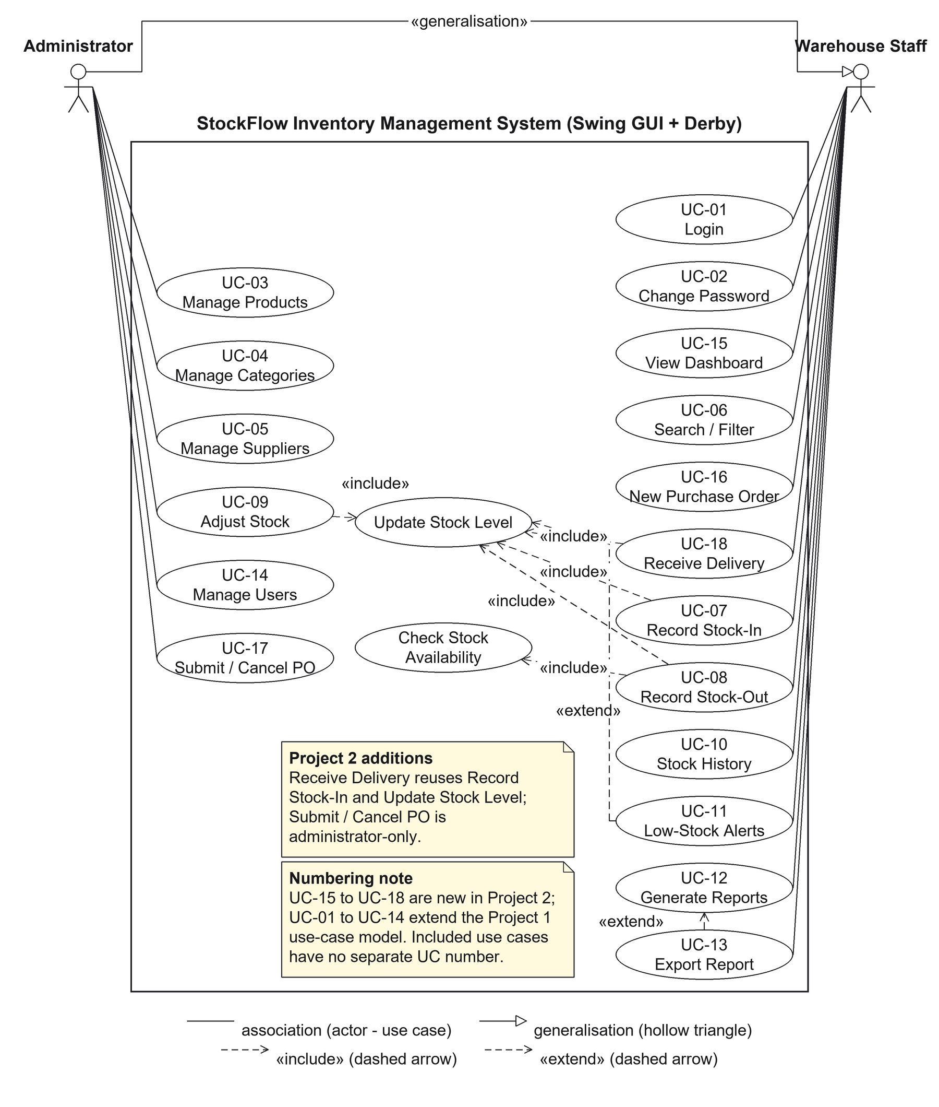
Figure 1: Use-case diagram for the Project 2 StockFlow system (UC-15 to UC-18 are the Project 2 additions).
Recommended placement: Section 3 (Software Design), use-case subsection; the model extends the Project 1 use cases with UC-15 to UC-18. See docs/design/README.md for the full relationship notes.
Figure 2 - Final class diagram
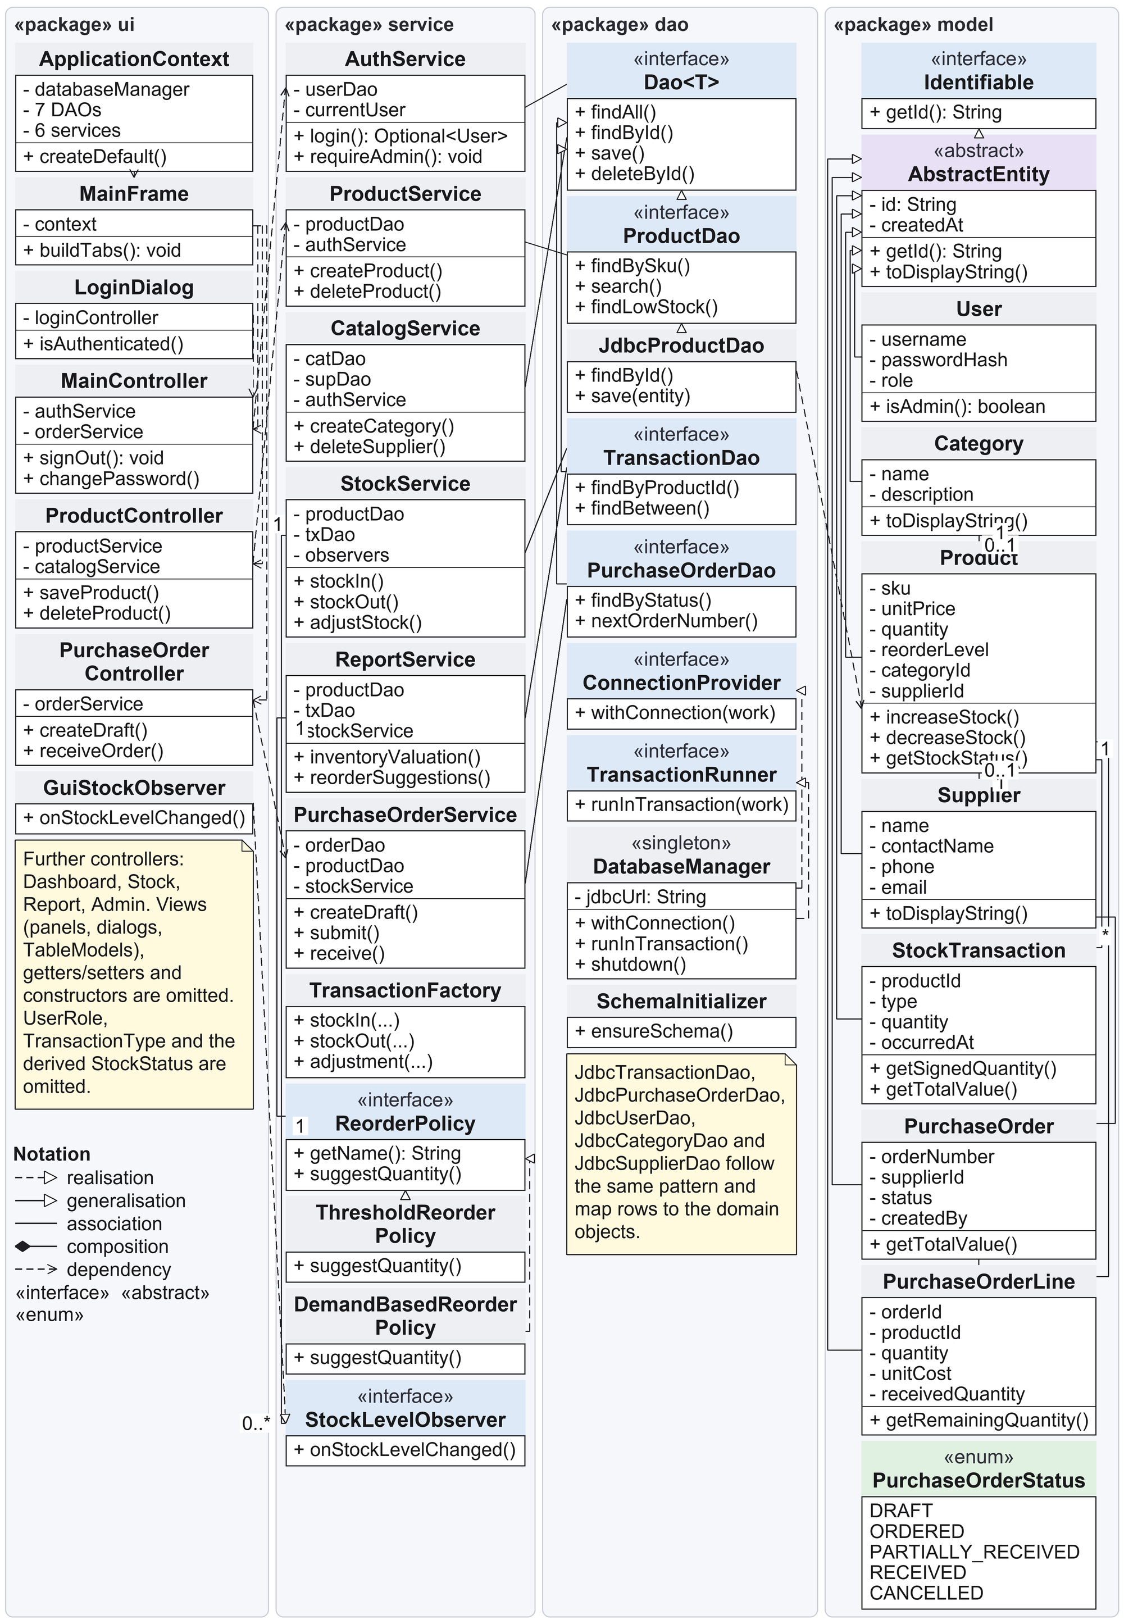
Figure 2: Final class diagram of the Project 2 design (MVC layer, service layer, JDBC DAO layer and domain model).
Recommended placement: Section 3, class/design subsection (replaces the Project 1 iteration-2 class diagram). See docs/design/README.md for the suggested design-evolution paragraph.
Figure 3 - Entity-relationship diagram
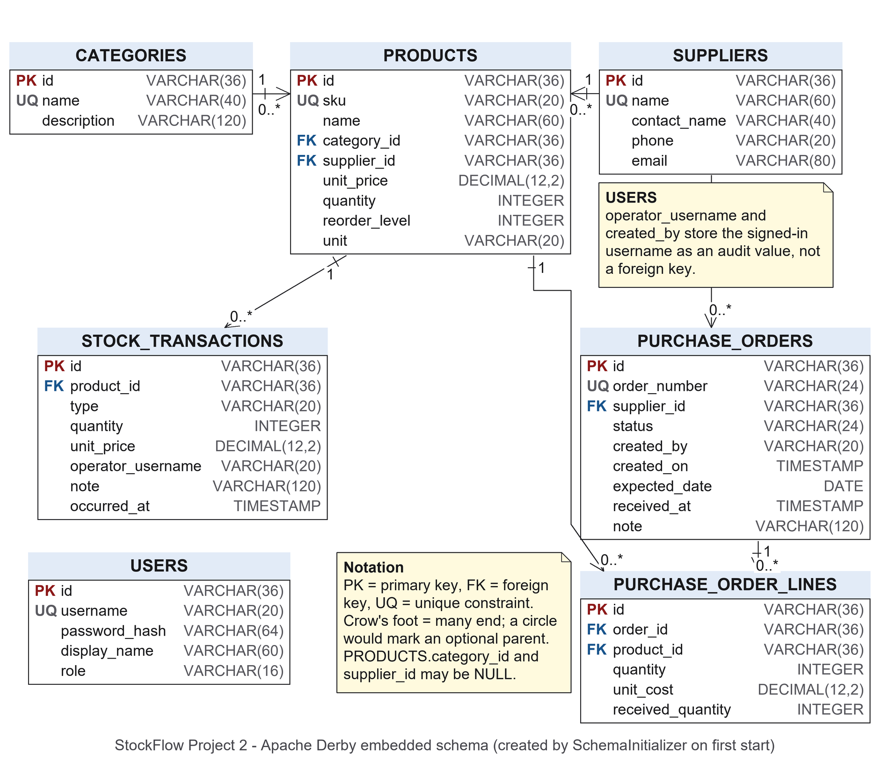
Figure 3: Entity-relationship diagram of the embedded Apache Derby database (seven tables).
Recommended placement: new Database-design subsection (Component 2.2), next to src/main/resources/db/schema.sql and the DAO tests. See docs/design/README.md for the key/cardinality notes.
Figure 4 - MVC and layered architecture
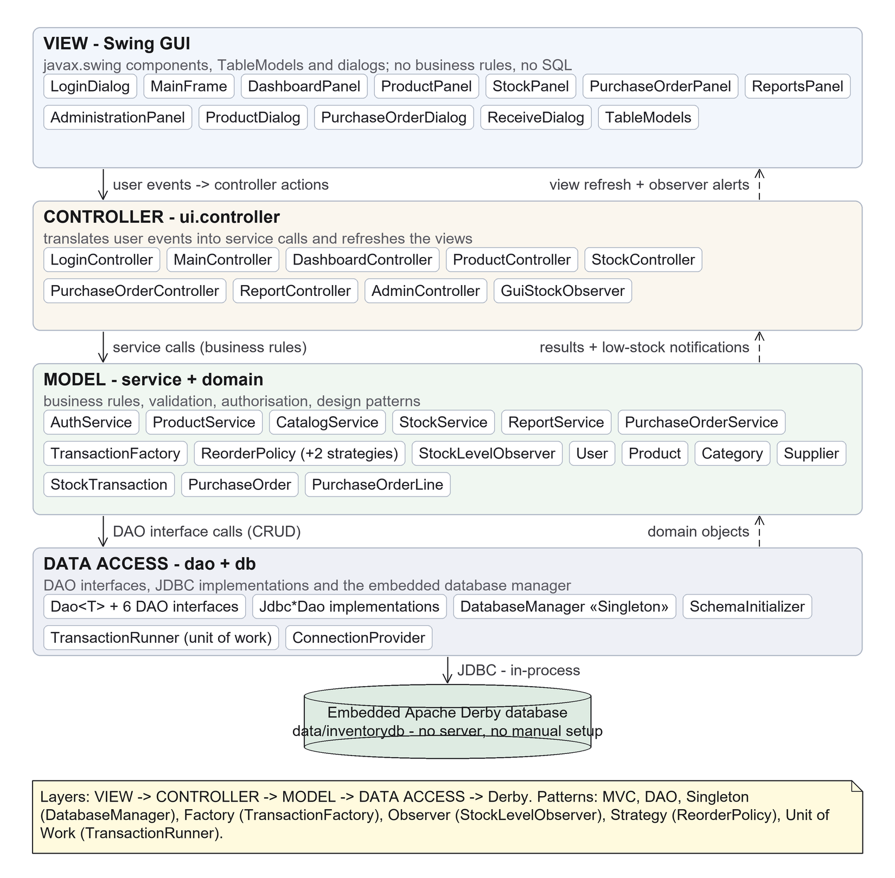
Figure 4: MVC and layered architecture of the Project 2 system with the design patterns used in each layer.
Recommended placement: Architecture subsection (Component 2.3.2); the note at the bottom of the figure maps MVC, DAO, Singleton, Factory, Observer, Strategy and Unit of Work to the classes.

