1. **Draw pentagon**

**Input**

Source code:

import cTurtle

myTurtle=cTurtle.turtle()

def drawPolygon(myTurtle,sideNumber,sideLength):

for i in range(sideNumber):

myTurtle.right(360/sideNumber)

myTurtle.forward(sideLength)

Shell:

Draw pentagon

>>> drawPolygon(myTurtle, 5, 100)

**Output:**

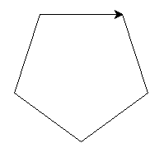

1. **Draw 7-gons**

**Input**Source code:

import cTurtle

myTurtle=cTurtle.Turtle()

def drawPolygon(myTurtle,sideNumber,sideLength):

for i in range(sideNumber):

myTurtle.right(360/sideNumber)

myTurtle.forward(sideLength)

Shell:

>>> import cTurtle

>>> myTurtle=cTurtle.Turtle()

>>> drawPolygon(myTurtle, 7, 100)

**Output**

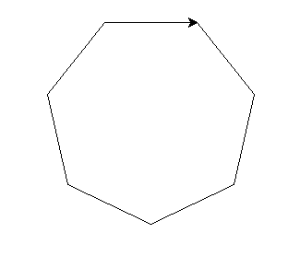

1. **Draw three circles:**

Source:

import cTurtle

import math

myTurtle=cTurtle.Turtle()

def drawCircle(myTurtle,radius):

forward=radius*2*math.pi/100

myTurtle.up()

myTurtle.left(90)

myTurtle.forward(radius)

myTurtle.right(90)

myTurtle.down()

for i in range(100):

myTurtle.right(360/100)

myTurtle.forward(forward)

myTurtle.up()

myTurtle.right(90)

myTurtle.forward(radius)

myTurtle.left(90)

def drawThreeCircle(myTurtle,radius):

myTurtle.right(30)

myTurtle.up()

myTurtle.forward(radius/math.sqrt(3))

drawCircle(myTurtle,radius)

myTurtle.backward(radius/math.sqrt(3))

myTurtle.left(120)

myTurtle.forward(radius/math.sqrt(3))

drawCircle(myTurtle,radius)

myTurtle.backward(radius/math.sqrt(3))

myTurtle.left(120)

myTurtle.forward(radius/math.sqrt(3))

drawCircle(myTurtle,radius)

myTurtle.backward(radius/math.sqrt(3))

Shell:

>>> drawThreeCircle (myTurtle,100)

**Output**

