DAC Lab – Creating a Shared Group Directory (sales)

Objective
Establish a group 'sales' and add users 'mimi', 'mrgray', and 'mommy'. Set up shared directory '/sales' and apply ACL to control access.

Phase 1 – Create sales group
Explanation:
In this phase, a new group named sales is created. This group will be used to manage access permissions collectively for users who need to share resources within the same department. By assigning users to a common group, we can simplify permission management.

sudo groupadd sales
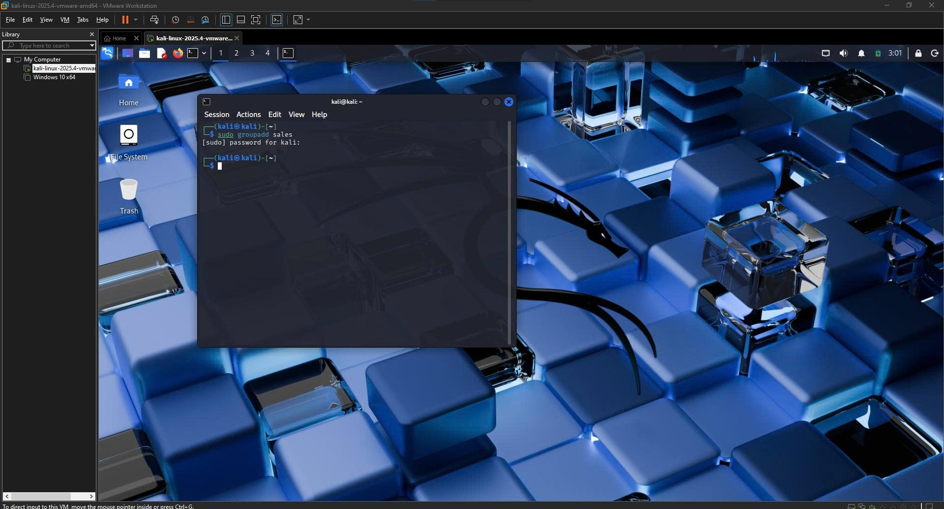

Phase 2 – Create users
Explanation:
Three users (mimi, mrgray, and mommy) are created and added to the sales group. This ensures that all users belong to the same group and can access shared resources according to group-based permissions.
sudo useradd -m -G sales mimi
sudo useradd -m -G sales mgray
sudo useradd -m -G sales mommy
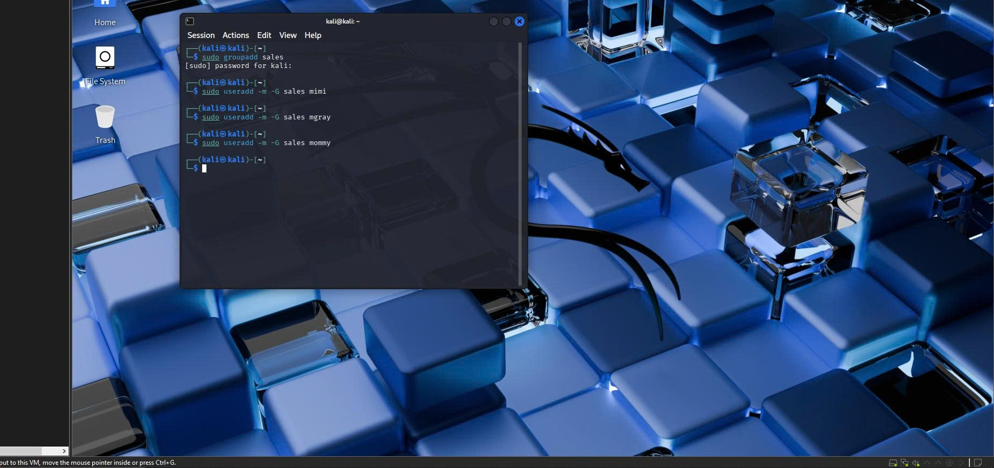

Phase 3 – Set passwords
Explanation:
Passwords are assigned to each user account to enable login. This step ensures that each user can authenticate and access the system using their own credentials.
sudo passwd mimi
sudo passwd mgray
sudo passwd mommy
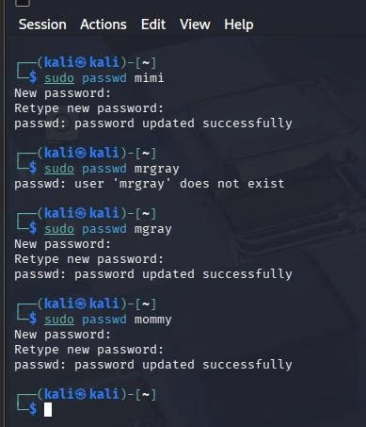

Phase 4 – Create shared directory
Explanation:
A shared directory /sales is created and assigned to the sales group. The SGID permission is applied so that all files created within the directory inherit the group ownership. This ensures consistent group-based access control.

sudo mkdir /sales
sudo chown nobody:sales /sales
sudo chmod 3770 /sales
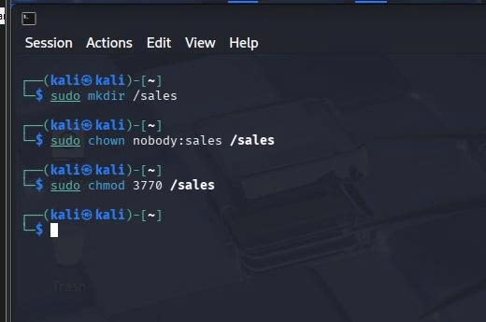

Phase 5 – mimi creates file
Explanation:
User mimi logs into the system and creates a file inside the shared directory. This file will later be used to demonstrate how the owner can control access permissions for other users.
su - mimi
cd /sales
echo "This file belongs to Mimi" > mimi_file.txt
ls -l

Phase 6 – Apply ACL
Explanation:
The file permission is restricted so that only the owner has full access. Then, an Access Control List (ACL) entry is added to grant read permission specifically to user mrgray. This demonstrates discretionary access control where the file owner decides who can access the resource.
chmod 600 mimi_file.txt
setfacl -m u:mrgray:r mimi_file.txt
getfacl mimi_file.txt
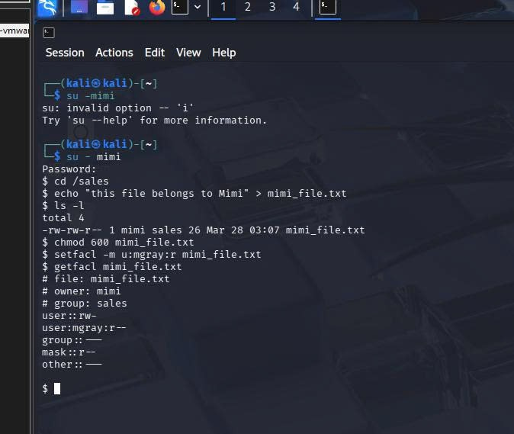

Phase 7 – Test mrgray
Explanation:
User mrgray attempts to read the file. Since he has been granted read permission via ACL, the access is successful. This confirms that the ACL configuration works correctly.
su - mrgray
cd /sales
cat mimi_file.txt

Phase 8 – Test mommy
Explanation:
User mommy attempts to access the file. Since no permission was granted to this user, access is denied. This demonstrates that only explicitly authorized users can access the resource.
su - mommy
cd /sales
cat mimi_file.txt
Expected: Permission denied
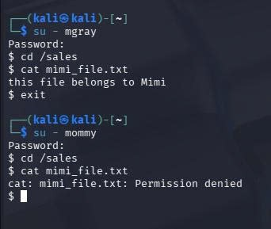

Conclusion
Owner mimi grants read access to mrgray using ACL while mommy is denied. This demonstrates Discretionary Access Control.

