Bài 1:

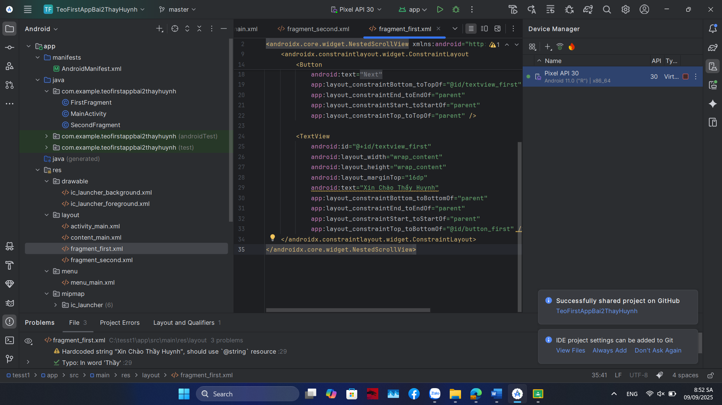

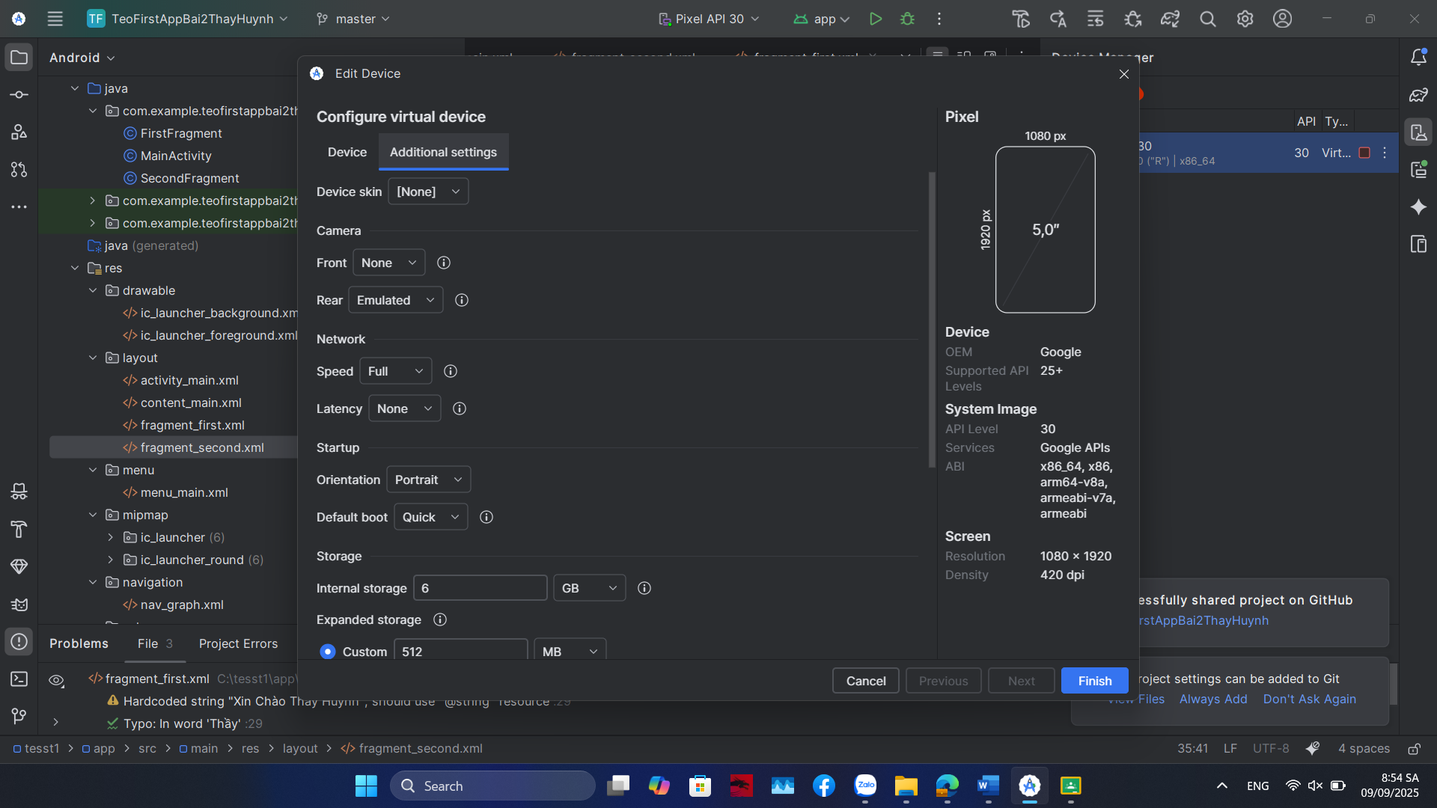

Bài 2

Soure Code

<?xml version="1.0" encoding="utf-8"?>  
<androidx.core.widget.NestedScrollView xmlns:android="http://schemas.android.com/apk/res/android"  
 xmlns:app="http://schemas.android.com/apk/res-auto"  
 xmlns:tools="http://schemas.android.com/tools"  
 android:layout_width="match_parent"  
 android:layout_height="match_parent"  
 tools:context=".FirstFragment">  
  
 <androidx.constraintlayout.widget.ConstraintLayout  
 android:layout_width="match_parent"  
 android:layout_height="match_parent"  
 android:padding="16dp">  
  
 <Button  
 android:id="@+id/button_first"  
 android:layout_width="wrap_content"  
 android:layout_height="wrap_content"  
 android:text="@string/next"  
 app:layout_constraintBottom_toTopOf="@id/textview_first"  
 app:layout_constraintEnd_toEndOf="parent"  
 app:layout_constraintStart_toStartOf="parent"  
 app:layout_constraintTop_toTopOf="parent" />  
  
 <TextView  
 android:id="@+id/textview_first"  
 android:layout_width="wrap_content"  
 android:layout_height="wrap_content"  
 android:layout_marginTop="16dp"  
 android:text="Xin Chào Thầy Huynh"  
 app:layout_constraintBottom_toBottomOf="parent"  
 app:layout_constraintEnd_toEndOf="parent"  
 app:layout_constraintStart_toStartOf="parent"  
 app:layout_constraintTop_toBottomOf="@id/button_first" />  
 </androidx.constraintlayout.widget.ConstraintLayout>  
</androidx.core.widget.NestedScrollView>

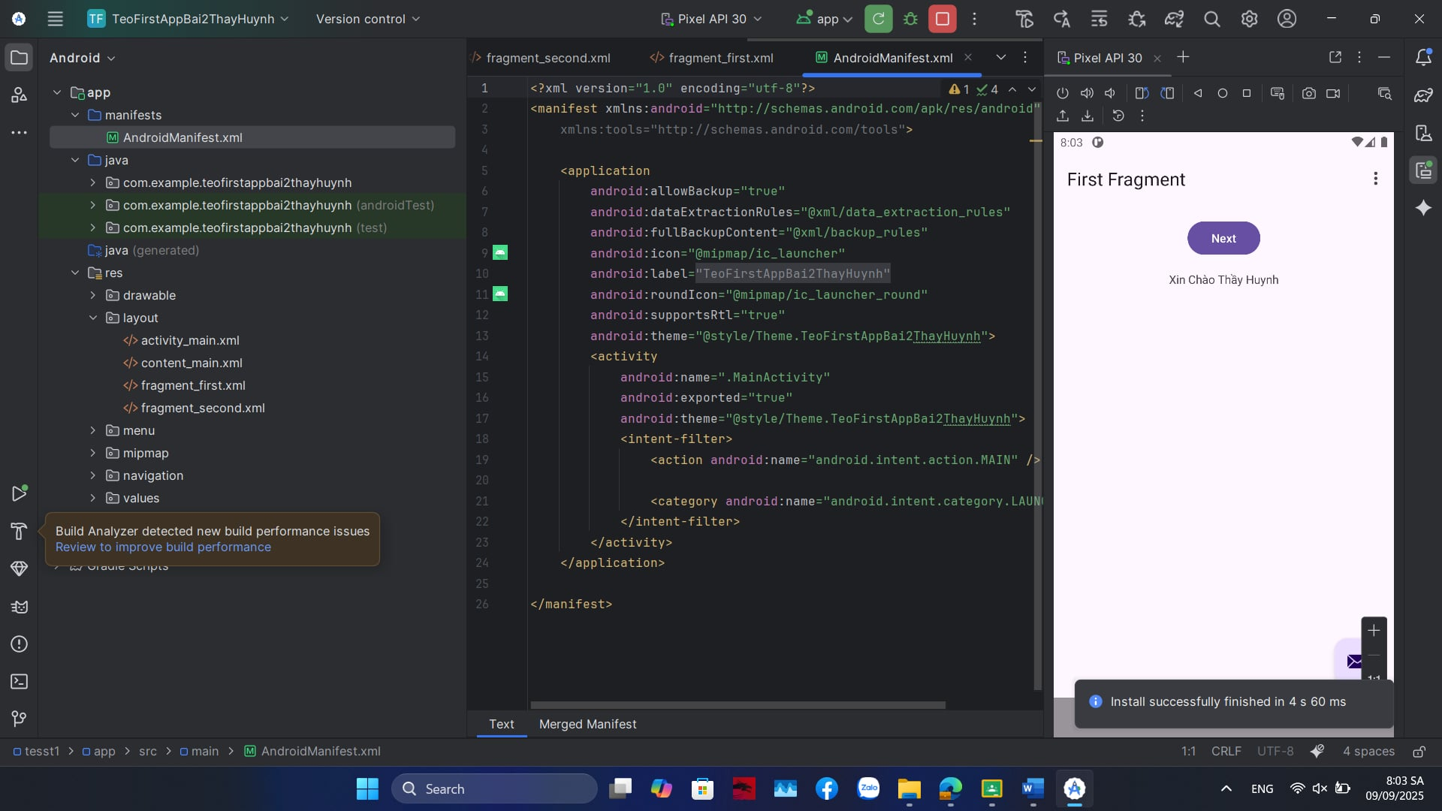

Link github: [huyvo130900/TeoFirstAppBai2ThayHuynh](https://github.com/huyvo130900/TeoFirstAppBai2ThayHuynh)