Lab 3

**RelativeLayout**

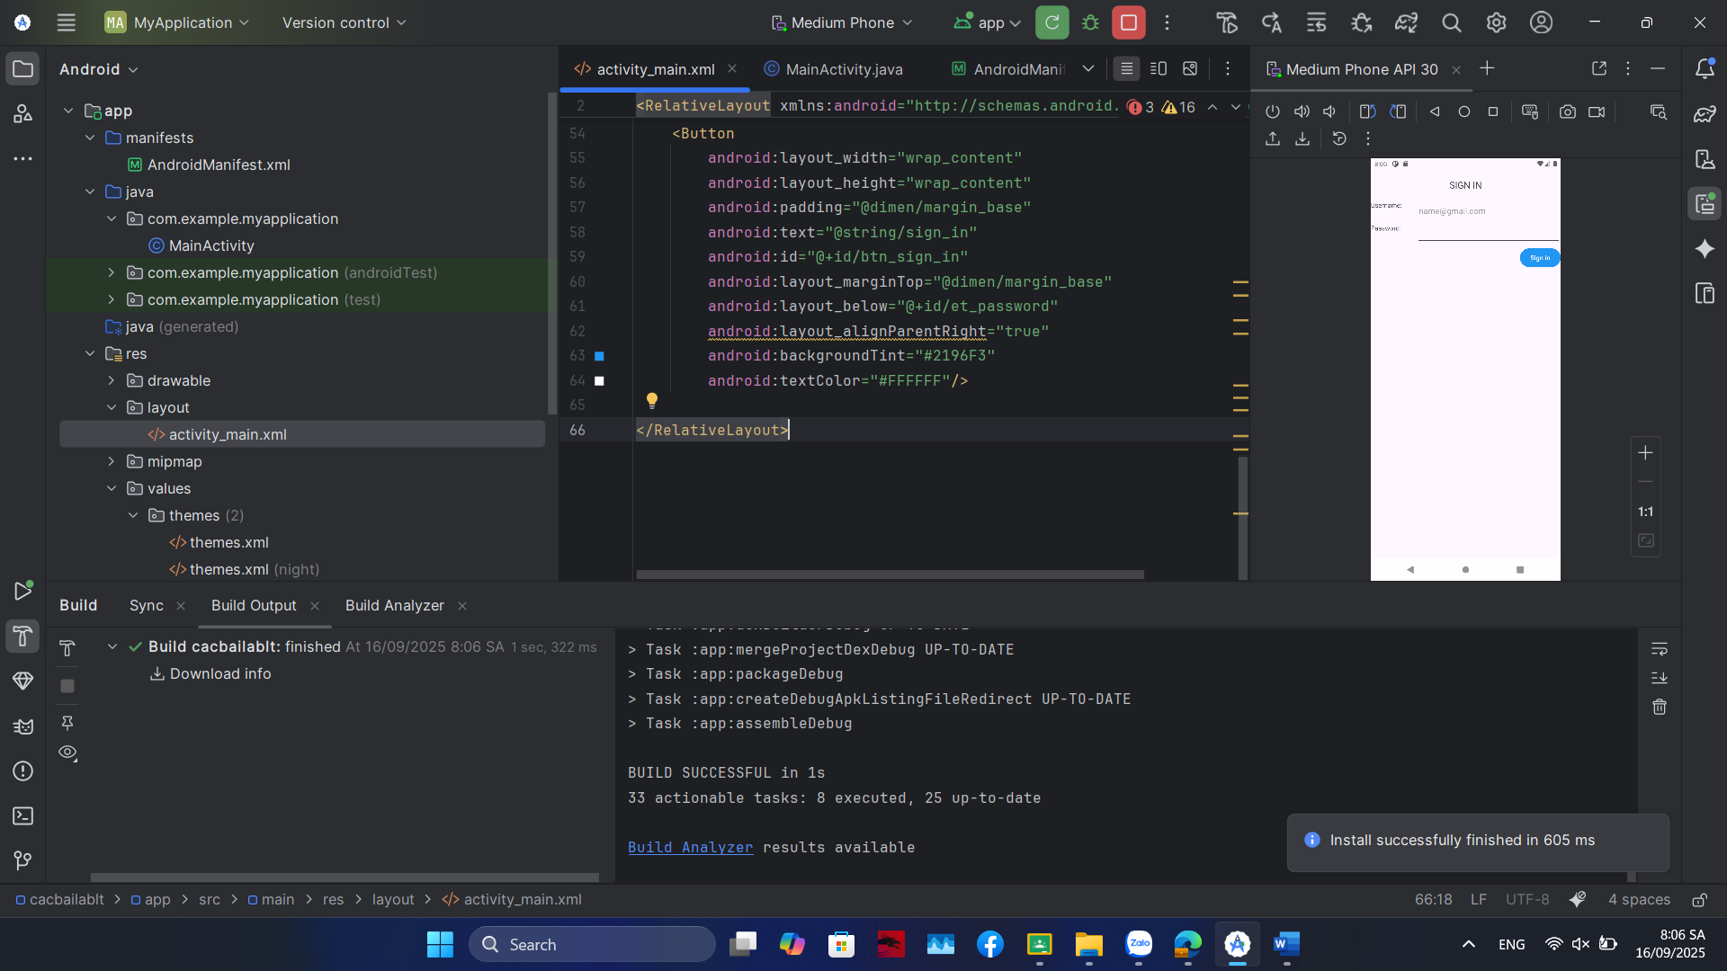

Code:

<?xml version="1.0" encoding="utf-8"?>  
<RelativeLayout xmlns:android="http://schemas.android.com/apk/res/android"  
 android:layout_width="match_parent"  
 android:id="@+id/main"  
 android:layout_height="match_parent"  
 android:paddingLeft="16dp"  
 android:paddingRight="16dp" >  
  
 <TextView  
 android:id="@+id/tv_sign_in"  
 android:layout_width="wrap_content"  
 android:layout_height="wrap_content"  
 android:text="@string/sign_in"  
 android:textAllCaps="true"  
 android:layout_centerHorizontal="true"  
 android:layout_marginTop="@dimen/margin_basex4"  
 android:textSize="@dimen/text_large" />  
  
 <TextView  
 android:layout_marginTop="@dimen/margin_basex4"  
 android:layout_width="100dp"  
 android:layout_height="wrap_content"  
 android:text="@string/username"  
 android:id="@+id/tv_user_name"  
 android:layout_below="@+id/tv_sign_in"  
 android:layout_alignParentLeft="true" />  
  
 <EditText  
 android:layout_width="match_parent"  
 android:layout_height="wrap_content"  
 android:id="@+id/et_username"  
 android:hint="name@gmail.com"  
 android:layout_alignTop="@+id/tv_user_name"  
 android:layout_toRightOf="@+id/tv_user_name" />  
  
 <TextView  
 android:layout_marginTop="@dimen/margin_base"  
 android:layout_width="100dp"  
 android:layout_height="wrap_content"  
 android:text="@string/password"  
 android:id="@+id/tv_password"  
 android:hint="******"  
 android:layout_below="@+id/et_username"  
 android:layout_alignParentLeft="true" />  
  
 <EditText  
 android:layout_width="match_parent"  
 android:layout_height="wrap_content"  
 android:id="@+id/et_password"  
 android:password="true"  
 android:layout_alignTop="@+id/tv_password"  
 android:layout_toRightOf="@+id/tv_password" />  
  
 <Button  
 android:layout_width="wrap_content"  
 android:layout_height="wrap_content"  
 android:padding="@dimen/margin_base"  
 android:text="@string/sign_in"  
 android:id="@+id/btn_sign_in"  
 android:layout_marginTop="@dimen/margin_base"  
 android:layout_below="@+id/et_password"  
 android:layout_alignParentRight="true"  
 android:backgroundTint="#2196F3"  
 android:textColor="#FFFFFF"/>  
  
</RelativeLayout>

Bản đầy đủ

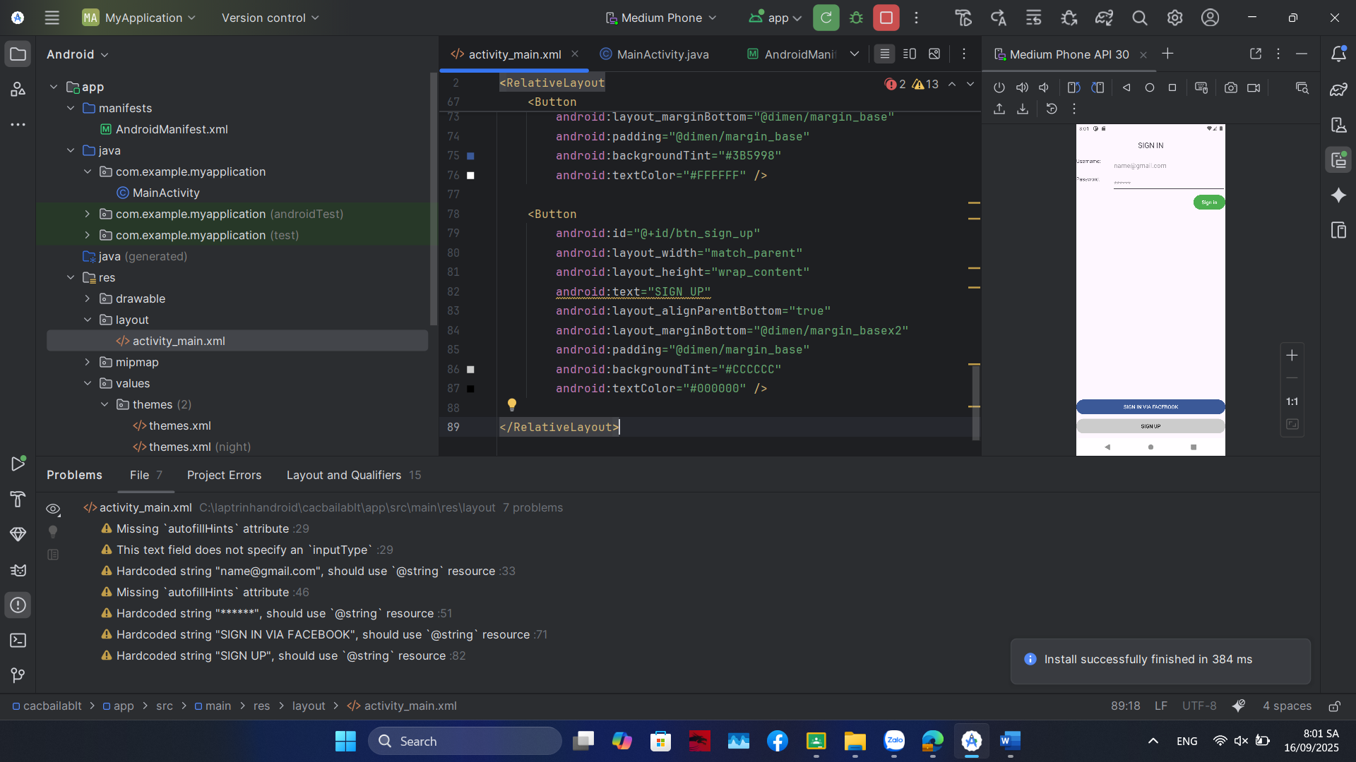

Code:

<?xml version="1.0" encoding="utf-8"?>  
<RelativeLayout  
 xmlns:android="http://schemas.android.com/apk/res/android"  
 android:layout_width="match_parent"  
 android:layout_height="match_parent"  
 android:paddingLeft="16dp"  
 android:paddingRight="16dp"  
 android:id="@+id/main">  
  
 <TextView  
 android:id="@+id/tv_sign_in"  
 android:layout_width="wrap_content"  
 android:layout_height="wrap_content"  
 android:text="@string/sign_in"  
 android:textAllCaps="true"  
 android:layout_centerHorizontal="true"  
 android:layout_marginTop="@dimen/margin_basex4"  
 android:textSize="@dimen/text_large" />  
  
 <TextView  
 android:id="@+id/tv_user_name"  
 android:layout_width="100dp"  
 android:layout_height="wrap_content"  
 android:text="@string/username"  
 android:layout_below="@+id/tv_sign_in"  
 android:layout_alignParentStart="true"  
 android:layout_marginTop="@dimen/margin_basex4" />  
  
 <EditText  
 android:id="@+id/et_username"  
 android:layout_width="match_parent"  
 android:layout_height="wrap_content"  
 android:hint="name@gmail.com"  
 android:layout_alignTop="@+id/tv_user_name"  
 android:layout_toEndOf="@+id/tv_user_name" />  
  
 <TextView  
 android:id="@+id/tv_password"  
 android:layout_width="100dp"  
 android:layout_height="wrap_content"  
 android:text="@string/password"  
 android:layout_below="@+id/et_username"  
 android:layout_alignParentStart="true"  
 android:layout_marginTop="@dimen/margin_base" />  
  
 <EditText  
 android:id="@+id/et_password"  
 android:layout_width="match_parent"  
 android:layout_height="wrap_content"  
 android:inputType="textPassword"  
 android:hint="******"  
 android:layout_alignTop="@+id/tv_password"  
 android:layout_toEndOf="@+id/tv_password" />  
  
 <Button  
 android:id="@+id/btn_sign_in"  
 android:layout_width="wrap_content"  
 android:layout_height="wrap_content"  
 android:text="@string/sign_in"  
 android:layout_below="@+id/et_password"  
 android:layout_alignParentEnd="true"  
 android:layout_marginTop="@dimen/margin_base"  
 android:padding="@dimen/margin_base"  
 android:backgroundTint="#4CAF50"  
 android:textColor="#FFFFFF" />  
  
 <Button  
 android:id="@+id/btn_sign_in_facebook"  
 android:layout_width="match_parent"  
 android:layout_height="wrap_content"  
 android:text="SIGN IN VIA FACEBOOK"  
 android:layout_above="@+id/btn_sign_up"  
 android:layout_marginBottom="@dimen/margin_base"  
 android:padding="@dimen/margin_base"  
 android:backgroundTint="#3B5998"  
 android:textColor="#FFFFFF" />  
  
 <Button  
 android:id="@+id/btn_sign_up"  
 android:layout_width="match_parent"  
 android:layout_height="wrap_content"  
 android:text="SIGN UP"  
 android:layout_alignParentBottom="true"  
 android:layout_marginBottom="@dimen/margin_basex2"  
 android:padding="@dimen/margin_base"  
 android:backgroundTint="#CCCCCC"  
 android:textColor="#000000" />  
  
</RelativeLayout>

2**ContraintLayout**

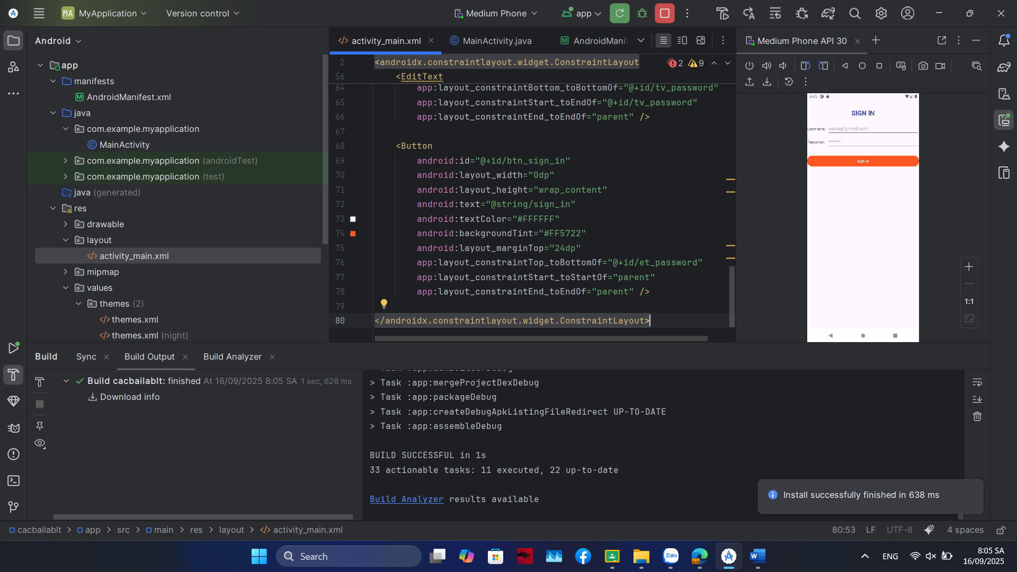

Code:

<?xml version="1.0" encoding="utf-8"?>  
<androidx.constraintlayout.widget.ConstraintLayout  
 android:id="@+id/main"  
 xmlns:android="http://schemas.android.com/apk/res/android"  
 xmlns:app="http://schemas.android.com/apk/res-auto"  
 xmlns:tools="http://schemas.android.com/tools"  
 android:layout_width="match_parent"  
 android:layout_height="match_parent"  
 android:padding="16dp"  
 tools:context=".MainActivity">  
  
 <TextView  
 android:id="@+id/tv_sign_in"  
 android:layout_width="wrap_content"  
 android:layout_height="wrap_content"  
 android:text="@string/sign_in"  
 android:textAllCaps="true"  
 android:textSize="24sp"  
 android:textStyle="bold"  
 android:textColor="#3F51B5"  
 android:layout_marginTop="32dp"  
 app:layout_constraintTop_toTopOf="parent"  
 app:layout_constraintStart_toStartOf="parent"  
 app:layout_constraintEnd_toEndOf="parent" />  
  
 <TextView  
 android:id="@+id/tv_user_name"  
 android:layout_width="wrap_content"  
 android:layout_height="wrap_content"  
 android:text="@string/username"  
 android:layout_marginTop="32dp"  
 app:layout_constraintTop_toBottomOf="@+id/tv_sign_in"  
 app:layout_constraintStart_toStartOf="parent" />  
  
 <EditText  
 android:id="@+id/et_username"  
 android:layout_width="0dp"  
 android:layout_height="wrap_content"  
 android:hint="name@gmail.com"  
 android:inputType="textEmailAddress"  
 android:layout_marginStart="8dp"  
 app:layout_constraintTop_toTopOf="@+id/tv_user_name"  
 app:layout_constraintBottom_toBottomOf="@+id/tv_user_name"  
 app:layout_constraintStart_toEndOf="@+id/tv_user_name"  
 app:layout_constraintEnd_toEndOf="parent" />  
  
 <TextView  
 android:id="@+id/tv_password"  
 android:layout_width="wrap_content"  
 android:layout_height="wrap_content"  
 android:text="@string/password"  
 android:layout_marginTop="16dp"  
 app:layout_constraintTop_toBottomOf="@+id/et_username"  
 app:layout_constraintStart_toStartOf="parent" />  
  
 <EditText  
 android:id="@+id/et_password"  
 android:layout_width="0dp"  
 android:layout_height="wrap_content"  
 android:hint="******"  
 android:inputType="textPassword"  
 android:layout_marginStart="8dp"  
 app:layout_constraintTop_toTopOf="@+id/tv_password"  
 app:layout_constraintBottom_toBottomOf="@+id/tv_password"  
 app:layout_constraintStart_toEndOf="@+id/tv_password"  
 app:layout_constraintEnd_toEndOf="parent" />  
  
 <Button  
 android:id="@+id/btn_sign_in"  
 android:layout_width="0dp"  
 android:layout_height="wrap_content"  
 android:text="@string/sign_in"  
 android:textColor="#FFFFFF"  
 android:backgroundTint="#FF5722"  
 android:layout_marginTop="24dp"  
 app:layout_constraintTop_toBottomOf="@+id/et_password"  
 app:layout_constraintStart_toStartOf="parent"  
 app:layout_constraintEnd_toEndOf="parent" />  
  
</androidx.constraintlayout.widget.ConstraintLayout>

Bản đầy đủ

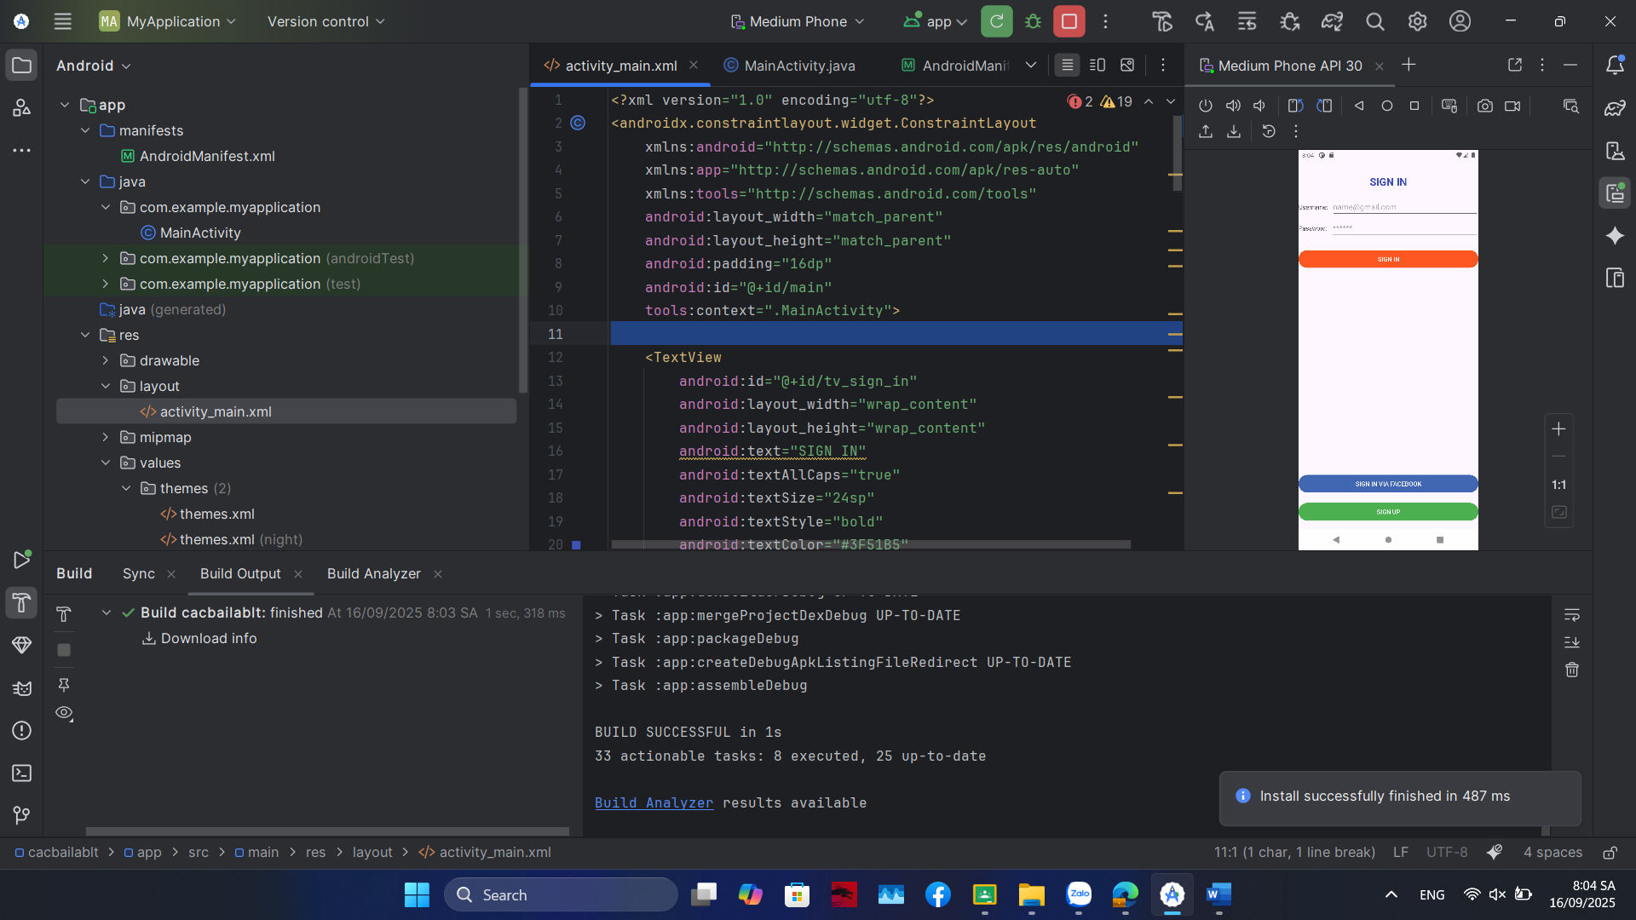

Code:

<?xml version="1.0" encoding="utf-8"?>  
<androidx.constraintlayout.widget.ConstraintLayout  
 xmlns:android="http://schemas.android.com/apk/res/android"  
 xmlns:app="http://schemas.android.com/apk/res-auto"  
 xmlns:tools="http://schemas.android.com/tools"  
 android:layout_width="match_parent"  
 android:layout_height="match_parent"  
 android:padding="16dp"  
 android:id="@+id/main"  
 tools:context=".MainActivity">  
  
 <TextView  
 android:id="@+id/tv_sign_in"  
 android:layout_width="wrap_content"  
 android:layout_height="wrap_content"  
 android:text="SIGN IN"  
 android:textAllCaps="true"  
 android:textSize="24sp"  
 android:textStyle="bold"  
 android:textColor="#3F51B5"  
 android:layout_marginTop="32dp"  
 app:layout_constraintTop_toTopOf="parent"  
 app:layout_constraintStart_toStartOf="parent"  
 app:layout_constraintEnd_toEndOf="parent" />  
  
 <TextView  
 android:id="@+id/tv_user_name"  
 android:layout_width="wrap_content"  
 android:layout_height="wrap_content"  
 android:text="Username:"  
 android:layout_marginTop="32dp"  
 app:layout_constraintTop_toBottomOf="@+id/tv_sign_in"  
 app:layout_constraintStart_toStartOf="parent" />  
  
 <EditText  
 android:id="@+id/et_username"  
 android:layout_width="0dp"  
 android:layout_height="wrap_content"  
 android:hint="name@gmail.com"  
 android:inputType="textEmailAddress"  
 android:layout_marginStart="8dp"  
 app:layout_constraintTop_toTopOf="@+id/tv_user_name"  
 app:layout_constraintBottom_toBottomOf="@+id/tv_user_name"  
 app:layout_constraintStart_toEndOf="@+id/tv_user_name"  
 app:layout_constraintEnd_toEndOf="parent" />  
  
 <TextView  
 android:id="@+id/tv_password"  
 android:layout_width="wrap_content"  
 android:layout_height="wrap_content"  
 android:text="Password:"  
 android:layout_marginTop="16dp"  
 app:layout_constraintTop_toBottomOf="@+id/et_username"  
 app:layout_constraintStart_toStartOf="parent" />  
  
 <EditText  
 android:id="@+id/et_password"  
 android:layout_width="0dp"  
 android:layout_height="wrap_content"  
 android:hint="******"  
 android:inputType="textPassword"  
 android:layout_marginStart="8dp"  
 app:layout_constraintTop_toTopOf="@+id/tv_password"  
 app:layout_constraintBottom_toBottomOf="@+id/tv_password"  
 app:layout_constraintStart_toEndOf="@+id/tv_password"  
 app:layout_constraintEnd_toEndOf="parent" />  
  
 <Button  
 android:id="@+id/btn_sign_in"  
 android:layout_width="0dp"  
 android:layout_height="wrap_content"  
 android:text="SIGN IN"  
 android:textColor="#FFFFFF"  
 android:backgroundTint="#FF5722"  
 android:layout_marginTop="24dp"  
 app:layout_constraintTop_toBottomOf="@+id/et_password"  
 app:layout_constraintStart_toStartOf="parent"  
 app:layout_constraintEnd_toEndOf="parent" />  
  
 <Button  
 android:id="@+id/btn_sign_in_facebook"  
 android:layout_width="0dp"  
 android:layout_height="wrap_content"  
 android:text="SIGN IN VIA FACEBOOK"  
 android:textColor="#FFFFFF"  
 android:backgroundTint="#4267B2"  
 android:layout_marginBottom="16dp"  
 app:layout_constraintBottom_toTopOf="@+id/btn_sign_up"  
 app:layout_constraintStart_toStartOf="parent"  
 app:layout_constraintEnd_toEndOf="parent" />  
  
 <Button  
 android:id="@+id/btn_sign_up"  
 android:layout_width="0dp"  
 android:layout_height="wrap_content"  
 android:text="SIGN UP"  
 android:textColor="#FFFFFF"  
 android:backgroundTint="#4CAF50"  
 android:layout_marginBottom="16dp"  
 app:layout_constraintBottom_toBottomOf="parent"  
 app:layout_constraintStart_toStartOf="parent"  
 app:layout_constraintEnd_toEndOf="parent" />  
  
</androidx.constraintlayout.widget.ConstraintLayout>