Bài 1:

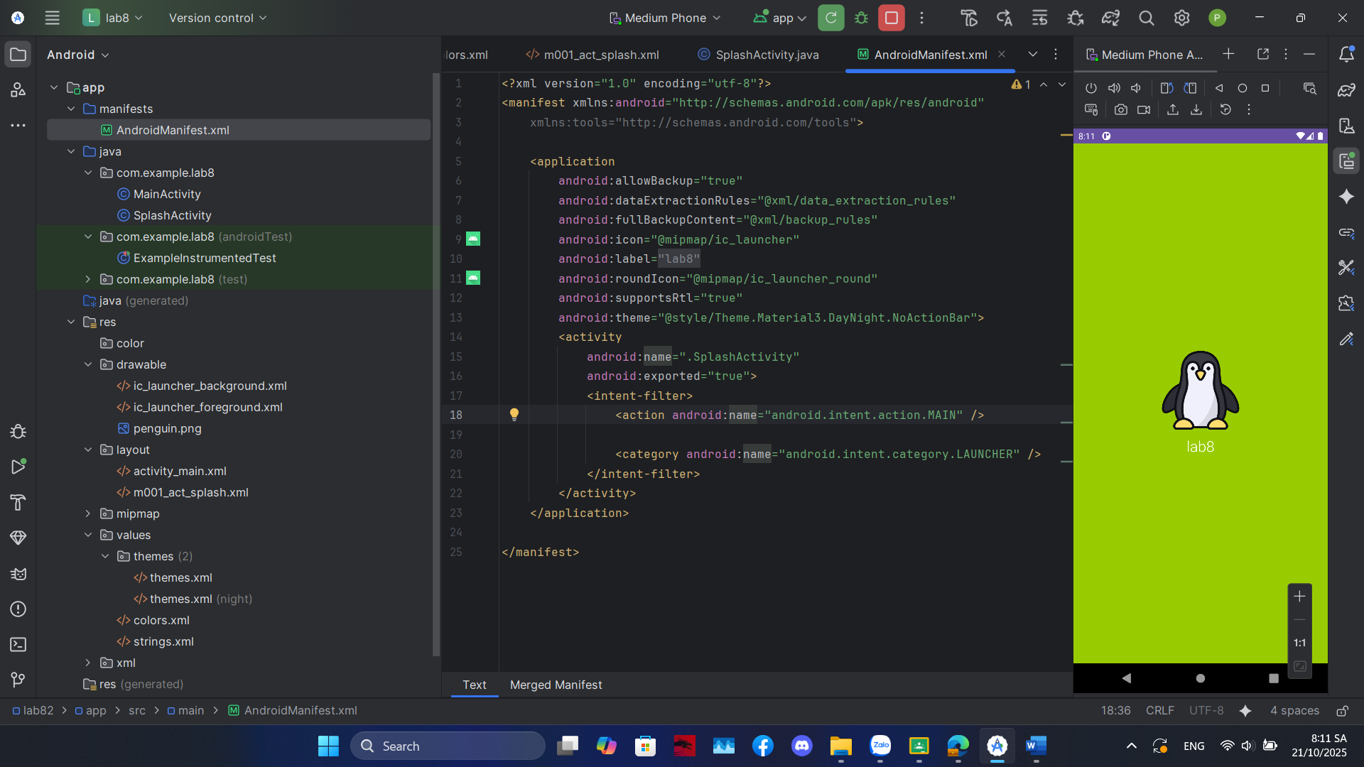

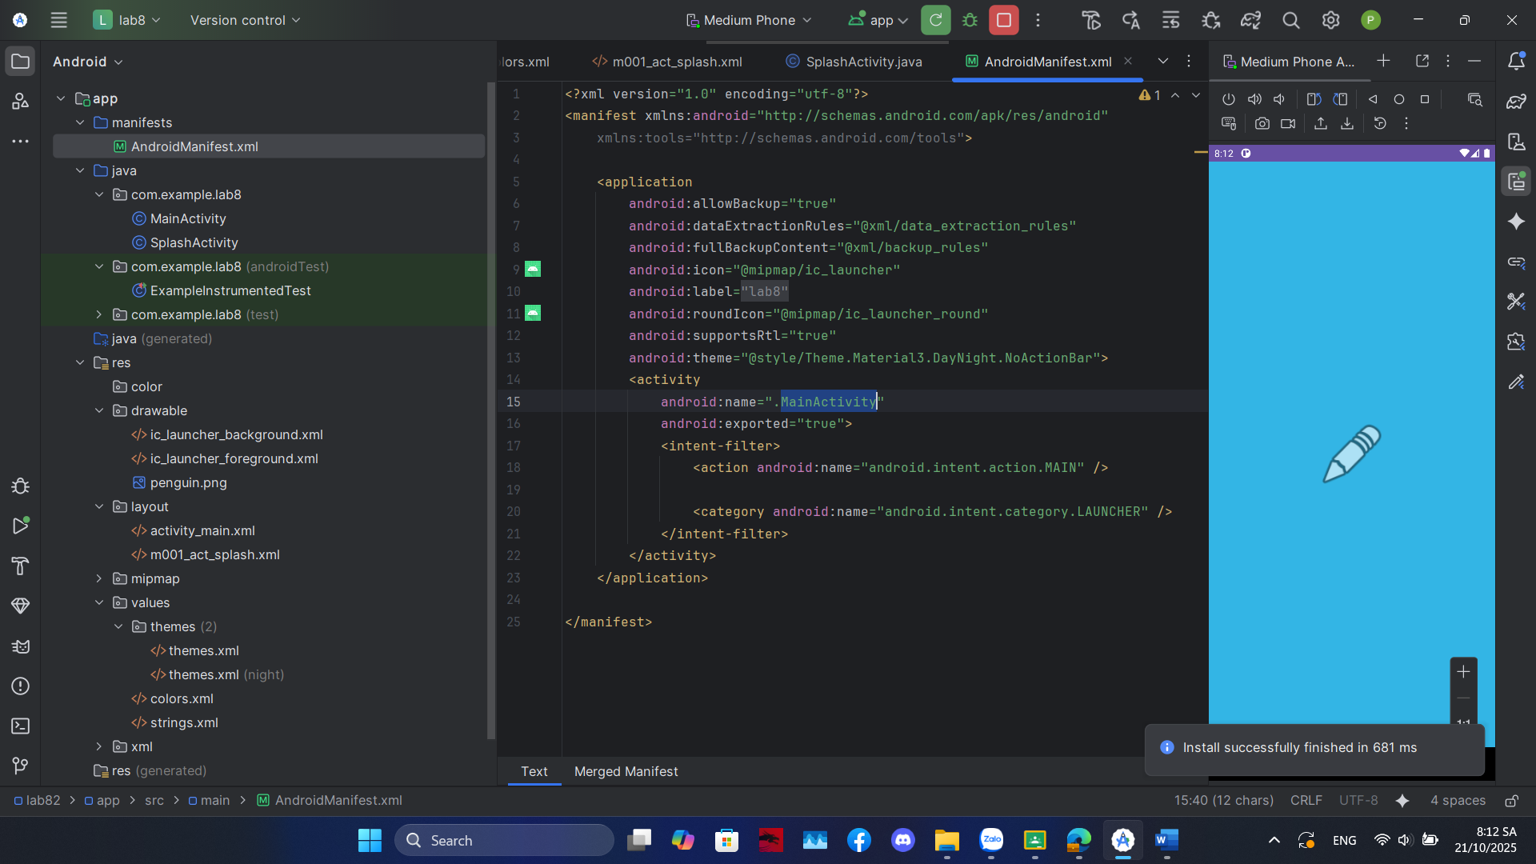

m001_act_splash

<?xml version="1.0" encoding="utf-8"?>  
<LinearLayout xmlns:android="http://schemas.android.com/apk/res/android"  
 xmlns:tools="http://schemas.android.com/tools"  
 android:id="@+id/splashLayout"  
 android:layout_width="match_parent"  
 android:layout_height="match_parent"  
 android:gravity="center"  
 android:orientation="vertical"  
 tools:context=".SplashActivity"  
 tools:background="@color/design_default_color_primary_dark">  
 <ImageView  
 android:id="@+id/splashIcon"  
 android:layout_width="128dp"  
 android:layout_height="128dp"  
 tools:ignore="ContentDescription"  
 tools:src="@android:drawable/ic_menu_gallery" />  
 <TextView  
 android:layout_width="wrap_content"  
 android:layout_height="wrap_content"  
 android:layout_marginTop="10dp"  
 android:fontFamily="sans-serif-light"  
 android:text="@string/app_name"  
 android:textColor="@color/white"  
 android:textSize="24sp" />  
</LinearLayout>

Bài 2:

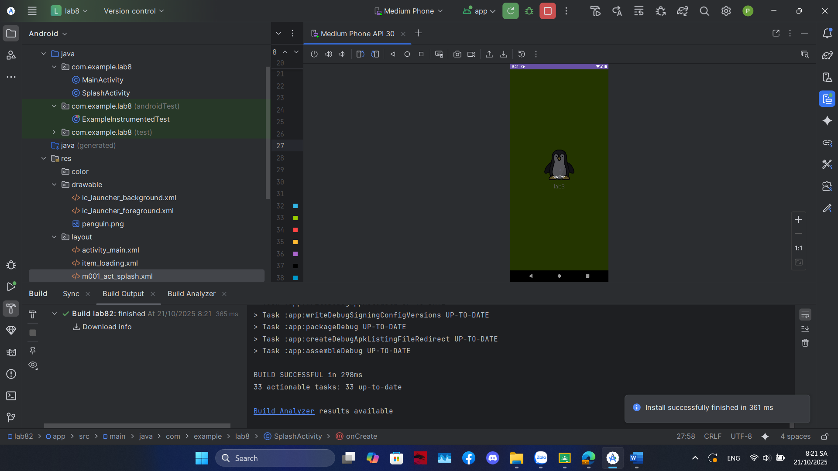

Item_loading:

<?xml version="1.0" encoding="utf-8"?>  
<LinearLayout xmlns:android="http://schemas.android.com/apk/res/android"  
 android:layout_width="match_parent"  
 android:layout_height="match_parent"  
 android:background="#A6000000"  
 android:gravity="center"  
 android:orientation="vertical"  
 android:clickable="true"  
 android:focusable="true">  
 <ProgressBar  
 android:layout_width="wrap_content"  
 android:layout_height="wrap_content"  
 android:indeterminate="true" />  
  
 <TextView  
 android:layout_width="wrap_content"  
 android:layout_height="wrap_content"  
 android:layout_marginTop="10dp"  
 android:text="Loading..."  
 android:textColor="@color/white"  
 android:textSize="18sp"  
 android:fontFamily="sans-serif-light" />  
  
</LinearLayout>

Bài 3:

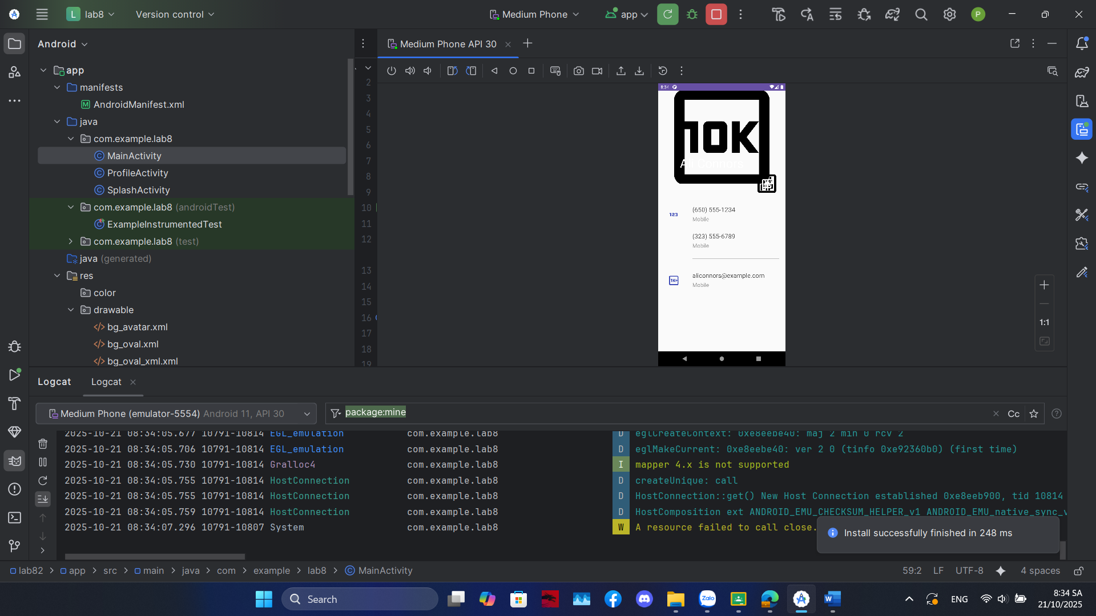

m001_act_profile

<?xml version="1.0" encoding="utf-8"?>  
<LinearLayout xmlns:android="http://schemas.android.com/apk/res/android"  
 xmlns:app="http://schemas.android.com/apk/res-auto"  
 xmlns:tools="http://schemas.android.com/tools"  
 android:layout_width="match_parent"  
 android:layout_height="match_parent"  
 android:background="@color/gray_light"  
 android:orientation="vertical"  
 tools:context=".ProfileActivity"> <FrameLayout  
 android:layout_width="match_parent"  
 android:layout_height="350dp">  
 <ImageView  
 android:layout_width="match_parent"  
 android:layout_height="300dp"  
 android:scaleType="centerCrop"  
 android:src="@drawable/bg_avatar"  
 tools:ignore="ContentDescription" />  
 <TextView  
 android:layout_width="wrap_content"  
 android:layout_height="wrap_content"  
 android:layout_gravity="bottom"  
 android:layout_marginStart="70dp"  
 android:layout_marginBottom="90dp"  
 android:fontFamily="sans-serif"  
 android:text="@string/txt_name"  
 android:textColor="@color/white"  
 android:textSize="40sp" />  
 <ImageView  
 android:layout_width="80dp"  
 android:layout_height="80dp"  
 android:layout_gravity="end|bottom"  
 android:layout_marginEnd="20dp"  
 android:layout_marginBottom="10dp"  
 android:background="@drawable/bg_oval"  
 android:padding="20dp"  
 android:src="@drawable/ic_star"  
 app:tint="@color/white"  
 tools:ignore="ContentDescription" />  
</FrameLayout>  
  
 <TableRow  
 android:id="@+id/row_phone_1"  
 android:layout_width="match_parent"  
 android:layout_height="wrap_content"  
 android:background="?attr/selectableItemBackground"  
 android:clickable="true"  
 android:focusable="true"  
 android:padding="20dp">  
 <ImageView  
 android:layout_width="60dp"  
 android:layout_height="60dp"  
 android:padding="10dp"  
 android:src="@drawable/ic_phone"  
 app:tint="@color/indigo"  
 tools:ignore="ContentDescription"/>  
 <LinearLayout  
 android:layout_width="match_parent"  
 android:layout_height="wrap_content"  
 android:layout_marginStart="30dp"  
 android:orientation="vertical">  
 <TextView  
 android:layout_width="match_parent"  
 android:layout_height="wrap_content"  
 android:text="@string/txt_phone1"  
 android:textColor="@color/gray_dark"  
 android:textSize="20sp" />  
 <TextView  
 android:layout_width="match_parent"  
 android:layout_height="wrap_content"  
 android:layout_marginTop="5dp"  
 android:text="@string/txt_title_mobile"  
 android:textColor="@color/gray_mid"  
 android:textSize="18sp" />  
  
 <TextView  
 android:layout_width="match_parent"  
 android:layout_height="wrap_content"  
 android:layout_marginTop="30dp"  
 android:text="@string/txt_phone2"  
 android:textColor="@color/gray_dark"  
 android:textSize="20sp" />  
 <TextView  
 android:layout_width="match_parent"  
 android:layout_height="wrap_content"  
 android:layout_marginTop="5dp"  
 android:text="@string/txt_title_mobile"  
 android:textColor="@color/gray_mid"  
 android:textSize="18sp" />  
 <View  
 android:layout_width="match_parent"  
 android:layout_height="0.5dp"  
 android:layout_marginTop="30dp"  
 android:background="@color/gray_mid"/>  
 </LinearLayout>  
 </TableRow>  
  
 <TableRow  
 android:id="@+id/row_email"  
 android:layout_width="match_parent"  
 android:layout_height="wrap_content"  
 android:background="?attr/selectableItemBackground"  
 android:clickable="true"  
 android:focusable="true"  
 android:padding="20dp">  
 <ImageView  
 android:layout_width="60dp"  
 android:layout_height="60dp"  
 android:padding="10dp"  
 android:src="@drawable/ic_email"  
 app:tint="@color/indigo"  
 tools:ignore="ContentDescription"/>  
 <LinearLayout  
 android:layout_width="match_parent"  
 android:layout_height="match_parent"  
 android:layout_marginStart="30dp"  
 android:orientation="vertical">  
 <TextView  
 android:layout_width="match_parent"  
 android:layout_height="wrap_content"  
 android:text="@string/txt_email"  
 android:textColor="@color/gray_dark"  
 android:textSize="20sp" />  
 <TextView  
 android:layout_width="match_parent"  
 android:layout_height="wrap_content"  
 android:layout_marginTop="5dp"  
 android:text="@string/txt_title_mobile"  
 android:textColor="@color/gray_mid"  
 android:textSize="18sp" />  
 </LinearLayout>  
 </TableRow>  
</LinearLayout>

ProfileActivity.java

package com.example.lab8;

import androidx.appcompat.app.AppCompatActivity;

import android.content.Intent;

import android.net.Uri;

import android.os.Bundle;

import android.view.View;

import android.widget.TableRow;

public class ProfileActivity extends AppCompatActivity {

TableRow rowPhone1;

TableRow rowEmail;

@Override

protected void onCreate(Bundle savedInstanceState) {

super.onCreate(savedInstanceState);

setContentView(R.layout.m001_act_profile);

rowPhone1 = findViewById(R.id.row_phone_1);

rowEmail = findViewById(R.id.row_email);

rowPhone1.setOnClickListener(new View.OnClickListener() {

@Override

public void onClick(View v) {

String phoneNumber = getString(R.string.txt_phone1);

dialPhoneNumber(phoneNumber);

}

});

rowEmail.setOnClickListener(new View.OnClickListener() {

@Override

public void onClick(View v) {

String emailAddress = getString(R.string.txt_email);

composeEmail(emailAddress);

}

});

}

private void dialPhoneNumber(String phoneNumber) {

Intent intent = new Intent(Intent.ACTION_DIAL);

intent.setData(Uri.parse("tel:" + phoneNumber));

if (intent.resolveActivity(getPackageManager()) != null) {

startActivity(intent);

}

}

private void composeEmail(String emailAddress) {

Intent intent = new Intent(Intent.ACTION_SENDTO);

intent.setData(Uri.parse("mailto:" + emailAddress));

if (intent.resolveActivity(getPackageManager()) != null) {

startActivity(intent);

}

}

}

Bài 4:

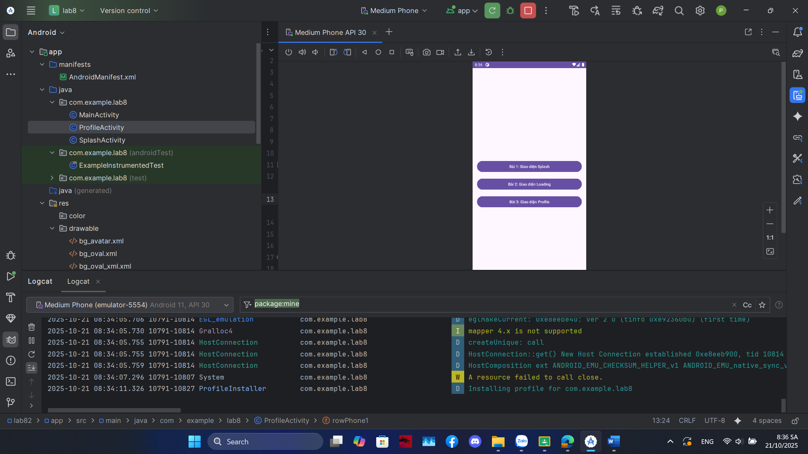

Activity_main.xml

<?xml version="1.0" encoding="utf-8"?>  
<LinearLayout xmlns:android="http://schemas.android.com/apk/res/android"  
 xmlns:tools="http://schemas.android.com/tools"  
 android:layout_width="match_parent"  
 android:layout_height="match_parent"  
 android:orientation="vertical"  
 android:gravity="center"  
 android:padding="16dp"  
 tools:context=".MainActivity">  
  
 <Button  
 android:id="@+id/btnBai1"  
 android:layout_width="match_parent"  
 android:layout_height="wrap_content"  
 android:text="Bài 1: Giao diện Splash" />  
  
 <Button  
 android:id="@+id/btnBai2"  
 android:layout_width="match_parent"  
 android:layout_height="wrap_content"  
 android:layout_marginTop="16dp"  
 android:text="Bài 2: Giao diện Loading" />  
  
 <Button  
 android:id="@+id/btnBai3"  
 android:layout_width="match_parent"  
 android:layout_height="wrap_content"  
 android:layout_marginTop="16dp"  
 android:text="Bài 3: Giao diện Profile" />  
  
</LinearLayout>

Mainactivity.java

package com.example.lab8;

import androidx.appcompat.app.AppCompatActivity;

import android.content.Intent;

import android.os.Bundle;

import android.view.View;

import android.widget.Button;

public class MainActivity extends AppCompatActivity {

Button btnBai1, btnBai2, btnBai3;

@Override

protected void onCreate(Bundle savedInstanceState) {

super.onCreate(savedInstanceState);

setContentView(R.layout.activity_main);

btnBai1 = findViewById(R.id.btnBai1);

btnBai2 = findViewById(R.id.btnBai2);

btnBai3 = findViewById(R.id.btnBai3);

btnBai1.setOnClickListener(new View.OnClickListener() {

@Override

public void onClick(View v) {

openDisplay(false);

}

});

btnBai2.setOnClickListener(new View.OnClickListener() {

@Override

public void onClick(View v) {

openDisplay(true);

}

});

btnBai3.setOnClickListener(new View.OnClickListener() {

@Override

public void onClick(View v) {

Intent intent = new Intent(MainActivity.this, ProfileActivity.class);

startActivity(intent);

}

});

}

private void openDisplay(boolean showLoading) {

Intent intent = new Intent(MainActivity.this, SplashActivity.class);

intent.putExtra("SHOW_LOADING", showLoading);

startActivity(intent);

}

}