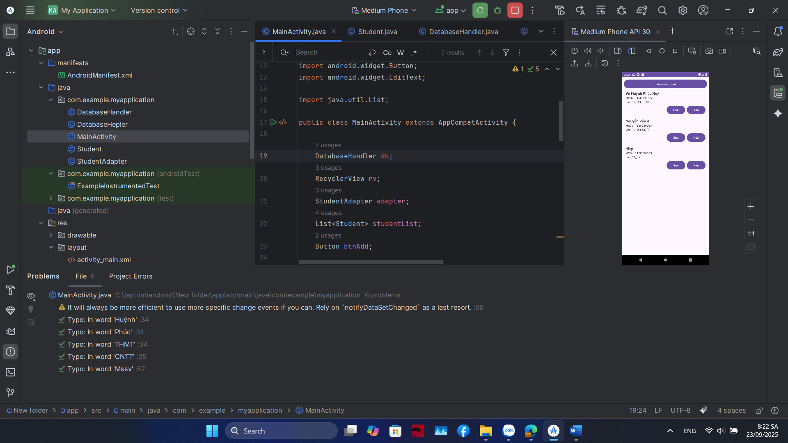

THÊM

@Override  
protected void onCreate(Bundle savedInstanceState) {  
 super.onCreate(savedInstanceState);  
 setContentView(R.layout.*activity_main*);  
  
 db = new DatabaseHandler(this);  
  
 // Thêm 2 dữ liệu mẫu lần đầu  
 if (db.getAllStudents().isEmpty()) {  
 db.addStudent(new Student("Võ Huỳnh Phúc Huy", "1150080055", "11_ĐH_THMT"));  
 db.addStudent(new Student("Nguyễn Văn A", "1150080066", "11_ĐH_CNTT"));  
 }  
  
 rv = findViewById(R.id.*rvStudents*);  
 btnAdd = findViewById(R.id.*btnAdd*);  
  
 studentList = db.getAllStudents();  
 adapter = new StudentAdapter(this, studentList);  
 rv.setLayoutManager(new LinearLayoutManager(this));  
 rv.setAdapter(adapter);  
  
 btnAdd.setOnClickListener(v -> showAddDialog());  
}

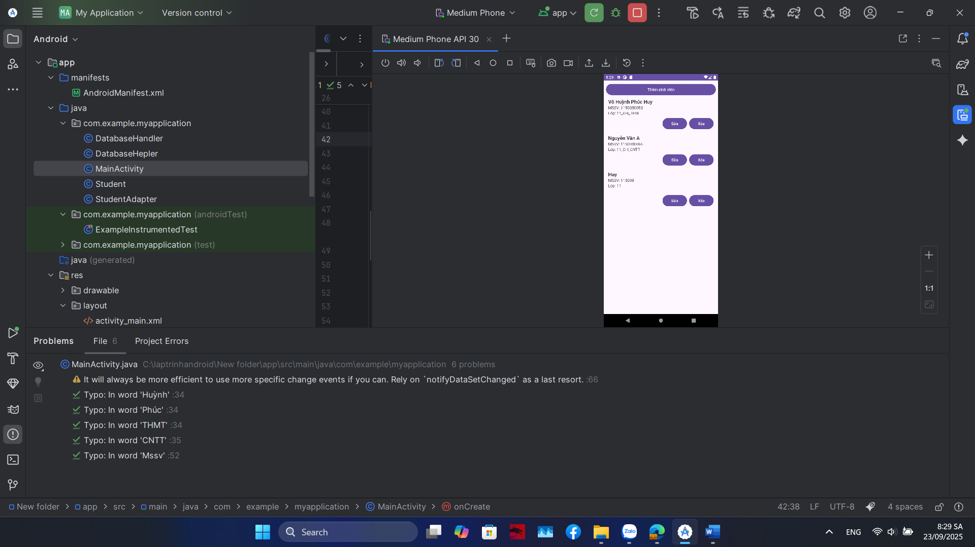

// ===== Nút XÓA =====  
holder.btnDelete.setOnClickListener(new View.OnClickListener() {  
 @Override  
 public void onClick(View v) {  
 db.deleteStudent(s.getId());  
 list.remove(position);  
 notifyItemRemoved(position);  
 }  
});

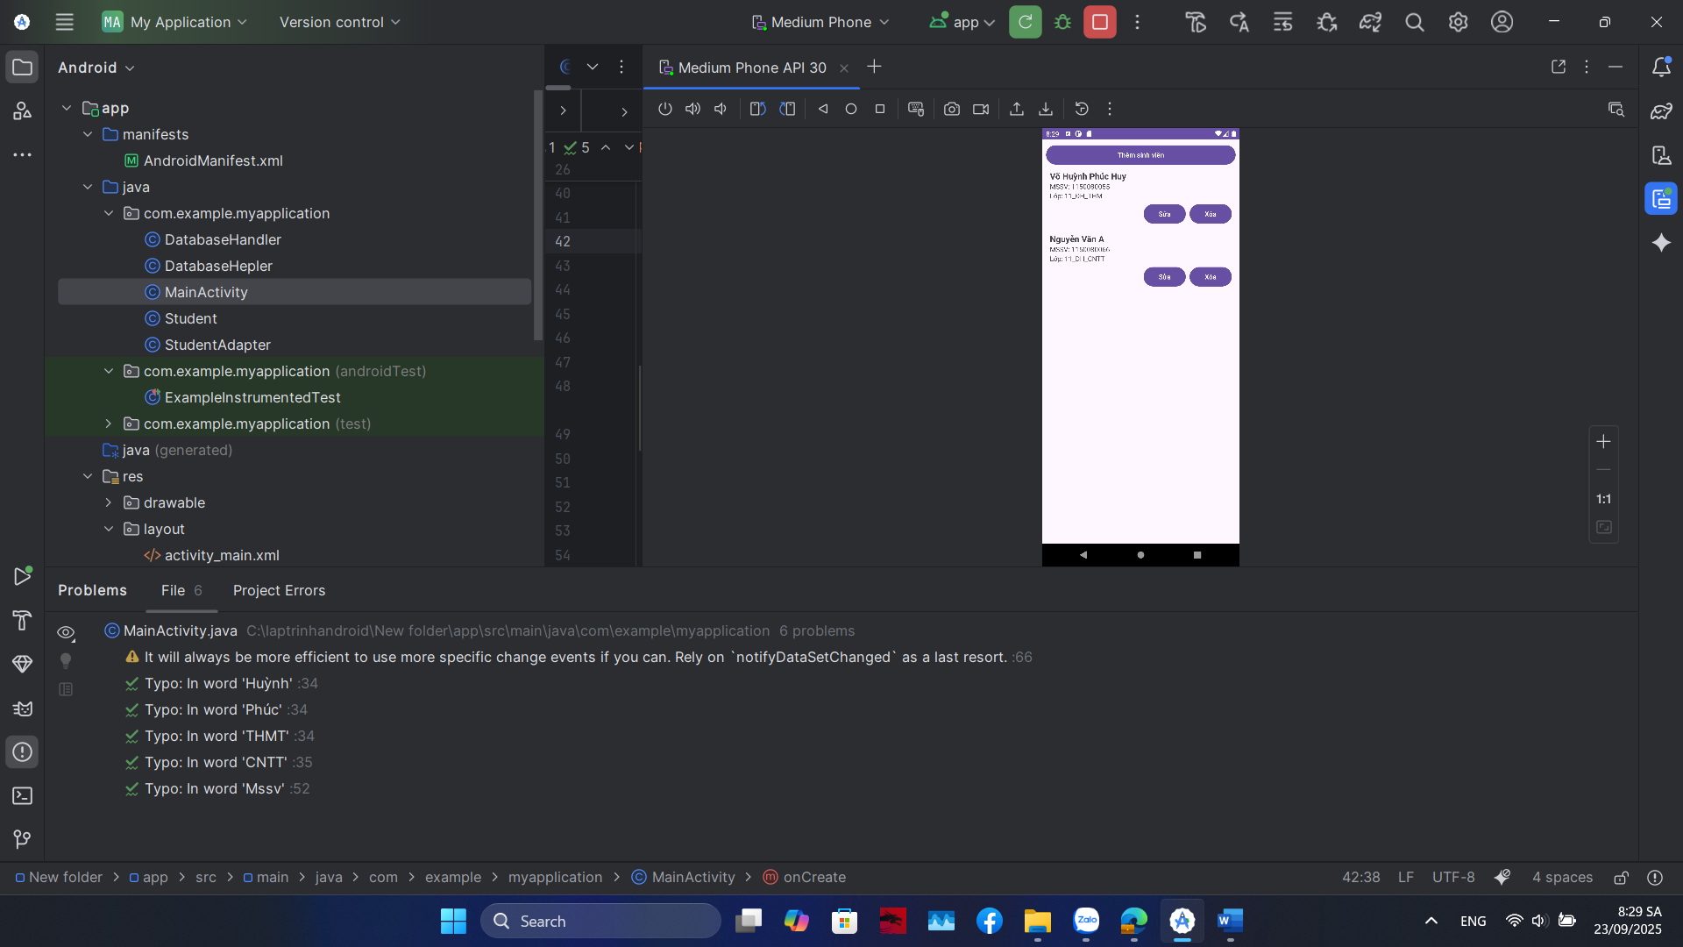

// ===== Nút SỬA =====  
 holder.btnEdit.setOnClickListener(new View.OnClickListener() {  
 @Override  
 public void onClick(View v) {  
 showEditDialog(position);  
 }  
 });  
}  
  
private void showEditDialog(int pos) {  
 Student st = list.get(pos);  
  
 View dialogView = LayoutInflater.*from*(context)  
 .inflate(R.layout.*dialog_edit_student*, null);  
 EditText etName = dialogView.findViewById(R.id.*etName*);  
 EditText etMssv = dialogView.findViewById(R.id.*etMssv*);  
 EditText etLop = dialogView.findViewById(R.id.*etLop*);  
  
 etName.setText(st.getName());  
 etMssv.setText(st.getMssv());  
 etLop.setText(st.getLop());  
  
 new AlertDialog.Builder(context)  
 .setTitle("Sửa sinh viên")  
 .setView(dialogView)  
 .setPositiveButton("Lưu", (dialog, which) -> {  
 st.setName(etName.getText().toString());  
 st.setMssv(etMssv.getText().toString());  
 st.setLop(etLop.getText().toString());  
 db.updateStudent(st);  
 notifyItemChanged(pos);  
 })  
 .setNegativeButton("Hủy", null)  
 .show();  
}

