Lab3
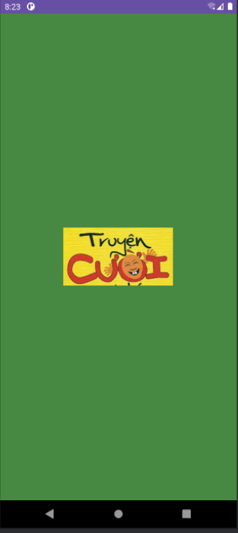

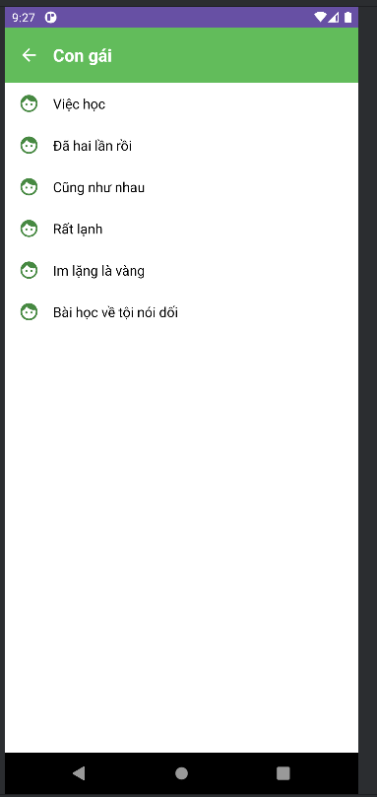
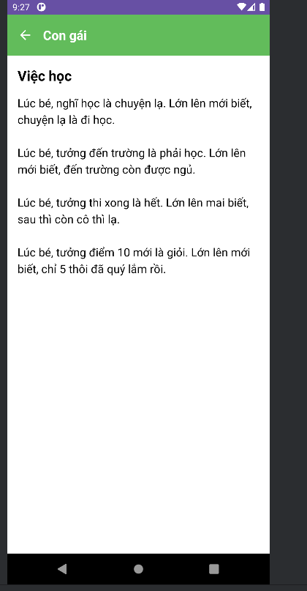
SwitchCompat swRotate = view.findViewById(R.id.sw_rotate);
if (getActivity() != null) {
if (swRotate.isChecked()) {
getActivity().setRequestedOrientation(ActivityInfo.SCREEN_ORIENTATION_SENSOR);
} else {
getActivity().setRequestedOrientation(ActivityInfo.SCREEN_ORIENTATION_PORTRAIT);
}
}
swRotate.setOnCheckedChangeListener((buttonView, isChecked) -> {
if (getActivity() == null) return;
if (isChecked) getActivity().setRequestedOrientation(ActivityInfo.SCREEN_ORIENTATION_SENSOR);
} else { getActivity().setRequestedOrientation(ActivityInfo.SCREEN_ORIENTATION_PORTRAIT);
}
});
Giai đoạn 1: Khởi tạo (Khi Fragment được tải)
- Tìm Switch (nút gạt) trong layout bằng findViewById.
- Kiểm tra trạng thái hiện tại của Switch:
  - Nếu Switch đang "On" (isChecked() là true), nó gọi setRequestedOrientation(ActivityInfo.SCREEN_ORIENTATION_SENSOR) để cho phép ứng dụng xoay theo cảm biến.
  - Nếu Switch đang "Off" (isChecked() là false), nó gọi setRequestedOrientation(ActivityInfo.SCREEN_ORIENTATION_PORTRAIT) để khóa ứng dụng ở chế độ màn hình dọc.
- Đây là bước quan trọng để duy trì trạng thái "Off" ngay cả khi màn hình bị xoay và tạo lại.
Giai đoạn 2: Lắng nghe sự kiện (Khi người dùng bấm vào Switch)
- Gắn một setOnCheckedChangeListener vào Switch. Đoạn code bên trong này chỉ chạy khi người dùng tương tác gạt nút.
- Khi sự kiện xảy ra, nó kiểm tra trạng thái mới (isChecked):
  - Nếu người dùng gạt "On" (isChecked là true), nó cho phép xoay (SENSOR).
  - Nếu người dùng gạt "Off" (isChecked là false), nó khóa dọc (PORTRAIT).
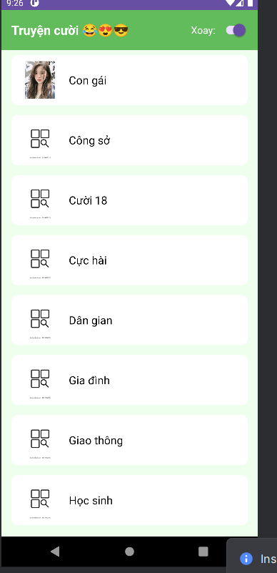
Bài 2:
Tạo file bài
Ta thêm các file ngôn ngữ theo cách:
Tạo res/values-vi/strings.xml (Tiếng Việt):
- Nhấp chuột phải vào res -> New -> Android Resource File.
- Tên file: strings.xml.
- Qualifier: Chọn Locale -> >> -> Language: vi (Vietnamese).
- Nhấn OK.
- Chép code sau vào file res/values-vi/strings.xml vừa tạo:
- <?xml version="1.0" encoding="utf-8"?>
<resources>
<string name="app_name">Truyện Cười</string>
<string name="welcome_message">Xin chào</string>
<string name="email_hint">Email</string>
<string name="password_hint">Mật khẩu</string>
<string name="no_account">Không có tài khoản. Vui lòng đăng ký</string>
- </resources>
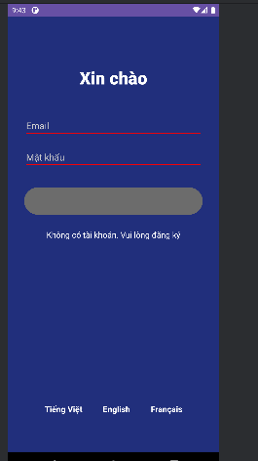
Hàm giúp chuyển đổi ngôn ngữ
private void setLocale(String langCode) {
Locale locale = new Locale(langCode);
Locale.setDefault(locale);
Resources res = getResources();
Configuration config = res.getConfiguration();
config.setLocale(locale);
res.updateConfiguration(config, res.getDisplayMetrics());
Intent intent = new Intent(this, LoginBai2Activity.class);
startActivity(intent);
finish();
}
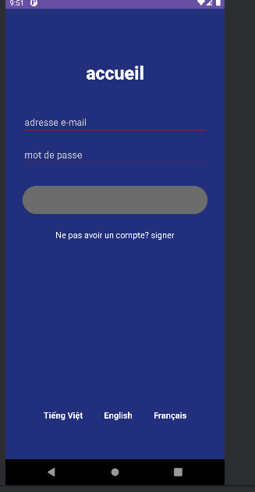
File activity_login_bai2:
<?xml version="1.0" encoding="utf-8"?>
<androidx.constraintlayout.widget.ConstraintLayout xmlns:android="http://schemas.android.com/apk/res/android"
xmlns:app="http://schemas.android.com/apk/res-auto"
xmlns:tools="http://schemas.android.com/tools"
android:layout_width="match_parent"
android:layout_height="match_parent"
android:background="#212F7C"
android:padding="32dp"
tools:context=".LoginBai2Activity">
<TextView
android:id="@+id/tv_welcome"
android:layout_width="wrap_content"
android:layout_height="wrap_content"
android:layout_marginTop="64dp"
android:fontFamily="sans-serif-medium"
android:text="@string/welcome_message"
android:textColor="@color/white"
android:textSize="34sp"
android:textStyle="bold"
app:layout_constraintEnd_toEndOf="parent"
app:layout_constraintStart_toStartOf="parent"
app:layout_constraintTop_toTopOf="parent" />
<EditText
android:id="@+id/et_email"
android:layout_width="0dp"
android:layout_height="wrap_content"
android:layout_marginTop="48dp"
android:hint="@string/email_hint"
android:inputType="textEmailAddress"
android:textColor="@color/white"
android:textColorHint="#CCCCCC"
android:backgroundTint="#FF0000"
app:layout_constraintEnd_toEndOf="parent"
app:layout_constraintStart_toStartOf="parent"
app:layout_constraintTop_toBottomOf="@id/tv_welcome" />
<EditText
android:id="@+id/et_password"
android:layout_width="0dp"
android:layout_height="wrap_content"
android:layout_marginTop="16dp"
android:hint="@string/password_hint"
android:inputType="textPassword"
android:textColor="@color/white"
android:textColorHint="#CCCCCC"
android:backgroundTint="#FF0000"
app:layout_constraintEnd_toEndOf="parent"
app:layout_constraintStart_toStartOf="parent"
app:layout_constraintTop_toBottomOf="@id/et_email" />
<Button
android:id="@+id/btn_login"
android:layout_width="0dp"
android:layout_height="60dp"
android:layout_marginTop="32dp"
android:backgroundTint="#6C6C6C"
android:text=""
app:layout_constraintEnd_toEndOf="parent"
app:layout_constraintStart_toStartOf="parent"
app:layout_constraintTop_toBottomOf="@id/et_password" />
<TextView
android:id="@+id/tv_signup"
android:layout_width="wrap_content"
android:layout_height="wrap_content"
android:layout_marginTop="24dp"
android:text="@string/no_account"
android:textColor="@color/white"
android:textSize="16sp"
app:layout_constraintEnd_toEndOf="parent"
app:layout_constraintStart_toStartOf="parent"
app:layout_constraintTop_toBottomOf="@id/btn_login" />
<LinearLayout
android:layout_width="wrap_content"
android:layout_height="wrap_content"
android:orientation="horizontal"
app:layout_constraintBottom_toBottomOf="parent"
app:layout_constraintEnd_toEndOf="parent"
app:layout_constraintStart_toStartOf="parent"
android:layout_marginBottom="32dp">
<TextView
android:id="@+id/tv_lang_vi"
android:layout_width="wrap_content"
android:layout_height="wrap_content"
android:text="@string/lang_vi"
android:textColor="@color/white"
android:textSize="16sp"
android:textStyle="bold"
android:padding="8dp"/>
<TextView
android:id="@+id/tv_lang_en"
android:layout_width="wrap_content"
android:layout_height="wrap_content"
android:layout_marginHorizontal="24dp"
android:text="@string/lang_en"
android:textColor="@color/white"
android:textSize="16sp"
android:textStyle="bold"
android:padding="8dp"/>
<TextView
android:id="@+id/tv_lang_fr"
android:layout_width="wrap_content"
android:layout_height="wrap_content"
android:text="@string/lang_fr"
android:textColor="@color/white"
android:textSize="16sp"
android:textStyle="bold"
android:padding="8dp"/>
</LinearLayout>
</androidx.constraintlayout.widget.ConstraintLayout>
Lab4
Tạo các file activity
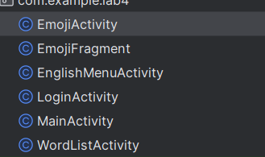
Nhớ khai báo trong mainfest
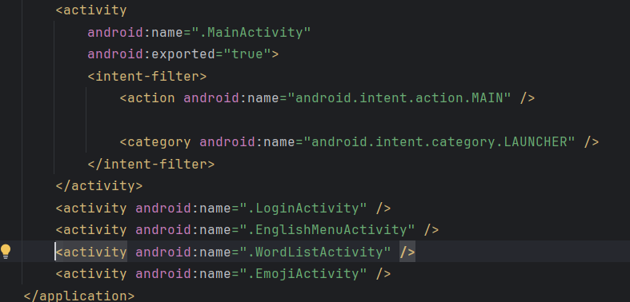
File color.xml
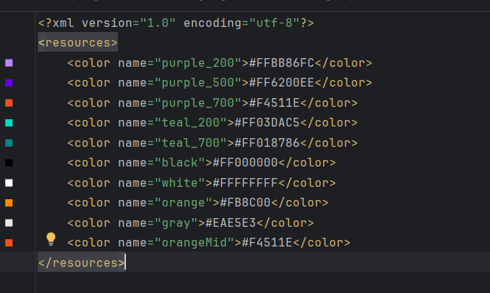
File String.xml
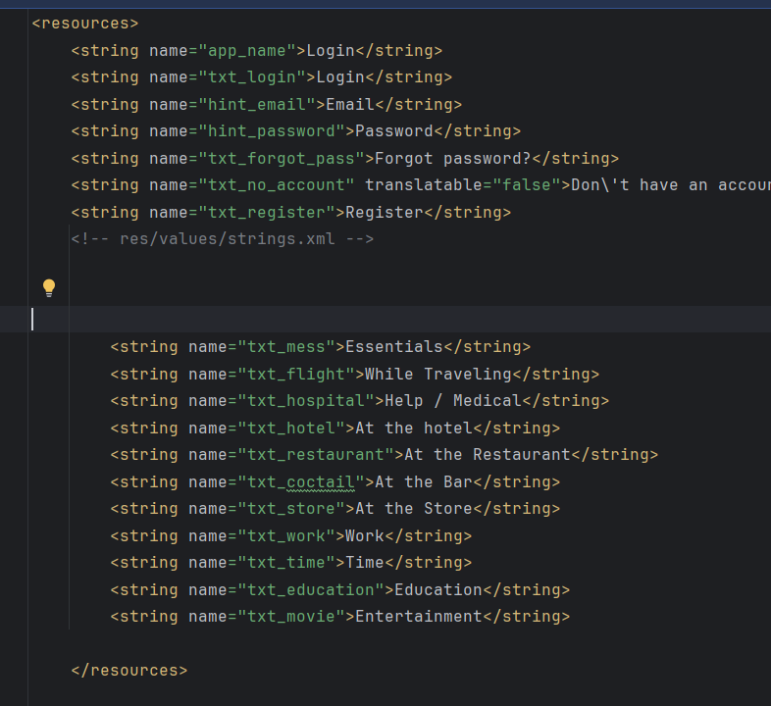
Bài 1 tạo login
File xml
<?xml version="1.0" encoding="utf-8"?>
<LinearLayout xmlns:android="http://schemas.android.com/apk/res/android"
android:layout_width="match_parent"
android:layout_height="match_parent"
android:background="@color/gray"
android:orientation="vertical">
<FrameLayout
android:layout_width="match_parent"
android:layout_height="wrap_content">
<View
android:layout_width="match_parent"
android:layout_height="300dp"
android:background="@drawable/bg_top" />
<TextView
android:layout_width="wrap_content"
android:layout_height="wrap_content"
android:layout_gravity="end"
android:layout_marginTop="220dp"
android:layout_marginEnd="30dp"
android:text="@string/txt_login"
android:textColor="@color/white"
android:textSize="20sp" />
</FrameLayout>
<EditText
android:id="@+id/edt_email"
android:layout_width="match_parent"
android:layout_height="50dp"
android:layout_marginHorizontal="30dp"
android:layout_marginTop="50dp"
android:layout_marginBottom="3dp"
android:background="@drawable/bg_radius"
android:drawableStart="@drawable/ic_mail"
android:drawablePadding="10dp"
android:hint="@string/hint_email"
android:padding="10dp"
android:textSize="18sp" />
<!-- Password -->
<EditText
android:id="@+id/edt_password"
android:layout_width="match_parent"
android:layout_height="50dp"
android:layout_marginHorizontal="30dp"
android:layout_marginTop="20dp"
android:layout_marginBottom="3dp"
android:background="@drawable/bg_radius"
android:drawableStart="@drawable/ic_key"
android:drawablePadding="10dp"
android:hint="@string/hint_password"
android:inputType="textPassword"
android:padding="10dp"
android:textSize="18sp" />
<TextView
android:layout_width="wrap_content"
android:layout_height="wrap_content"
android:layout_gravity="end"
android:layout_marginTop="10dp"
android:layout_marginEnd="30dp"
android:text="@string/txt_forgot_pass"
android:textColor="@color/black"
android:textSize="18sp" />
<Button
android:id="@+id/btn_login"
android:layout_width="match_parent"
android:layout_height="50dp"
android:layout_marginHorizontal="30dp"
android:layout_marginTop="50dp"
android:background="@drawable/bg_login"
android:text="@string/txt_login"
android:textColor="@color/white"
android:textSize="18sp" />
<TableRow
android:layout_width="match_parent"
android:layout_height="wrap_content"
android:layout_marginTop="50dp"
android:gravity="center">
<TextView
android:layout_width="wrap_content"
android:layout_height="wrap_content"
android:text="@string/txt_no_account"
android:textColor="@color/black"
android:textSize="14sp" />
<TextView
android:layout_width="wrap_content"
android:layout_height="wrap_content"
android:text="@string/txt_register"
android:textColor="@color/orange"
android:textSize="14sp"
android:textStyle="bold" />
</TableRow>
</LinearLayout>
Tạo các nút và nền bg_rect.xml, bg_login.xml, bg_top.xml
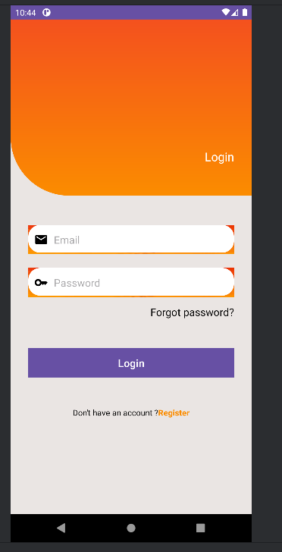
Bài 2:
Tạo file xml
<LinearLayout xmlns:android="http://schemas.android.com/apk/res/android"
xmlns:tools="http://schemas.android.com/tools"
android:layout_width="match_parent"
android:layout_height="match_parent"
android:orientation="vertical"
tools:context=".EnglishMenuActivity">
<!-- ActionBar -->
<include layout="@layout/actionbar_home" />
<!-- Danh sách chủ đề -->
<LinearLayout
android:id="@+id/ln_topics"
android:layout_width="match_parent"
android:layout_height="match_parent"
android:orientation="vertical"
android:padding="10dp" />
</LinearLayout>
Tạo file item_topic
<?xml version="1.0" encoding="utf-8"?>
<LinearLayout xmlns:android="http://schemas.android.com/apk/res/android"
android:layout_width="match_parent"
android:layout_height="match_parent"
android:orientation="horizontal"
android:background="?android:attr/selectableItemBackground">
<ImageView
android:id="@+id/iv_icon"
android:layout_width="64dp"
android:layout_height="match_parent"
android:src="@drawable/ic_mess" />
<TextView
android:id="@+id/tv_title"
android:layout_width="match_parent"
android:layout_height="match_parent"
android:gravity="center_vertical"
android:paddingStart="16dp"
android:textSize="18sp"
android:textColor="@android:color/black" />
</LinearLayout>
Hàm xử lý
private void initTopics() { LinearLayout container = findViewById(R.id.ln_topics); for (int i = 0; i < DRAWABLES.length; i++) { View item = LayoutInflater.from(this).inflate(R.layout.item_topic, null); ImageView iv = item.findViewById(R.id.iv_icon); TextView tv = item.findViewById(R.id.tv_title); iv.setImageResource(DRAWABLES[i]); tv.setText(TEXTS[i]);
String topic = getString(TEXTS[i]); item.setOnClickListener(v -> { Intent intent = new Intent(this, WordListActivity.class); intent.putExtra("TOPIC", topic); startActivity(intent); });
container.addView(item); } }
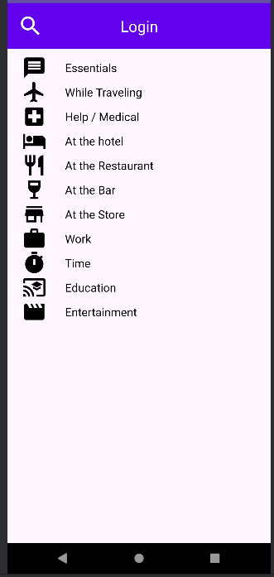
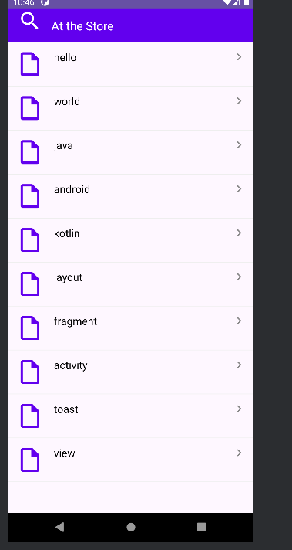

Bài 3:
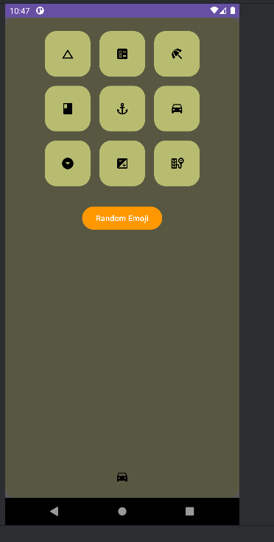
Tạo file fragment_emoji.xml
<?xml version="1.0" encoding="utf-8"?>
<FrameLayout xmlns:android="http://schemas.android.com/apk/res/android"
android:layout_width="match_parent"
android:layout_height="match_parent">
<ImageView
android:layout_width="match_parent"
android:layout_height="match_parent"
android:src="@drawable/bg_emoij"
android:scaleType="centerCrop" />
<!-- Lớp mờ + nội dung -->
<LinearLayout
android:layout_width="match_parent"
android:layout_height="match_parent"
android:background="#A6000000"
android:orientation="vertical"
android:padding="24dp">
<!-- Dòng 1 -->
<TableRow
android:layout_width="match_parent"
android:layout_height="wrap_content"
android:gravity="center"
android:layout_marginBottom="16dp">
<ImageView
android:id="@+id/iv1"
android:layout_width="80dp"
android:layout_height="80dp"
android:src="@drawable/ic_angry"
android:background="@drawable/bg_emoij"
android:padding="16dp"
android:scaleType="centerInside" />
<ImageView
android:id="@+id/iv2"
android:layout_width="80dp"
android:layout_height="80dp"
android:src="@drawable/ic_baffle"
android:background="@drawable/bg_emoij"
android:padding="16dp"
android:scaleType="centerInside"
android:layout_marginStart="16dp" />
<ImageView
android:id="@+id/iv3"
android:layout_width="80dp"
android:layout_height="80dp"
android:src="@drawable/ic_beauty"
android:background="@drawable/bg_emoij"
android:padding="16dp"
android:scaleType="centerInside"
android:layout_marginStart="16dp" />
</TableRow>
<!-- Dòng 2 -->
<TableRow
android:layout_width="match_parent"
android:layout_height="wrap_content"
android:gravity="center"
android:layout_marginBottom="16dp">
<ImageView
android:id="@+id/iv4"
android:layout_width="80dp"
android:layout_height="80dp"
android:src="@drawable/ic_boss"
android:background="@drawable/bg_emoij"
android:padding="16dp"
android:scaleType="centerInside" />
<ImageView
android:id="@+id/iv5"
android:layout_width="80dp"
android:layout_height="80dp"
android:src="@drawable/ic_choler"
android:background="@drawable/bg_emoij"
android:padding="16dp"
android:scaleType="centerInside"
android:layout_marginStart="16dp" />
<ImageView
android:id="@+id/iv6"
android:layout_width="80dp"
android:layout_height="80dp"
android:src="@drawable/ic_dribble"
android:background="@drawable/bg_emoij"
android:padding="16dp"
android:scaleType="centerInside"
android:layout_marginStart="16dp" />
</TableRow>
<!-- Dòng 3 -->
<TableRow
android:layout_width="match_parent"
android:layout_height="wrap_content"
android:gravity="center"
android:layout_marginBottom="32dp">
<ImageView
android:id="@+id/iv7"
android:layout_width="80dp"
android:layout_height="80dp"
android:src="@drawable/ic_look_down"
android:background="@drawable/bg_emoij"
android:padding="16dp"
android:scaleType="centerInside" />
<ImageView
android:id="@+id/iv8"
android:layout_width="80dp"
android:layout_height="80dp"
android:src="@drawable/ic_sure"
android:background="@drawable/bg_emoij"
android:padding="16dp"
android:scaleType="centerInside"
android:layout_marginStart="16dp" />
<ImageView
android:id="@+id/iv9"
android:layout_width="80dp"
android:layout_height="80dp"
android:src="@drawable/ic_tire"
android:background="@drawable/bg_emoij"
android:padding="16dp"
android:scaleType="centerInside"
android:layout_marginStart="16dp" />
</TableRow>
<!-- Nút Random -->
<Button
android:id="@+id/btn_random"
android:layout_width="wrap_content"
android:layout_height="wrap_content"
android:text="Random Emoji"
android:layout_gravity="center"
android:backgroundTint="#FF9800"
android:textColor="@android:color/white" />
</LinearLayout>
</FrameLayout>
Hàm xử lý ở trong file EmojiFragment.java
private final int[] emojiIds = {
R.id.iv1, R.id.iv2, R.id.iv3,
R.id.iv4, R.id.iv5, R.id.iv6,
R.id.iv7, R.id.iv8, R.id.iv9
};
@Override
public View onCreateView(LayoutInflater inflater, ViewGroup container, Bundle savedInstanceState) {
View v = inflater.inflate(R.layout.fragment_emoji, container, false);
initViews(v);
return v;
}
private void initViews(View v) {
for (int id : emojiIds) {
v.findViewById(id).setOnClickListener(this);
}
v.findViewById(R.id.btn_random).setOnClickListener(this);
}
@Override
public void onClick(View v) {
ImageView iv;
if (v.getId() == R.id.btn_random) {
Random r = new Random();
int idx = r.nextInt(emojiIds.length);
iv = getView().findViewById(emojiIds[idx]);
} else {
iv = (ImageView) v;
}
showToast(iv.getDrawable());
}
Tổng các file drawtable cần tạo để làm bài lab4
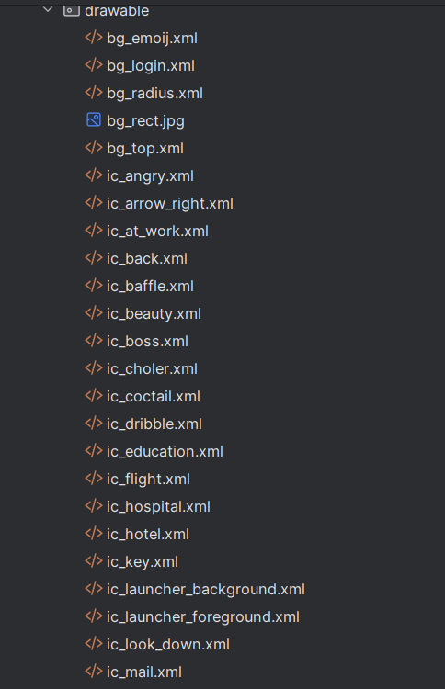
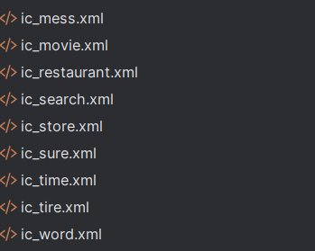
Lab5
Tạo file anim trong res
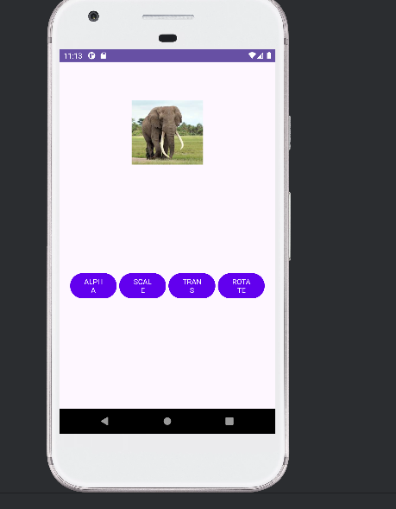
Với 4 file
Alpha.xml
<?xml version="1.0" encoding="utf-8"?>
<alpha xmlns:android="http://schemas.android.com/apk/res/android"
android:duration="1000"
android:fromAlpha="1.0"
android:toAlpha="0.0"
android:repeatCount="infinite"
android:repeatMode="reverse" />
Rotate.xml
<?xml version="1.0" encoding="utf-8"?>
<rotate xmlns:android="http://schemas.android.com/apk/res/android"
android:duration="1000"
android:fromDegrees="0"
android:toDegrees="360"
android:pivotX="50%" android:pivotY="50%"
android:repeatCount="infinite"
android:repeatMode="reverse" />
Scale.xml
<?xml version="1.0" encoding="utf-8"?>
<scale xmlns:android="http://schemas.android.com/apk/res/android"
android:duration="1000"
android:fromXScale="1" android:fromYScale="1"
android:toXScale="2" android:toYScale="2"
android:pivotX="50%" android:pivotY="50%"
android:repeatCount="infinite"
android:repeatMode="reverse" />
Trainlaste.xml
<?xml version="1.0" encoding="utf-8"?>
<translate xmlns:android="http://schemas.android.com/apk/res/android"
android:duration="1000"
android:fromXDelta="0"
android:toXDelta="200"
android:repeatCount="infinite"
android:repeatMode="reverse" />
File activityanimation.java
<?xml version="1.0" encoding="utf-8"?>
<LinearLayout xmlns:android="http://schemas.android.com/apk/res/android"
xmlns:tools="http://schemas.android.com/tools"
android:layout_width="match_parent"
android:layout_height="match_parent"
android:orientation="vertical"
android:gravity="center_horizontal"
android:padding="20dp"
tools:context=".AnimationActivity">
<ImageView
android:id="@+id/iv_animal"
android:layout_width="128dp"
android:layout_height="128dp"
android:layout_marginTop="50dp"
android:src="@drawable/ic_elephant" />
<TableRow
android:layout_width="match_parent"
android:layout_height="wrap_content"
android:layout_marginTop="200dp">
<Button android:id="@+id/bt_alpha" style="?android:attr/buttonBarStyle"
android:layout_width="0dp" android:layout_height="wrap_content"
android:layout_weight="1" android:backgroundTint="@color/design_default_color_primary"
android:text="@string/txt_alpha" android:textAllCaps="true" android:textColor="@color/white" />
<Button android:id="@+id/bt_scale" style="?android:attr/buttonBarStyle"
android:layout_width="0dp" android:layout_height="wrap_content"
android:layout_weight="1" android:layout_marginStart="5dp"
android:backgroundTint="@color/design_default_color_primary"
android:text="@string/txt_scale" android:textAllCaps="true" android:textSize="14sp" />
<Button android:id="@+id/bt_trans" style="?android:attr/buttonBarStyle"
android:layout_width="0dp" android:layout_height="wrap_content"
android:layout_weight="1" android:layout_marginStart="5dp"
android:backgroundTint="@color/design_default_color_primary"
android:text="@string/txt_trans" android:textAllCaps="true" android:textSize="14sp" />
<Button android:id="@+id/bt_rotate" style="?android:attr/buttonBarStyle"
android:layout_width="0dp" android:layout_height="wrap_content"
android:layout_weight="1" android:layout_marginStart="5dp"
android:backgroundTint="@color/design_default_color_primary"
android:text="@string/txt_rotate" android:textAllCaps="true" android:textSize="14sp" />
</TableRow>
</LinearLayout>

