Tên:Võ Huỳnh Phúc Huy
Lớp:11_ĐH_THMT
Bài Lab6:
Chuyển đổi đơn vị tiền tệ:
Ta điền và file strings.xml
<resources>
<string name="app_name">Chương trình đổi tiền</string>
<string name="author">Điền họ và tên của bạn</string>
<string name="computer">Điền tên máy đang dùng</string>
<string name="textbox_hint">Nhập số tiền</string>
<string name="usd_name">American Dollar</string>
<string name="eur_name">European Cash</string>
<string name="gbp_name">Great Britain</string>
<string name="aud_name">Australia Dollar</string>
<string name="cad_name">Canadian Dollar</string>
<string name="zar_name">South Africa Rand</string>
<string name="nzd_name">New Zealand Dollar</string>
<string name="inr_name">Indian Rupe</string>
<string name="jpy_name">Yên Nhật</string>
<string name="vnd_name">Việt Nam Đồng</string>
<string name="usd_unit">USD</string>
<string name="eur_unit">EUR</string>
<string name="gbp_unit">GBP</string>
<string name="aud_unit">AUD</string>
<string name="cad_unit">CAD</string>
<string name="zar_unit">ZAR</string>
<string name="nzd_unit">NZD</string>
<string name="inr_unit">INR</string>
<string name="jpy_unit">JPY</string>
<string name="vnd_unit">VND</string>
</resources>
File MainActivity.java
Khai báo biến:
Spinner spFrom, spTo;
EditText edtMoney;
TextView tvResult;
Button btnConvert;
String[] moneyNames = {
"USD", "EUR", "GBP", "AUD", "CAD",
"ZAR", "NZD", "INR", "JPY", "VND"
};
double[][] rate = {
//USD EUR GBP AUD CAD ZAR NZD INR JPY VND
{1, 0.90, 0.78, 1.48, 1.36, 18.0, 1.62, 83.0, 151.0, 25000}, // USD
{1.1, 1, 0.86, 1.65, 1.51, 20.0, 1.80, 92.0, 168.0, 27500}, // EUR
{1.28, 1.16, 1, 1.90, 1.73, 22.0, 2.00, 105.0, 190.0, 31000}, // GBP
{0.68, 0.60, 0.52, 1, 0.91, 11.5, 1.05, 55.0, 100.0, 16000}, // AUD
{0.73, 0.66, 0.58, 1.10, 1, 12.0, 1.15, 60.0, 108.0, 17500}, // CAD
{0.055,0.050,0.045,0.087,0.083,1, 0.095,5.0, 9.0, 1500}, // ZAR
{0.62, 0.55, 0.50, 0.95, 0.87, 10.5, 1, 52.0, 95.0, 15500}, // NZD
{0.012,0.011,0.0095,0.018,0.016,0.20,0.019,1, 1.8, 300}, // INR
{0.0066,0.0060,0.0052,0.010,0.0092,0.11,0.0105,0.55,1, 170}, // JPY
{0.000040,0.000036,0.000032,0.000062,0.000057,0.00066,0.000064,0.0033,0.0059,1} // VND
};
int fromPos = 0, toPos = 0;
Phần gọi giao diện:
@Override
protected void onCreate(Bundle savedInstanceState) {
super.onCreate(savedInstanceState);
setContentView(R.layout.activity_main);
spFrom = findViewById(R.id.spFrom);
spTo = findViewById(R.id.spTo);
edtMoney = findViewById(R.id.edtMoney);
tvResult = findViewById(R.id.tvResult);
btnConvert = findViewById(R.id.btnConvert);
ArrayAdapter<String> adapter =
new ArrayAdapter<>(this, android.R.layout.simple_spinner_item, moneyNames);
adapter.setDropDownViewResource(android.R.layout.simple_spinner_dropdown_item);
spFrom.setAdapter(adapter);
spTo.setAdapter(adapter);
spFrom.setOnItemSelectedListener(new AdapterView.OnItemSelectedListener() {
@Override public void onItemSelected(AdapterView<?> adapterView, View view, int i, long l) {
fromPos = i;
}
@Override public void onNothingSelected(AdapterView<?> adapterView) { }
});
spTo.setOnItemSelectedListener(new AdapterView.OnItemSelectedListener() {
@Override public void onItemSelected(AdapterView<?> adapterView, View view, int i, long l) {
toPos = i;
}
@Override public void onNothingSelected(AdapterView<?> adapterView) { }
});

Hàm xử lý việc chuyển đổi
btnConvert.setOnClickListener(v -> {
String val = edtMoney.getText().toString().trim();
if (val.isEmpty()) {
tvResult.setText("Vui lòng nhập số tiền!");
return;
}
double input = Double.parseDouble(val);
double output = input * rate[fromPos][toPos];
tvResult.setText("Kết quả: " + output);
});

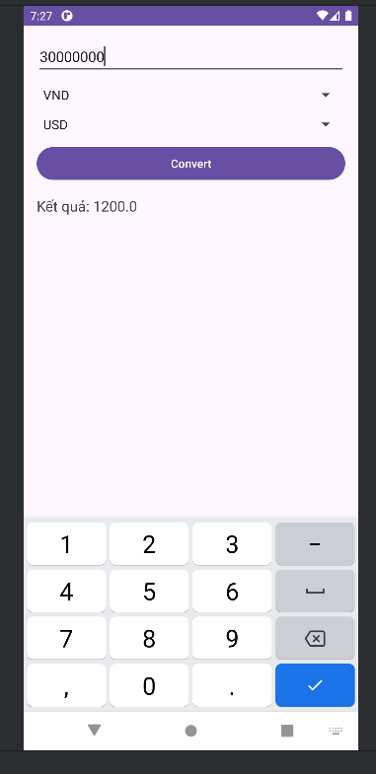

Chuyển đổi đơn vị độ dài
Đầu tiên ta tạo file xml activity_length.xml
<?xml version="1.0" encoding="utf-8"?>
<LinearLayout xmlns:android="http://schemas.android.com/apk/res/android"
android:orientation="vertical"
android:padding="16dp"
android:layout_width="match_parent"
android:layout_height="match_parent">
<EditText
android:id="@+id/edtValue"
android:layout_width="match_parent"
android:layout_height="wrap_content"
android:hint="Nhập giá trị"
android:inputType="numberDecimal" />
<Spinner
android:id="@+id/spUnitFrom"
android:layout_width="match_parent"
android:layout_height="wrap_content"
android:layout_marginTop="12dp" />
<Spinner
android:id="@+id/spUnitTo"
android:layout_width="match_parent"
android:layout_height="wrap_content"
android:layout_marginTop="8dp" />
<Button
android:id="@+id/btnConvert"
android:layout_width="match_parent"
android:layout_height="wrap_content"
android:text="Convert"
android:onClick="convert"
android:layout_marginTop="12dp" />
<TextView
android:id="@+id/tvOutput"
android:layout_width="match_parent"
android:layout_height="wrap_content"
android:text="Kết quả:"
android:textSize="18sp"
android:layout_marginTop="16dp" />
</LinearLayout>
Ta tạo file MainActivityLength.java
Khai báo biến:
Spinner spUnitFrom, spUnitTo;
EditText edtValue;
TextView tvOutput;
String[] units = {"m", "cm", "inch", "foot"};
double[][] lenRate = {
{1.0, 100.0, 39.37, 3.28},
{0.01, 1.0, 0.3937, 0.0328},
{0.0254, 2.54, 1.0, 0.083333},
{0.3048, 30.48, 12.0, 1.0}
};
int from = 0, to = 0;
Phần gọi giao diện ra để hiển thị:
@Override
protected void onCreate(Bundle savedInstanceState) {
super.onCreate(savedInstanceState);
setContentView(R.layout.activity_length);
spUnitFrom = findViewById(R.id.spUnitFrom);
spUnitTo = findViewById(R.id.spUnitTo);
edtValue = findViewById(R.id.edtValue);
tvOutput = findViewById(R.id.tvOutput);
ArrayAdapter<String> adapter =
new ArrayAdapter<>(this, android.R.layout.simple_spinner_item, units);
adapter.setDropDownViewResource(android.R.layout.simple_spinner_dropdown_item);
spUnitFrom.setAdapter(adapter);
spUnitTo.setAdapter(adapter);
spUnitFrom.setOnItemSelectedListener(new AdapterView.OnItemSelectedListener() {
@Override public void onItemSelected(AdapterView<?> parent, View view, int position, long id) {
from = position;
}
@Override public void onNothingSelected(AdapterView<?> parent) {}
});
spUnitTo.setOnItemSelectedListener(new AdapterView.OnItemSelectedListener() {
@Override public void onItemSelected(AdapterView<?> parent, View view, int position, long id) {
to = position;
}
@Override public void onNothingSelected(AdapterView<?> parent) {}
});
}

Hàm xử lý việc chuyển đổi:
public void convert(View v) {
String s = edtValue.getText().toString().trim();
if (s.isEmpty()) {
tvOutput.setText("Chưa nhập giá trị!");
return;
}
double input;
try {
input = Double.parseDouble(s);
} catch (NumberFormatException ex) {
tvOutput.setText("Giá trị không hợp lệ!");
return;
}
double result = input * lenRate[from][to];
tvOutput.setText(String.format("%s %s = %.6f %s", s, units[from], result, units[to]));
}
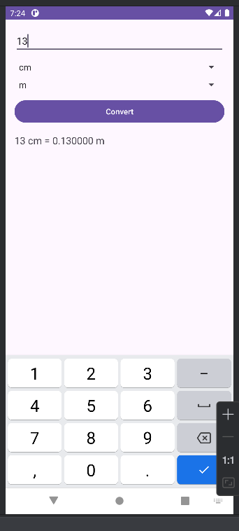

Bài Lab7:
Bài 1:
Code theo giao diện:
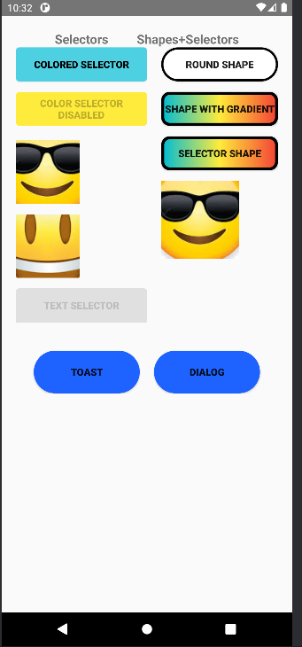
File xml
<ScrollView xmlns:android="http://schemas.android.com/apk/res/android"
android:layout_width="match_parent"
android:layout_height="match_parent">
<LinearLayout
android:layout_width="match_parent"
android:layout_height="wrap_content"
android:orientation="vertical"
android:padding="20dp">
<!-- Tiêu đề -->
<LinearLayout
android:layout_width="match_parent"
android:layout_height="wrap_content"
android:gravity="center">
<TextView
android:layout_width="wrap_content"
android:layout_height="wrap_content"
android:text="Selectors"
android:textStyle="bold"
android:textSize="18sp" />
<View
android:layout_width="40dp"
android:layout_height="1dp" />
<TextView
android:layout_width="wrap_content"
android:layout_height="wrap_content"
android:text="Shapes+Selectors"
android:textStyle="bold"
android:textSize="18sp" />
</LinearLayout>
<LinearLayout
android:layout_width="match_parent"
android:layout_height="wrap_content"
android:orientation="horizontal"
android:weightSum="2">
<!-- Cột trái -->
<LinearLayout
android:layout_width="0dp"
android:layout_height="wrap_content"
android:orientation="vertical"
android:layout_weight="1">
<!-- COLORED SELECTOR -->
<Button
android:id="@+id/btnColorSelector"
android:layout_width="match_parent"
android:layout_height="wrap_content"
android:background="@drawable/colored_selector"
android:text="COLORED SELECTOR"
android:textStyle="bold"
android:textColor="#000" />
<!-- DISABLED SELECTOR -->
<Button
android:id="@+id/btnDisabled"
android:layout_width="match_parent"
android:layout_height="wrap_content"
android:text="COLOR SELECTOR DISABLED"
android:textStyle="bold"
android:enabled="false"
android:layout_marginTop="15dp"
android:background="@drawable/selector_disabled" />
<!-- EMOJI -->
<ImageButton
android:id="@+id/btnEmoji1"
android:layout_width="90dp"
android:layout_height="90dp"
android:src="@drawable/emoji"
android:background="@drawable/emoji_border"
android:layout_marginTop="20dp" />
<ImageButton
android:id="@+id/btnEmoji2"
android:layout_width="90dp"
android:layout_height="90dp"
android:src="@drawable/emoji1"
android:background="@drawable/emoji_border"
android:layout_marginTop="15dp" />
<!-- TEXT SELECTOR -->
<Button
android:id="@+id/btnTextSelector"
android:layout_width="match_parent"
android:layout_height="wrap_content"
android:text="TEXT SELECTOR"
android:textStyle="bold"
android:textColor="@drawable/text_selector"
android:layout_marginTop="15dp"
android:background="@drawable/text_bg" />
</LinearLayout>
<!-- Cột phải -->
<LinearLayout
android:layout_width="0dp"
android:layout_height="wrap_content"
android:orientation="vertical"
android:layout_weight="1"
android:paddingLeft="20dp">
<!-- ROUND SHAPE -->
<Button
android:id="@+id/btnRoundShape"
android:layout_width="match_parent"
android:layout_height="wrap_content"
android:text="ROUND SHAPE"
android:background="@drawable/shape_round"
android:textStyle="bold" />
<!-- SHAPE WITH GRADIENT -->
<Button
android:id="@+id/btnGradient"
android:layout_width="match_parent"
android:layout_height="wrap_content"
android:text="SHAPE WITH GRADIENT"
android:background="@drawable/shape_gradient_big"
android:textStyle="bold"
android:layout_marginTop="15dp" />
<!-- SELECTOR SHAPE -->
<Button
android:id="@+id/btnSelectorShape"
android:layout_width="match_parent"
android:layout_height="wrap_content"
android:text="SELECTOR SHAPE"
android:background="@drawable/selector_shape_big"
android:textStyle="bold"
android:layout_marginTop="15dp" />
<!-- EMOJI 3 -->
<ImageButton
android:id="@+id/btnEmoji3"
android:layout_width="110dp"
android:layout_height="110dp"
android:layout_marginTop="15dp"
android:src="@drawable/emoji"
android:background="@drawable/emoji_border" />
</LinearLayout>
</LinearLayout>
<LinearLayout
android:layout_width="match_parent"
android:layout_height="wrap_content"
android:orientation="horizontal"
android:gravity="center"
android:layout_marginTop="40dp">
<Button
android:id="@+id/btnToast"
android:layout_width="150dp"
android:layout_height="60dp"
android:text="TOAST"
android:textStyle="bold"
android:background="@drawable/shape_toast_button"/>
<Button
android:id="@+id/btnDialog"
android:layout_width="150dp"
android:layout_height="60dp"
android:text="DIALOG"
android:layout_marginLeft="20dp"
android:textStyle="bold"
android:background="@drawable/shape_toast_button"/>
</LinearLayout>
</LinearLayout>
</ScrollView>

Bài 2
Yêu cầu:dựa trên bài 1 làm các animation cho các ảnh, tạo ra 1 giao diện đăng nhập cơ bản
Giao diện
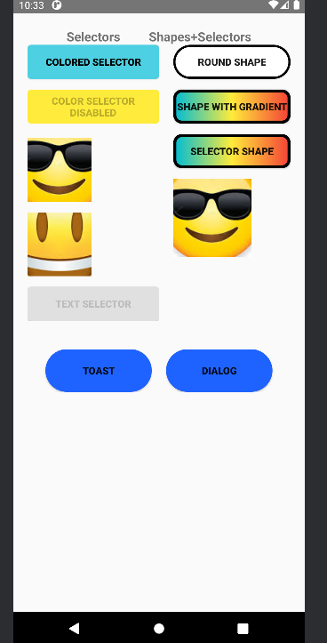
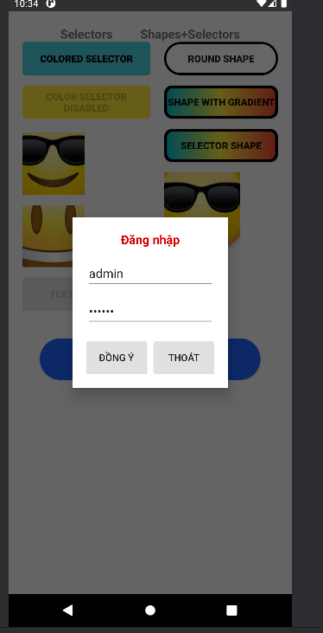
Drawable
Các drawtable:
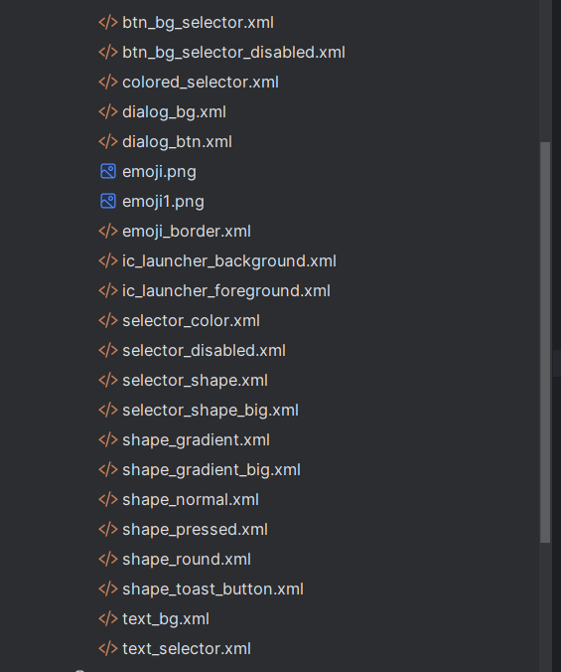
Layout
<ScrollView xmlns:android="http://schemas.android.com/apk/res/android"
android:layout_width="match_parent"
android:layout_height="match_parent">
<LinearLayout
android:layout_width="match_parent"
android:layout_height="wrap_content"
android:orientation="vertical"
android:padding="20dp">
<!-- Tiêu đề -->
<LinearLayout
android:layout_width="match_parent"
android:layout_height="wrap_content"
android:gravity="center">
<TextView
android:layout_width="wrap_content"
android:layout_height="wrap_content"
android:text="Selectors"
android:textStyle="bold"
android:textSize="18sp" />
<View
android:layout_width="40dp"
android:layout_height="1dp" />
<TextView
android:layout_width="wrap_content"
android:layout_height="wrap_content"
android:text="Shapes+Selectors"
android:textStyle="bold"
android:textSize="18sp" />
</LinearLayout>
<LinearLayout
android:layout_width="match_parent"
android:layout_height="wrap_content"
android:orientation="horizontal"
android:weightSum="2">
<!-- Cột trái -->
<LinearLayout
android:layout_width="0dp"
android:layout_height="wrap_content"
android:orientation="vertical"
android:layout_weight="1">
<!-- COLORED SELECTOR -->
<Button
android:id="@+id/btnColorSelector"
android:layout_width="match_parent"
android:layout_height="wrap_content"
android:background="@drawable/colored_selector"
android:text="COLORED SELECTOR"
android:textStyle="bold"
android:textColor="#000" />
<!-- DISABLED SELECTOR -->
<Button
android:id="@+id/btnDisabled"
android:layout_width="match_parent"
android:layout_height="wrap_content"
android:text="COLOR SELECTOR DISABLED"
android:textStyle="bold"
android:enabled="false"
android:layout_marginTop="15dp"
android:background="@drawable/selector_disabled" />
<!-- EMOJI -->
<ImageButton
android:id="@+id/btnEmoji1"
android:layout_width="90dp"
android:layout_height="90dp"
android:src="@drawable/emoji"
android:background="@drawable/emoji_border"
android:layout_marginTop="20dp" />
<ImageButton
android:id="@+id/btnEmoji2"
android:layout_width="90dp"
android:layout_height="90dp"
android:src="@drawable/emoji1"
android:background="@drawable/emoji_border"
android:layout_marginTop="15dp" />
<!-- TEXT SELECTOR -->
<Button
android:id="@+id/btnTextSelector"
android:layout_width="match_parent"
android:layout_height="wrap_content"
android:text="TEXT SELECTOR"
android:textStyle="bold"
android:textColor="@drawable/text_selector"
android:layout_marginTop="15dp"
android:background="@drawable/text_bg" />
</LinearLayout>
<!-- Cột phải -->
<LinearLayout
android:layout_width="0dp"
android:layout_height="wrap_content"
android:orientation="vertical"
android:layout_weight="1"
android:paddingLeft="20dp">
<!-- ROUND SHAPE -->
<Button
android:id="@+id/btnRoundShape"
android:layout_width="match_parent"
android:layout_height="wrap_content"
android:text="ROUND SHAPE"
android:background="@drawable/shape_round"
android:textStyle="bold" />
<!-- SHAPE WITH GRADIENT -->
<Button
android:id="@+id/btnGradient"
android:layout_width="match_parent"
android:layout_height="wrap_content"
android:text="SHAPE WITH GRADIENT"
android:background="@drawable/shape_gradient_big"
android:textStyle="bold"
android:layout_marginTop="15dp" />
<!-- SELECTOR SHAPE -->
<Button
android:id="@+id/btnSelectorShape"
android:layout_width="match_parent"
android:layout_height="wrap_content"
android:text="SELECTOR SHAPE"
android:background="@drawable/selector_shape_big"
android:textStyle="bold"
android:layout_marginTop="15dp" />
<!-- EMOJI 3 -->
<ImageButton
android:id="@+id/btnEmoji3"
android:layout_width="110dp"
android:layout_height="110dp"
android:layout_marginTop="15dp"
android:src="@drawable/emoji"
android:background="@drawable/emoji_border" />
</LinearLayout>
</LinearLayout>
<LinearLayout
android:layout_width="match_parent"
android:layout_height="wrap_content"
android:orientation="horizontal"
android:gravity="center"
android:layout_marginTop="40dp">
<Button
android:id="@+id/btnToast"
android:layout_width="150dp"
android:layout_height="60dp"
android:text="TOAST"
android:textStyle="bold"
android:background="@drawable/shape_toast_button"/>
<Button
android:id="@+id/btnDialog"
android:layout_width="150dp"
android:layout_height="60dp"
android:text="DIALOG"
android:layout_marginLeft="20dp"
android:textStyle="bold"
android:background="@drawable/shape_toast_button"/>
</LinearLayout>
</LinearLayout>
</ScrollView>

Code Activity
Code Bai2activtity
package com.example.lab7;
import android.app.Dialog;
import android.os.Bundle;
import android.view.Gravity;
import android.view.LayoutInflater;
import android.view.View;
import android.view.animation.Animation;
import android.view.animation.AnimationUtils;
import android.widget.Button;
import android.widget.EditText;
import android.widget.LinearLayout;
import android.widget.TextView;
import android.widget.Toast;
import androidx.appcompat.app.AppCompatActivity;
public class Bai2Activity extends AppCompatActivity {
Animation animBounce, animFade, animRotate;
@Override
protected void onCreate(Bundle savedInstanceState) {
super.onCreate(savedInstanceState);
setContentView(R.layout.activity_bai2);
// Load animation
animBounce = AnimationUtils.loadAnimation(this, R.anim.btn_bounce);
animFade = AnimationUtils.loadAnimation(this, R.anim.btn_fade_color);
animRotate = AnimationUtils.loadAnimation(this, R.anim.btn_rotate);
// Gán animation cho các nút
setAction(R.id.btnColorSelector, animBounce);
setAction(R.id.btnDisabled, animFade);
setAction(R.id.btnTextSelector, animFade);
setAction(R.id.btnRoundShape, animBounce);
setAction(R.id.btnGradient, animRotate);
setAction(R.id.btnSelectorShape, animBounce);
setAction(R.id.btnEmoji1, animRotate);
setAction(R.id.btnEmoji2, animBounce);
setAction(R.id.btnEmoji3, animRotate);
// TOAST
findViewById(R.id.btnToast).setOnClickListener(v -> showCustomToast());
// DIALOG
findViewById(R.id.btnDialog).setOnClickListener(v -> showCustomDialog());
}
private void setAction(int id, Animation anim) {
View v = findViewById(id);
if (v == null) return;
v.setOnClickListener(x -> {
v.startAnimation(anim);
});
}
// CUSTOM TOAST
private void showCustomToast() {
LayoutInflater inflater = getLayoutInflater();
View layout = inflater.inflate(R.layout.custom_toast, null);
Toast toast = new Toast(getApplicationContext());
toast.setDuration(Toast.LENGTH_LONG);
toast.setGravity(Gravity.CENTER_HORIZONTAL | Gravity.BOTTOM, 0, 200);
toast.setView(layout);
toast.show();
}
// CUSTOM DIALOG
private void showCustomDialog() {
Dialog dialog = new Dialog(this);
dialog.setContentView(R.layout.custom_dialog);
dialog.setCancelable(true);
EditText edtUser = dialog.findViewById(R.id.edtUser);
EditText edtPass = dialog.findViewById(R.id.edtPass);
Button btnOK = dialog.findViewById(R.id.btnOK);
Button btnCancel = dialog.findViewById(R.id.btnCancel);
btnOK.setOnClickListener(v -> {
Toast.makeText(this,
"User: " + edtUser.getText() + "\nPass: " + edtPass.getText(),
Toast.LENGTH_LONG).show();
});
btnCancel.setOnClickListener(v -> dialog.dismiss());
dialog.show();
}
}
bài 3:
Yêu cầu:tạo các 1 layout chỉnh các màu theo giao diện đã cho
Giao diện:
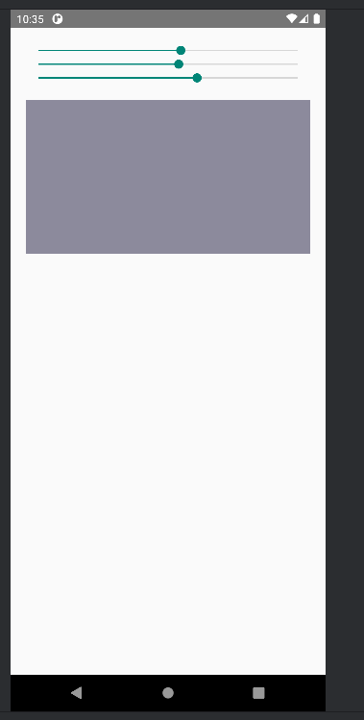
File xml:
<LinearLayout xmlns:android="http://schemas.android.com/apk/res/android"
android:layout_width="match_parent"
android:layout_height="match_parent"
android:orientation="vertical"
android:padding="20dp">
<SeekBar
android:id="@+id/seekR"
android:layout_width="match_parent"
android:layout_height="wrap_content"
android:max="255" />
<SeekBar
android:id="@+id/seekG"
android:layout_width="match_parent"
android:layout_height="wrap_content"
android:max="255" />
<SeekBar
android:id="@+id/seekB"
android:layout_width="match_parent"
android:layout_height="wrap_content"
android:max="255" />
<View
android:id="@+id/viewColor"
android:layout_width="match_parent"
android:layout_height="200dp"
android:layout_marginTop="20dp"
android:background="#000000" />
</LinearLayout>
Code Activity:
Khai báo biến và gọi giao diện:
SeekBar seekR, seekG, seekB;
View viewColor;
@Override
protected void onCreate(Bundle savedInstanceState) {
super.onCreate(savedInstanceState);
setContentView(R.layout.activity_bai3);
seekR = findViewById(R.id.seekR);
seekG = findViewById(R.id.seekG);
seekB = findViewById(R.id.seekB);
viewColor = findViewById(R.id.viewColor);
SeekBar.OnSeekBarChangeListener listener = new SeekBar.OnSeekBarChangeListener() {
@Override
public void onProgressChanged(SeekBar seekBar, int i, boolean b) {
updateColor();
}
@Override public void onStartTrackingTouch(SeekBar seekBar) {}
@Override public void onStopTrackingTouch(SeekBar seekBar) {}
};
seekR.setOnSeekBarChangeListener(listener);
seekG.setOnSeekBarChangeListener(listener);
seekB.setOnSeekBarChangeListener(listener);
}
Update màu:
private void updateColor() {
int r = seekR.getProgress();
int g = seekG.getProgress();
int b = seekB.getProgress();
viewColor.setBackgroundColor(Color.rgb(r, g, b));
}
Lab8:
Bài 1&2
Ta tạo các file java model Contributor và Food để lưu các biến
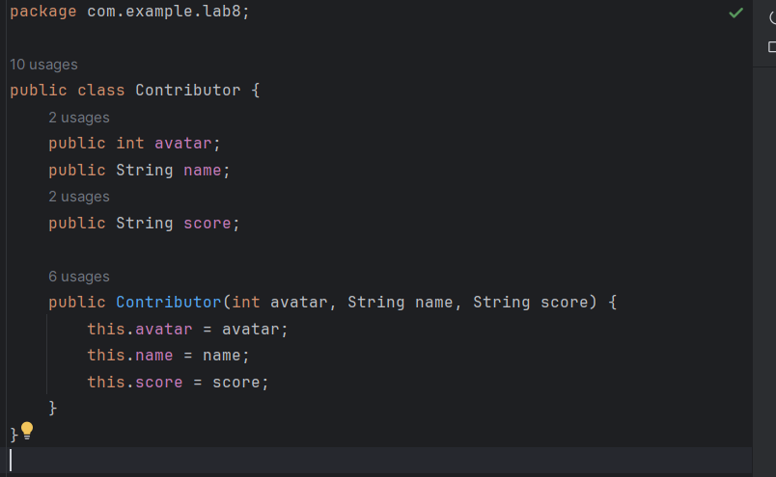
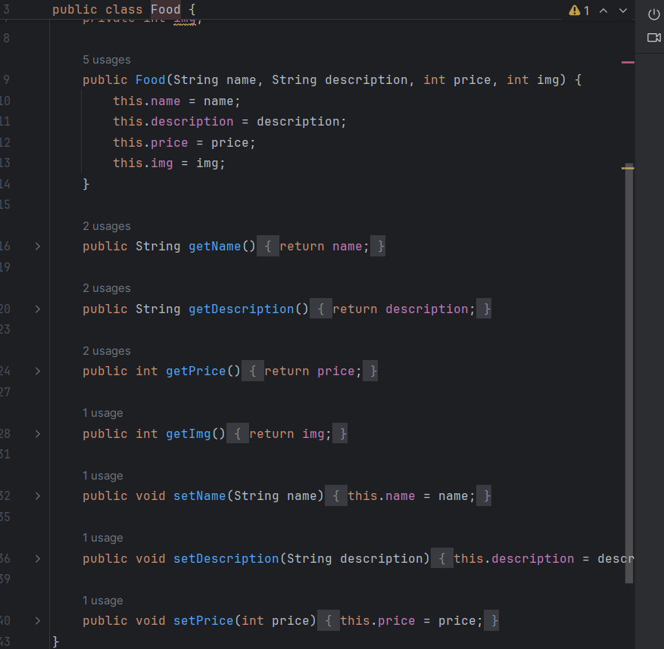
Sau đó ta cần các file adapter để gọi các giá trị này lên các file xml:

ContributorAdapter
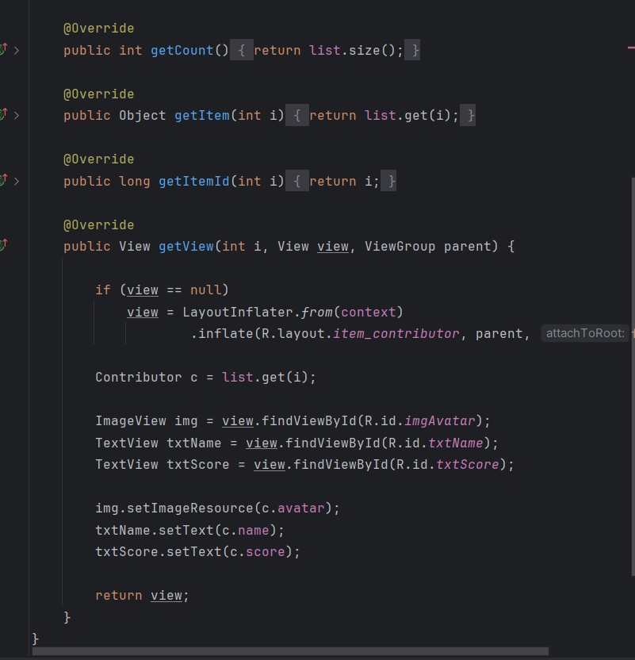
FoodAdapter:
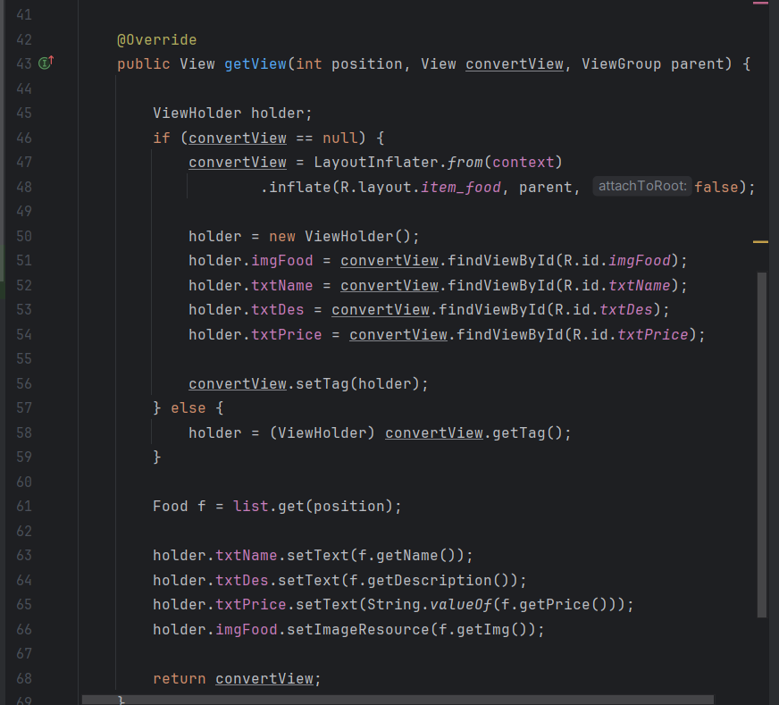
File ListActivity.java để gọi giao diện và hiển thị các ảnh đã thêm vào mục drawtable:
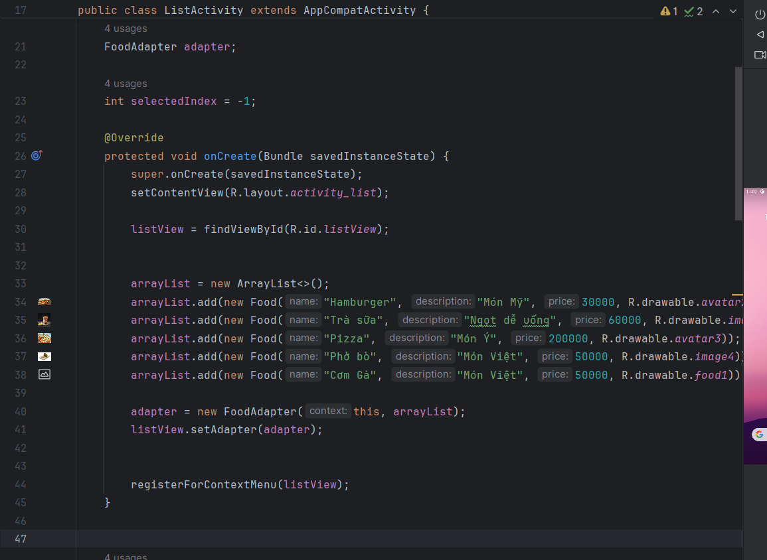
Các file xml:
activity_grid
<?xml version="1.0" encoding="utf-8"?>
<GridView xmlns:android="http://schemas.android.com/apk/res/android"
android:id="@+id/gridContributors"
android:layout_width="match_parent"
android:layout_height="match_parent"
android:background="#FFFF"
android:numColumns="2"
android:horizontalSpacing="10dp"
android:verticalSpacing="10dp"
android:padding="10dp">
</GridView>
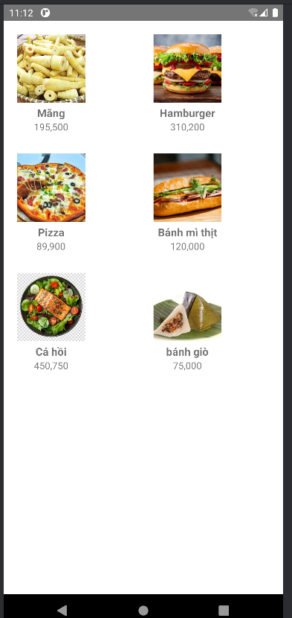
activity_list

<?xml version="1.0" encoding="utf-8"?>
<LinearLayout xmlns:android="http://schemas.android.com/apk/res/android"
android:orientation="vertical"
android:padding="10dp"
android:layout_width="match_parent"
android:layout_height="match_parent">
<ListView
android:id="@+id/listView"
android:layout_width="match_parent"
android:layout_height="match_parent"
android:dividerHeight="10dp"/>
</LinearLayout>
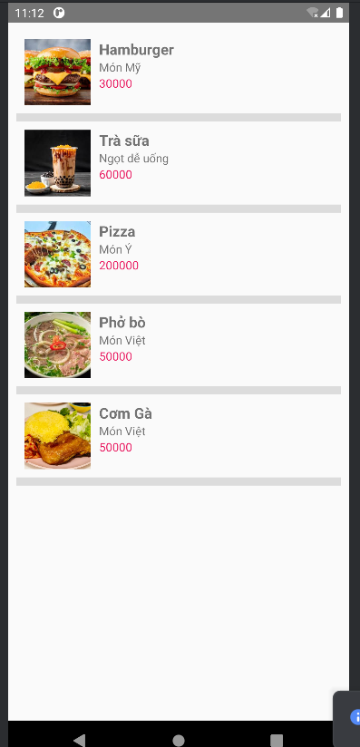
File item_contributor.xml để định dạng các các item trong contributor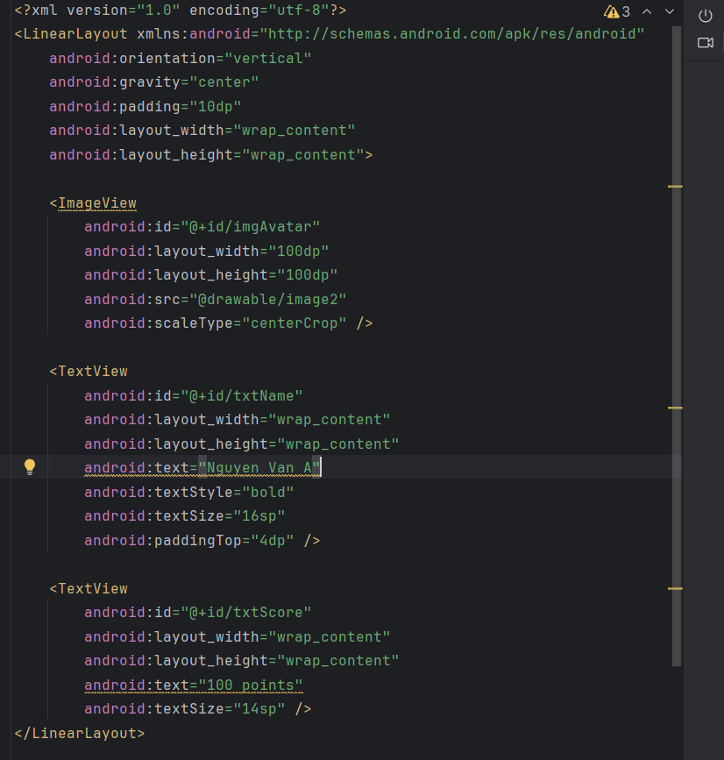
File item_food để định dạng các item trong food
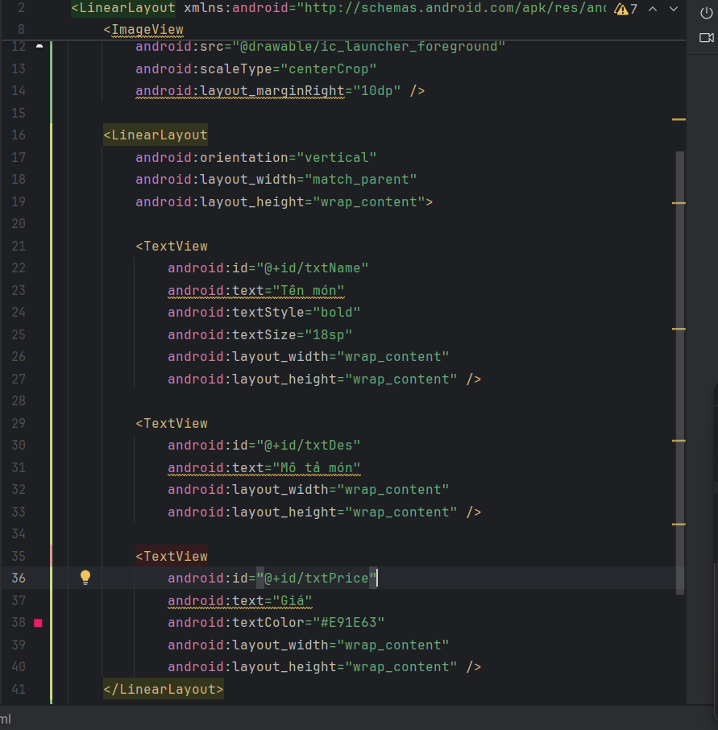
Sửa trong AndroidMainFest.xml
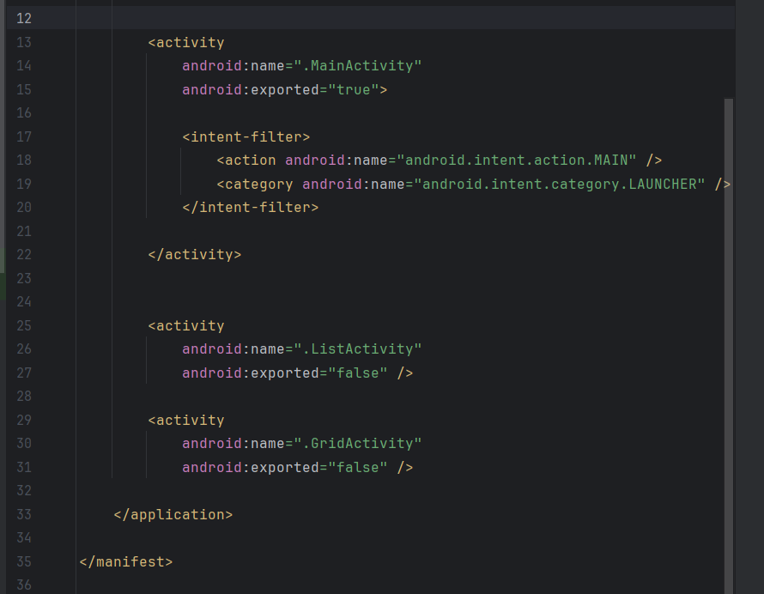

Bài 3:
Hàm xử lý sửa xóa:
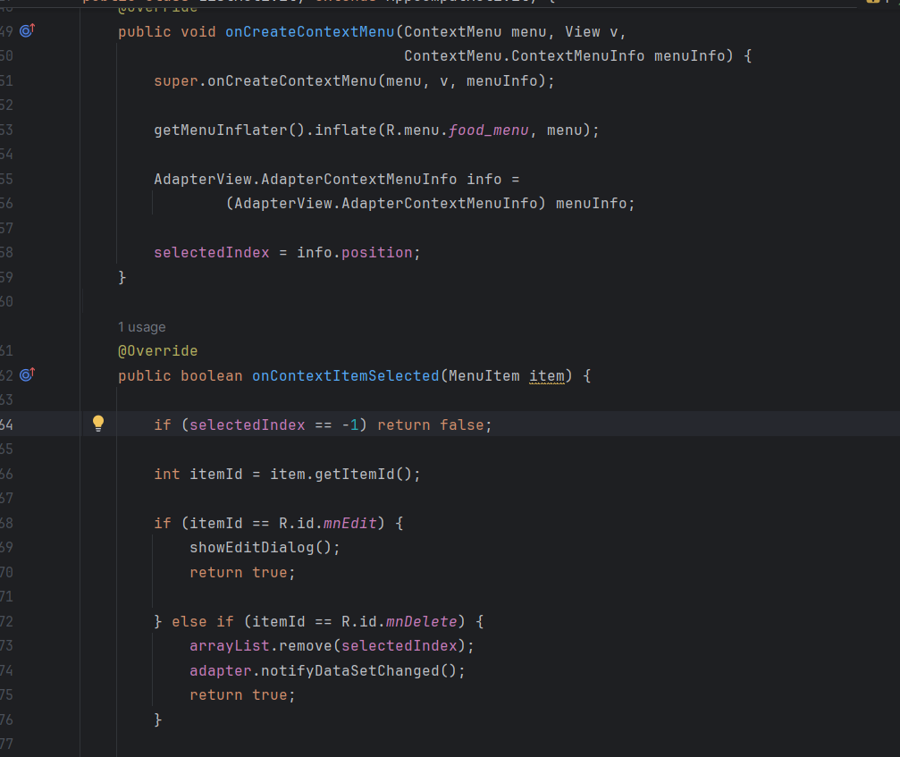
Giao diện sửa:
