Bài 1:Hoàn thiện các chức năng của một máy tính, có các phép +, -, *, /,
B1:sửa file activity_main.xml
<LinearLayout
xmlns:android="http://schemas.android.com/apk/res/android"
xmlns:app="http://schemas.android.com/apk/res-auto"
xmlns:tools="http://schemas.android.com/tools"
android:layout_width="match_parent"
android:layout_height="match_parent"
android:orientation="vertical"
android:weightSum="10"
tools:context=".MainActivity">
<EditText
android:id="@+id/txtX"
android:gravity="center"
android:layout_width="match_parent"
android:layout_weight="1"
android:layout_height="0dp"/>
<EditText
android:id="@+id/txtY"
android:gravity="center"
android:layout_width="match_parent"
android:layout_weight="1"
android:layout_height="0dp"/>
<TextView
android:id="@+id/txtResult"
android:layout_width="match_parent"
android:layout_height="0dp"
android:layout_weight="1"
android:gravity="center"
android:text="@string/result" />
<LinearLayout
android:layout_width="match_parent"
android:layout_height="0dp"
android:layout_weight="1"
android:orientation="horizontal"
android:weightSum="5">
<Button
android:id="@+id/btnPlus"
android:layout_width="0dp"
android:layout_weight="1"
android:text="@string/plus"
android:layout_height="match_parent"/>
<Button
android:id="@+id/btnMinus"
android:layout_width="0dp"
android:layout_weight="1"
android:text="@string/minus"
android:layout_height="match_parent"/>
<Button
android:id="@+id/btnMultiply"
android:layout_width="0dp"
android:layout_weight="1"
android:text="@string/multiply"
android:layout_height="match_parent"/>
<Button
android:id="@+id/btnDivide"
android:layout_width="0dp"
android:layout_weight="1"
android:text="@string/divide"
android:layout_height="match_parent"/>
<Button
android:id="@+id/btnModulo"
android:layout_width="0dp"
android:layout_weight="1"
android:text="@string/modulo"
android:layout_height="match_parent"/>
</LinearLayout>
</LinearLayout>
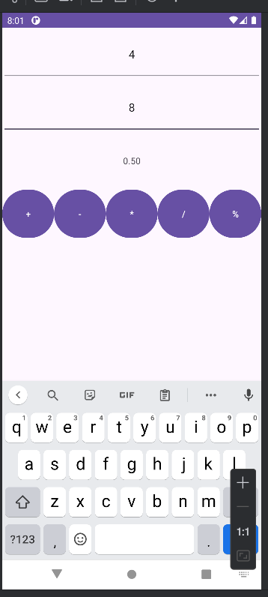
Sửa file String.xml như sau:
<resources>
<string name="app_name">Caculator</string>
<string name="from_xml">From Xml</string>
<string name="from_code">From CODE</string>
<string name="fade_in">Fade In</string>
<string name="fade_out">Fade Out</string>
<string name="blink">Blink</string>
<string name="zoom_in">Zoom In</string>
<string name="zoom_out">Zoom Out</string>
<string name="rotate">Rotate</string>
<string name="move">Move</string>
<string name="slide_up">Slide Up</string>
<string name="bounce">Bounce</string>
<string name="combine">Combine</string>
<string name="status_playing">Playing....</string>
<string name="result">Result</string>
<string name="plus">+</string>
<string name="minus">-</string>
<string name="multiply">*</string>
<string name="divide">/</string>
<string name="equal">+</string>
<string name="modulo">%</string>
</resources>
Sau đó ta viết các hàm để thực hiện các phép tính ở file Mainactivity.java
package com.example.firstprogram;
import android.os.Bundle;
import android.view.View;
import android.widget.Button;
import android.widget.EditText;
import android.widget.TextView;
import android.widget.Toast;
import androidx.appcompat.app.AppCompatActivity;
public class MainActivity extends AppCompatActivity {
EditText txtX, txtY;
TextView txtResult;
Button btnPlus, btnMinus, btnMultiply, btnDivide, btnModulo;
@Override
protected void onCreate(Bundle savedInstanceState) {
super.onCreate(savedInstanceState);
setContentView(R.layout.activity_main);
initControl();
}
private void initControl() {
txtX = findViewById(R.id.txtX);
txtY = findViewById(R.id.txtY);
txtResult = findViewById(R.id.txtResult);
btnPlus = findViewById(R.id.btnPlus);
btnMinus = findViewById(R.id.btnMinus);
btnMultiply = findViewById(R.id.btnMultiply);
btnDivide = findViewById(R.id.btnDivide);
btnModulo = findViewById(R.id.btnModulo);
// Sửa lỗi cú pháp: loại bỏ 'operator:'
btnPlus.setOnClickListener(v -> performOperation('+'));
btnMinus.setOnClickListener(v -> performOperation('-'));
btnMultiply.setOnClickListener(v -> performOperation('*'));
btnDivide.setOnClickListener(v -> performOperation('/'));
btnModulo.setOnClickListener(v -> performOperation('%'));
}
private void performOperation(char operator) {
try {
String xStr = txtX.getText().toString();
String yStr = txtY.getText().toString();
// Sửa lỗi cú pháp: loại bỏ 'context:' và 'text:'
if (xStr.isEmpty() || yStr.isEmpty()) {
Toast.makeText(this, "Please enter both X and Y", Toast.LENGTH_SHORT).show();
return;
}
double x = Double.parseDouble(xStr);
double y = Double.parseDouble(yStr);
double result = 0;
switch (operator) {
case '+':
result = x + y;
break;
case '-':
result = x - y;
break;
case '*':
result = x * y;
break;
case '/':
if (y == 0) {
// Sửa lỗi cú pháp: loại bỏ 'context:' và 'text:'
Toast.makeText(this, "Cannot divide by zero", Toast.LENGTH_SHORT).show();
return;
}
result = x / y; // Bổ sung phần còn thiếu
break; // Bổ sung phần còn thiếu
// Bổ sung case '%' cho btnModulo
case '%':
if (y == 0) {
Toast.makeText(this, "Cannot modulo by zero", Toast.LENGTH_SHORT).show();
return;
}
result = x % y;
break;
}
// Hiển thị kết quả với 2 chữ số thập phân
txtResult.setText(String.format("%.2f", result));
} catch (NumberFormatException e) {
// Bắt lỗi nếu người dùng nhập không phải là số
Toast.makeText(this, "Invalid input. Please enter numbers.", Toast.LENGTH_SHORT).show();
}
}
}
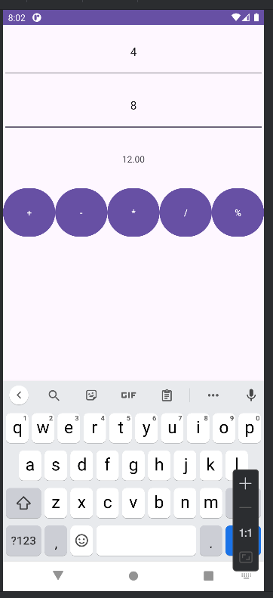
Bài 2: Xây dựng một ứng dụng cho phép mỗi khi người dùng nhấn nút thì xuất một số ngẫu nhiên ra màn hình (trái). Cải tiến để minh họa tung khối xúc xắc 6 mặt như hình phải.
Đầu tiên ta tạo 1 file java với tên DiceActivity, sau đó vào AndroidMainfest để thay đổi activity
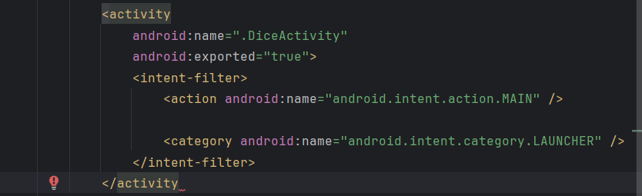
File DiceActivity.java
package com.example.firstprogram;
import android.os.Bundle;
import android.view.View;
import android.widget.Button;
import android.widget.ImageView;
import android.widget.TextView;
import androidx.appcompat.app.AppCompatActivity;
import java.util.Random;
public class DiceActivity extends AppCompatActivity {
// Khai báo biến (từ ảnh 1)
TextView txtNumber;
ImageView imgDice;
Button btnRoll;
Random random = new Random();
@Override
protected void onCreate(Bundle savedInstanceState) {
super.onCreate(savedInstanceState);
setContentView(R.layout.activity_dice);
// Ánh xạ View (từ cả 2 ảnh)
txtNumber = findViewById(R.id.txtNumber);
imgDice = findViewById(R.id.imgDice);
btnRoll = findViewById(R.id.btnRoll);
// Xử lý sự kiện click nút (ghép từ cả 2 ảnh)
btnRoll.setOnClickListener(new View.OnClickListener() {
@Override
public void onClick(View v) {
// Tạo số ngẫu nhiên từ 1-6
int number = random.nextInt(6) + 1;
txtNumber.setText("Number: " + number);
// Ánh xạ số với hình ảnh xúc xắc
int diceImage = R.drawable.so1; // Ảnh mặc định
switch (number) {
case 1:
diceImage = R.drawable.so1;
break;
case 2:
diceImage = R.drawable.so2;
break;
case 3:
diceImage = R.drawable.so3;
break;
case 4:
diceImage = R.drawable.so4;
break;
case 5:
diceImage = R.drawable.so5;
break;
case 6:
diceImage = R.drawable.so6;
break;
default:
diceImage = R.drawable.so1;
break;
}
// Hiển thị hình ảnh xúc xắc (từ ảnh 2)
imgDice.setImageResource(diceImage);
}
});
}
}
sau đó ta tạo file activity_dice.xml
<?xml version="1.0" encoding="utf-8"?>
<LinearLayout xmlns:android="http://schemas.android.com/apk/res/android"
android:layout_width="match_parent"
android:layout_height="match_parent"
android:orientation="vertical"
android:gravity="center"
android:padding="16dp">
<TextView
android:id="@+id/txtNumber"
android:layout_width="wrap_content"
android:layout_height="wrap_content"
android:text="Number: -"
android:textSize="24sp"
android:layout_marginBottom="16dp" />
<ImageView
android:id="@+id/imgDice"
android:layout_width="100dp"
android:layout_height="100dp"
android:layout_marginBottom="16dp" />
<Button
android:id="@+id/btnRoll"
android:layout_width="wrap_content"
android:layout_height="wrap_content"
android:text="Roll Dice" />
</LinearLayout>
Ta tìm kiếm 6 ảnh của 6 ảnh xúc xắc để thêm vào thư mục drawtable(lưu ý đặt tên file bằng chữ thường không được in hoa)
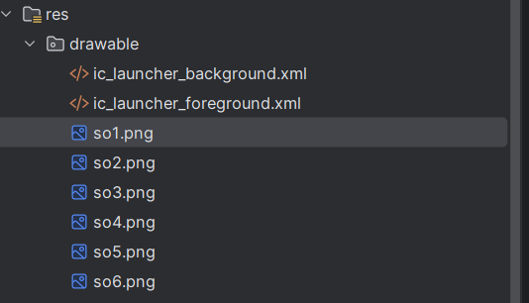
Sản phẩm thì ta có như sau
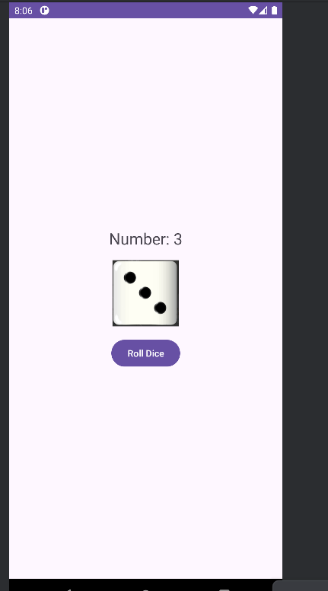
Bài 3:Viết chương trình cho phép gọi, nhắn tin trên Hệ điều hành Android.
Đầu tiên ta tạo 1 file java với tên PhoneActivity, sau đó vào AndroidMainfest để thay đổi activity
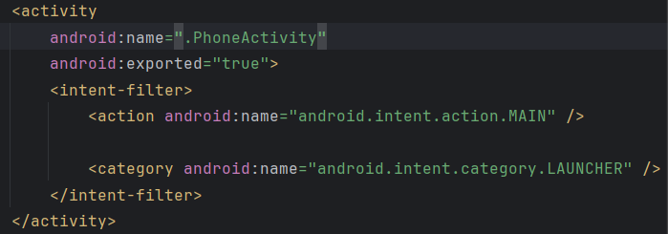
Thêm 3 dòng này ở file Androidmainfest trước thẻ application
<uses-permission android:name="android.permission.CALL_PHONE" />
<uses-permission android:name="android.permission.SEND_SMS" />
<uses-feature android:name="android.hardware.telephony" android:required="false" />
Code file PhoneActivity
package com.example.firstprogram;
// Các import này được lấy từ ảnh 581add.png
import android.content.pm.PackageManager;
import android.net.Uri;
import android.os.Bundle;
import android.telephony.SmsManager;
import android.widget.Button;
import android.widget.EditText;
import android.widget.Toast;
import androidx.appcompat.app.AppCompatActivity;
import androidx.core.app.ActivityCompat;
import androidx.core.content.ContextCompat;
// Các import này cần thiết cho code trong các ảnh sau
import android.content.Intent;
import android.view.View;
public class PhoneActivity extends AppCompatActivity {
// Khai báo biến (từ ảnh 581add.png)
EditText txtPhone;
Button btnCall, btnSendSMS;
private static final int REQUEST_CALL_PHONE = 1;
private static final int REQUEST_SEND_SMS = 2;
@Override
protected void onCreate(Bundle savedInstanceState) {
super.onCreate(savedInstanceState);
setContentView(R.layout.activity_phone);
// Ánh xạ view (từ ảnh 581add.png)
txtPhone = findViewById(R.id.txtPhone);
btnCall = findViewById(R.id.btnCall);
btnSendSMS = findViewById(R.id.btnSendSMS);
// Gán sự kiện click (hoàn thiện từ ảnh 581add.png)
btnCall.setOnClickListener(new View.OnClickListener() {
@Override
public void onClick(View v) {
makePhoneCall();
}
});
btnSendSMS.setOnClickListener(new View.OnClickListener() {
@Override
public void onClick(View v) {
sendSMS();
}
});
}
// Phương thức makePhoneCall (từ ảnh 581b3b.png)
private void makePhoneCall() {
String phoneNumber = txtPhone.getText().toString().trim();
if (phoneNumber.isEmpty()) {
Toast.makeText(this, "Please enter a phone number", Toast.LENGTH_SHORT).show();
return;
}
if (ContextCompat.checkSelfPermission(this, android.Manifest.permission.CALL_PHONE)
!= PackageManager.PERMISSION_GRANTED) {
ActivityCompat.requestPermissions(this,
new String[]{android.Manifest.permission.CALL_PHONE}, REQUEST_CALL_PHONE);
} else {
Intent callIntent = new Intent(Intent.ACTION_CALL);
callIntent.setData(Uri.parse("tel:" + phoneNumber));
startActivity(callIntent);
}
}
// Phương thức sendSMS (từ ảnh 581b5c.png)
private void sendSMS() {
String phoneNumber = txtPhone.getText().toString().trim();
if (phoneNumber.isEmpty()) {
Toast.makeText(this, "Please enter a phone number", Toast.LENGTH_SHORT).show();
return;
}
if (ContextCompat.checkSelfPermission(this, android.Manifest.permission.SEND_SMS)
!= PackageManager.PERMISSION_GRANTED) {
ActivityCompat.requestPermissions(this,
new String[]{android.Manifest.permission.SEND_SMS}, REQUEST_SEND_SMS);
} else {
try {
SmsManager smsManager = SmsManager.getDefault();
smsManager.sendTextMessage(phoneNumber, null, "Hello from Lab1!", null, null);
Toast.makeText(this, "SMS sent", Toast.LENGTH_SHORT).show();
} catch (Exception e) {
Toast.makeText(this, "Failed to send SMS", Toast.LENGTH_SHORT).show();
}
}
}
// Phương thức onRequestPermissionsResult (từ ảnh 581b99.png)
@Override
public void onRequestPermissionsResult(int requestCode, String[] permissions, int[] grantResults) {
super.onRequestPermissionsResult(requestCode, permissions, grantResults);
if (requestCode == REQUEST_CALL_PHONE) {
if (grantResults.length > 0 && grantResults[0] == PackageManager.PERMISSION_GRANTED) {
makePhoneCall();
} else {
Toast.makeText(this, "Call permission denied", Toast.LENGTH_SHORT).show();
}
} else if (requestCode == REQUEST_SEND_SMS) {
if (grantResults.length > 0 && grantResults[0] == PackageManager.PERMISSION_GRANTED) {
sendSMS();
} else {
Toast.makeText(this, "Send SMS permission denied", Toast.LENGTH_SHORT).show();
}
}
}
}
file activity_phone_xml
<?xml version="1.0" encoding="utf-8"?>
<LinearLayout xmlns:android="http://schemas.android.com/apk/res/android"
android:layout_width="match_parent"
android:layout_height="match_parent"
android:orientation="vertical"
android:padding="16dp">
<EditText
android:id="@+id/txtPhone"
android:layout_width="match_parent"
android:layout_height="wrap_content"
android:hint="Enter phone number"
android:inputType="phone" />
<Button
android:id="@+id/btnCall"
android:layout_width="match_parent"
android:layout_height="wrap_content"
android:text="Call" />
<Button
android:id="@+id/btnSendSMS"
android:layout_width="match_parent"
android:layout_height="wrap_content"
android:text="Send SMS" />
</LinearLayout>
Sau khi mở:
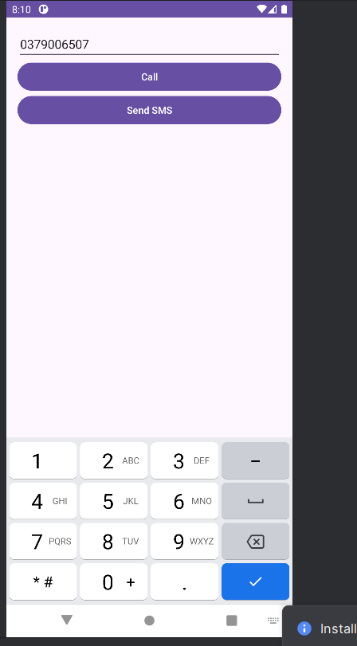
Khi ta gọi thành công:
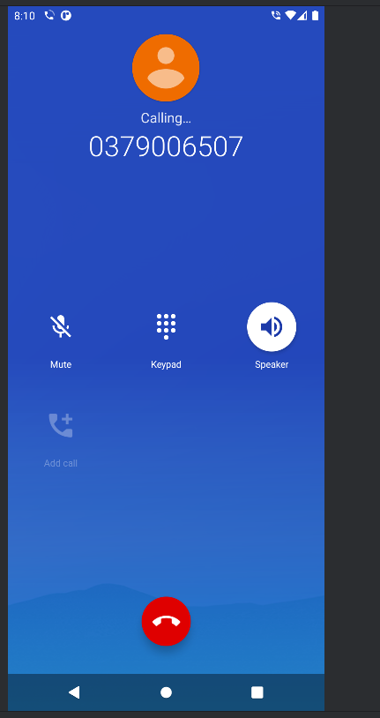
Gửi tin nhắn thành công:
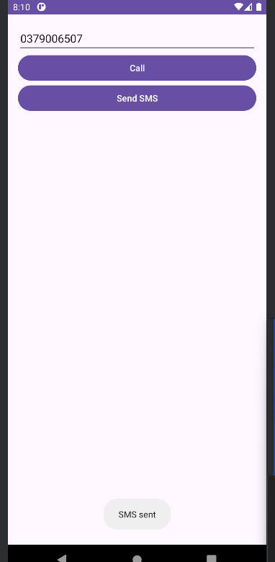
Lab2:
Bài 1:
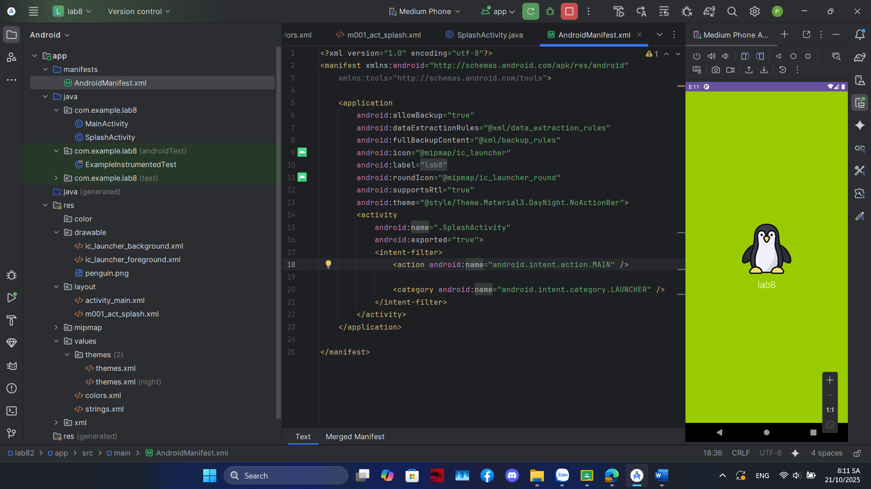
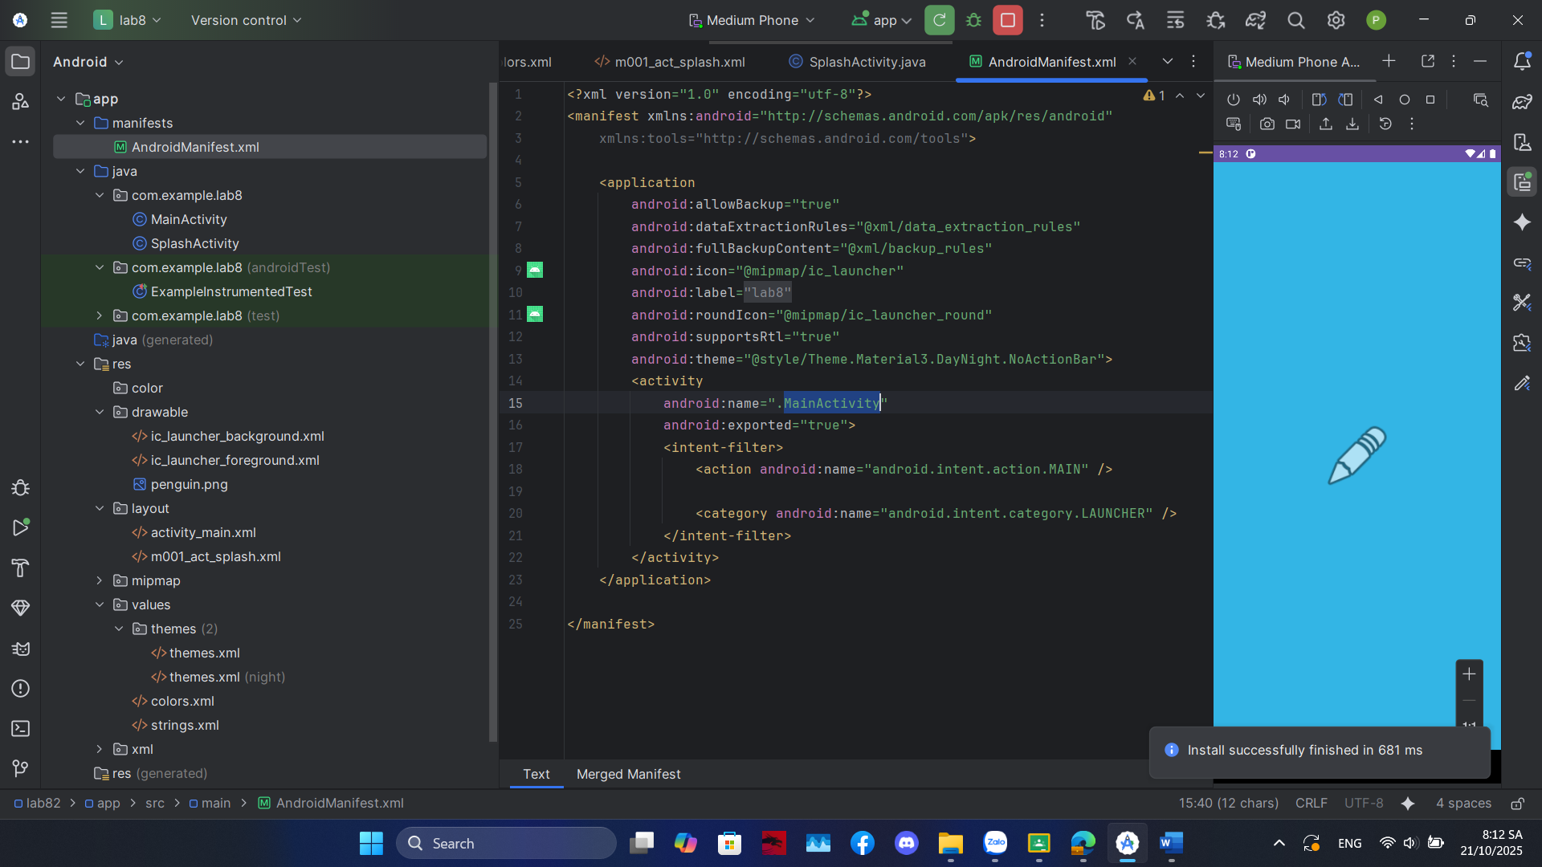
m001_act_splash
<?xml version="1.0" encoding="utf-8"?>
<LinearLayout xmlns:android="http://schemas.android.com/apk/res/android"
xmlns:tools="http://schemas.android.com/tools"
android:id="@+id/splashLayout"
android:layout_width="match_parent"
android:layout_height="match_parent"
android:gravity="center"
android:orientation="vertical"
tools:context=".SplashActivity"
tools:background="@color/design_default_color_primary_dark">
<ImageView
android:id="@+id/splashIcon"
android:layout_width="128dp"
android:layout_height="128dp"
tools:ignore="ContentDescription"
tools:src="@android:drawable/ic_menu_gallery" />
<TextView
android:layout_width="wrap_content"
android:layout_height="wrap_content"
android:layout_marginTop="10dp"
android:fontFamily="sans-serif-light"
android:text="@string/app_name"
android:textColor="@color/white"
android:textSize="24sp" />
</LinearLayout>
Bài 2:
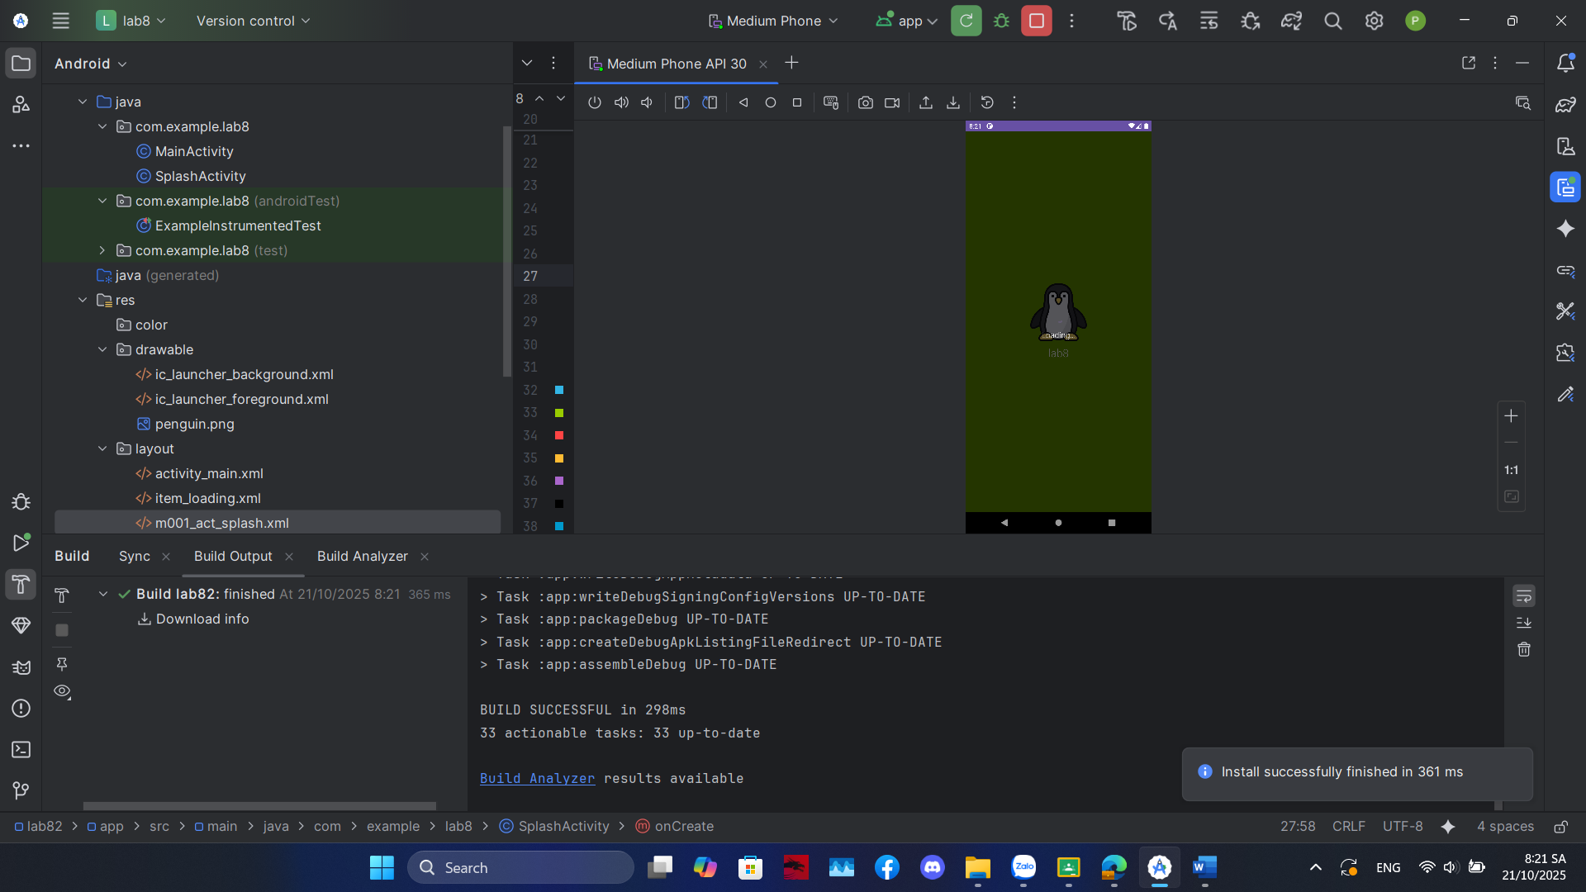
Item_loading:
<?xml version="1.0" encoding="utf-8"?>
<LinearLayout xmlns:android="http://schemas.android.com/apk/res/android"
android:layout_width="match_parent"
android:layout_height="match_parent"
android:background="#A6000000"
android:gravity="center"
android:orientation="vertical"
android:clickable="true"
android:focusable="true">
<ProgressBar
android:layout_width="wrap_content"
android:layout_height="wrap_content"
android:indeterminate="true" />
<TextView
android:layout_width="wrap_content"
android:layout_height="wrap_content"
android:layout_marginTop="10dp"
android:text="Loading..."
android:textColor="@color/white"
android:textSize="18sp"
android:fontFamily="sans-serif-light" />
</LinearLayout>
Bài 3:
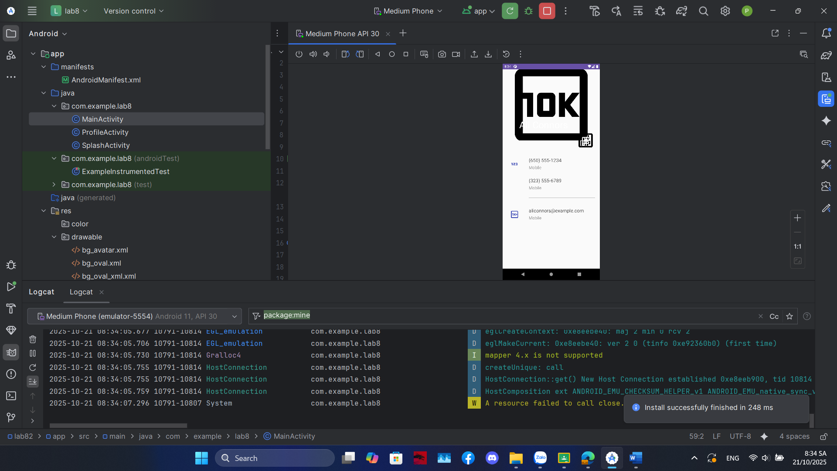

Tạo file m001_act_profile.xml
<?xml version="1.0" encoding="utf-8"?>
<LinearLayout xmlns:android="http://schemas.android.com/apk/res/android"
xmlns:app="http://schemas.android.com/apk/res-auto"
xmlns:tools="http://schemas.android.com/tools"
android:layout_width="match_parent"
android:layout_height="match_parent"
android:background="@color/gray_light"
android:orientation="vertical"
tools:context=".ProfileActivity">
<FrameLayout
android:layout_width="match_parent"
android:layout_height="350dp">
<ImageView
android:layout_width="match_parent"
android:layout_height="300dp"
android:scaleType="centerCrop"
android:src="@drawable/dog"
tools:ignore="ContentDescription" />
<TextView
android:layout_width="wrap_content"
android:layout_height="wrap_content"
android:layout_gravity="bottom"
android:layout_marginStart="70dp"
android:layout_marginBottom="90dp"
android:fontFamily="sans-serif"
android:text="@string/txt_name"
android:textColor="@color/black"
android:textSize="40sp" />
<ImageView
android:layout_width="80dp"
android:layout_height="80dp"
android:layout_gravity="end|bottom"
android:layout_marginEnd="20dp"
android:layout_marginBottom="10dp"
android:background="@drawable/bg_oval"
android:padding="20dp"
android:src="@drawable/ic_star"
app:tint="@color/white"
tools:ignore="ContentDescription" />
</FrameLayout>
<TableRow
android:id="@+id/row_phone_1"
android:layout_width="match_parent"
android:layout_height="wrap_content"
android:background="?attr/selectableItemBackground"
android:clickable="true"
android:focusable="true"
android:padding="20dp">
<ImageView
android:layout_width="60dp"
android:layout_height="60dp"
android:padding="10dp"
android:src="@drawable/ic_phone"
app:tint="@color/indigo"
tools:ignore="ContentDescription"/>
<LinearLayout
android:layout_width="match_parent"
android:layout_height="wrap_content"
android:layout_marginStart="30dp"
android:orientation="vertical">
<TextView
android:layout_width="match_parent"
android:layout_height="wrap_content"
android:text="@string/txt_phone1"
android:textColor="@color/gray_dark"
android:textSize="20sp" />
<TextView
android:layout_width="match_parent"
android:layout_height="wrap_content"
android:layout_marginTop="5dp"
android:text="@string/txt_title_mobile"
android:textColor="@color/gray_mid"
android:textSize="18sp" />
<TextView
android:layout_width="match_parent"
android:layout_height="wrap_content"
android:layout_marginTop="30dp"
android:text="@string/txt_phone2"
android:textColor="@color/gray_dark"
android:textSize="20sp" />
<TextView
android:layout_width="match_parent"
android:layout_height="wrap_content"
android:layout_marginTop="5dp"
android:text="@string/txt_title_mobile"
android:textColor="@color/gray_mid"
android:textSize="18sp" />
<View
android:layout_width="match_parent"
android:layout_height="0.5dp"
android:layout_marginTop="30dp"
android:background="@color/gray_mid"/>
</LinearLayout>
</TableRow>
<TableRow
android:id="@+id/row_email"
android:layout_width="match_parent"
android:layout_height="wrap_content"
android:background="?attr/selectableItemBackground"
android:clickable="true"
android:focusable="true"
android:padding="20dp">
<ImageView
android:layout_width="60dp"
android:layout_height="60dp"
android:padding="10dp"
android:src="@drawable/ic_email"
app:tint="@color/indigo"
tools:ignore="ContentDescription"/>
<LinearLayout
android:layout_width="match_parent"
android:layout_height="match_parent"
android:layout_marginStart="30dp"
android:orientation="vertical">
<TextView
android:layout_width="match_parent"
android:layout_height="wrap_content"
android:text="@string/txt_email"
android:textColor="@color/gray_dark"
android:textSize="20sp" />
<TextView
android:layout_width="match_parent"
android:layout_height="wrap_content"
android:layout_marginTop="5dp"
android:text="@string/txt_title_mobile"
android:textColor="@color/gray_mid"
android:textSize="18sp" />
</LinearLayout>
</TableRow>
<!-- HÀNG SMS ĐƯỢC THÊM VÀO -->
<TableRow
android:id="@+id/row_sms"
android:layout_width="match_parent"
android:layout_height="wrap_content"
android:background="?attr/selectableItemBackground"
android:clickable="true"
android:focusable="true"
android:padding="20dp">
<ImageView
android:layout_width="60dp"
android:layout_height="60dp"
android:padding="10dp"
android:src="@drawable/ic_sms"
app:tint="@color/indigo"
tools:ignore="ContentDescription" />
<!-- Bạn cần thêm icon ic_sms vào drawable -->
<LinearLayout
android:layout_width="match_parent"
android:layout_height="match_parent"
android:layout_marginStart="30dp"
android:orientation="vertical">
<TextView
android:layout_width="match_parent"
android:layout_height="wrap_content"
android:text="@string/txt_phone1"
android:textColor="@color/gray_dark"
android:textSize="20sp" />
<!-- Hiển thị số điện thoại sẽ gửi tin nhắn -->
<TextView
android:layout_width="match_parent"
android:layout_height="wrap_content"
android:layout_marginTop="5dp"
android:text="Send Message"
android:textColor="@color/gray_mid"
android:textSize="18sp" />
<!-- Tiêu đề phụ là "Send Message" -->
</LinearLayout>
</TableRow>
</LinearLayout>
Kế tiếp tạo file ProfileActivity.java
package com.example.lab2th;
import androidx.annotation.NonNull;
import androidx.appcompat.app.AppCompatActivity;
import androidx.core.app.ActivityCompat;
import androidx.core.content.ContextCompat;
import android.content.Intent;
import android.content.pm.PackageManager;
import android.net.Uri;
import android.os.Bundle;
import android.telephony.SmsManager; // --- Thêm import này ---
import android.view.View;
import android.widget.TableRow;
import android.widget.Toast;
public class ProfileActivity extends AppCompatActivity {
// Khai báo hằng số để nhận diện yêu cầu xin quyền
private static final int REQUEST_CALL_PHONE = 1;
private static final int REQUEST_SEND_SMS = 2; // --- Thêm hằng số này ---
TableRow rowPhone1;
TableRow rowEmail;
TableRow rowSms;
private String phoneNumber1;
@Override
protected void onCreate(Bundle savedInstanceState) {
super.onCreate(savedInstanceState);
setContentView(R.layout.m001_act_profile);
// Ánh xạ các View
rowPhone1 = findViewById(R.id.row_phone_1);
rowEmail = findViewById(R.id.row_email);
rowSms = findViewById(R.id.row_sms); // Đảm bảo ID này có trong XML
// Lấy số điện thoại và email từ strings.xml
phoneNumber1 = getString(R.string.txt_phone1);
final String emailAddress = getString(R.string.txt_email);
// Xử lý sự kiện click vào hàng số điện thoại
rowPhone1.setOnClickListener(new View.OnClickListener() {
@Override
public void onClick(View v) {
makePhoneCall();
}
});
// Xử lý sự kiện click vào hàng email
rowEmail.setOnClickListener(new View.OnClickListener() {
@Override
public void onClick(View v) {
composeEmail(emailAddress);
}
});
// --- ĐÃ THAY ĐỔI ---
// Xử lý sự kiện click vào hàng SMS
if (rowSms != null) {
rowSms.setOnClickListener(new View.OnClickListener() {
@Override
public void onClick(View v) {
// Gọi hàm tự động gửi SMS (thay vì mở app)
sendSms();
}
});
}
}
/**
* Thực hiện cuộc gọi (ACTION_CALL)
*/
private void makePhoneCall() {
if (ContextCompat.checkSelfPermission(this, android.Manifest.permission.CALL_PHONE)
!= PackageManager.PERMISSION_GRANTED) {
ActivityCompat.requestPermissions(this,
new String[]{android.Manifest.permission.CALL_PHONE},
REQUEST_CALL_PHONE);
} else {
Intent intent = new Intent(Intent.ACTION_CALL);
intent.setData(Uri.parse("tel:" + phoneNumber1));
startActivity(intent);
}
}
/**
* Mở ứng dụng Email
*/
private void composeEmail(String emailAddress) {
Intent intent = new Intent(Intent.ACTION_SENDTO);
intent.setData(Uri.parse("mailto:" + emailAddress));
if (intent.resolveActivity(getPackageManager()) != null) {
startActivity(intent);
}
}
/**
* --- HÀM MỚI ---
* Tự động gửi SMS và hiển thị Toast "SMS sent"
* Yêu cầu kiểm tra và xin quyền SEND_SMS lúc chạy
*/
private void sendSms() {
// Kiểm tra xem quyền SEND_SMS đã được cấp chưa
if (ContextCompat.checkSelfPermission(this, android.Manifest.permission.SEND_SMS)
!= PackageManager.PERMISSION_GRANTED) {
// Nếu chưa, yêu cầu người dùng cấp quyền
ActivityCompat.requestPermissions(this,
new String[]{android.Manifest.permission.SEND_SMS},
REQUEST_SEND_SMS);
} else {
// Nếu đã có quyền, thực hiện gửi tin nhắn
try {
SmsManager smsManager = SmsManager.getDefault();
// Gửi tin nhắn
smsManager.sendTextMessage(phoneNumber1, null, "Hello from ProfileActivity!", null, null);
// Hiển thị thông báo thành công
Toast.makeText(this, "SMS sent", Toast.LENGTH_SHORT).show();
} catch (Exception e) {
// Hiển thị thông báo nếu có lỗi
Toast.makeText(this, "Failed to send SMS", Toast.LENGTH_SHORT).show();
e.printStackTrace();
}
}
}
/**
* --- ĐÃ CẬP NHẬT ---
* Hàm này được gọi sau khi người dùng trả lời hộp thoại xin quyền
*/
@Override
public void onRequestPermissionsResult(int requestCode, @NonNull String[] permissions, @NonNull int[] grantResults) {
super.onRequestPermissionsResult(requestCode, permissions, grantResults);
if (requestCode == REQUEST_CALL_PHONE) {
if (grantResults.length > 0 && grantResults[0] == PackageManager.PERMISSION_GRANTED) {
makePhoneCall();
} else {
Toast.makeText(this, "Call permission denied", Toast.LENGTH_SHORT).show();
}
}
// Thêm xử lý cho REQUEST_SEND_SMS
else if (requestCode == REQUEST_SEND_SMS) {
if (grantResults.length > 0 && grantResults[0] == PackageManager.PERMISSION_GRANTED) {
// Nếu người dùng "Allow", gọi lại hàm sendSms() để gửi
sendSms();
} else {
// Nếu người dùng "Deny", thông báo cho họ
Toast.makeText(this, "Send SMS permission denied", Toast.LENGTH_SHORT).show();
}
}
}
}
Sau đó vào androidMainFest.xml để thêm activity của ProfileActivity vào, và thêm các dòng để gọi thành công
<uses-permission android:name="android.permission.CALL_PHONE" />
<uses-permission android:name="android.permission.SEND_SMS" />
<uses-feature android:name="android.hardware.telephony" android:required="false" />
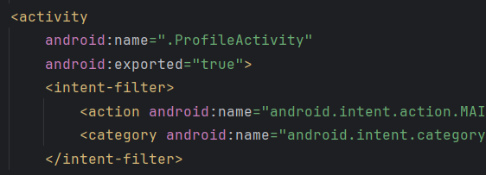
đã có thể gọi được khi click vào phone
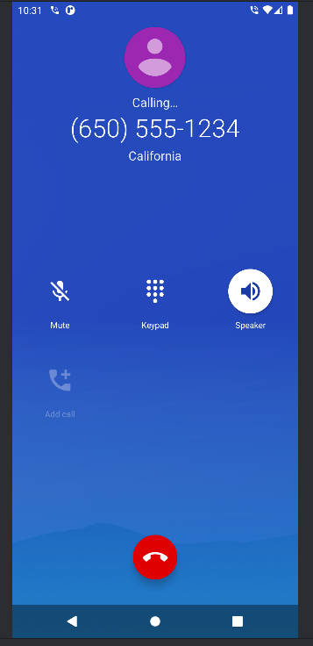
Gửi sms thành công
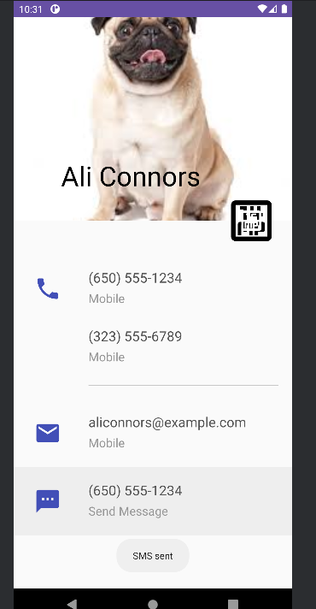

Bài 4:
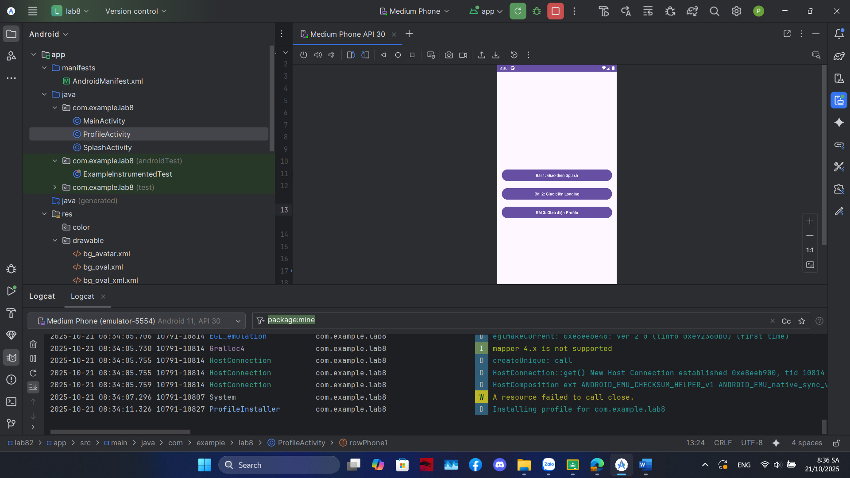
Activity_main.xml
<?xml version="1.0" encoding="utf-8"?>
<LinearLayout xmlns:android="http://schemas.android.com/apk/res/android"
xmlns:tools="http://schemas.android.com/tools"
android:layout_width="match_parent"
android:layout_height="match_parent"
android:orientation="vertical"
android:gravity="center"
android:padding="16dp"
tools:context=".MainActivity">
<Button
android:id="@+id/btnBai1"
android:layout_width="match_parent"
android:layout_height="wrap_content"
android:text="Bài 1: Giao diện Splash" />
<Button
android:id="@+id/btnBai2"
android:layout_width="match_parent"
android:layout_height="wrap_content"
android:layout_marginTop="16dp"
android:text="Bài 2: Giao diện Loading" />
<Button
android:id="@+id/btnBai3"
android:layout_width="match_parent"
android:layout_height="wrap_content"
android:layout_marginTop="16dp"
android:text="Bài 3: Giao diện Profile" />
</LinearLayout>
Mainactivity.java
package com.example.lab8;

import androidx.appcompat.app.AppCompatActivity;

import android.content.Intent;
import android.os.Bundle;
import android.view.View;
import android.widget.Button;

public class MainActivity extends AppCompatActivity {

Button btnBai1, btnBai2, btnBai3;

@Override
protected void onCreate(Bundle savedInstanceState) {
super.onCreate(savedInstanceState);
setContentView(R.layout.activity_main);

btnBai1 = findViewById(R.id.btnBai1);
btnBai2 = findViewById(R.id.btnBai2);
btnBai3 = findViewById(R.id.btnBai3);

btnBai1.setOnClickListener(new View.OnClickListener() {
@Override
public void onClick(View v) {
openDisplay(false);
}
});

btnBai2.setOnClickListener(new View.OnClickListener() {
@Override
public void onClick(View v) {
openDisplay(true);
}
});

btnBai3.setOnClickListener(new View.OnClickListener() {
@Override
public void onClick(View v) {
Intent intent = new Intent(MainActivity.this, ProfileActivity.class);
startActivity(intent);
}
});
}

private void openDisplay(boolean showLoading) {
Intent intent = new Intent(MainActivity.this, SplashActivity.class);
intent.putExtra("SHOW_LOADING", showLoading);
startActivity(intent);
}
}

