**CULINARY CULTURE IN CANBERRA WEBSITE**

**Existing solution**

There are some existing websites offering me with motivation to create my own Culinary culture in Canberra website, which will focus on delivering the content of food from diverse communities.

1. **Out In Canberra**

<https://www.outincanberra.com.au/>

Out In Canberra is a reference point where users can find almost everything they want to do in Canberra. There are a range of not only dinning but also the entertainment including music, theather and art.

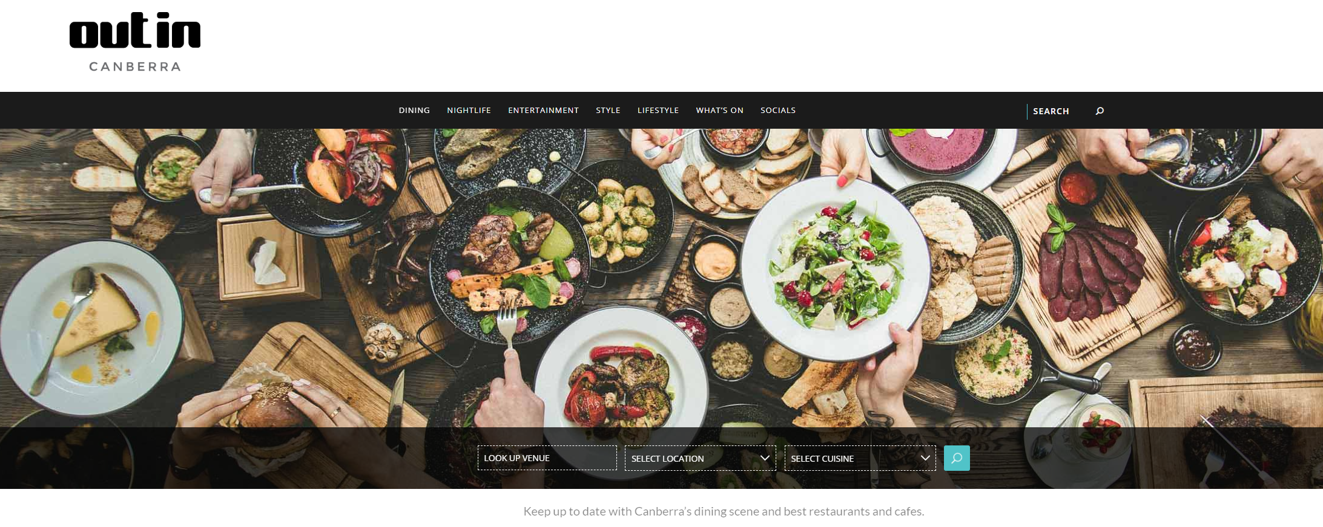

1. **CanberraTimes/Food-Drink**

<https://www.canberratimes.com.au/whats-on/food-drink/>

Food-Drink session in CanberraTimes is a collection of news, articles related to cuisine. There are also some reviews or share experience for particular dining location. Viewers can find the mix of professionally written conclusion by nutritionist or just personal opinion like some recommendation which helps increase the healthy lifestyle or remediate cooking problem.

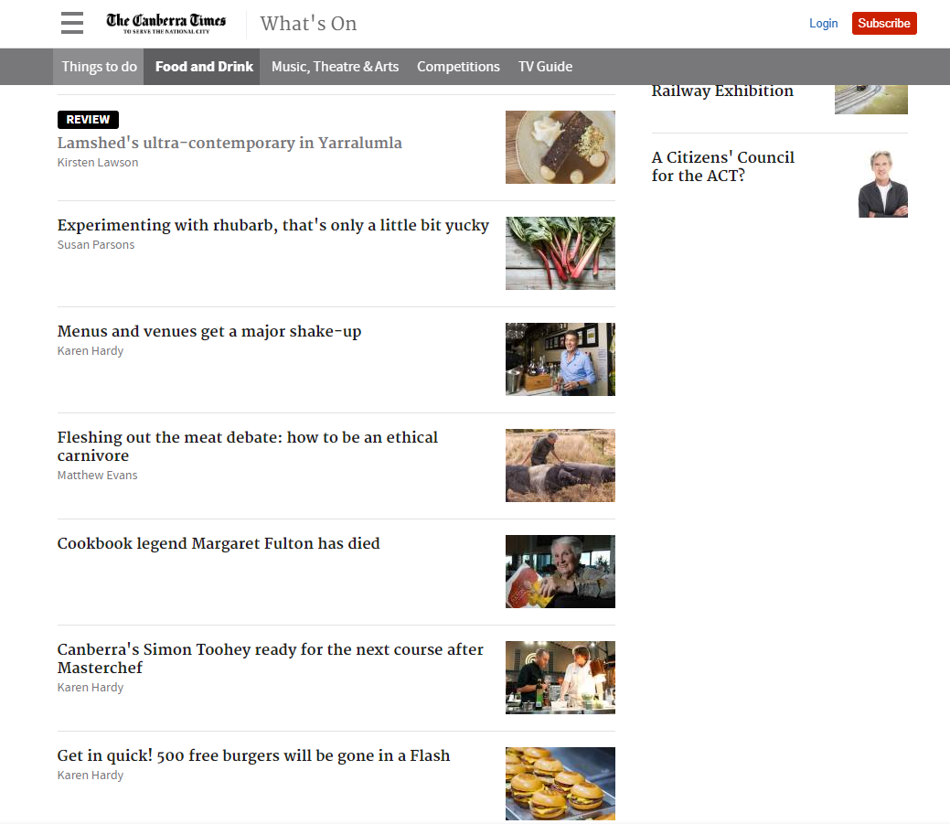

**Design direction**

The design direction for Culinary culture in Canberra is to bring people closer to Canberra – Australian capital city with the incredible richness of culinary arts. This direction has been selected as the driving objective to make sure the website will deliver a useful and impressive tool to embrace Canberra and people in terms of inspiring, informing and connecting.

Culinary culture in Canberra will be a four-page website. This website will be responsive, and responding to the user's environment based on screen size.

-What's on: This is news and articles about food in Canberra. It will be operational as a dynamic news‐based webpage. The news is updated and provided to users instantly. Those information is considered as live or real‐time broadcast.

-Dining spot: This page can be considered as all in one kiosk as multiple functions will be aggregated at users’s convenience.

Cuisine will be categorised and in each category, for example Asian, European, Australian, Middle-east..., there will be a list of recommended restaurants in Canberra. The map is available to navigate them to the requested place or the restaurant from the search in Canberra.

The images used in the Dining spot will be 3D images, which is crucial to convey the interaction feature. Users are able to rotate the image of the chosen dish, in this case, users can slide left and right the image to have a better view and feeling.

-Special event: It will display the upcoming food events or festivals for example: Multicultural, Thai food fair, Korean food day... The events will be sorted out based on the date.

-Contact us: Users can provide additional information which can be used for update for the website or enquiry which will be considered and replied by admin.

This design direction has been considered in the key color theme and background image and logo. The navy blue and yellow color which are used in ACT flag will be applied in the background for button functions. The main layout is ensured to be consistent over sub-pages.

**Minimalistic Design**

The users should be able to utilize or take advantage of all functions which were created for them to use. They must have a feeling of ease when navigating through all pages. Each webpage presents content in transparent way and eay-to-use for all viewers.

**Continuity**

Continuity is one of the most important elements which can contribute in deciding whether it is a good design or not. When using this website, users expect data flow is not beyond their knowledge. In other word, users can foresee the action/design of next stage based on some lines/element. This is considered as “Continuity” in the form of a line or a direction from one page to another.

**Similarity**

The similarity rule is considered as one of the principles which construct a good design. Similaritycan be reflected in the context of alignment and layout, or shape or color etc. Alignment is one of those important things that can help to enhance an experience for the user. Grid systems can be a handy option which we can deal with in terms of alignment.

**User interaction**

The interaction between Culinary culture in Canberra and end-users is designed to provide them with handy and benificial information; especially for people who plan an unforgettable Canberra holiday. There will be available list of popular restaurants or common destinations which are categorised in different culture.

**EASY TRANSFER WEBSITE**

**Existing solution**

There are some exisiting solutions to send/receive message or files. The below examples are two samples for this purpose. The only concern with those options is users need to log in using their email account. This might be a drawback considering when users using public devices or borrowing someone else’s computer. It will cause the security consequence if they forgot to log off their account.

In this project, I will inherit the simple design from those existing solutions. One of the benefits of minialist design is the important elements of the website will be enforced and focused.

In order to make the EasyTransfer website to be strong in terms of reliability, a verification function will be introduced. Receivers will be taking action to validate whether it is acceptable to start the transfer. This will prevent the spam messages being attacking receivers’ account.

1. Facebook messenger

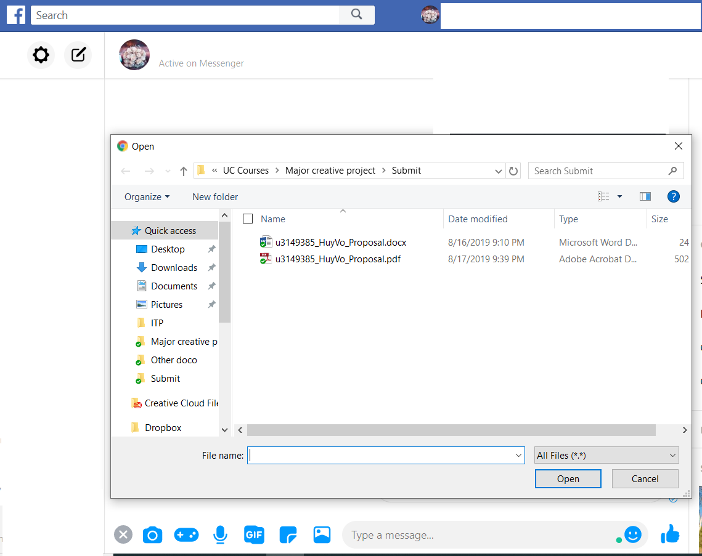

1. Yahoo mail

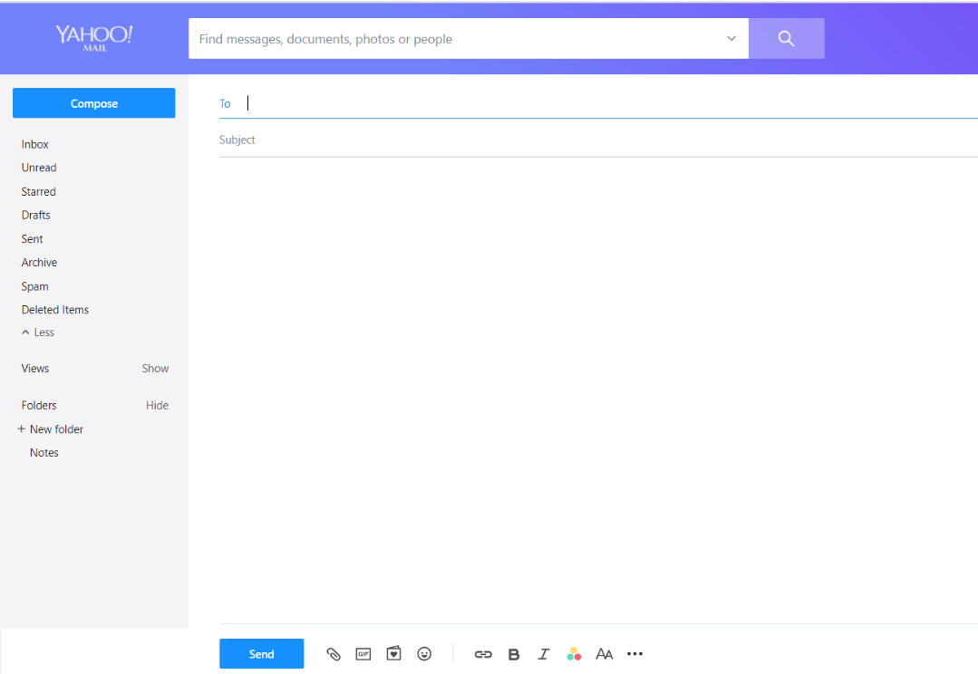

**Design direction**

**Usability**

The users should be able to utilize or take advantage of all functions which were created for them to use. They must have a feeling of ease and guidance when using any function of the website. There should be error pop up message to give users an indication of a problem happened and solution to resolve it.

**Minimalistic Design**

The user interface should be clear and simple. All functions should work as it is supposed in design. Users will find convenient when using this website. Some other features which demonstrate the minialism are only three colors (white, blue and black) and lots of space used in design. Those will help increase content legibility.

**Consistency**

The website should give users a sense of comfort and security, which means they know what will happen when performing an action for example clicking a specific button. The website should be filled with logical information which users know how to get to.

**Resposiveness**

Website should be responsive to various types of devices including smartphone, laptop, tablet or destop computers. The website should display correctly on different screen sizes.