Name: ____________________________________________________________
Class: ___________________________Date:_____________________________

LESSON 13. THE SET OF INTEGERS
3.1. Rewrite the following information without using a negative number: "The submarine is at a height of −120 m compared with sea level."
_________________________________________________________________________
_________________________________________________________________________
3.2. Mr Tám received a text message from his bank saying that the change in his account balance is −356 500 dong. What does this message mean?
_________________________________________________________________________
_________________________________________________________________________
3.3. Which integer does each point M, N, P, Q in Figure 3.1 represent?
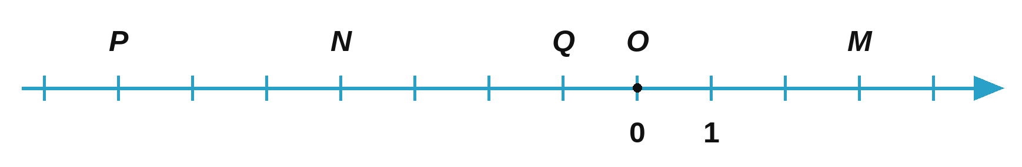
_________________________________________________________________________
3.4. Mark the following numbers on the same number line: 5; −5; −3; 3; −2; 2.
_________________________________________________________________________
_________________________________________________________________________
_________________________________________________________________________
3.5. An ant crawls along a number line with origin O. The positive direction is from left to right and the opposite direction is the negative direction. Suppose the ant walks 13 units and then stops. At which point on the number line does the ant stop in each case below?
a) The ant starts at the origin O and walks in the positive direction;
_________________________________________________________________________
b) The ant starts at the origin O and walks in the negative direction.
_________________________________________________________________________
3.6. List the elements of the following set in increasing order:
M = {x ∈ ℤ | x ends in the digit 3 and −25 < x ≤ 30}.
_________________________________________________________________________
_________________________________________________________________________
3.7. Compare the two numbers: −57 312 and −57 298.
_________________________________________________________________________

