Name: ____________________________________________________________
Class: ___________________________Date:_____________________________

LESSON 10. PRIME NUMBERS
2.23. Write the numbers A and B below as products of prime factors:
A = 10³ · 4²; B = 5 · 6² · 49.
_________________________________________________________________________
_________________________________________________________________________
2.24. Write the following numbers as products of prime factors: 165; 290; 2 030.
_________________________________________________________________________
_________________________________________________________________________
2.25. Find the digit a such that:
a) $\overline{38a}$ is a prime number; b) $\overline{22a}$ is a composite number.
_________________________________________________________________________
_________________________________________________________________________
_________________________________________________________________________
2.26. Using divisibility rules or a table of prime numbers, check which of the following numbers are prime and which are composite: 677; 853; 7 245; 9 873; 15 238.
_________________________________________________________________________
_________________________________________________________________________
_________________________________________________________________________
2.27. Fill in the missing numbers in the prime factorisation diagrams below:
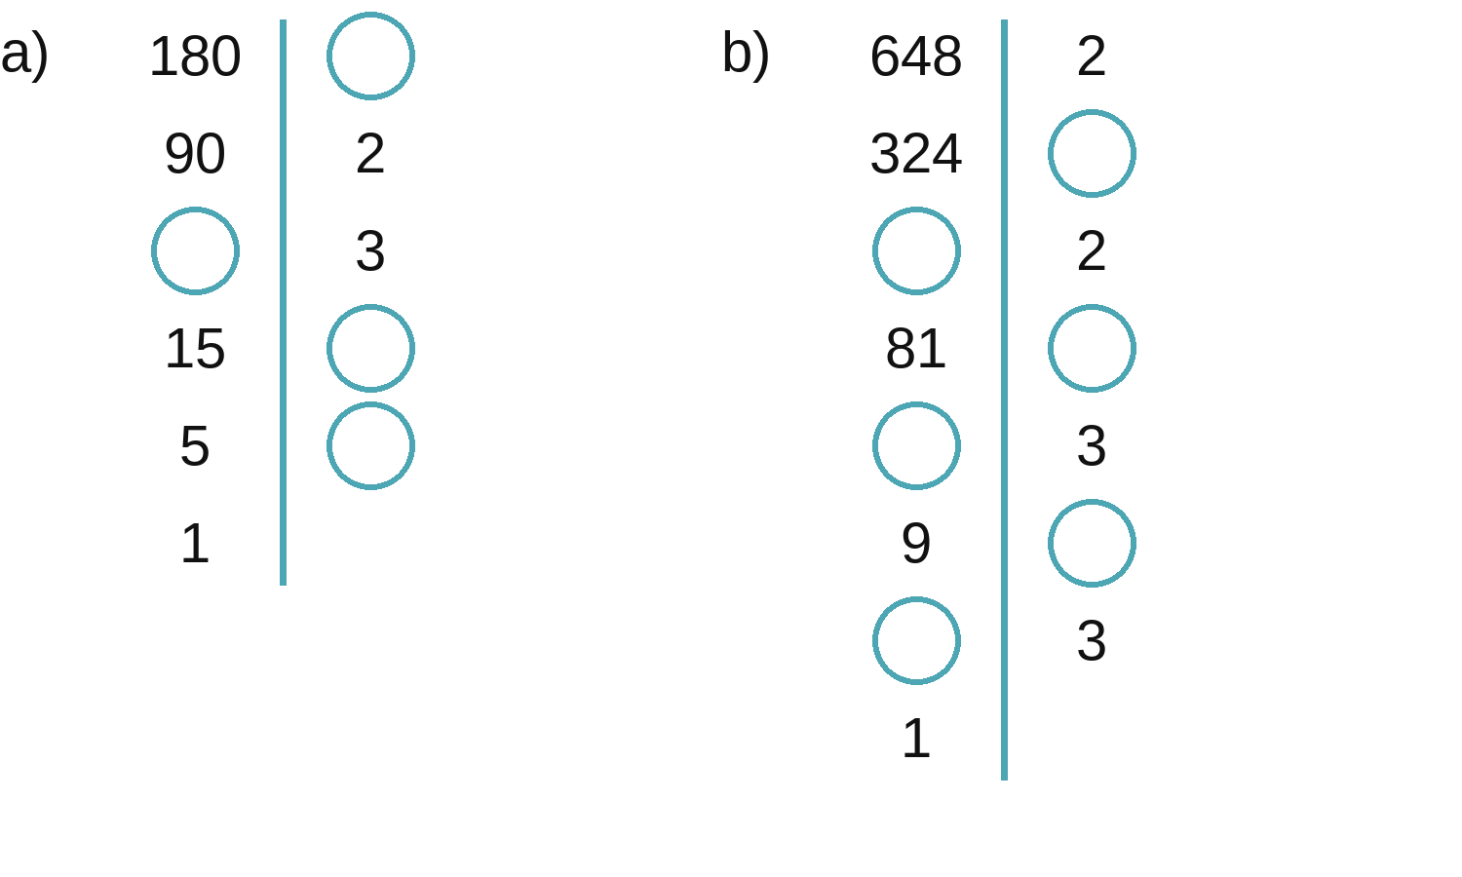
_________________________________________________________________________
_________________________________________________________________________
2.28. Fill in the missing numbers in the factor trees below:
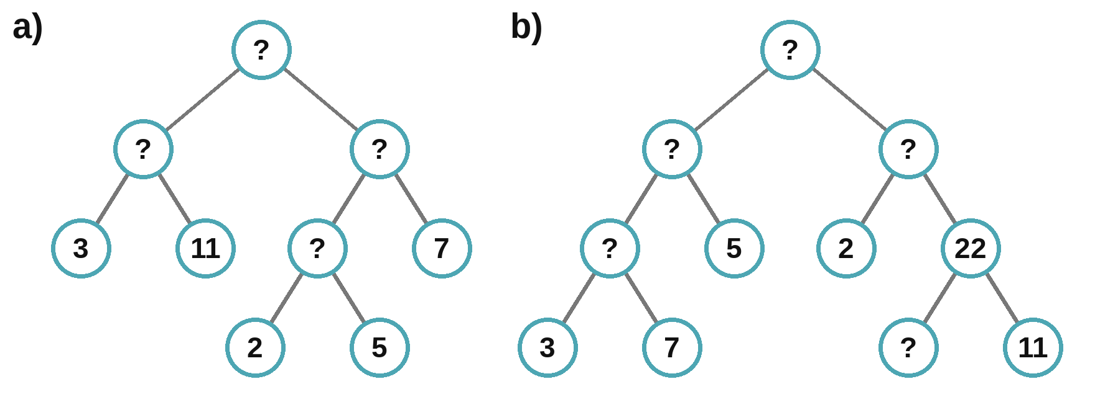
_________________________________________________________________________
_________________________________________________________________________
2.29. Can the number 2 027 be written as the sum of two prime numbers? Why?
_________________________________________________________________________
_________________________________________________________________________
2.30. With 10 unit squares, there are two ways to arrange them into rectangles, as shown below:
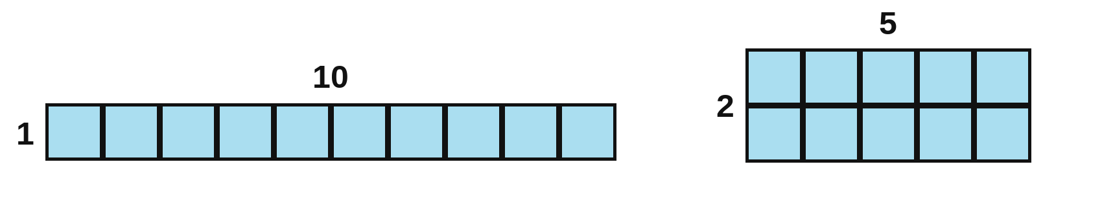
a) With 11 unit squares, how many ways are there to arrange them into rectangles?
_________________________________________________________________________
b) With 18 unit squares, how many ways are there to arrange them into rectangles?
_________________________________________________________________________
c) Given n unit squares (n > 1). For which numbers n is there only one way to arrange them into a rectangle? For which numbers n is there more than one way?
_________________________________________________________________________
_________________________________________________________________________
2.31. Is each sum below a prime number or a composite number?
a) 13 · 14 · 15 + 16 · 17; b) 13 · 15 · 17 + 19 · 21 · 23.
_________________________________________________________________________
_________________________________________________________________________
2.32. a) In 1742, the German mathematician Goldbach wrote a letter to the Swiss mathematician Euler. He wrote: every natural number greater than 5 can be written as the sum of three prime numbers, for example 7 = 2 + 2 + 3; 8 = 2 + 3 + 3. Write the numbers 19 and 22 as sums of three prime numbers.
_________________________________________________________________________
b) In his reply to Goldbach, Euler said: every even number greater than 2 can be written as the sum of two prime numbers. Write the numbers 40 and 46 as sums of two prime numbers. (Nobody has been able to prove these two statements yet.)
_________________________________________________________________________

