Name: ____________________________________________________________
Class: ___________________________Date:_____________________________

CHAPTER IV REVIEW
A. MULTIPLE-CHOICE QUESTIONS
1. Which of the figures below (Figure 4.21) is an isosceles trapezoid?
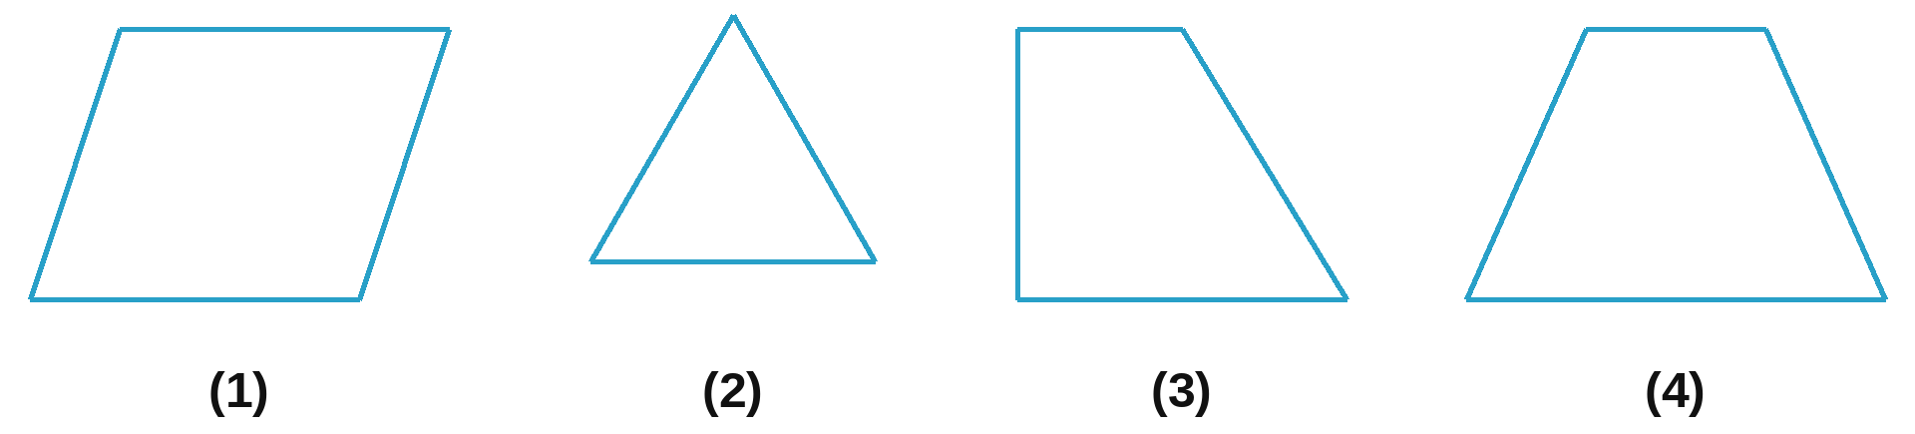
(A) Figure (1); (B) Figure (2); (C) Figure (3); (D) Figure (4).
Answer: ____________________
2. Which of the figures below (Figure 4.22) is a parallelogram?
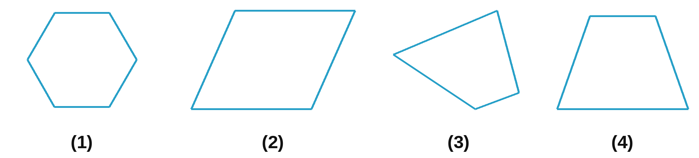
(A) Figure (1); (B) Figure (2); (C) Figure (3); (D) Figure (4).
Answer: ____________________
3. Which statement is correct? In a rectangle:
(A) the two diagonals are parallel to each other;
(B) the four angles are equal and each is 90°;
(C) the two diagonals are not equal;
(D) the four angles are equal and each is 60°.
Answer: ____________________
4. Which statement is correct? In a regular hexagon:
(A) the main diagonals are equal;
(B) the angles are equal and each is 60°;
(C) a main diagonal is equal to a short diagonal;
(D) the angles are equal and each is 90°.
Answer: ____________________
5. Which statement is false?
(A) In a rectangle, the two diagonals cut each other at the midpoint of each diagonal;
(B) In a rhombus, the opposite angles are not equal;
(C) The two angles next to one base of an isosceles trapezoid are equal;
(D) The two diagonals of a square are equal.
Answer: ____________________
6. A square with sides of 12 cm has a perimeter of:
(A) 144 cm²; (B) 48 cm; (C) 48 cm²; (D) 96 cm.
Answer: ____________________
7. A rectangle has an area of 1 200 m² and one side of 40 m. Its perimeter is:
(A) 70 m; (B) 140 m; (C) 120 m; (D) 2 400 m.
Answer: ____________________
8. A rhombus has diagonals of 10 cm and 12 cm. Its area is:
(A) 120 cm²; (B) 22 cm²; (C) 11 cm²; (D) 60 cm².
Answer: ____________________
9. A parallelogram has one side of 12 cm and the matching height of 7 cm. Its area is:
(A) 84 cm; (B) 84 cm²; (C) 42 cm²; (D) 38 cm².
Answer: ____________________
10. An isosceles trapezoid has bases of 6 cm and 12 cm and a height of 5 cm. Its area is:
(A) 18 cm²; (B) 90 cm²; (C) 45 cm²; (D) 360 cm².
Answer: ____________________
B. EXERCISES
4.29. Draw the following figures:
a) A square with sides of 4.5 cm;
b) A rectangle with one side of 5 cm and an area of 35 cm²;
c) A rhombus with sides of 5 cm and one angle of 60°;
d) A parallelogram with two neighbouring sides of 5 cm and 7 cm and a height of 4 cm.

4.30. Look at Figure 4.23 (O is the centre of the hexagon). Check and name the regular hexagon, the rhombus and the equilateral triangle in the figure.  ___________________________________________________  ___________________________________________________ | 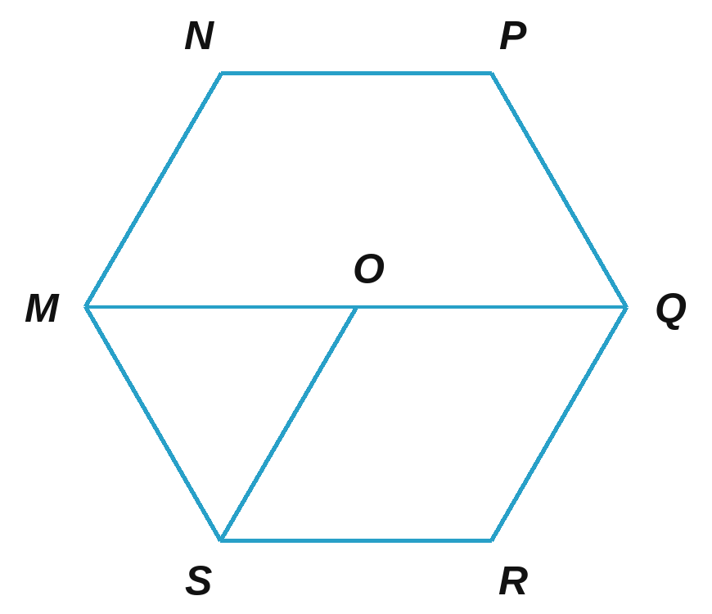

4.31. Look at Figure 4.24 (PQRS is a square; E, F, G, H are the midpoints of its sides).  a) Check whether the quadrilateral ABCD is a square.  b) Is the quadrilateral AFRH an isosceles trapezoid?  ___________________________________________________  ___________________________________________________ | 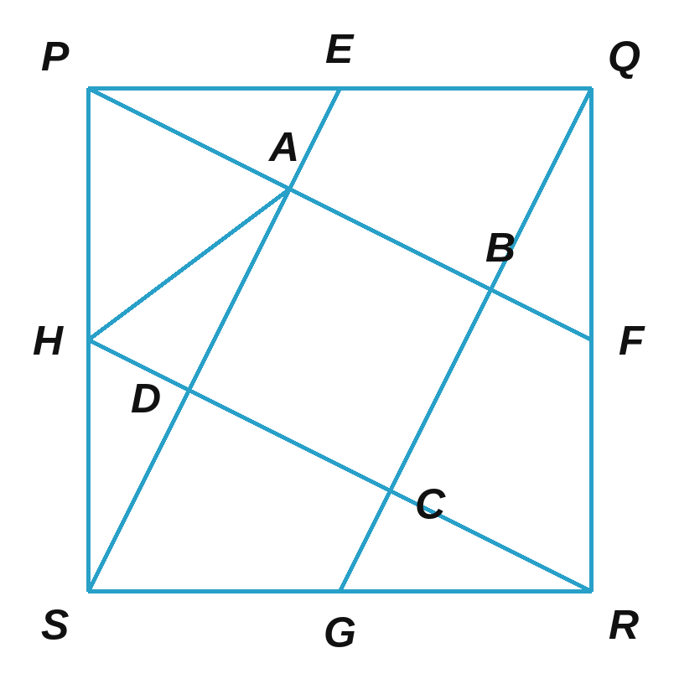

4.32. Cut a rectangular piece of card with sides of 3 cm and 12 cm (Figure 4.25) into four pieces, then put the four pieces together (without overlapping) to make a square.  _________________________________________________ | 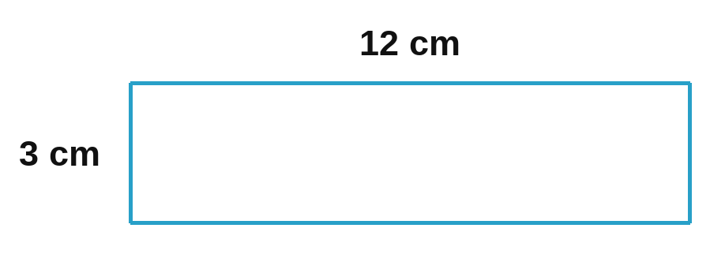

4.33. A yard has the shape and size shown in Figure 4.26.  a) Calculate the area of the yard.  b) If the yard is tiled with square tiles with sides of 50 cm, how many tiles are needed?  ____________________________________________________  ____________________________________________________  ____________________________________________________ | 

