Name: ____________________________________________________________
Class: ___________________________Date:_____________________________

LESSON 19. RECTANGLES. RHOMBUSES. PARALLELOGRAMS. ISOSCELES TRAPEZOIDS
4.8. Look at Figure 4.11 and say which figure is a rectangle and which figure is a rhombus.
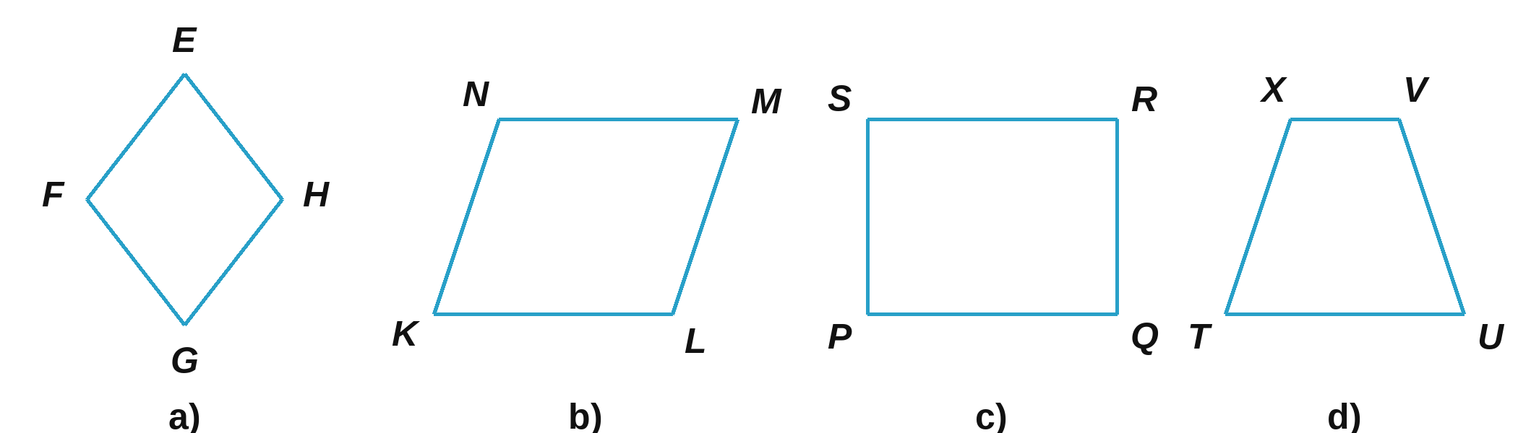
_________________________________________________________________________
4.9. Look at Figure 4.12 and say which figure is a parallelogram and which figure is an isosceles trapezoid.
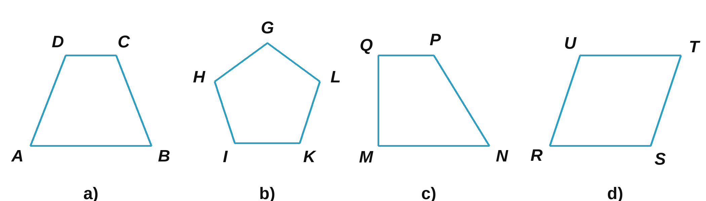
_________________________________________________________________________
4.10. Draw a rectangle ABCD with AB = 6 cm; BC = 4 cm.

4.11. Draw a rhombus MNPQ with side MN = 3 cm.

4.12. Draw a parallelogram EFHK with EF = 5 cm; FH = 3 cm.

4.13. Draw a parallelogram ABCD with AB = 4 cm; BC = 6 cm; AC = 7 cm.

4.14. Draw a rhombus MNPQ with sides of 4 cm and one angle of 60°.

4.15. Look at Figure 4.13 (EFGH is a rectangle; I, K, L, M are the midpoints of its sides). Check whether the quadrilateral IKLM is a rhombus.  __________________________________________________  __________________________________________________ | 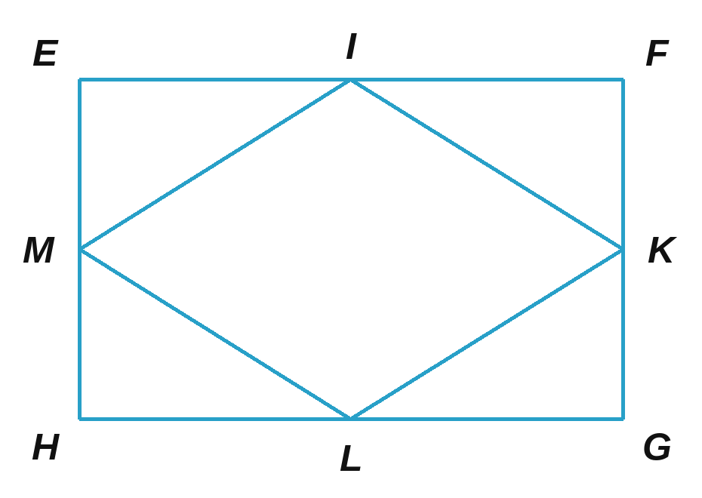

4.16. Look at Figure 4.14. Check whether the quadrilateral WXYZ is a parallelogram. Is the quadrilateral KLMN a rectangle?  ______________________________________________  ______________________________________________ | 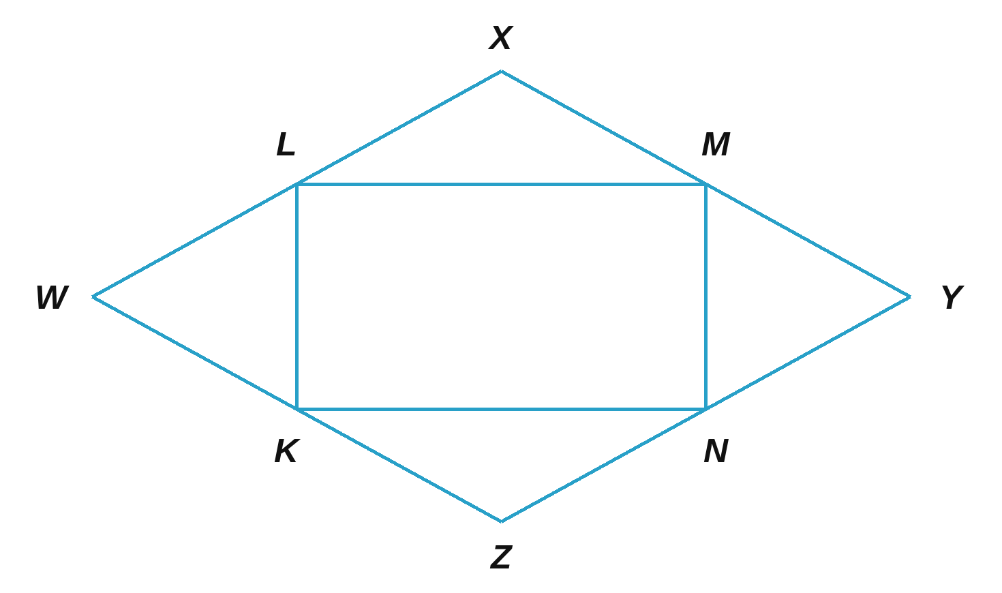

4.17. Look at Figure 4.15 (I is the centre of the circle). Check whether the quadrilaterals ITPQ and IQRS are rhombuses. Is the quadrilateral PSRQ an isosceles trapezoid?  ___________________________________________________  ___________________________________________________ | 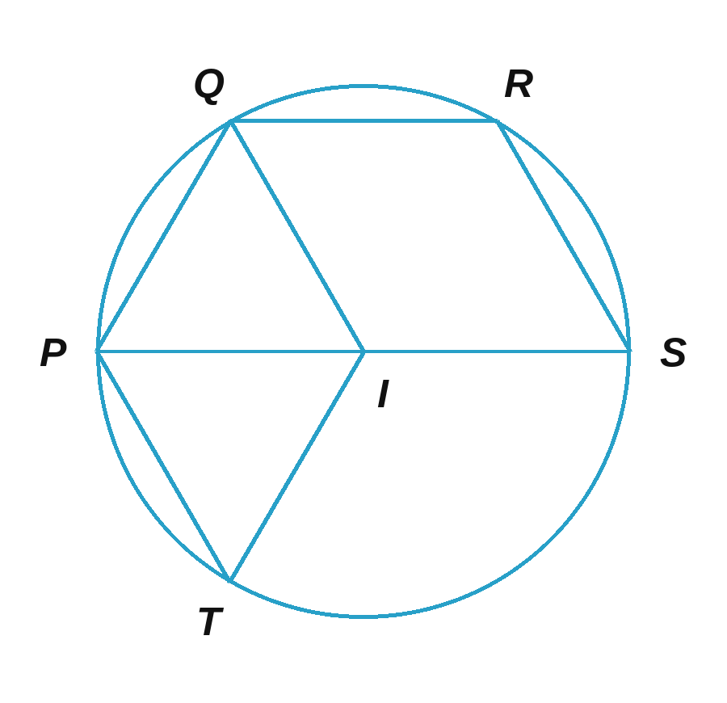

4.18. Cut out three equilateral triangles with sides of 3 cm and put them together to make an isosceles trapezoid.
4.19. Cut out eight isosceles trapezoids whose short base is equal to their legs, then arrange them to make the top of a Tết sweets tray like Figure 4.16. | 

