Name: ____________________________________________________________
Class: ___________________________Date:_____________________________

LESSON 20. PERIMETER AND AREA OF SOME QUADRILATERALS
4.20. Calculate the area and the perimeter of a rectangle with a length of 12 cm and a width of 7 cm.
_________________________________________________________________________
4.21. A rectangular piece of wood has one side of 9 cm and an area of 72 cm². Find the length of the other side.
_________________________________________________________________________
4.22. Calculate the area of each figure below:
a) A square with sides of 7 cm;
b) An isosceles trapezoid with bases of 8 cm and 12 cm and a height of 5 cm;
c) A rhombus with diagonals of 8 cm and 14 cm;
d) A parallelogram with one side of 15 cm and the matching height of 6 cm.
_________________________________________________________________________
_________________________________________________________________________
4.23. A man plans to use an iron bar 7 metres long to make the bars for a window vent with the size shown in Figure 4.19. Is the material he prepared enough? (Ignore the joints.)  _________________________________________________  _________________________________________________ | 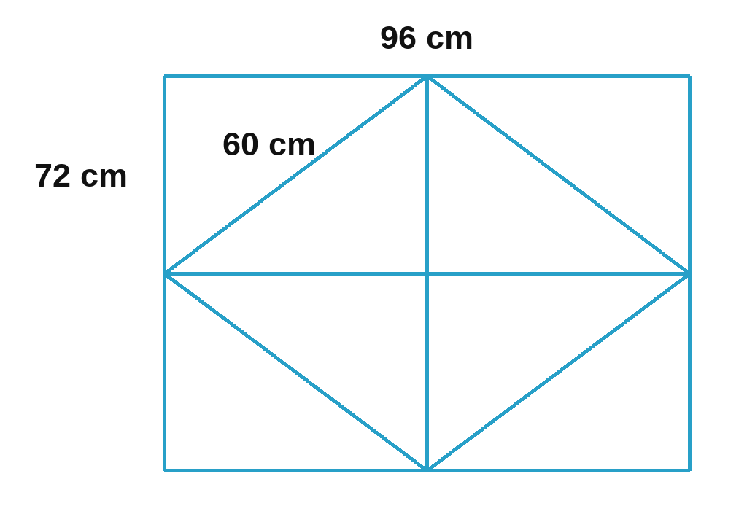

4.24. Calculate the perimeter and the area of the garden with the shape and size shown in Figure 4.20.  ___________________________________________________  ___________________________________________________ | 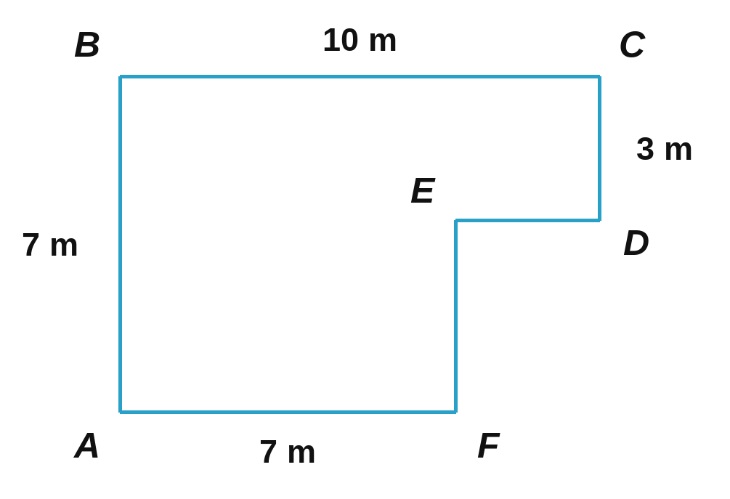

4.25. A garden paving stone in the shape of a regular hexagon is made by putting together a small regular hexagon and 6 isosceles trapezoids (see the figure). Each trapezoid has bases of 20 cm and 40 cm and a height of 17.3 cm; the small hexagon is made of 6 equilateral triangles with sides of 20 cm and heights of 17.3 cm. What is the area of the paving stone? (Ignore the joints.)  ________________________________________________________  ________________________________________________________ | 

4.26. A rectangular garden has an area of 3 500 m² and a width of 50 m. The garden gate is 4 m wide. People want to build a fence around the garden with two layers of barbed wire. How many metres of barbed wire do they need?
_________________________________________________________________________
4.27. Mrs Thu's yard is a rectangle 16 m long and 9 m wide. She buys square floor tiles with sides of 0.6 m to tile the yard. Each box has 8 tiles. How many boxes of tiles does she need to buy?
_________________________________________________________________________
4.28. A man plans to put paving stones and grass in turns on the yard of a house. The yard is a rectangle measuring 18 m × 25 m. He uses 1 000 square paving stones with sides of 60 cm; the rest of the yard is planted with grass. How much does the grass cost if each square metre of grass costs 40 000 dong?
_________________________________________________________________________
_________________________________________________________________________

