Name: ____________________________________________________________
Class: ___________________________Date:_____________________________

CHAPTER I REVIEW
A. MULTIPLE-CHOICE QUESTIONS
Choose the correct answer.
1. The set of letters in the phrase "ĐÀ NẴNG" is:
(A) {ĐÀ; NẴNG}; (B) {Đ; À; N; Ẵ; N; G};
(C) {Đ; À; N; Ẵ; G}; (D) {D; A; N; G}.
Answer: ____________________
2. In the number 37 412:
(A) the value of digit 4 is twice the value of digit 2;
(B) the value of digit 4 is 20 times the value of digit 2;
(C) the value of digit 4 is 200 times the value of digit 2;
(D) the value of digit 4 is 2 000 times the value of digit 2.
Answer: ____________________
3. Write a = 36 207 as the sum of the values of its digits. The result is:
(A) a = 36 000 + 200 + 7; (B) a = 30 000 + 6 000 + 207;
(C) a = 30 000 + 6 000 + 200 + 7; (D) a = 30 000 + 6 200 + 7.
Answer: ____________________
4. Given k ∈ ℕ*. Three consecutive natural numbers in decreasing order are:
(A) k − 1, k, k + 1; (B) k + 2, k + 1, k;
(C) k, k − 1, k − 2; (D) k + 1, k, k + 2.
Answer: ____________________
5. Given set Q (Figure 1.5). Which statement below is false?
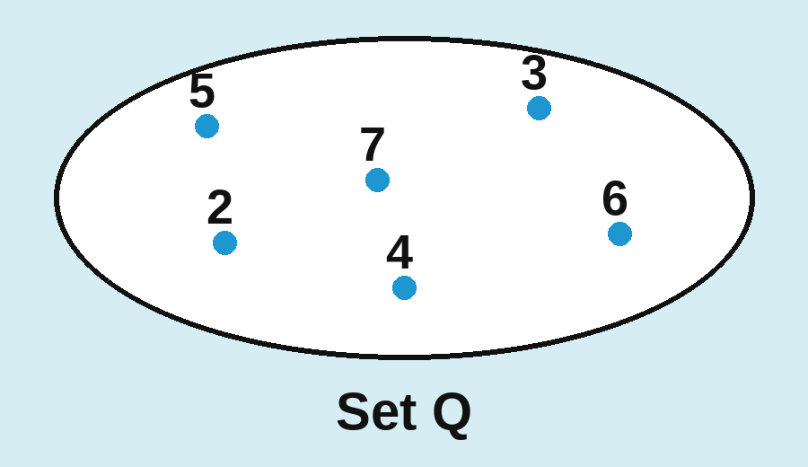
(A) Q = {2; 3; 4; 5; 6; 7}; (B) Q = {x ∈ ℕ | 2 ≤ x ≤ 7};
(C) Q = {x ∈ ℕ | 1 < x < 8}; (D) Q = {x ∈ ℕ | 2 < x ≤ 7}.
Answer: ____________________
6. Given the set B = {x ∈ ℕ | x < 9}. Which number below does not belong to set B?
(A) 0; (B) 8; (C) 9; (D) 3.
Answer: ____________________
7. Which statement below is true?
(A) 3 072 divided by 256 gives a quotient of 0;
(B) 7 340 divided by 140 gives a remainder of 152;
(C) 851 divided by 24 gives a remainder of 11;
(D) 415 divided by 5 gives a quotient of 500.
Answer: ____________________
8. Which property of powers is correct (a ≠ 0, m ≥ n)?
(A) a^{m} : a^{n} = a^{m : n}; (B) a^{m} : a^{n} = a^{m − n};
(C) a^{m} · a^{n} = a^{m · n}; (D) a^{m} : a^{n} = a^{m + n}.
Answer: ____________________
9. What is the value of the power 10⁷?
(A) 1 000 000; (B) 10 000 000;
(C) 100 000 000; (D) 70.
Answer: ____________________
B. EXERCISES
1.68. Let P be the set of even natural numbers greater than 4 but not greater than 12.
a) Describe set P in two ways;
_________________________________________________________________________
_________________________________________________________________________
b) Mark the elements of set P on the same number ray.
_________________________________________________________________________
_________________________________________________________________________
1.69. A two-digit number has its tens digit greater than its units digit by 9. What is the number?
_________________________________________________________________________
1.70. Find all odd three-digit natural numbers whose digits add up to 4.
_________________________________________________________________________
1.71. Find all even three-digit natural numbers whose digits add up to 4.
_________________________________________________________________________
1.72. Let E be the set of five-digit natural numbers whose digits are in non-decreasing order (from left to right) and whose set of digits is {2; 4; 6; 8}.
a) Write set E by listing its elements;
_________________________________________________________________________
b) Let n be the largest number in set E. Write n as the sum of the values of its digits.
_________________________________________________________________________
1.73. How many two-digit numbers contain the digit 5?
_________________________________________________________________________
1.74. Class 6A has 40 students. During the competition to celebrate Vietnamese Teachers' Day (20 November), every student in the class got at least one mark of 10. Find the total number of 10s the class got, knowing that 36 students got two or more 10s, 15 students got three or more 10s, 6 students got four 10s and nobody got more than four 10s.
_________________________________________________________________________
_________________________________________________________________________
_________________________________________________________________________
1.75. When multiplying a · 315 in columns, Quang wrote all the partial products directly under each other (units under units, tens under tens, ...) and got 10 917. If he had written them correctly, what would the result be?
_________________________________________________________________________
_________________________________________________________________________
_________________________________________________________________________
1.76. Calculate S = 1 + 2 − 3 − 4 + 5 + 6 − 7 − 8 + 9 + 10 − ... + 2 022 − 2 023 − 2 024 + 2 025.
_________________________________________________________________________
_________________________________________________________________________
_________________________________________________________________________
1.77. In a division, the dividend is 123 and the remainder is 14. Find the divisor and the quotient.
_________________________________________________________________________
_________________________________________________________________________

