Name: ____________________________________________________________
Class: ___________________________Date:_____________________________

LESSON 4. ADDITION AND SUBTRACTION OF NATURAL NUMBERS
1.29. Use the properties of addition to calculate quickly:
a) 34 + 278 + 66; b) 163 + 95 + 237.
_________________________________________________________________________
_________________________________________________________________________
1.30. Calculate mentally using the associative property of addition:
a) 2 996 + 58; b) 93 + 258.
_________________________________________________________________________
_________________________________________________________________________
1.31. Calculate mentally by adding a number to one term and subtracting the same number from the other term:
a) 298 + 1 427; b) 1 994 + 67.
_________________________________________________________________________
_________________________________________________________________________
1.32. Calculate mentally by adding the same number to (or subtracting the same number from) both numbers of the subtraction:
a) 754 − 298; b) 2 995 − 461.
_________________________________________________________________________
_________________________________________________________________________
1.33. Find the natural number x, given:
a) x + 368 = 905; b) x − 437 = 48; c) 836 − x = 718.
_________________________________________________________________________
_________________________________________________________________________
_________________________________________________________________________
1.34. Calculate the sums:
a) 312 + 314 + 316 + 318 + 320;
b) S = 3 · 11 + 3 · 13 + 3 · 15 + ... + 3 · 21.
_________________________________________________________________________
_________________________________________________________________________
_________________________________________________________________________
1.35. Without calculating, explain why each result below is wrong:
a) 131 + 242 + 353 + 864 + 998 = 2 587;
b) 131 + 242 + 353 + 864 + 998 = 5 588.
_________________________________________________________________________
_________________________________________________________________________
_________________________________________________________________________
1.36. The cleaner at my school lives in the suburbs. Every day she rides her bicycle to the bus station, parks it there, takes two buses and then walks a short way to school. Riding to the bus station takes about 12 minutes; parking takes at most 2 minutes; the first bus takes at most 23 minutes and the second bus at most 16 minutes; then she walks from the bus stop to school in about 6 minutes.
a) In the best case (she does not have to wait for any bus), how long does it take her to get from home to school?
_________________________________________________________________________
b) To be at school before 6:15 (she cleans the classrooms from 6:15 to 7:15), what is the latest time she can leave home?
_________________________________________________________________________
1.37. Replace each ? with a suitable digit to make correct calculations:
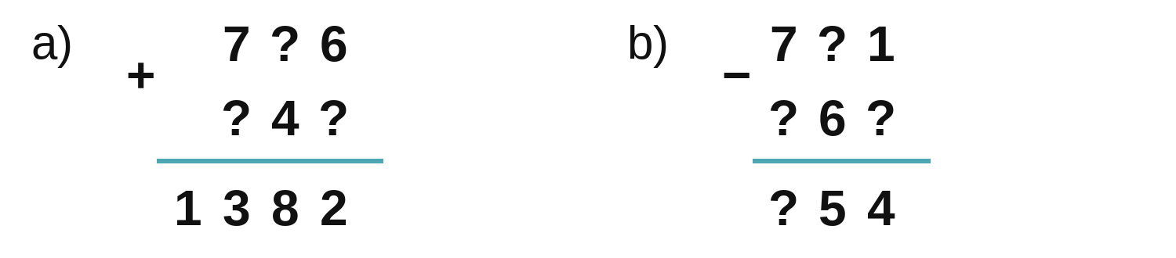
_________________________________________________________________________
1.38. In a 3 × 3 square, each cell contains a natural number so that the sums of the numbers in each row, each column and each diagonal are all equal. A naughty student erased the numbers in 5 cells, so only the numbers below are left. Restore the square.
48 |  | 46
 |  | 47
44

_________________________________________________________________________
_________________________________________________________________________
_________________________________________________________________________

