Name: ____________________________________________________________
Class: ___________________________Date:_____________________________

LESSON 22. SHAPES WITH A CENTRE OF SYMMETRY
5.11. List the shapes below that have a centre of symmetry: a rhombus, an isosceles trapezoid (whose legs are not parallel), a square, an equilateral triangle, a regular hexagon, a parallelogram, a circle.
_________________________________________________________________________
5.12. Which of the following signs have a centre of symmetry?
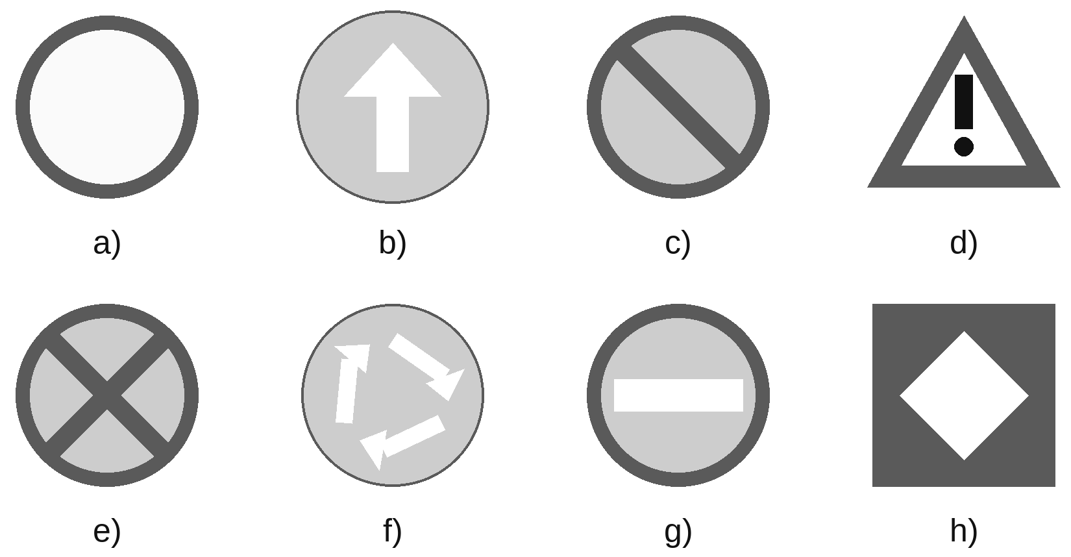
_________________________________________________________________________
5.13. Which of the following patterns have a centre of symmetry?
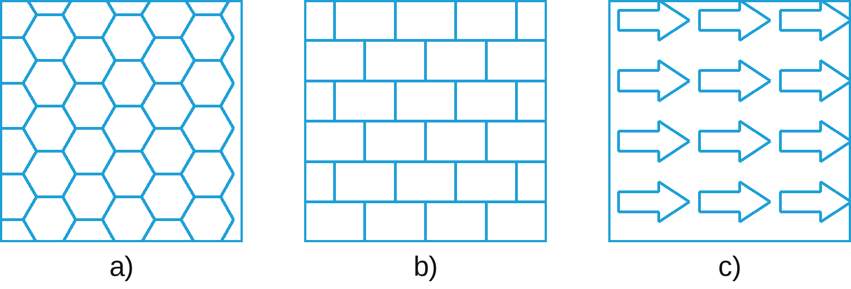
_________________________________________________________________________
5.14. A table top is a regular hexagon as shown in the figure. Its main diagonal is 1.4 m long. Find the distance from the centre of symmetry of the table top to each vertex, and the perimeter of the table top.  __________________________________________________________  __________________________________________________________ | 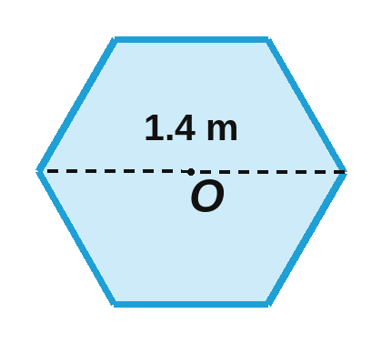

5.15. Which of the shapes below have a centre of symmetry?
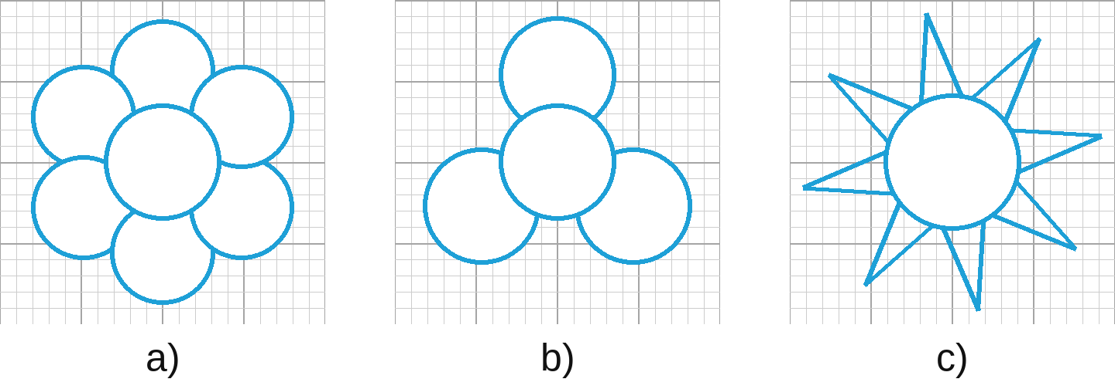
_________________________________________________________________________
5.16. Draw more on each shape below so that point O is the centre of symmetry of the new shape.
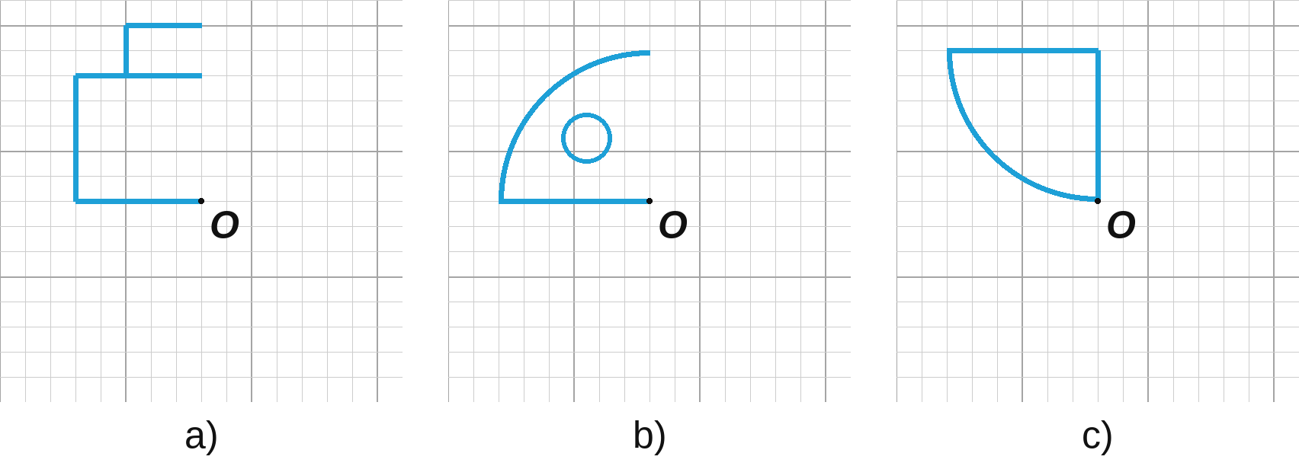
5.17. Nam folds a rectangular sheet of paper in half along its width, then folds it in half again along its length, and cuts along the blue dashed line as shown in Figure 5.12. What shape will Nam get when he opens it?  ________________________________________________________  ________________________________________________________ | 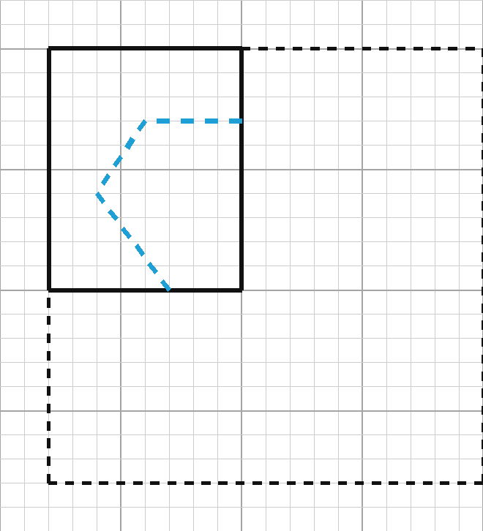

5.18. Complete Figure 5.13 to get a shape that has O as its centre of symmetry and also has an axis of symmetry. | 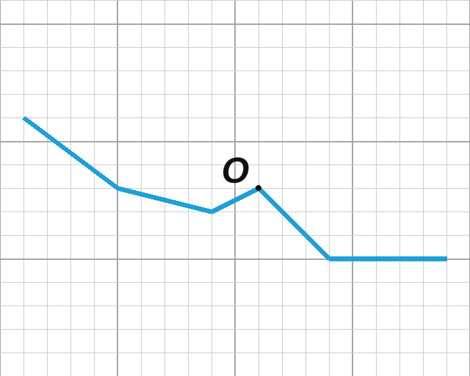

5.19. Figure 5.14 shows a broken line 4 units long (1 unit = the side of a large square). Draw more on it:  a) a broken line 6 units long to get a shape that has a centre of symmetry but no axis of symmetry;  b) a broken line 8 units long to get a shape that has a centre of symmetry and four axes of symmetry;  c) the shortest broken line to get a shape that has a centre of symmetry;  d) the shortest broken line to get a shape that has a centre of symmetry and an axis of symmetry. | 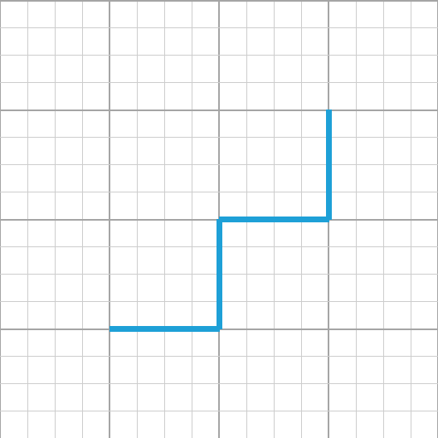

5.20. Put three of the number cards below side by side to make a picture of a three-digit number so that the picture has a centre of symmetry. (Each card can be used only once.)
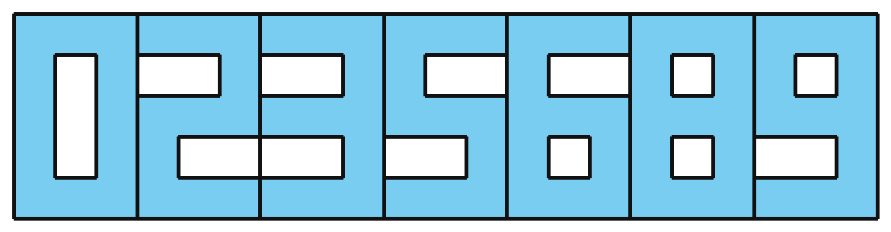
How many such "numbers" can you make?
_________________________________________________________________________
5.21. From a rectangular sheet of coloured paper measuring 4 cm × 6 cm, explain how to fold the paper so that you can cut out the digit 0 (Figure 5.15) with only one cut.  _____________________________________________________________  _____________________________________________________________ | 

