Name: ____________________________________________________________
Class: ___________________________Date:_____________________________

LESSON 18. EQUILATERAL TRIANGLES. SQUARES. REGULAR HEXAGONS
4.1. Look at Figure 4.4. Which figure is an equilateral triangle, which is a square and which is a regular hexagon?
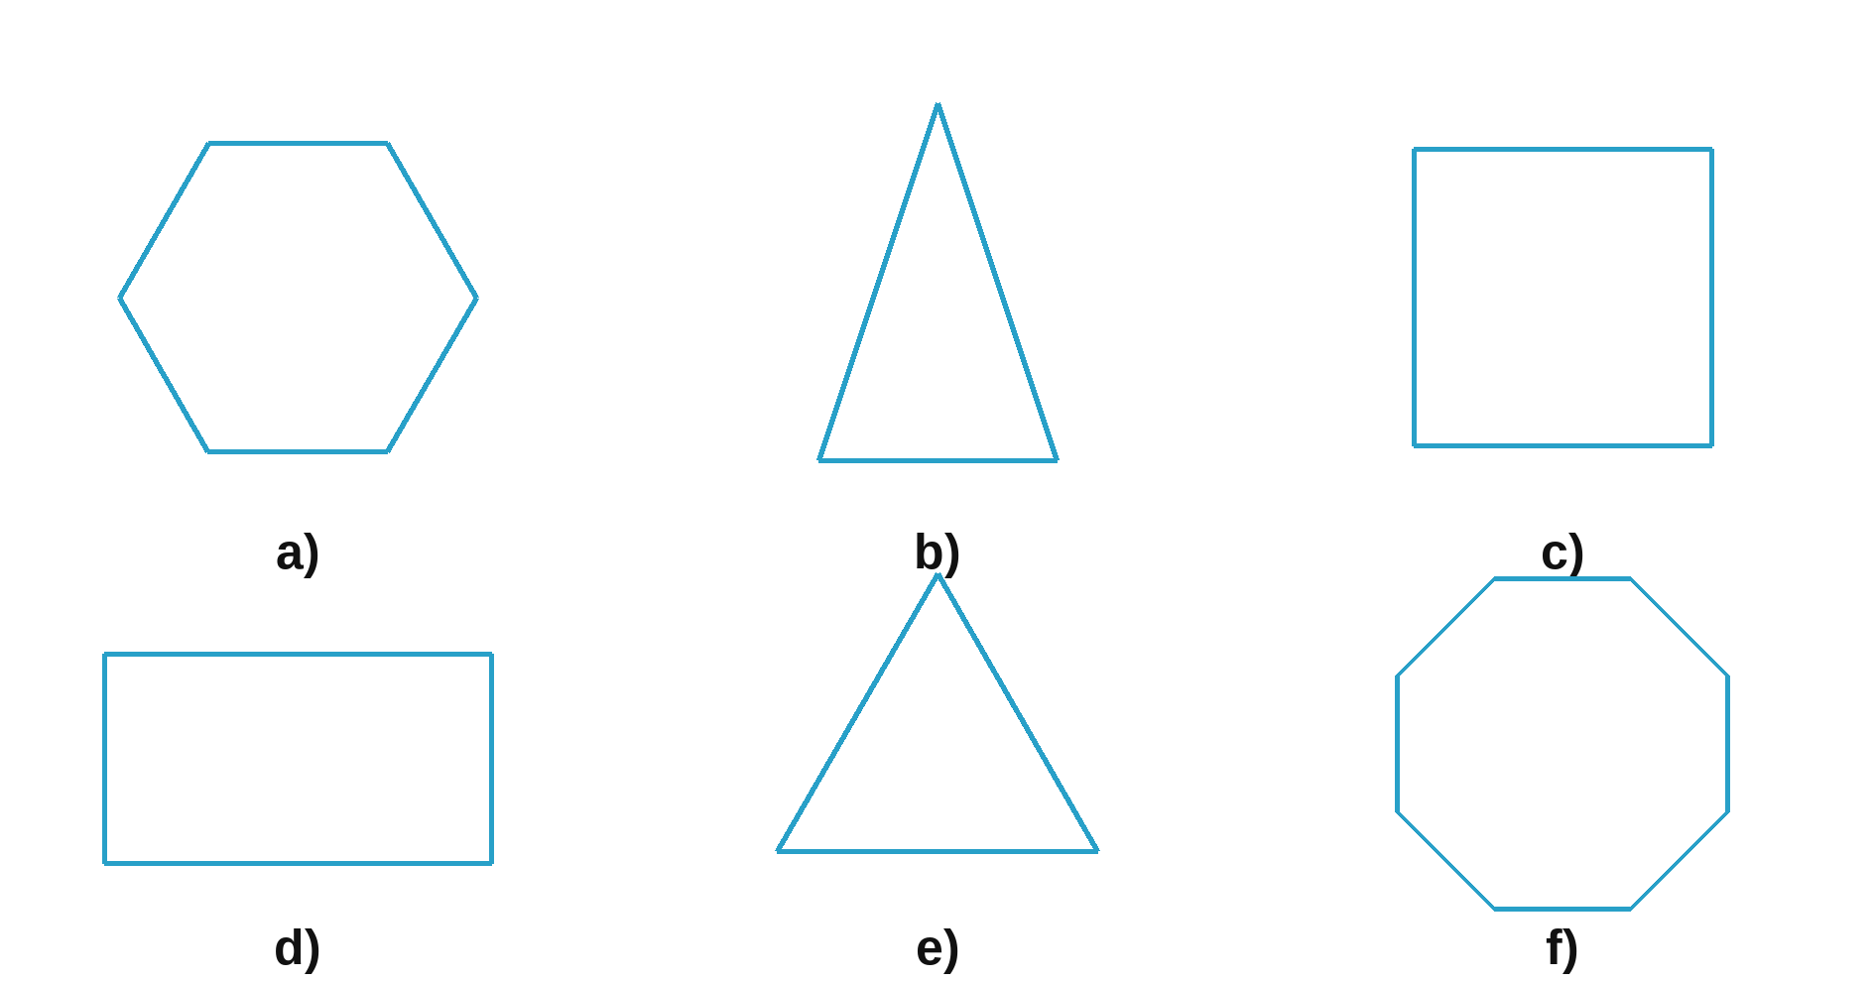
_________________________________________________________________________
4.2. Draw an equilateral triangle EFG with side EF = 6 cm.

4.3. Draw a square MNPQ with side MN = 4 cm. Draw its two diagonals MP and NQ. Check whether MP and NQ are perpendicular to each other.

_________________________________________________________________________
4.4. Look at Figure 4.5.  a) Name the short diagonals of the regular hexagon ABCDEF;  b) Measure the side lengths and decide whether triangle ACE and triangle BDF in Figure 4.5 are equilateral triangles.  _______________________________________________________  _______________________________________________________ | 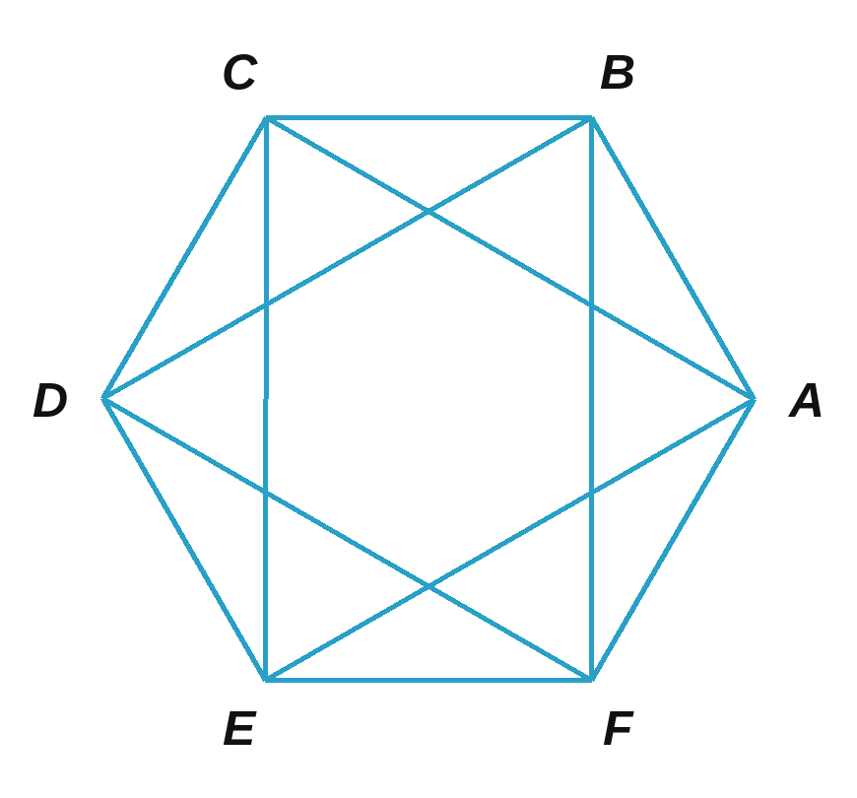

4.5. Look at Figure 4.6.  a) Use a compass to check whether ABC is an equilateral triangle.  b) Use a compass and a set square (or a protractor) to check whether MNPQ is a square.  ___________________________________________________  ___________________________________________________ | 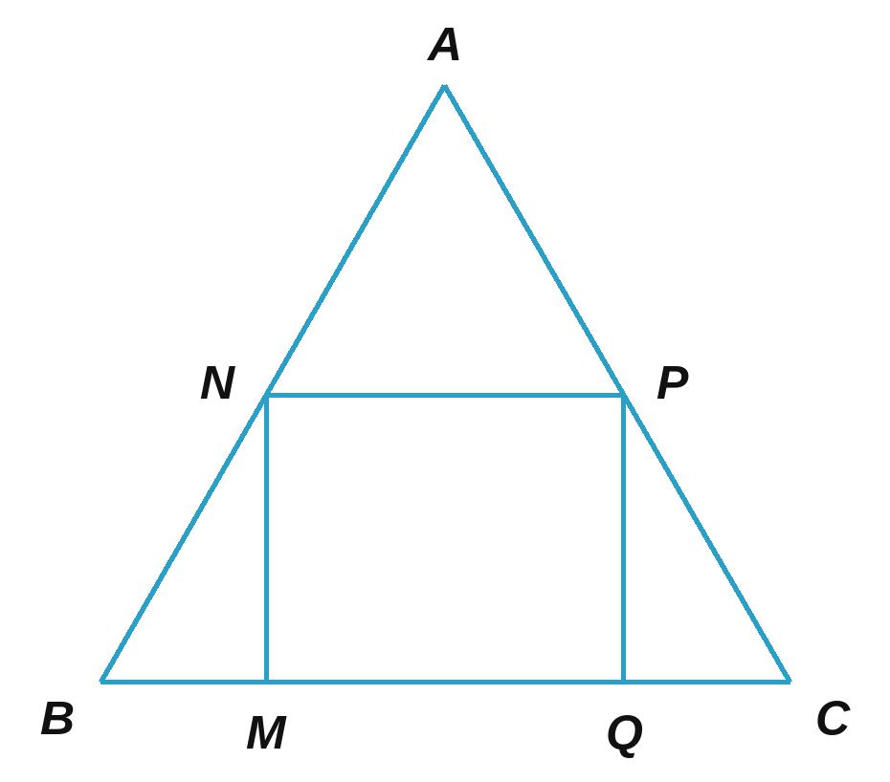

4.6. Cut out 6 equilateral triangles with sides of 4 cm and put them together to make a regular hexagon (Figure 4.7). Calculate the length of a main diagonal of the regular hexagon you made.  _________________________________________ | 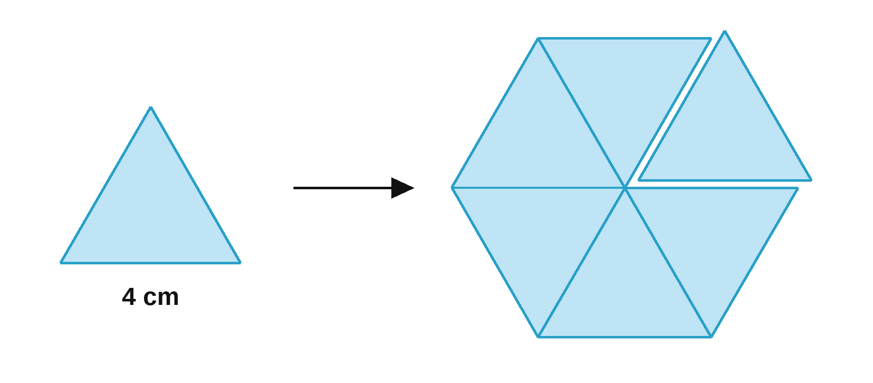

4.7. Look at Figure 4.8.  a) Check how many regular hexagons there are. Which are they?  b) How many equilateral triangles are there in total?  _____________________________________________________  _____________________________________________________  _____________________________________________________ | 

