Name: ____________________________________________________________
Class: ___________________________Date:_____________________________

LESSON 3. ORDER IN THE SET OF NATURAL NUMBERS
1.22. Draw a number ray and mark the numbers 6 and 13 on it.
_________________________________________________________________________
_________________________________________________________________________
1.23. Which number does each point E, F, G in Figure 1.2 represent?
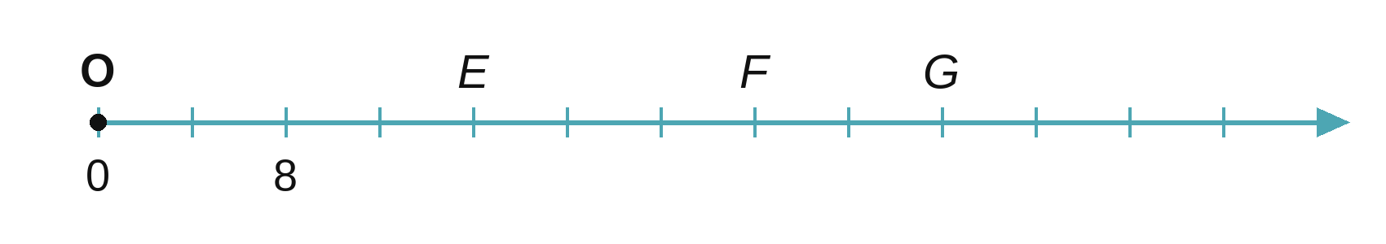
_________________________________________________________________________
1.24. On the road you see a kilometre post like the one in Figure 1.3. How many more kilometres must you travel to reach Sơn La? Draw a number ray to model National Highway 6 from post km0 to Sơn La: its origin is post km0; mark the point for post km125 and the point for Sơn La (the distances do not need to be exact).  Note: "km125" on the post means that this place is 125 km from the start of National Highway 6 (post km0). | 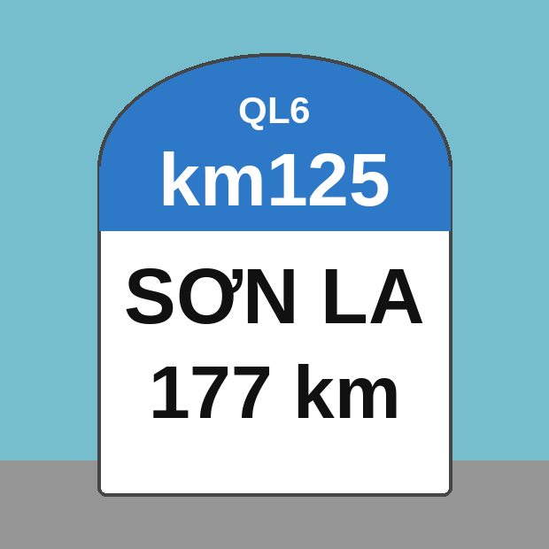

_________________________________________________________________________
_________________________________________________________________________
_________________________________________________________________________
1.25. Four points A, B, C, D lie on the same number ray in this order. They represent the four numbers 43 618; 43 529; 42 937 and 43 607. Which point represents which number?
_________________________________________________________________________
_________________________________________________________________________
1.26. A health centre recorded the number of new flu cases in a town each day from 1 March to 16 March, as shown in the chart below:
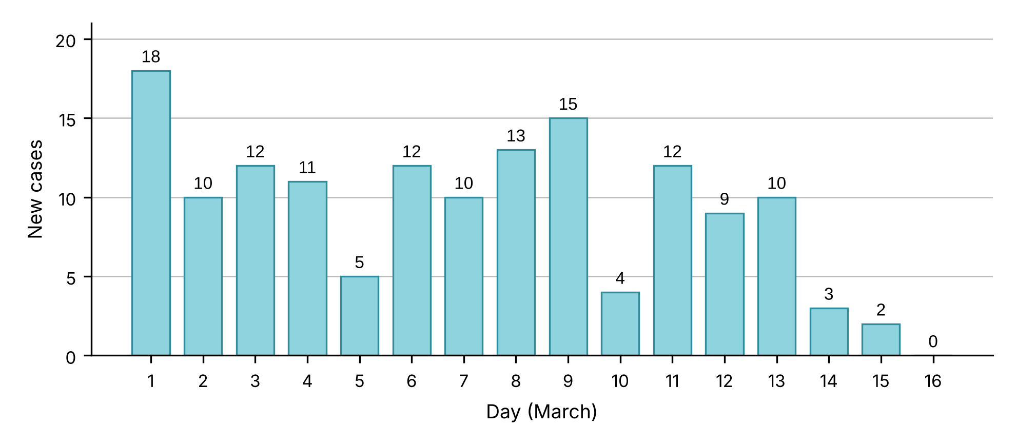
Imagine that the left side of the chart is a number ray showing the numbers 0; 5; 10; 15 and 20. The number on top of each column is the number of new cases on that day.
a) On which days were there 5, 10 and 15 new cases?
_________________________________________________________________________
_________________________________________________________________________
b) On which day were there the most new cases? On which day were there the fewest?
_________________________________________________________________________
c) Why can the health centre say: "The number of new cases has been going down in the last few days"?
_________________________________________________________________________
_________________________________________________________________________
1.27. Given four sets: A = {x ∈ ℕ | x is a multiple of 3 and x < 12}, B = {x ∈ ℕ | x is a multiple of 3 and x ≤ 12}, C = {x ∈ ℕ* | x is a multiple of 3 and x < 12} and D = {x ∈ ℕ* | x is a multiple of 3 and x ≤ 12}. Write each set by listing its elements.
_________________________________________________________________________
_________________________________________________________________________
_________________________________________________________________________
_________________________________________________________________________
1.28. Given the set P = {$\frac{1}{x}$ | x ∈ ℕ* and x ≤ 5}. Write set P by listing its elements.
_________________________________________________________________________
_________________________________________________________________________

