Name: ____________________________________________________________
Class: ___________________________Date:_____________________________

CHAPTER V REVIEW
A. MULTIPLE-CHOICE QUESTIONS
1. Which statement below is correct?
(A) A rectangle with two different side lengths has 4 axes of symmetry;
(B) An isosceles trapezoid whose base angles are not 90° has exactly one axis of symmetry;
(C) A parallelogram has two axes of symmetry;
(D) An equilateral triangle has 6 axes of symmetry.
Answer: ____________________
2. Which statement below is false?
(A) A regular hexagon has exactly 3 axes of symmetry;
(B) A square has exactly 4 axes of symmetry;
(C) A rectangle with two different side lengths has exactly two axes of symmetry;
(D) A rhombus whose angles are not 90° has exactly 2 axes of symmetry.
Answer: ____________________
3. Which statement below is correct?
(A) A trapezoid has a centre of symmetry at the point where its two diagonals meet;
(B) An equilateral triangle has a centre of symmetry where its three axes of symmetry meet;
(C) A parallelogram has a centre of symmetry where its two diagonals meet;
(D) An isosceles trapezoid whose base angles are not 90° has a centre of symmetry where its two diagonals meet.
Answer: ____________________
4. Which statement below is false?
(A) A rectangle has a centre of symmetry where its two diagonals meet;
(B) A circle has a centre of symmetry at the centre of the circle;
(C) A square has 4 centres of symmetry;
(D) A regular hexagon has a centre of symmetry where its main diagonals meet.
Answer: ____________________
B. EXERCISES
5.22. Segment MN is 6 cm long. Let O be the centre of symmetry of segment MN. Find the length of OM.
_________________________________________________________________________
5.23. Look at the shapes below:
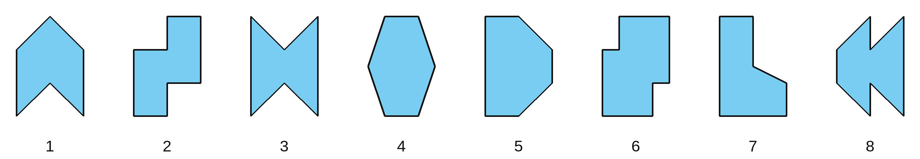
a) How many shapes have a centre of symmetry? b) How many shapes have exactly one axis of symmetry?
c) How many shapes have both a centre of symmetry and an axis of symmetry?
d) How many shapes have neither a centre of symmetry nor an axis of symmetry?
_________________________________________________________________________
_________________________________________________________________________
5.24. Complete the drawings below to get shapes that have d as an axis of symmetry.
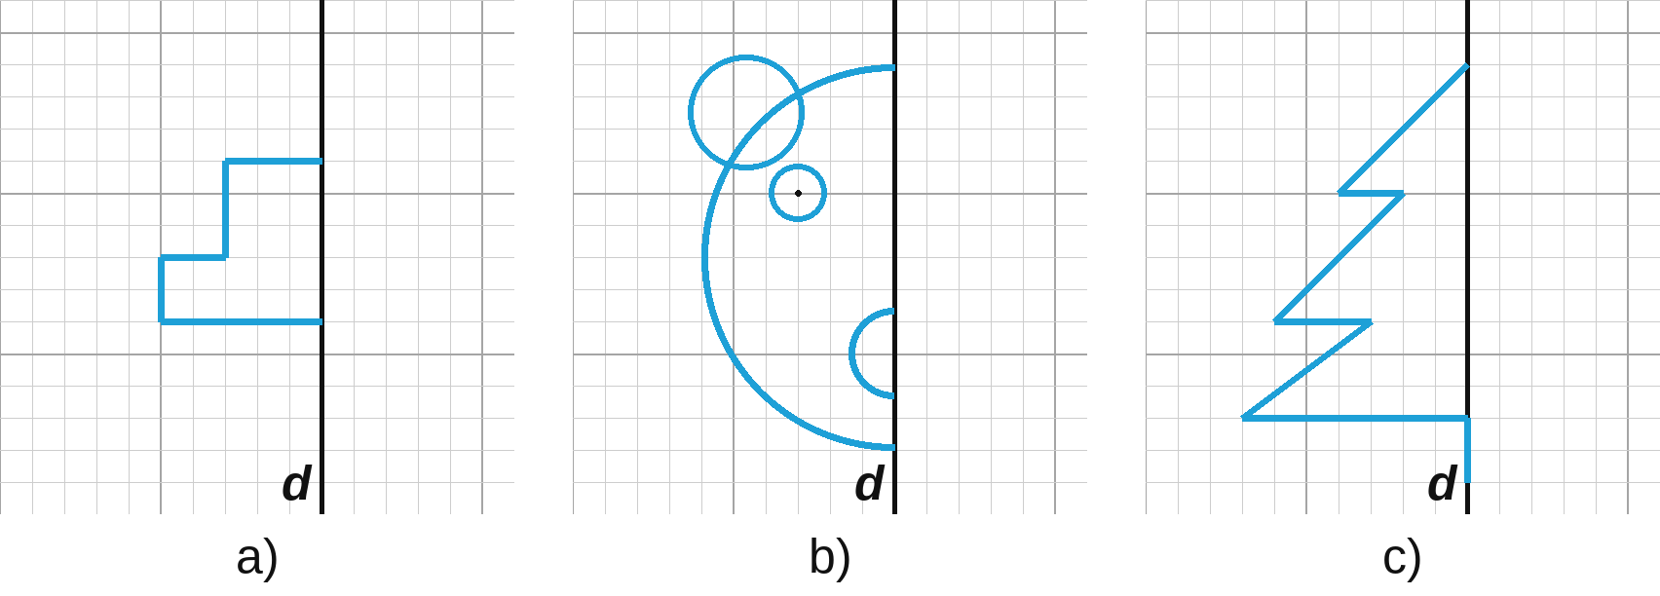
5.25. Complete the drawings below to get shapes that have d as an axis of symmetry.
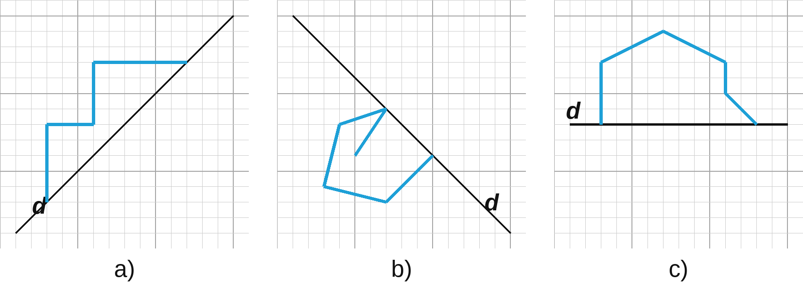
5.26. Complete the drawings below to get shapes that have O as the centre of symmetry.
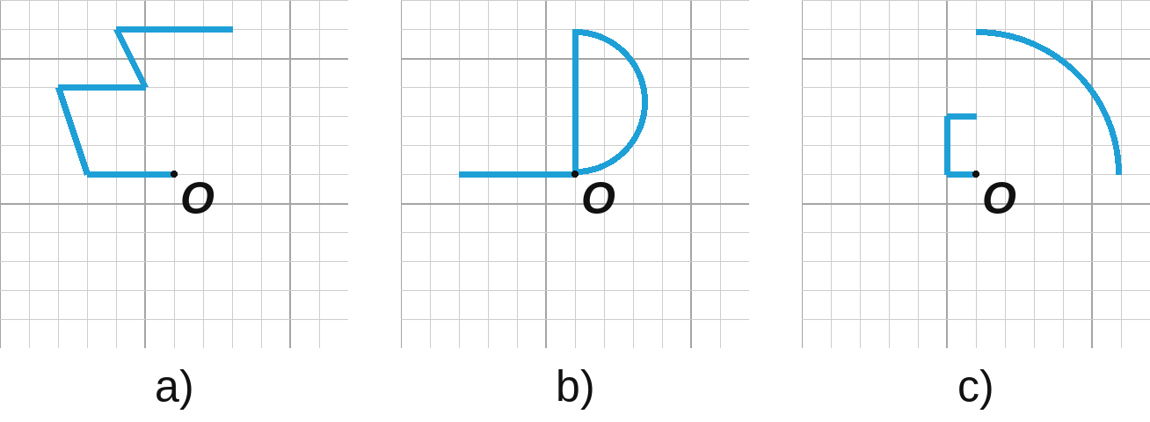
5.27. Complete the drawings below to get shapes that have d as an axis of symmetry and O as the centre of symmetry.
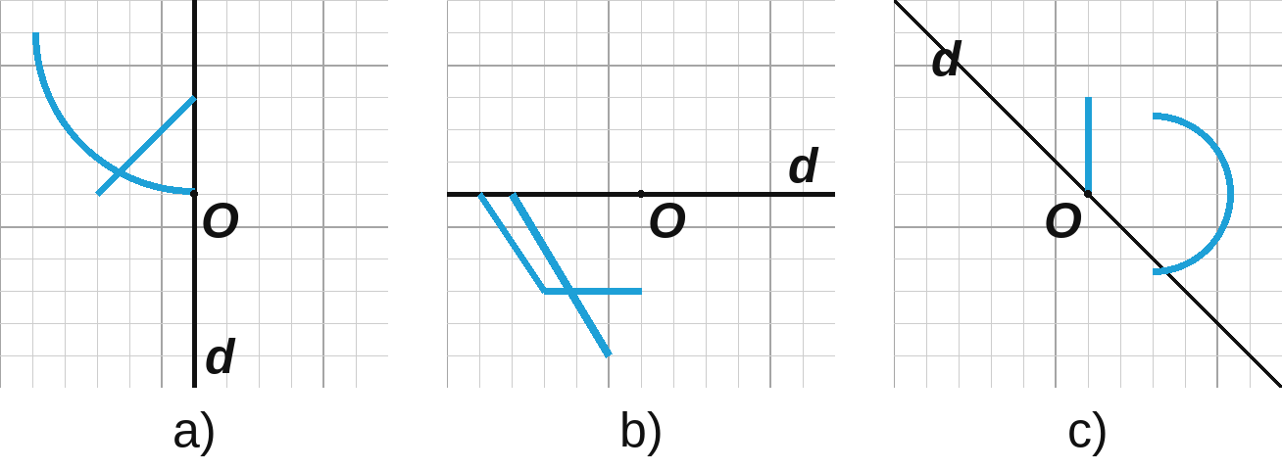
5.28. Put two of the number cards below side by side to make a picture of a two-digit number so that:
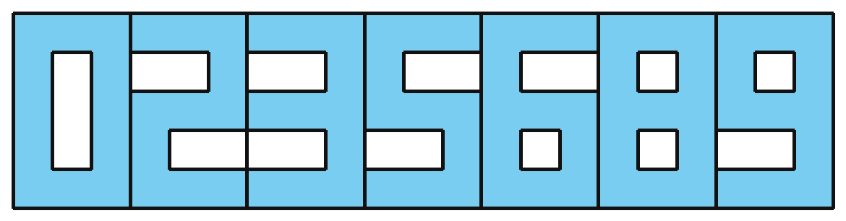
a) the picture has an axis of symmetry; b) the picture has a centre of symmetry.
In each case, how many such "numbers" can you make?
_________________________________________________________________________
_________________________________________________________________________
5.29. Rhombus EFGH has centre of symmetry O. Given OE = 4 cm and OF = 3 cm, find the area of the rhombus.
_________________________________________________________________________
_________________________________________________________________________

