Name: ____________________________________________________________
Class: ___________________________Date:_____________________________

LESSON 21. SHAPES WITH AN AXIS OF SYMMETRY
5.1. How many axes of symmetry does each of the following shapes have: an isosceles trapezoid, a rhombus, a rectangle (not a square), a circle?
_________________________________________________________________________
5.2. Copy the shapes below into your notebook and draw all of their axes of symmetry (if any).
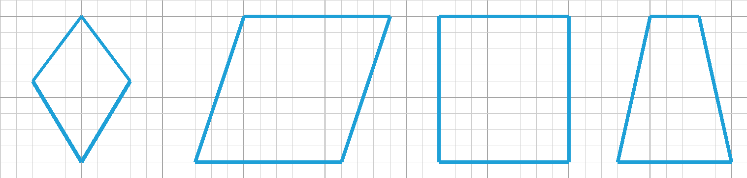
5.3. Among the letters and digits below, list:
a) the letters and digits that have exactly one axis of symmetry;
b) the letters and digits that have two axes of symmetry.

_________________________________________________________________________
_________________________________________________________________________
5.4. Which of the following symbols have an axis of symmetry?
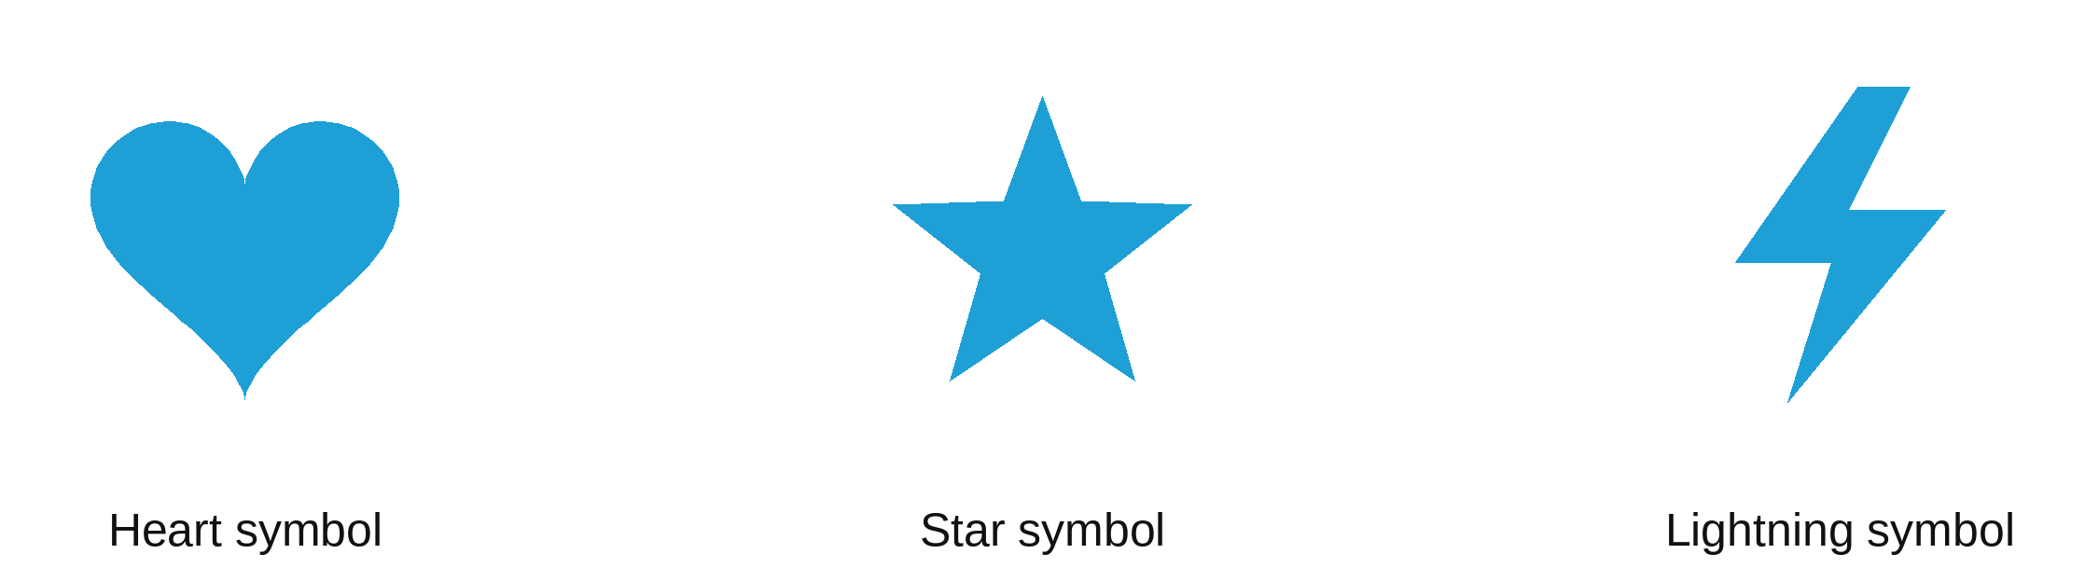
_________________________________________________________________________
5.5. Draw all the axes of symmetry (if any) of the shapes below:
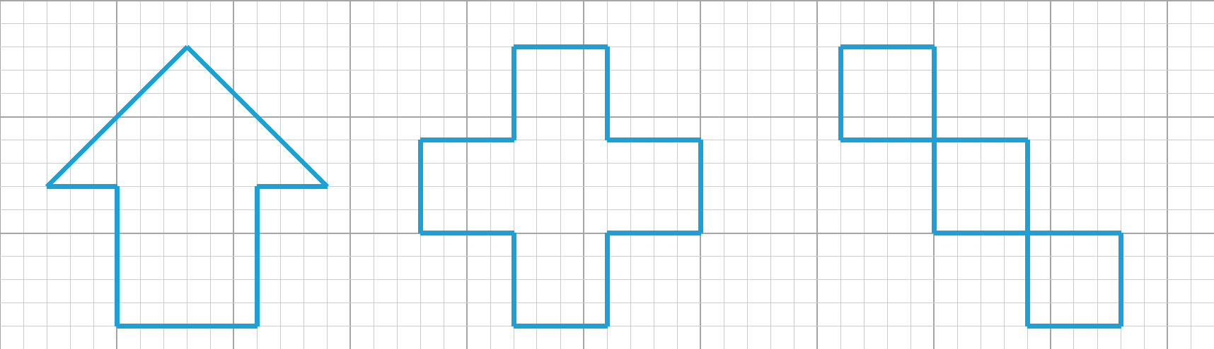
5.6. Draw more on each shape below so that line d is an axis of symmetry of the new shape.
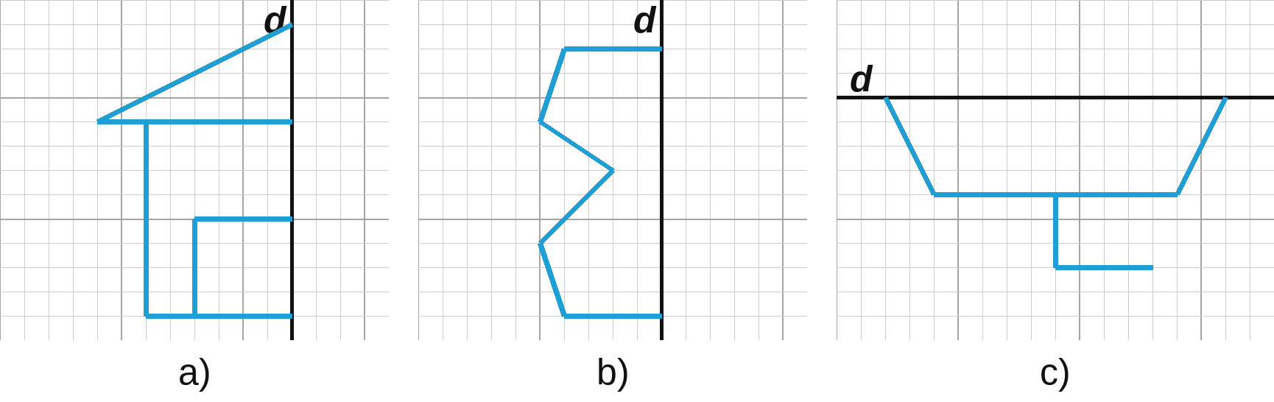
5.7. Lan folds some rectangular sheets of paper in half and cuts along the dashed lines as shown below (the thick black side is the fold). What shapes will Lan get when she opens the pieces?
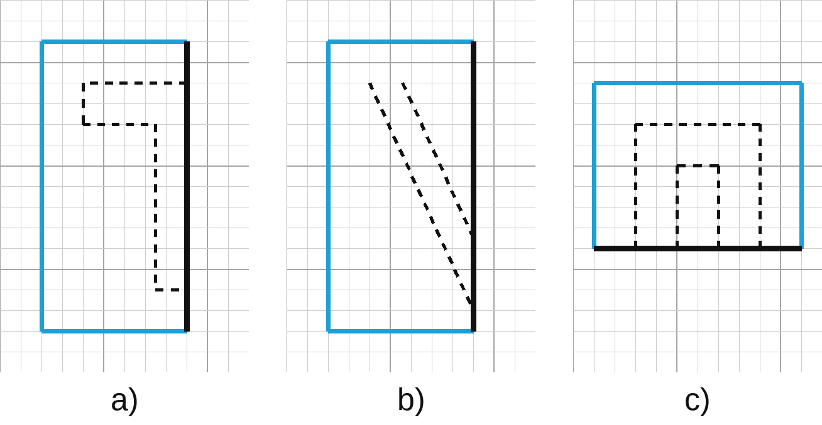
_________________________________________________________________________
5.8. Draw more on each shape below so that line d is an axis of symmetry of the new shape.
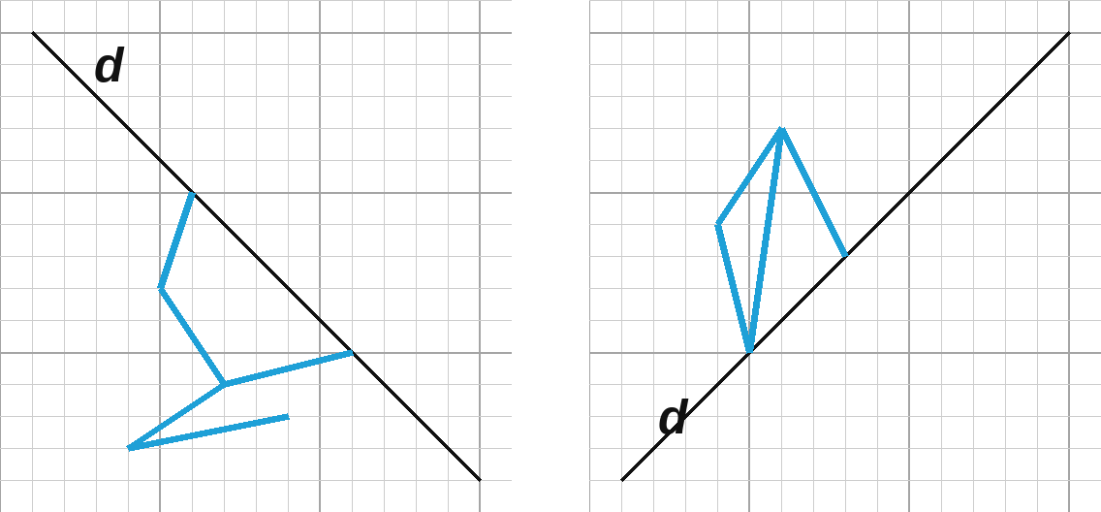
5.9. The figure shows a broken line 4 units long (1 unit = the side of a large square). Draw more on it:  a) a broken line 4 units long to get a shape with exactly one axis of symmetry;  b) a broken line 4 units long to get a shape with exactly two axes of symmetry;  c) a broken line 8 units long to get a shape with exactly four axes of symmetry. | 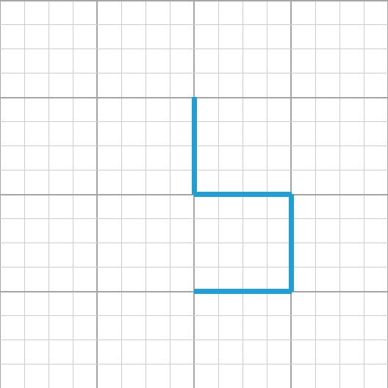

5.10. Put three of the number cards below side by side to make a picture of a three-digit number so that the picture has an axis of symmetry. (Each card can be used only once.)
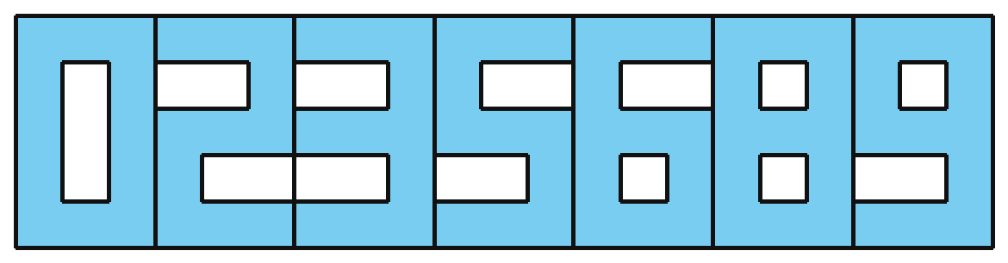
How many such "numbers" can you make?
_________________________________________________________________________
_________________________________________________________________________

