# Micro:bit Traffic Light Simulator

### Submitted by:

Name: Huzaifaa Hassan Latheef  
UWE Student number: 22040156

## Introduction

The Micro:bit Traffic Light Simulator is a project that uses the BBC micro:bit to create a basic traffic light simulation. The simulation includes a sequence of traffic light colors along with a pedestrian crossing signal. This project is a great way to learn about programming LEDs and creating simulations with the micro:bit.

## Materials Needed

* 1 x micro:bit
* 1 x green LED
* 1 x orange LED
* 1 x red LED
* 3 x 220 Ohm resistors
* Breadboard
* Jumper wires
* Battery holder for 2 x AA batteries
* 2 x AA batteries
* USB cable (for programming the micro:bit)
* Computer for programming

## How to Set Up

1. Connect the Micro:bit:

Connect the micro:bit to your computer using a USB cable. This will power the micro:bit and allow you to upload code.

1. Arrange the Components:

Set up the breadboard with the micro:bit and the LEDs as follows:  
- Connect the micro:bit's GND (ground) pin to the breadboard's ground rail.  
- Connect the micro:bit's 3V or VCC pin to the breadboard's positive power rail.  
Insert the green, orange, and red LEDs into the breadboard. Connect the anodes (longer legs) of the LEDs to the micro:bit's pin P0, P1, and P2 respectively. Connect the cathodes (shorter legs) of the LEDs to the ground rail through the 220 Ohm resistors.

1. Upload the Code:

Open the micro:bit Python editor in your web browser. Write or paste the provided Python code into the editor. Download the compiled .hex file after writing the code.  
Connect the micro:bit to your computer via USB and transfer the .hex file to the micro:bit by dragging and dropping it onto the micro:bit icon.

1. Power the Circuit:

If using the USB connection for power, the micro:bit will be powered by the computer. If using a separate power source (battery holder), ensure that the micro:bit is connected to the breadboard and powered.

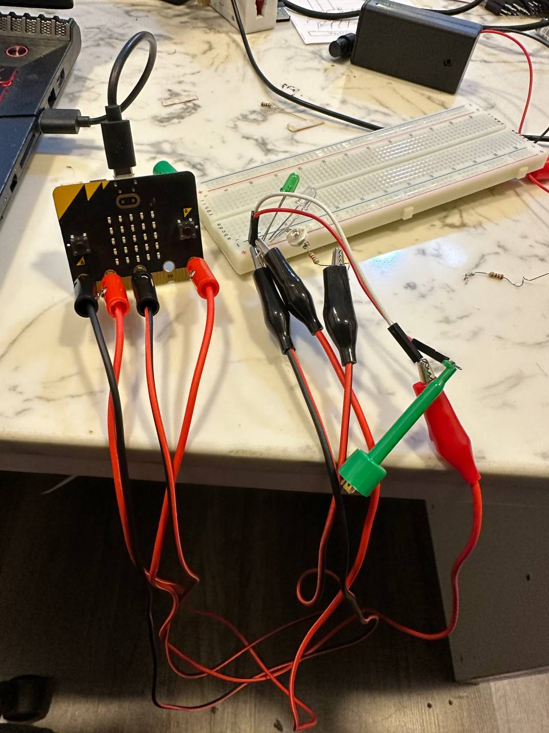

## How It Works

The Micro:bit Traffic Light Simulator follows a basic traffic light sequence:  
1. The green LED turns on for 3 seconds, indicating that vehicles can proceed.  
2. The green LED turns off, and the orange LED turns on for 1 second, signaling a caution period.  
3. The orange LED turns off, and the red LED turns on for 3 seconds, indicating that vehicles should stop.  
During this sequence, the pedestrian signal micro:bit receives signals to indicate when it's safe to cross the street. The LEDs' state changes simulate the behavior of a real traffic light.

## Code

from microbit import *

# Set up LED pins

green_pin = pin0

orange_pin = pin1

red_pin = pin2

def setup():

# Set LED pins as output

green_pin.write_digital(0)

orange_pin.write_digital(0)

red_pin.write_digital(0)

def traffic_light():

green_pin.write_digital(1) # Turn on green LED

sleep(10000) # Green light for 10 seconds

green_pin.write_digital(0) # Turn off green LED

orange_pin.write_digital(1) # Turn on orange LED

sleep(5000) # Orange light for 5 second

orange_pin.write_digital(0) # Turn off orange LED

red_pin.write_digital(1) # Turn on red LED

sleep(10000) # Red light for 10 seconds

red_pin.write_digital(0) # Turn off red LED

# Setup LED pins as outputs

setup()

while True:

traffic_light()

## Conclusion

The Micro:bit Traffic Light Simulator is a fun and educational project that introduces you to programming LEDs and creating simulations with the micro:bit. By following the steps in this documentation, you can successfully set up and run the simulation, gaining hands-on experience with micro:bit programming and electronics.