Spotify Listening Analysis – Storytelling Report (With Visuals)

# 🎧 Dashboard 1: Spotify Listening Patterns (Albums, Artists, Tracks)

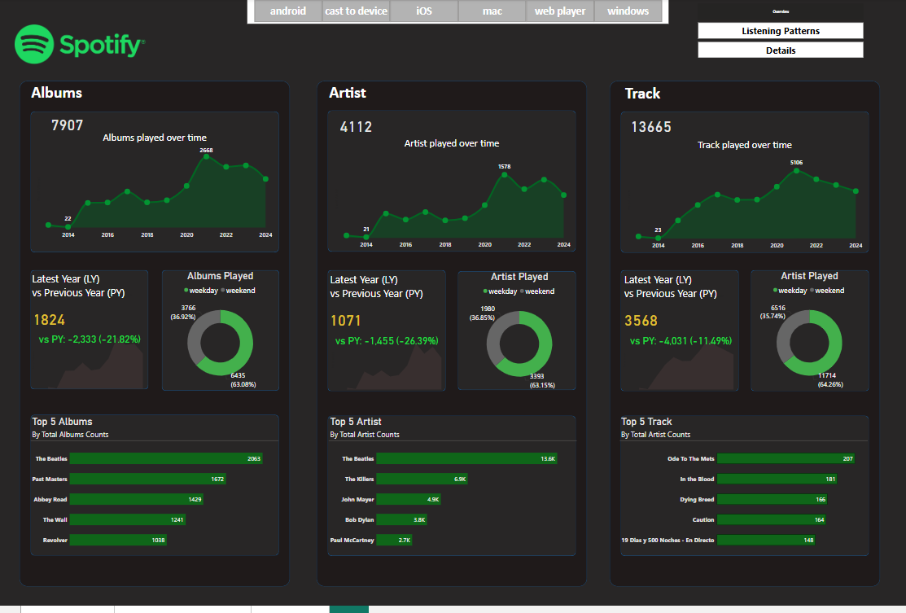

## 🎯 Dashboard Focus

This dashboard analyzes Spotify users' listening behavior with a focus on Albums, Artists, and Tracks from 2014 to 2024. The insights help understand listening trends, user engagement patterns, and potential areas of growth.

## 🔹 1. Albums Analysis

- Total Albums Played: 7,907  
- Trend: Album plays increased until 2021 (peak: 2,668), then declined.  
- Year-on-Year Drop: 2024 saw a -21.82% drop (1,824 vs previous year).  
- Listening Behavior: 63% Weekend vs 36% Weekday plays.  
- Top 5 Albums: Dominated by The Beatles, especially 'The Beatles' album (2,063 plays).

📘 Insight: Audience strongly favors classic albums, particularly The Beatles. However, the recent decline shows decreasing engagement with new content.

## 🔹 2. Artist Analysis

- Total Unique Artists Played: 4,112  
- Peak in 2021: 1,578 artists played  
- Year-on-Year Drop: -26.39% (1,071 vs previous year)  
- Listening Behavior: 63.15% Weekend vs 36.85% Weekday  
- Top 5 Artists: The Beatles, The Killers, John Mayer, Bob Dylan, Paul McCartney

📘 Insight: Users show less interest in discovering new artists and focus on specific favorites.

## 🔹 3. Track Analysis

- Total Tracks Played: 13,665  
- Peak in 2021: 5,106 tracks played  
- Year-on-Year Drop: -11.49% (3,568 vs previous year)  
- Listening Behavior: 64.26% Weekend vs 35.74% Weekday  
- Top 5 Tracks: 'Ode To The Mets', 'In The Blood', 'Dying Bread', 'Caution', '19 Días y 500 Noches – En Directo'

📘 Insight: Weekend listening dominates, and repeat track plays show strong user loyalty.

## 🧠 Overall Key Takeaways

1. Clear downward trend post-2021 across all metrics.  
2. Weekend listening dominates user behavior.  
3. Classic rock and iconic artists like The Beatles still have strong influence.  
4. Engagement drop may signal a need for new content or platform improvements.

## 💡 Business Recommendations

- Push new artist discovery through curated playlists.  
- Promote weekday listening with personalized content.  
- Re-engage users with campaigns like 'Flashback Fridays' or 'Your Top Albums'.  
- Investigate user churn post-2021 to uncover potential issues.

# 📊 Dashboard 2: Spotify Listening Behavior – Time & Track Analysis

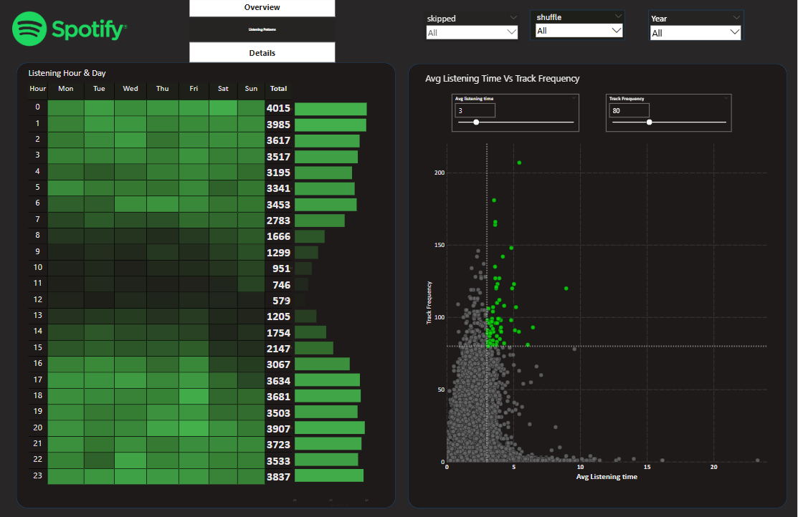

## 🕒 1. Listening Hour & Day Analysis

- Most Active Listening Hours: Midnight to 6 AM (peak at 12 AM and 1 AM), and again from 4 PM to 11 PM.  
- Least Active Hours: 9 AM to 1 PM.  
- Most Active Days: Saturday and Sunday.

📘 Insight: Users prefer night-time listening, suggesting usage for relaxation, sleep, or mood setting.

## 🎵 2. Track-Level Listening (Avg Listening Time vs Frequency)

- Most frequently played tracks are under 5 minutes in average duration.  
- Few tracks with high frequency have average listening time of ~2–4 minutes.  
- Long tracks (>10 minutes) are rarely played fully or frequently.

📘 Insight: Shorter tracks drive higher engagement and replays. Users are less likely to complete long tracks.

## 🧠 Key Takeaways

1. Peak Listening: Midnight and Evening hours.  
2. Weekend dominates user activity.  
3. Short tracks (<5 mins) perform better.  
4. Behavior reflects passive/repetitive listening.

## 💡 Business Recommendations

- Introduce night-themed playlists for late-night listeners.  
- Optimize content scheduling based on time patterns.  
- Promote artists to produce shorter tracks for better engagement.  
- Use repeat data to power personalized 'Top Tracks' playlists.