CST2355 - Database Systems

Assignment #4 Redesign [15%]

This assignment relates to the following Course Learning Requirements:
CLR 2 - Develop Advanced Database Design and Normalization
CLR 3 - Develop advanced subjects and techniques of using the SQL database language
CLR 4 - Use Oracle Procedural programming language (PL/SQL) to write programs that contain SQL statements
CLR5 - Develop advanced Database Queries
CLR6 - Understand and create users, privileges, and roles

adhere to the Academic Integrity policy - no sharing, no copying, no group work
provide ONLY your own work.

Background
The company GlyphParts was started by a group of engineers that bought and resold salvaged auto parts. When they started they tracked their data solely with spreadsheets. Once those speadsheets became cumbersome they moved those spreadsheets to QuickBooks to better manage their data and operations. There was a point however where QuickBooks didn't meet their needs. It had limitations for reporting and integration. So all information was exported out of QuickBooks and imported into a Microsoft Access database with little consideration for data integrity and design. After three years, the Access database reached its size limitation. It was clear now that the company needed a better database with better performance and security. They decided to assign you the task to reverse engineer their existing Access database and create a new database where they will now house their data.

Access Database Design
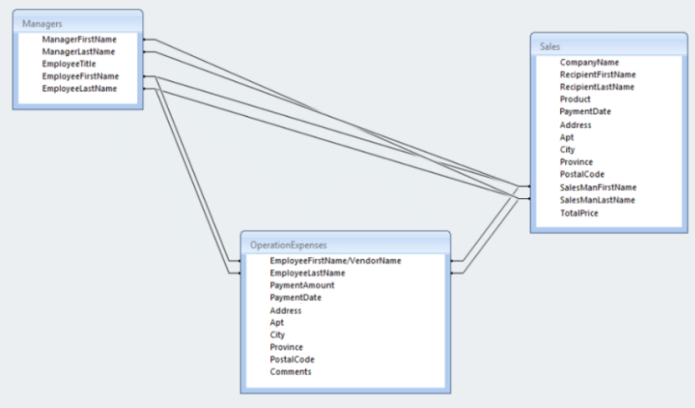

This Access database has four major design issues:

- The data is not normalized and fields are duplicated
- There are minimal constraints on the data
- Table structures are missing primary and foreign keys
- The structure of the data doesn’t reflect how the business communicates with each other nor operates

Pre-Assignment Instructions
1 -- Read Modules 10 and 11 on Brightspace
2 -- Review the assignment support videos in the Additional Resources folder on Brightspace
3 -- Confirm Oracle Data Modeler, Oracle Database, SQL Developer, SQLPLUS are installed

4 -- Review the scripts provided with this assignment

5 -- Use the ASSIGN_4 user. Create the user if it doesn’t exist.

Embed all screenshots in the document where requested.
For full marks screenshots must have formatted output and complete showing ONLY the information requested. Include multiple screenshots if needed.Clear your screen using the CLEAR SCREEN command and use the CST2355_A4_Format.SQL script to beautify your query results.

Instructions
SQLPLUS and SQL Developer each have their own connection to the database. They cannot see each other’s changes without you running COMMIT. If either tool hangs, try running COMMIT in both tools. If hanging still occurs, close both tools and reopen them.

The most common activity you will be a part of is redesign. You’ll be working on something already developed where it ran over-budget and several corners were cut. Not to mention the poor assumptions made on how the business and the technology works. You will need to redesign to fix the main problems after the fact.

The Managers table in the MS Access database diagram is a list of managers and employees who report to those managers. A manager is duplicated for each employee that reports to them. A manager is also duplicated as an employee since they too will have their own manager. Each employee reports to only one direct manager Allowing for duplicate data is a bad design decision.

The Sales table is a list of the products sold by which sales people to which customers. A vendor sells the product to the company. The sales person resells the product to the customer. The column names in this table don’t match the terminology the business uses. This is a bad design decision.

The OperationalExpenses table is all expenses costing the company money. It is a mixture of vendor payments and employee wages. Management uses the wage data for their budgeting. Payments and wages need to be separate entities. FirstName / VendorName is a column being used for two kinds of values. One for people’s names and the other for vendor names. You can tell it is a vendor name when the LastName is blank. This is a bad design decision.

The AS-IS Data Model specifies how the business uses the data. To start a redesign, you start with the current state of the business and how they currently use the business. To start the data model, you use the business requirements.

Pay attention to the min and max cardinalities for relationships. When an entity is about money transfers (payments, wages, purchases, fees), that entity is the child. For example, in a bank it is -- ACCOUNT --< TRANSACTION. If you have it backwards ACCOUNT >-- TRANSACTION, an account can have only have one transaction for all time.

1 -- Create a AS-IS Logical Model using Data Modeler.

Set the notation to Information Engineering Notation. Make labels viewable.

Add the entities, primary IDs, 1:N relationships, and relationship labels that meet the following requirements.
- customer requests purchase (identifying relationship)
- purchase includes product (identifying relationship)
- vendor sells product (non-identifying relationship)
- employee submits payment (identifying relationship)
- payment made to vendor (identifying relationship)
- employee receives wage (identifying relationship)

You do not add the entity when it is a type of another entity. For instance you would have a CustomerType attribute for CUSTOMER to represent different kinds of customers. Add the type attributes, 1:N relationship and relationship label that meet the following requirements.
- sales person is a type of employee
- sales person facilitates purchase (non-identifying relationship)

In the case with managers you would use a recursive relationship. Add the 1:N recursive relationship and relationship label that meet the following requirements.
- manager is a type of employee
- manager monitors employee (non-identifying relationship)

Reposition the entities in the diagram to match their position in the requirement statement. For instance, “customer requests purchase”, the CUSTOMER entity needs to be above or to the left of the PURCHASE entity.

Go to each primary ID and turn primary UID on. Go to each foreign ID created and turn its primary UID off. Hide all IDs and keys.

2 -- Review the Access Design diagram. Add each field as an attribute in the appropriate entity for the AS-IS Logical Model. You will need to rename the attribute so it best matches the entity it’s in. For example: When adding from SALES, Product would be ProductName; RecipientLastName would be LastName; and TotalPrice & PaymentDate would be PurchasePrice & PurchaseDate.

Leave all datatypes as unknown. Please note --

- fields from multiple tables may produce the same attribute for an entity. Do not add the attribute again if it already exists in the entity.

- add the Addresses attribute (plural) to CUSTOMER, EMPLOYEE, and VENDOR. Do not add the Address, Apartment, City, Province, PostalCode as attributes.

- A payment column in OPERATIONALEXPENSES create two attributes. One attribute become a payment named attribute in PAYMENT. The other attribute becomes a wage named attribute in WAGE

- add the PricePerUnit attribute to PRODUCT

Pay attention to the identifying attributes for money transfer entities. They always have the date the money is sent as an identifying attribute. They also always use the identifying attributes of the the entity receiving the money.

3 -- Specify the identifying attributes for each entity by setting the data type to either Identifying Name or Identifying Date. In some cases you may need to add the identifying attributes of some or all of the entity’s parents.

Move the identifying attributes to the top of each entity.

Add your name, student number, and the current date at the bottom right corner.

Provide a screenshot from Data Modeler of your AS-IS Logical Model.

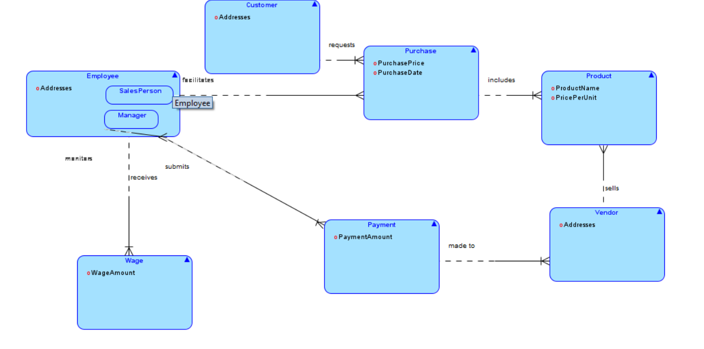

The business is taking the opportunity to specify new requirements. You will use these requirements to expand on your AS-IS conceptual data model. This expanded model is your TO-BE Data Model.

4 -- Save your AS-IS Logical Model in Data Modeler. Create a new TO-BE Logical Model. Copy and paste all objects from the AS-IS diagram to the TO-BE diagram.

- department supported by employee (non-identifying relationship)
department attributes: department name
- marketing department is a type of department (do not add a marketing department entity)
- price renegotiation initiated by marketing department (identifying relationship)
- price renegotiation accepted by vendor (identifying relationship)
- price renegotiation involves assessment of product (identifying relationship)
- price renegotiation approved by sales person (identifying relationship)
price renegotiation attributes: department name, vendor name, product name, sales person first name, sales person last name, approval date, original price, vendor price, approved price

Reposition the entities on the diagram to match their position in the statement. For instance, “department supported by employee”, the DEPARTMENT entity needs to be above or to the left of the EMPLOYEE entity.

Go to each primary ID and turn primary UID on. Go to each foreign ID created and turn its primary UID off. Hide all IDs and Keys.

5 -- Add to the TO-BE Logical Model the 1:N relationships, and relationship labels based on the requirements. Confirm the correctness of each relationship’s min/max cardinalities based on the entities involved.

6 -- Specify in the TO_BE Logical Model the identifying attributes for each entity by setting the attribute’s datatype to either to Identifying Name or Identifying Date. You may need to add the identifying attributes from the entity’s parents.

Provide a screenshot from Data Modeler of your TO-BE Logical Model.

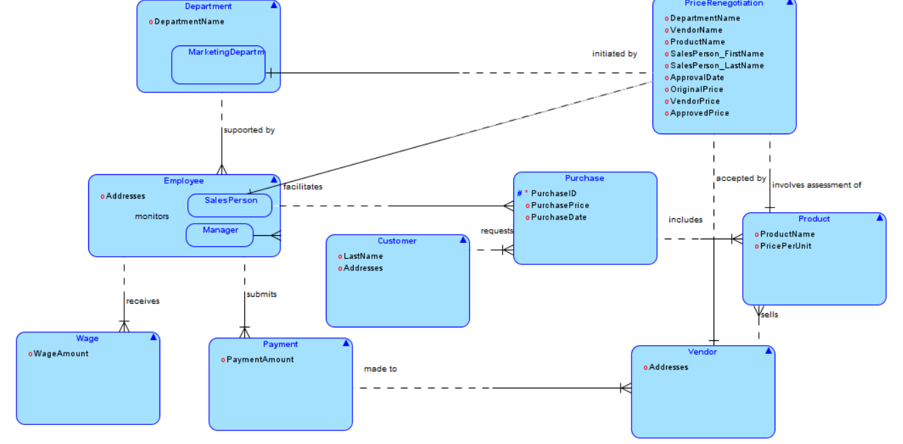
The next steps include forward engineering your Logical Model to a Relational Model. Then forward engineer the relational model into code and run it on the destination database. These steps were done by another team. They handed you a script that generates the new database tables along with copies of the three MS Access tables. You will use these IMPORT tables to insert data into the EMPLOYEE destination table.

7 -- Run the CST2355_A4_DB.SQL to create you IMPORT and destination tables.

Create an INSERT INTO EMPLOYEE statement to insert the data found in the IMPORT_MANAGERS employee columns. Do not insert the manager column data. Assume the EmployeeType is FullTime. Do not insert employees that already exist in EMPLOYEE using EmployeeID and the NOT IN operator.

Add a comment before your statement that includes your name, student number, and today’s date.

Copy and paste to run your statement in SQLPLUS. Run COMMIT.

Provide a screenshot from SQLPLUS of your statement with its run results.
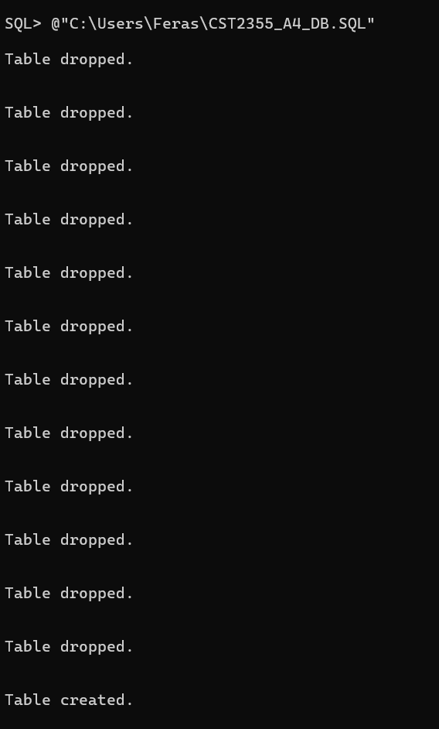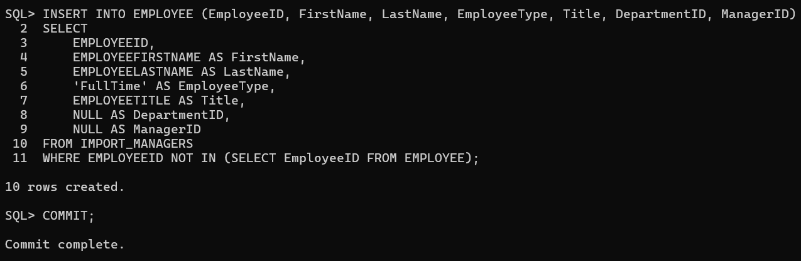
8 -- Create a UPDATE EMPLOYEE SET ManagerID statement to update the ManagerID for an employee using the IMPORT_MANAGERS. Use the following pattern.

UPDATE DEST_TABLE SET ParentID =
(SELECT ChildID FROM IMPORT WHERE (Column1, Column2, Column3) IN
(SELECT Column4, Column5, Column6
FROM IMPORT WHERE ChildID = DEST_TABLE.ChildID ));

To test the update, run SELECT EmployeeID, ManagerID FROM EMPLOYEE WHERE ManagerID = 101
It should return EmployeeID 102, 103, and 104.

Add a comment before your statement that includes your name, student number, and today’s date.

Copy and paste to run your statement in SQLPLUS. Run COMMIT.

Provide a screenshot from SQLPLUS of your statement, its run results, and the test run results.
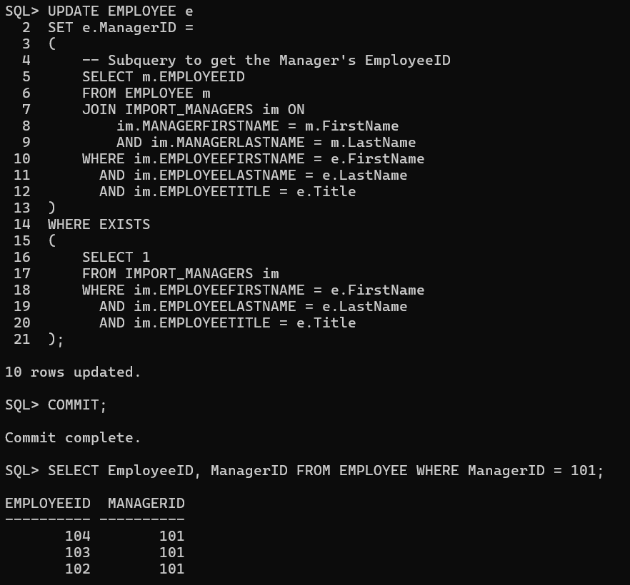
9 -- Create an INSERT INTO EMPLOYEE statement to insert the data found in the IMPORT_SALES table. Assume the EmployeeType is Sales and the Title is Sales Person. Do not insert employees that already exist in EMPLOYEE using EmployeeID and the NOT IN operator.

Add a comment before your statement that includes your name, student number, and today’s date.

Copy and paste to run your statement in SQLPLUS. Run COMMIT.

Provide a screenshot from SQLPLUS of your statement with its run results.
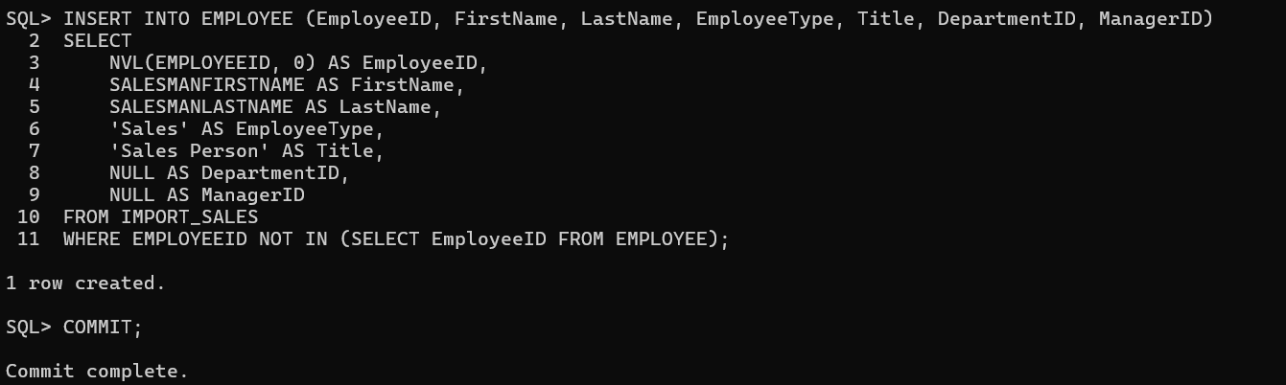
10 -- Create an UPDATE EMPLOYEE SET EmployeeType = 'Sales' statement to update all employees in EMPLOYEE that are also found in IMPORT_SALES. Update only employees in SALES using EmployeeID and the IN operator.

Add a comment before your statement that includes your name, student number, and today’s date.

Copy and paste to run your script in SQLPLUS. Run COMMIT.

Provide a screenshot from SQLPLUS of your script with its results.
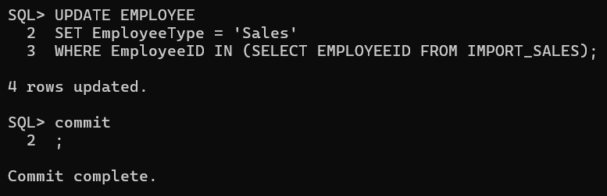
After importing your data, it is always a good idea to confirm the there is no duplication. Correlated queries are used to identifying minor changes in the data to rule out any potential duplicates. Duplicates can be caused by typos, name changes, and other human errors.

11 -- Create two correlated queries using the following pattern.

SELECT * FROM …
WHERE Column1 IN
(
SELECT Column1 FROM …
WHERE ___.Column1 = ___.Column1
AND ___.Column2 = ___.Column2
…
AND ___.ColumnN <> ___.ColumnN
);

Create a correlated query using EMPLOYEE that returns employees having the same last name but different first names.

Create a correlated query using PURCHASE that returns the same products sold at the same price on the same date to the same customer (same CustomerID) but have different PurchaseIDs.

Add a comment before your statements that includes your name, student number, and today’s date.

Copy and paste to run your script in SQLPLUS.

Provide screenshots from SQLPLUS of your script with its returned results.
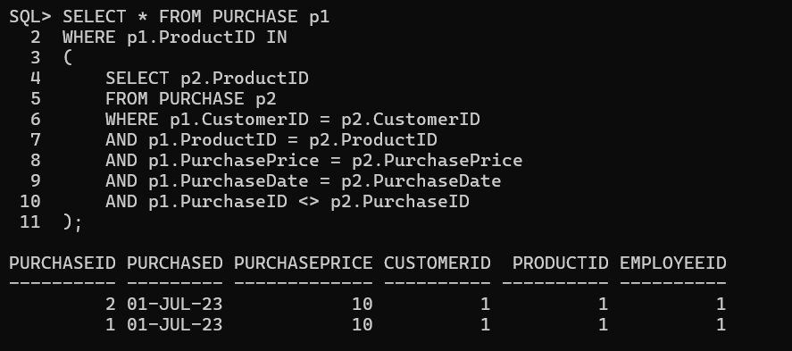

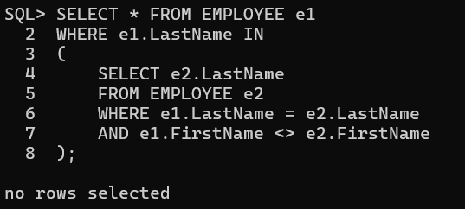
When doing redesign, constraints are not added to the tables until all data is imported and cleaned up. To confirm that the constraints will be successfully created you need to check for data integrity. Invalid foreign key checks are used to identify parents that don’t have children and children that don’t have parents. Once you know which rows have incorrect data you can correct them so the constraints are successfully corrected.

12 -- Create two statements to check the exists of parents and children using the following pattern.

SELECT * FROM …
WHERE ColumnID NOT IN (SELECT ParentID FROM … WHERE ParentID IS NOT NULL);

Create a statement that returns employees that work for a department that doesn’t exist.

Create a statement that returns departments that don’t have employees.

Add a comment before your statements that includes your name, student number, and today’s date.

Copy and paste to run your script in SQLPLUS.

Provide screenshots from SQLPLUS of your script with its returned results.
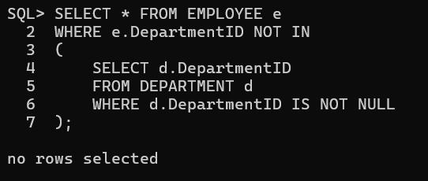

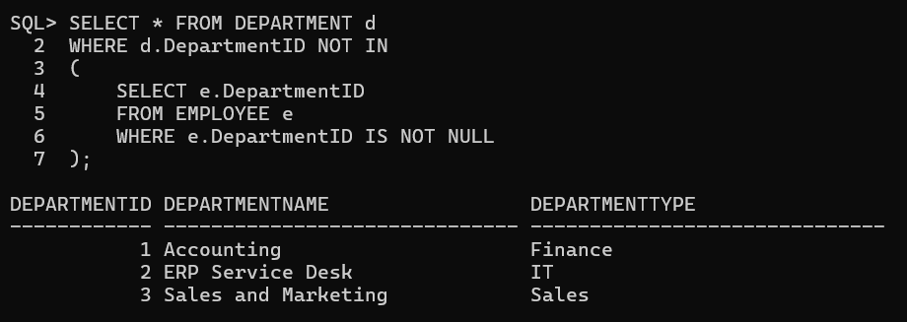
Often unconstrained data from old databases have poor field validation .That means column values likely do not have proper values. Some values shouldn’t have spaces, may be required to have a certain number of digits, or be in a certain format like phone numbers and postal codes.

13 -- Use REGEXP_LIKE() function to return invalid values using the following pattern.

SELECT …
WHERE REGEXP_LIKE (ColumnName,…);

Do not use the NOT operator. Use ONLY the following within the REGEXP_LIKE() function.

^ | $ | \W | \d | \. | + | {n} where n is a number

Uses the following for reference for their use.
https://www.oracletutorial.com/oracle-string-functions/oracle-regexp_like/
https://docs.oracle.com/cd/B13789_01/server.101/b10759/ap_posix001.htm#i690819

Do not use what is not included above. For instance, do not use [A-Z], {n,}, or [:alpha:]

Create a statement that returns employees that don’t have all alphabetical characters in their first or last name.

Create a statement using an IS NULL condition and two REGEXP_LIKE conditions that returns purchases that have --
- [condition 1] no amounts
- [condition 2] amounts with 6 or more digits before the decimal
- [condition 3] amounts with 3 or more digits after the decimal
You should have 3 conditions in the WHERE clause. Keep it simple.

Add a comment before your statements that includes your name, student number, and today’s date.

Copy and paste to run your script in SQLPLUS.

Provide screenshots from SQLPLUS of your script with its returned results.
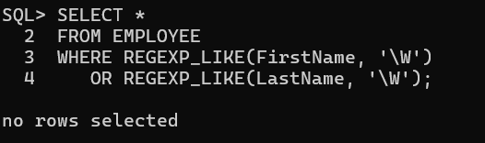

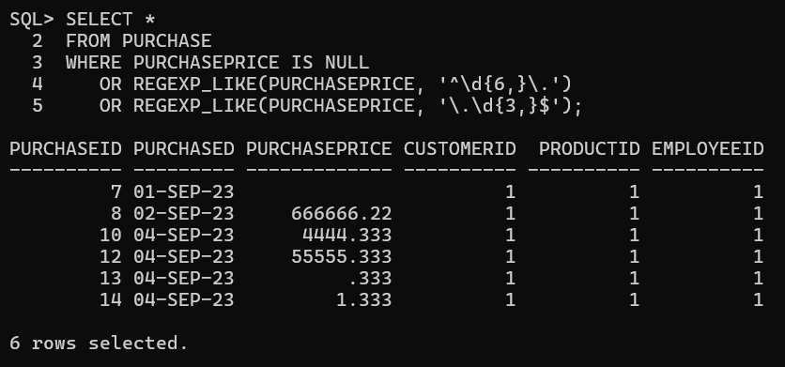
Once data has been imported and cleaned in the database, you add constraints to your tables to enforce data integrity.

14 -- Create a new script.

Add ALTER statements to add primary key constraint to the parents of PURCHASE. Add ALTER statements to add foreign key constraints for PURCHASE and its parents

Add a comment at the start of your script that includes your name, student number, and today’s date.

Copy and paste to run your script in SQLPLUS.

Provide screenshots from SQLPLUS of your script with its results.
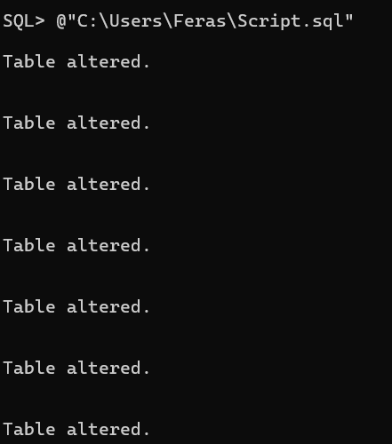
Now that the data is successfully constrained you will create permissions so users can CREATE a new table, select from EMPLOYEE and update EMPLOYEE.

15 -- Go to SQLPLUS using SQLPLUS / AS SYSDBA
If SYS has a password use SQLPLUS SYS/put_password_here AS SYSDBA

Run @CST2355_A4_Users.SQL to create user ASSIGN_4X, user ASSIGN_4Y, and user ASSIGN_4Z. Clear your screen.

Your next step is to see run statements to see which privileges a user has and doesn’t have based on the messages you’ll receive.

Connect as ASSIGN_4X by running CONNECT ASSIGN_4X/CST2355db
Run CREATE TABLE ASSIGN_4Z.TABLE_X (TestColumn INT);
Run SELECT * FROM ASSIGN_4Z.TABLE_Z;

Examine the code in the CST2355_A4_Users.SQL script and locate the grant statements that allows the SELECT and determine why it doesn’t allow the CREATE.

Connect as ASSIGN_4Y by running CONNECT ASSIGN_4Y/CST2355db
Run CREATE TABLE ASSIGN_4Z.TABLE_Y (TestColumn INT);
Run SELECT * FROM ASSIGN_4Z.TABLE_Z;

Examine the code in the CST2355_A4_Users.SQL script and locate the grant statements that allows the CREATE and determine why it doesn’t allow the SELECT.

Clear your screen. In SQLPLUS use the CONNECT, GRANT, and UPDATE statements so you can use the ASSIGN_4Z user to run an UPDATE ASSIGN_4.EMPLOYEE to change the first name from Bob Jr to Bob JR. Do not use the ALL PRIVILEGES permission.

Add a comment that includes your name, student number, and today’s date.

Provide your screenshots from SQLPLUS.
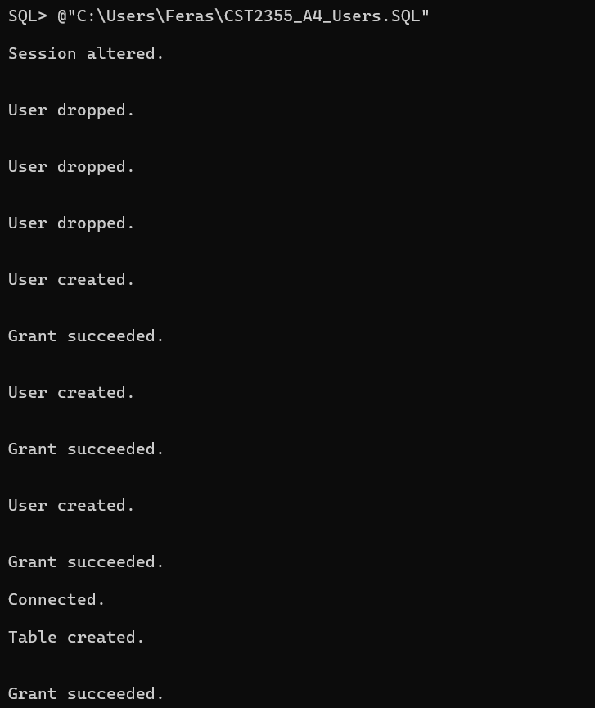

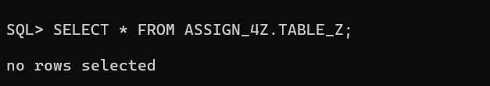

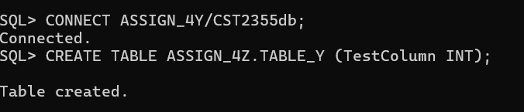
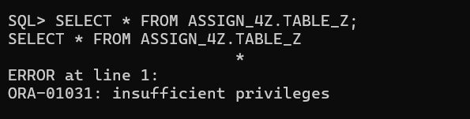

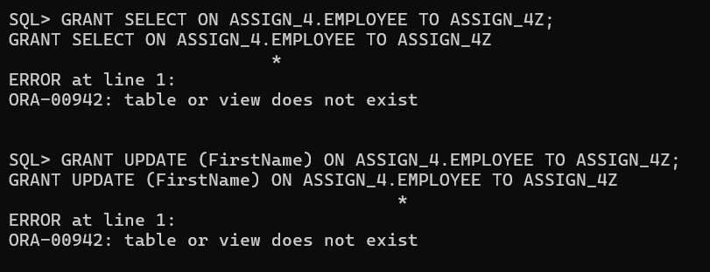

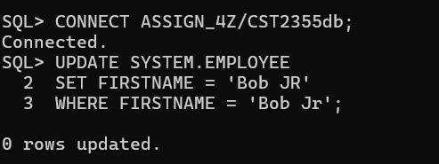

Confirm all screenshots are correct and not clipped. Save your assignment as a PDF and submit it in the assignment submission folder.

Assignment 4 Rubric
Criteria | Accomplished | Developing | Incomplete
 | 1 points | 0.5 point | 0 points
1 -- AS-IS Data Model - Entities & Relationships | Completed all instructions and submitted correct results | Completed most of the instructions and submitted partial or incorrect results | Not per instructions, incomplete, or omitted
2 -- AS-IS Data Model - Attributes | Completed all instructions and submitted correct results | Completed most of the instructions and submitted partial or incorrect results | Not per instructions, incomplete, or omitted
3 -- AS-IS Data Model - Identifying Attributes | Completed all instructions and submitted correct results | Completed most of the instructions and submitted partial or incorrect results | Not per instructions, Incomplete or omitted
4 -- TO-BE Data Model - Entities and Attributes | Completed all instructions and submitted correct results | Completed most of the instructions and submitted partial or incorrect results | Not per instructions, Incomplete or omitted
5 -- TO-BE Data Model - Relationships | Completed all instructions and submitted correct results | Completed most of the instructions and submitted partial or incorrect results | Not per instructions, incomplete, or omitted
6 -- TO-BE Data Model - Identifying attributes | Completed all instructions and submitted correct results | Completed most of the instructions and submitted partial or incorrect results | Not per instructions, Incomplete or omitted
7 -- Import from IMPORT_MANAGERS | Completed all instructions and submitted correct results | SQL follows most of the instructions and produced unexpected run results | Doesn't compile, SQL not per instructions, incomplete or omitted steps
8 -- Import from IMPORT_MANAGERS (ManagerID) | Completed all instructions and submitted correct results | SQL follows most of the instructions and produced unexpected run results | Doesn't compile, SQL not per instructions, incomplete or omitted steps
9 -- Import from IMPORT_SALES | Completed all instructions and submitted correct results | SQL follows most of the instructions and produced unexpected run results | Doesn't compile, SQL not per instructions, incomplete or omitted steps
10 -- Import from IMPORT_SALES (EmployeeType) | Completed all instructions and submitted correct results | SQL follows most of the instructions and produced unexpected run results | Doesn't compile, SQL not per instructions, incomplete or omitted steps
11 -- Correlated Queries | Completed all instructions and submitted correct results | SQL follows most of the instructions and produced unexpected run results | Doesn't compile, SQL not per instructions, incomplete or omitted steps
12 -- Invalid Foreign Keys | Completed all instructions and submitted correct results | SQL follows most of the instructions and produced unexpected run results | Doesn't compile, SQL not per instructions, incomplete or omitted steps
13 -- Invalid Values | Completed all instructions and submitted correct results | SQL follows most of the instructions and produced unexpected run results | Doesn't compile, SQL not per instructions, incomplete or omitted steps
14 -- Data Integrity | Completed all instructions and submitted correct results | SQL follows most of the instructions and produced unexpected run results | Doesn't compile, SQL not per instructions, incomplete or omitted steps
15 -- Permissions | Completed all instructions and submitted correct results | SQL follows most of the instructions and produced unexpected run results | Doesn't compile, SQL not per instructions, incomplete or omitted steps

