**Table of Contents**

1. **Detailed Functional Requirements**............................................ 2
   1. **Task Assignment Module**………………………………………………… 2
   2. **Application Management Module**…………....……………...…………... 2
   3. **Profile Management Module**……………………………………………. 2
   4. **Role-Based Access Control Module**........................................................... 2
   5. **Feedback Module**………………………………………………...………. 3
2. **ERD**………………………………………………………………………….…. 4
3. **EERD**……………………………………………………………………….…. 5
4. **Relational Schema/Logical Schema**………………………… 6
5. **User Document and help**…………………………………………. 7-8
6. **Screenshots of implemented code**…………………………... 9-14

**Detailed Functional Requirements**

1. **Task Assignment Module**

**1.1 Faculty Members**

* Ability to assign tasks or modules to TAs and Lab Demonstrators.
* View and modify task assignments.

**1.2 Teacher Assistants (TAs) and Lab Demonstrators**

* View assigned tasks or modules.

**2. Application Management Module**

**2.1** **Administrators**

* Will see all the application
* Select the required ones

**2.2** **Teacher Assistants (TAs) and Lab Demonstrators**

* Apply for application

**3. Profile Management Module**

**3.1 Administrators**

* Can change password.

**3.2 Faculty Members**

* Can change password.

**3.3 Teacher Assistants (TAs) and Lab Demonstrators**

* Can change password.

**4. Role-Based Access Control Module**

**4.1 Administrators**

* Manage user roles.

**4.2 Faculty Members**

* Access specific functionalities based on their role.
* View and modify assignments.
  1. **Teacher Assistants (TAs) and Lab Demonstrators**
* Access functionalities relevant to their roles.
* View assignments and update.

**5. Feedback Module**

**5.1 Administrators**

* Review and analyze feedback.
* Generate reports on TA and Lab Demonstrator performance.

**5.2 Faculty Members**

* Provide feedback and evaluations for TAs and Lab Demonstrators.
* View and analyze feedback.

**5.3 Teacher Assistants (TAs) and Lab Demonstrators**

* Access feedback and evaluations provided by faculty members.
* Receive constructive feedback for improvement.

Top of Form

**ERD**

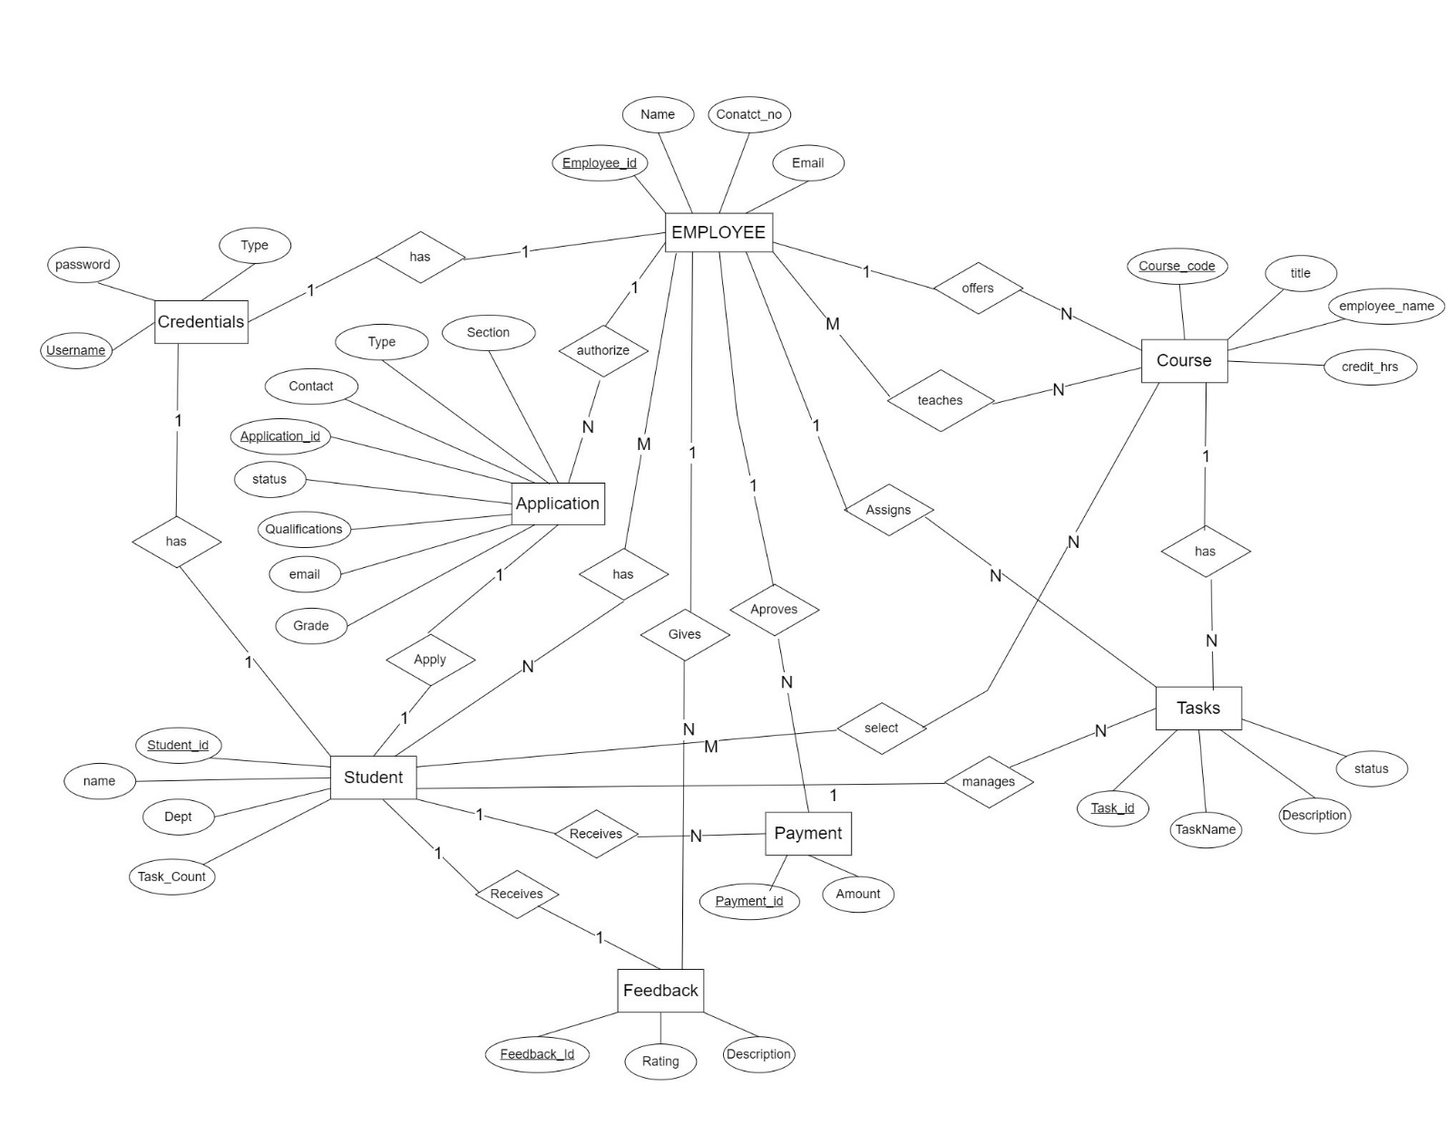

%3CmxGraphModel%3E%3Croot%3E%3CmxCell%20id%3D%220%22%2F%3E%3CmxCell%20id%3D%221%22%20parent%3D%220%22%2F%3E%3CmxCell%20id%3D%222%22%20value%3D%22%26lt%3Bfont%20style%3D%26quot%3Bfont-size%3A%2018px%3B%26quot%3B%26gt%3BGrade%26lt%3B%2Ffont%26gt%3B%22%20style%3D%22rounded%3D0%3BwhiteSpace%3Dwrap%3Bhtml%3D1%3B%22%20vertex%3D%221%22%20parent%3D%221%22%3E%3CmxGeometry%20x%3D%22-496.15%22%20y%3D%22-520%22%20width%3D%22120%22%20height%3D%2260%22%20as%3D%22geometry%22%2F%3E%3C%2FmxCell%3E%3C%2Froot%3E%3C%2FmxGraphModel%3E

**EERD**

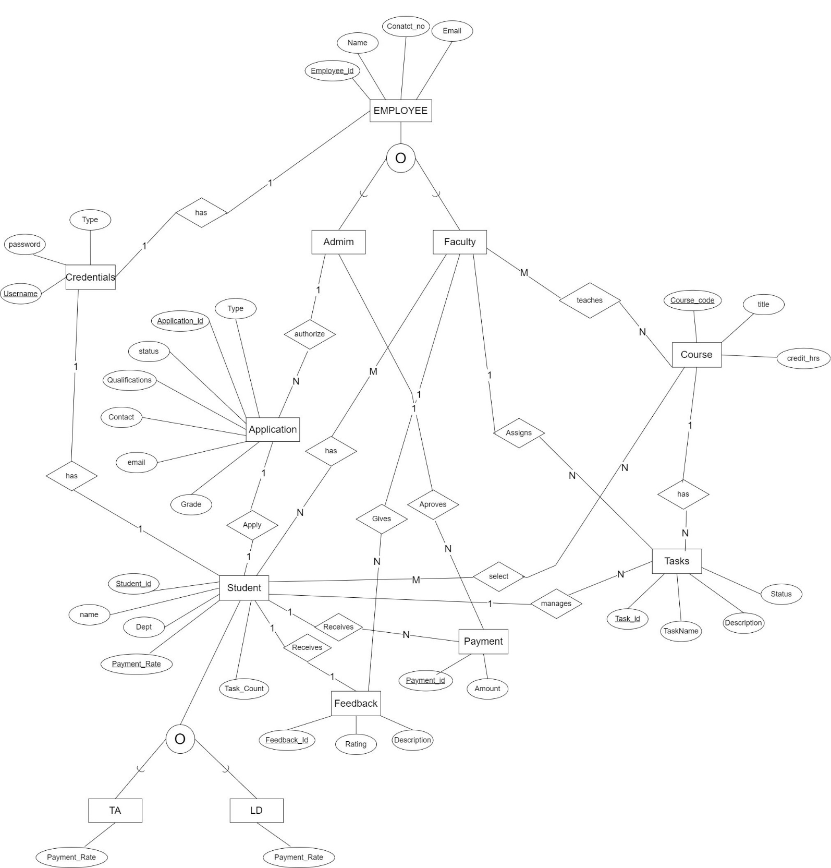

**Relational Schema/Logical Schema**

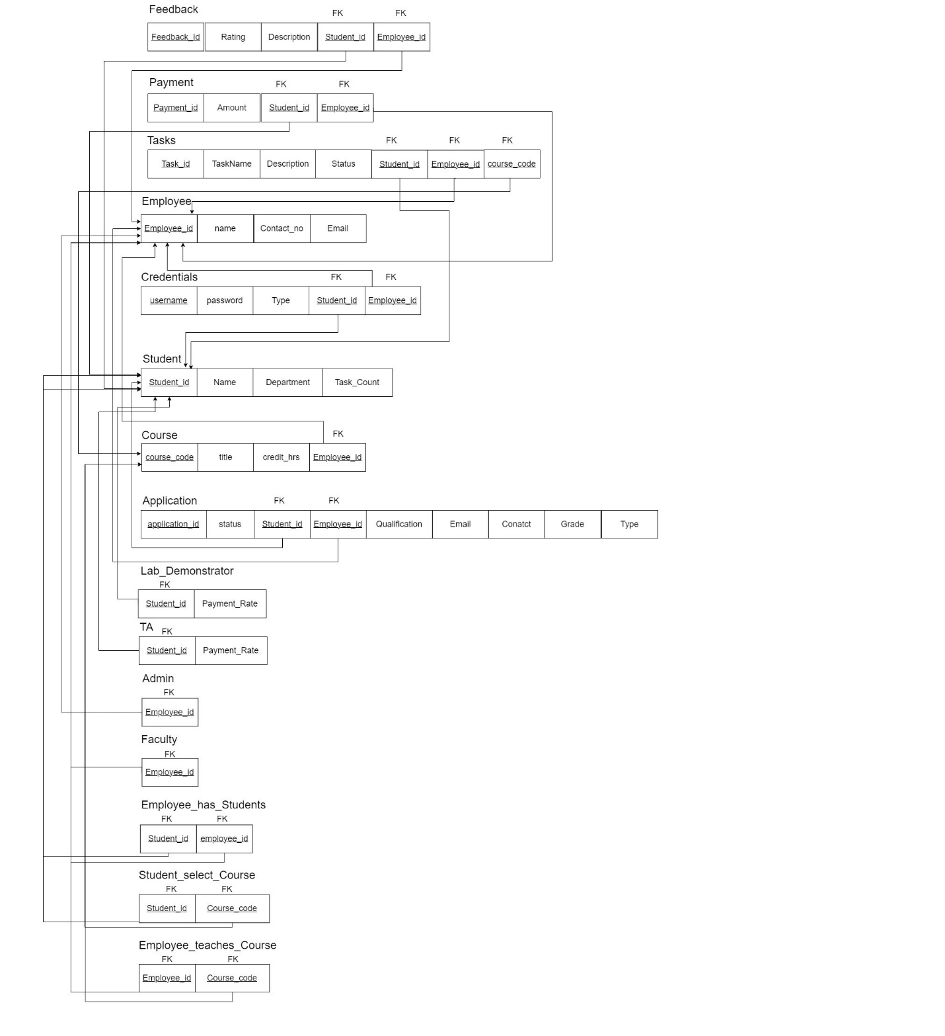

**User Documentation and Help**

Welcome to the TA and Lab Demonstrator Management System! This user guide is designed to help you navigate through the various modules and features of the system efficiently. Whether you are an administrator, faculty member, or a TA/Lab Demonstrator, this guide will provide you with step-by-step instructions on how to use the system effectively.

**1. Login and Registration**

**1.1 Logging In**

* Visit the login page and enter your credentials.
* Click "Login" to access the system.

**2. Task Assignment Module**

**2.1 Assignment Overview**

* Navigate to the Task Assignment module from the dashboard.
* Review the list of assigned tasks and their status.
  1. **Assigning Tasks**
* Faculty members can assign tasks.

**2.3 Viewing Assigned Tasks**

* TAs and Lab Demonstrators can view their assigned tasks in the "My Tasks" section.
* Access task details and update the task status as needed.

**3. Profile Management Module**

**3.1 Updating password**

* Click on the "Change Password" option to update your password.
* Save changes to reflect the updated information.

**4. Role-Based Access Control**

**4.1 Understanding User Roles**

* Familiarize yourself with the different user roles: administrators, faculty members, TAs, and Lab Demonstrators.
* Each role has specific access permissions based on their responsibilities.
  1. **Accessing Role-Specific Functionalities**
* Use the navigation menu to access functionalities relevant to your role.

**5. Feedback and Evaluation Module**

**5.1 Providing Feedback**

* Faculty members can provide feedback in the Feedback module.

**5.2 Viewing Feedback and Evaluations**

* TAs and Lab Demonstrators can view feedback provided by faculty members.

Feel free to explore the system and use this guide as a reference for any questions you may have. If you encounter any issues or need further assistance, please contact our support team at [[waizhassan44@gmail.com](mailto:waizhassan44@gmail.com)]. We hope you find the TA and Lab Demonstrator Management System a valuable tool for efficient task management and collaboration within the educational institution.

**Screen Shots of Implemented Code**

