

HCI – CS421

Project - Deliverable #1

**Members:**

Huzaifa – 2017192  
Subhash – 2017445  
Shahzaib – 2017430  
Salman – 2017406

Friday, 06 November 2020

Contents

1 Project Idea/Description 3

1.1 Introduction 3

1.2 Problem Statement 3

1.3 Existing System 3

1.4 Proposed Interface 3

1.5 Solution 3

2 Users 4

2.1 Persona Identification and attributes 4

2.1.1 Patients 4

2.1.2 Administration 4

2.1.3 Doctor 4

2.2 Persona Goals 4

2.2.1 Patients 4

2.2.2 Administration 5

2.2.3 Doctor 5

3 Scenarios 5

3.1 Scenario Details 5

3.2 Scenario flow charts 6

# Project Idea/Description

## Introduction

Aim of this project “GI-Clinic – Smart system for medical centre” is to create doctor patient handling management system that will help doctors in their work and will also help patients to book doctor appointments and view medical progress. The system allows administration to manage their booking slots online. Patients are allowed to book empty slots online and those slots are reserved in their name. The system manages the appointment data for multiple doctors of various date and times. Each time a user visits a doctor his/her medical entry is stored in the database by doctor. Next time a user logs in he may view his/her entire medical history as and when needed. At the same time a doctor may view patient’s previews medical history while the patient visits him. The system also consists of Blood donor module. This module allows for Blood donation registration as well as Blood group search.

## Problem Statement

Since Hospital is associated with the lives of common people and their day-to-day routines so we decided to work on this project.

The manual handling of the record is time consuming and highly prone to error. The purpose of this project is to automate, the process of day-to-day activities like make an appointment, view available doctors, Blood bank etc.

## Existing System

The existing system in GIK Institute is manual system where the students/staff have to physically go to the Medical Centre for an appointment and then wait for the doctor. This process is very cumbersome and inefficient. All the work is done on paper with a high chance of documents being misplaced and incorrect data entry. In this day and age, no-one has time to waste so waiting for an appointment in totally out of the books.

## Proposed Interface

Our proposed interface is a mobile application.

## Solution

Hospital are the essential part of our lives, providing best medical facilities to people suffering from various ailments, which may be due to change in climatic conditions, increased work-load, emotional trauma stress etc. It is necessary for the hospitals to keep track of its day-to-day activities & records of its patients, doctors, nurses, ward boys and other staff personals that keep the hospital running smoothly & successfully.

But keeping track of all the activities and their records on paper is very cumbersome and error prone. It also is very inefficient and a time-consuming process considering the continuous increase in population and number of people visiting the medical centre. Recording and maintaining all these records is highly unreliable, inefficient and error-prone. It is also not economically & technically feasible to maintain these records on paper. Thus keeping the working of the manual system as the basis of our project. We have developed an automated version of the manual system, named as “GI-Clinic – Smart system for medical centre”. The main aim of our project is to provide a paper-less hospital up to 90%.

# Users

User personas are representations of your target customers. Creating user personas involves researching and outlining your ideal customer’s goals, pain points, behaviour, and demographic information.

## Persona Identification and attributes

### Patients

|  |
| --- |
| **Attributes** |
| Registration Number |
| Name |
| Age |
| Faculty |
| Qualification |

### Administration

|  |
| --- |
| **Attributes** |
| S_ID |
| Name |
| Age |
| Position |

### Doctor

|  |
| --- |
| **Attributes** |
| D_ID |
| Name |
| Age |
| Specialization |
| Timings |

## Persona Goals

### Patients

The goals for patients would be:

* Book an appointment.
* View updates about medical centre.
* Cancel an appointment.
* Check Doctor Availability.

### Administration

The goals for administration would be:

* Confirm the patient’s appointment by SMS/Appointment desk.
* Inform the doctor about appointment.
* Assigning doctors to patients according to doctor availability.
* Facilitate the patients with already given prescriptions.
* Update records.
* Cancelling the appointment in case of emergency by SMS or CALL.

### Doctor

The goals for doctors would be:

* View the appointments for the day.
* Access to patient medical history.
* Confirm availability for appointments.
* Give prescriptions to patients.

# Scenarios

## Scenario Details

Patient uses the app to book an appointment. The appointment information is then transferred to the admin staff. The admin staff then checks for doctor availability. If a doctor is available then the appointment info is transferred as a notification to the doctor. The doctor then confirms his availability for the appointment. Finally then the appointment is confirmed and stored in database and appointment list. A confirmation notification is sent to both the doctor and patient.

Patient uses the app to cancel appointment. The admin then receives the notification of cancellation. The admin then updates the list of appointments while marking the particular appointment as cancelled. Lastly the patient and doctor receives the cancellation notification.

Patient arrives at the admin desk to cancel appointment. The admin then marks the order as cancelled in the appointment list and update it. The patient and doctor then receives the cancelation notification.

On arriving of an emergency the doctor then sends an appointment cancellation request to the admin. The admin then cancels the appointment and notifies the patient of the cancellation. The admin then asks the patient for other suitable day and time options for rescheduling the appointment. Then according to patient’s preferred day and time the appointment is rescheduled. The patient and doctor then receives a notification of the rescheduled appointment.

The Patient arrives for the appointment. The doctor then checks for the previous medical history of the patient. Then after hearing about the illness, he diagnosis the patient according to his previous medical history. The doctor then updates the medical record of the patient.

## Scenario flow charts

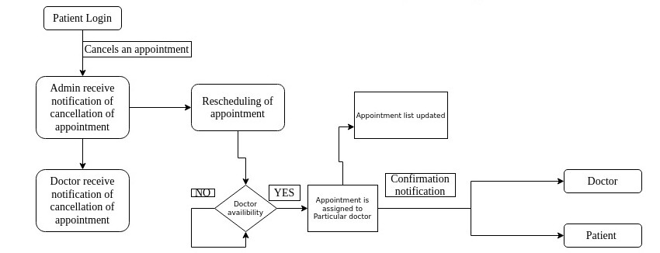Patient cancels the appointment

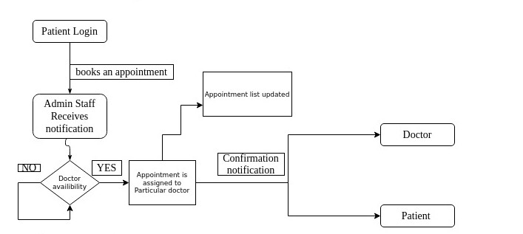Patient Books an Appointment

Doctor cancels the appointment

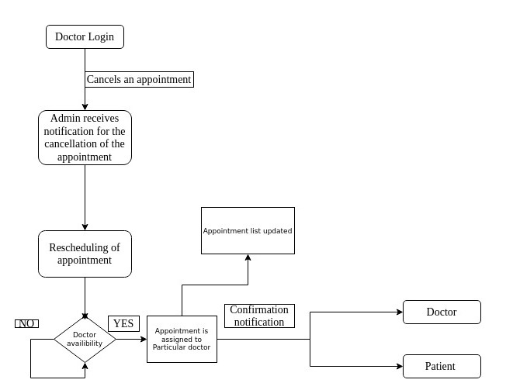

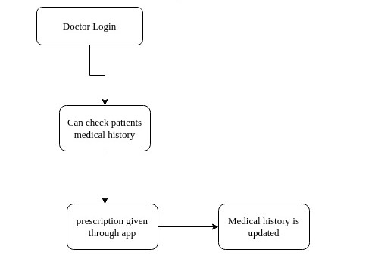Doctor checks patient’s Medical records and updates it