

HCI – CS421

Project - Deliverable #2

**Members:**

Huzaifa – 2017192  
Subhash – 2017445  
Shahzaib – 2017430  
Salman – 2017406

Monday, 04th January 2020

Contents

1 Scenarios 4

1.1 Scenario Details 4

1.2 Scenario flow charts 4

**Scenarios for Patients**

**Scenario 1: Patients Login**

Patients can login using already created account.

<https://drive.google.com/file/d/1NWJOKLJpN1JDLn1nBDhQUpCUBCG9y4E5/view?usp=sharing>

**Scenario 2: Patients can create a new account**

Patients can create a new account.

<https://drive.google.com/file/d/1ynNmJxhlz4joc_tqX_I2ev0JTPYsmZ2w/view?usp=sharing>

**Scenario 3: Patients can forget password**

Patients can get a new password for already created account.

<https://drive.google.com/file/d/1oXnTor0hsTIWElMD5DfjD7QAdyw8juna/view?usp=sharing>

**Scenario 4: Patients can book appointment**

Patients can book an appointment by providing required information.

<https://drive.google.com/file/d/1Fz0SmUN_WjIJSYO4VjzNsC6Nfijy0iVJ/view?usp=sharing>

**Scenario 5: Patients can view the available doctors**

Patients can book the appointment.

<https://drive.google.com/file/d/1-uVc9RnzKZaceUdWTRXDxrw27g_pWRvV/view?usp=sharing>

**Scenario 6: Patients can cancel any booked appointment**

Patients can book the appointment.

<https://drive.google.com/file/d/1-uVc9RnzKZaceUdWTRXDxrw27g_pWRvV/view?usp=sharing>

**Scenario 7: Patients can view their account updates**

Patients can view updates regarding prescriptions, confirmed appointments and cancelled appointments etc.

<https://drive.google.com/file/d/1-uVc9RnzKZaceUdWTRXDxrw27g_pWRvV/view?usp=sharing>

**Scenario 8: Patients can contact user support.**

Patients can write suggestions/complaints and contact the developers.

<https://drive.google.com/file/d/1eYdg2m-RJA2sD45XiirbE2KEQylhklFY/view?usp=sharing>

**Scenarios for Administration**

**Scenario 1: Administration can confirm the appointments**

Administration can confirm the appointments by assigning the patient the patient a doctor.

<https://drive.google.com/file/d/10bWBR2mT_BO8Re1M9WVz58UY1_h1DuE5/view?usp=sharing>

**Scenario 2: Administration can view available doctors**

Administration can view available doctors

<https://drive.google.com/file/d/10bWBR2mT_BO8Re1M9WVz58UY1_h1DuE5/view?usp=sharing>

**Scenario 3: Administration can cancel any booked appointment**

Administration can cancel any appointment.

<https://drive.google.com/file/d/10bWBR2mT_BO8Re1M9WVz58UY1_h1DuE5/view?usp=sharing>

**Scenario 4: Administration can view their account updates**

Administrationcan view updates regarding prescriptions, confirmed appointments and cancelled appointments etc.

<https://drive.google.com/file/d/1u71QC53NK7ACo2ybM33_zXqdikqj-O_q/view?usp=sharing>

**Scenarios for Doctors**

**Scenario 1: Doctor can view all the appointments for the day**

Doctor can view all the appointment along with patient names.

<https://drive.google.com/file/d/1FM3Qq1JhvXI7zEl0aZUllTmnjIczJUrq/view?usp=sharing>

**Scenario 2: Doctor can view the confidential patient data**

Doctor can view all the patient data along with all other information.

<https://drive.google.com/file/d/1_gy7IMqEZ0emnogivzvPD4aPc65PyBZW/view?usp=sharing>

**Scenario 3: Doctor can cancel any booked appointment**

Doctor can cancel any appointment.

<https://drive.google.com/file/d/1FM3Qq1JhvXI7zEl0aZUllTmnjIczJUrq/view?usp=sharing>

**Scenario 4: Doctor can prescribe medicines to his patients.**

Doctor can prescribe the medicines to the patient and it would directly send to the patient and administration.

<https://drive.google.com/file/d/1foeKVx5zF1-3cv4KMTTPDVXjjz64_Vbx/view?usp=sharing>

**Scenario 5: Doctor can toggle his availability.**

Doctor can mark himself as available or unavailable.

<https://drive.google.com/file/d/1Cg6yRfiR9mjsNKQmRNnDpJopWxpkUGqr/view?usp=sharing>

# Scenarios

## Scenario Details

Patient uses the app to book an appointment. The appointment information is then transferred to the admin staff. The admin staff then checks for doctor availability. If a doctor is available then the appointment info is transferred as a notification to the doctor. The doctor then confirms his availability for the appointment. Finally then the appointment is confirmed and stored in database and appointment list. A confirmation notification is sent to both the doctor and patient.

Patient uses the app to cancel appointment. The admin then receives the notification of cancellation. The admin then updates the list of appointments while marking the particular appointment as cancelled. Lastly the patient and doctor receives the cancellation notification.

Patient arrives at the admin desk to cancel appointment. The admin then marks the order as cancelled in the appointment list and update it. The patient and doctor then receives the cancelation notification.

On arriving of an emergency the doctor then sends an appointment cancellation request to the admin. The admin then cancels the appointment and notifies the patient of the cancellation. The admin then asks the patient for other suitable day and time options for rescheduling the appointment. Then according to patient’s preferred day and time the appointment is rescheduled. The patient and doctor then receives a notification of the rescheduled appointment.

The Patient arrives for the appointment. The doctor then checks for the previous medical history of the patient. Then after hearing about the illness, he diagnosis the patient according to his previous medical history. The doctor then updates the medical record of the patient.

## Scenario flow charts

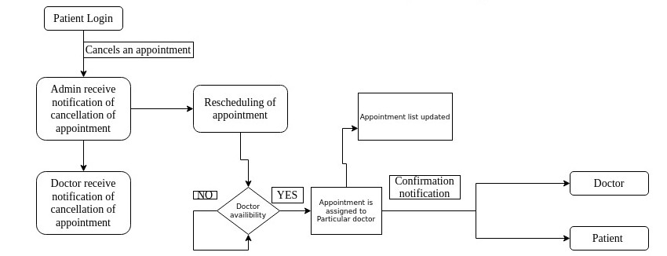Patient cancels the appointment

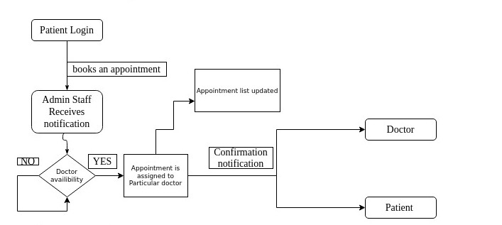Patient Books an Appointment

Doctor cancels the appointment

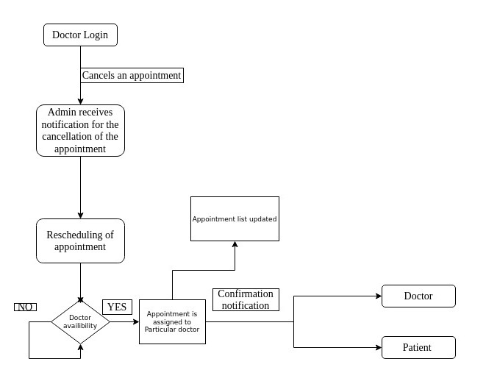

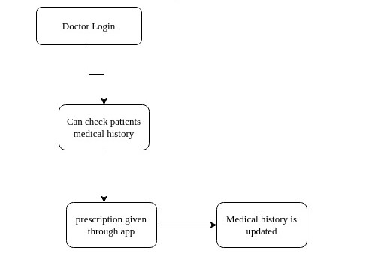Doctor checks patient’s Medical records and updates it