# TASK 1:

print("My name is Huzaifa Arhsad \nMy Roll No is 21F-9323 \nI like AI course \n")

# OUTPUT:

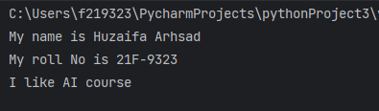

# TASK 2:

def addition(num1, num2):  
 sum = num1 + num2  
 print(f"Addition: ",{sum})  
  
def subtraction(num1 ,num2):  
 sub = num1 - num2  
 print(f"Subtraction: ",{sub})  
  
def multiplication(num1 ,num2):  
 mul = num1 * num2  
 print(f"Multiplication: ",{mul})  
  
def division(num1 ,num2):  
 div = num1 / num2  
 print(f"Division: ",{div})  
  
def square(num):  
 square = num * num  
 print(f"Square: ",{square})  
  
def cube(num):  
 cube = num*num*num  
 print(f"Cube: ",{cube})  
  
  
num1 = int(input("Enter 1st No: "))  
num2 = int(input("Enter 2nd No: "))  
  
addition(num1, num2)  
subtraction(num1, num2)  
multiplication(num1, num2)  
division(num1, num2)  
square(num1)  
cube(num2)

# OUTPUT:

# TASK 3:

def fun(num1, num2, num3):  
 five = num1 + 5  
 ten = num2 + 10  
 fifteen = num3 + 15  
 return five, ten, fifteen  
  
  
num1 = float(input("Enter 1st No: "))  
num2 = float(input("Enter 2nd No: "))  
num3 = float(input("Enter 3rd No: "))  
  
ans = fun(num1, num2, num3)  
  
print(f"Answer is: ", {ans})

# OUTPUT:

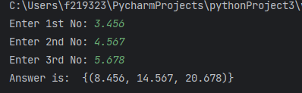

# TASK 4:

str1 = "HELLO, WORLD"  
str2 = ("HOW, arE yOu")  
  
str3 = str1 + " " + str2  
print(str3)  
  
print(str1.upper())  
print(str1.lower())  
  
print(str2.upper())  
print(str2.lower())  
  
print(str1[7:12])  
print(str2[-5:-1])

# OUTPUT:

# TASK 5:

start = int(input("Enter start No: "))  
end = int(input("Enter End No: "))  
  
  
while start<=end:  
 if start%2==0:  
 print(f"Even",{start})  
 else:  
 print(f"Odd: ",{start})  
  
 start+=1

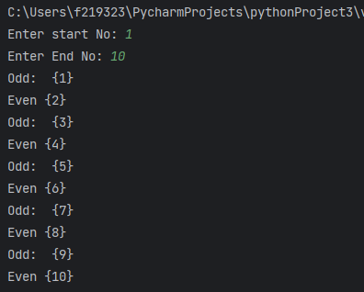

start = int(input("Enter start No: "))  
end = int(input("Enter End No: "))  
  
  
for i in range(start,end):  
 if start%2==0:  
 print(f"Even",{start})  
 else:  
 print(f"Odd: ",{start})  
  
 start+=1

