# TASK 1:

import string

import random

class PasswordGenerator:

    def __init__(self, length=12):

        self.length = length

        self.character_sets = ["upper", "lower", "digits", "special"]

    def set_length(self, length):

        self.length = length

    def set_character_sets(self, character_sets):

        self.character_sets = character_sets

    def generate_password(self):

        password = ""

        all_characters = {

            "upper": string.ascii_uppercase,

            "lower": string.ascii_lowercase,

            "digits": string.digits,

            "special": string.punctuation

        }

        while len(password) != self.length:

            for char_set in self.character_sets:

                password += random.choice(all_characters[char_set])

        return password

password_generator = PasswordGenerator()

print("Generated Password:", password_generator.generate_password())

# OUTPUT:

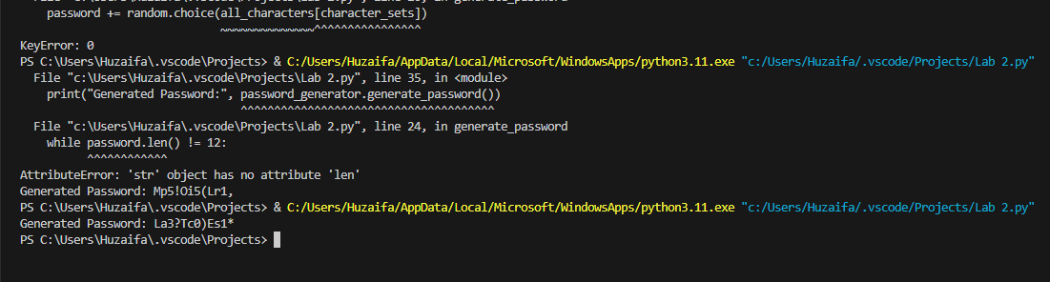

# TASK 2:

class ListOperations:

    def __init__(self, initial_list=None):

        self.my_list = initial_list

    def add_element(self, element):

        self.my_list.append(element)

    def remove_element(self, element):

        if element in self.my_list:

            self.my_list.remove(element)

        else:

            print(f"{element} not found in the list.")

    def find_maximum(self):

        if not self.my_list:

            print("List is empty.")

            return None

        return max(self.my_list)

    def find_minimum(self):

        if not self.my_list:

            print("List is empty.")

            return None

        return min(self.my_list)

initial_list = [5, 3, 8, 2, 7]

list = ListOperations(initial_list)

list.add_element(10)

print("List after adding 10:", list.my_list)

list.remove_element(8)

print("List after removing 8:", list.my_list)

max_value = list.find_maximum()

print("Maximum value in the list:", max_value)

min_value = list.find_minimum()

print("Minimum value in the list:", min_value)

# OUTPUT:

# 

# TASK 4:

import random

from datetime import datetime, timedelta

class LibrarySystem:

    def __init__(self):

        self.students = {}

    def register_student(self, name, roll_number):

        if roll_number in self.students:

            print("Student with the given roll number already exists.")

        else:

            self.students[roll_number] = {'name': name, 'books': {}}

            print(f"Hi {name}! You have been successfully registered with roll number {roll_number}.")

    def display_categories(self):

        print("\nBook Categories:")

        print("1. Fiction")

        print("2. Science Fiction")

        print("3. Mystery")

        print("4. History")

        print("5. Science")

    def display_books(self, category):

        categories = {

            1: ["Fiction Book 1", "Fiction Book 2", "Fiction Book 3"],

            2: ["Sci-Fi Book 1", "Sci-Fi Book 2", "Sci-Fi Book 3"],

            3: ["Mystery Book 1", "Mystery Book 2", "Mystery Book 3"],

            4: ["History Book 1", "History Book 2", "History Book 3"],

            5: ["Science Book 1", "Science Book 2", "Science Book 3"]

        }

        if category in categories:

            print(f"\nBooks in the {categories[category]} category:")

            for i, book in enumerate(categories[category], start=1):

                print(f"{i}. {book}")

        else:

            print("Invalid category.")

    def borrow_book(self, roll_number, category, book_index):

        if roll_number in self.students:

            student = self.students[roll_number]

            book_categories = {

                1: "Fiction",

                2: "Science Fiction",

                3: "Mystery",

                4: "History",

                5: "Science"

            }

            if category in book_categories:

                selected_book = book_categories[category][book_index - 1]

                student['books'][selected_book] = datetime.now() + timedelta(days=random.randint(7, 21))

                print(f"\n{student['name']}, you have successfully borrowed {selected_book}.")

                print(f"Please return the book by {student['books'][selected_book]}")

            else:

                print("Invalid category.")

        else:

            print("Student not found.")

library = LibrarySystem()

name = input("Enter your name: ")

roll_number = input("Enter your roll number: ")

library.register_student(name, roll_number)

if roll_number in library.students:

    library.display_categories()

    selected_category = int(input("Enter the number of the book category you are interested in: "))

    library.display_books(selected_category)

    selected_book_index = int(input("Enter the number of the book you want to borrow: "))

    library.borrow_book(roll_number, selected_category, selected_book_index)

# OUTPUT:

# 

# TASK 5:

class Graph:

    def __init__(self):

        self.adjacency_list = {}

    def add_edge(self, vertex, edge):

        if vertex not in self.adjacency_list:

            self.adjacency_list[vertex] = []

        self.adjacency_list[vertex].append(edge)

    def print_graph(self):

        for vertex, edges in self.adjacency_list.items():

            print(f"{vertex} -> {', '.join(edges)}")

graph = Graph()

graph.add_edge('A', 'B')

graph.add_edge('A', 'C')

graph.add_edge('A', 'D')

graph.add_edge('B', 'E')

graph.add_edge('B', 'F')

graph.add_edge('E', 'G')

graph.add_edge('F', 'H')

graph.print_graph()

# OUTPUT:

# 

# TASK 6:

class Graph:

    def __init__(self, vertices):

        self.vertices = vertices

        self.adjacency_matrix = [[0] * (vertices + 1) for _ in range(vertices + 1)]

    def add_edge(self, start, end, weight):

        if 1 <= start <= self.vertices and 1 <= end <= self.vertices:

            self.adjacency_matrix[start][end] = weight

            self.adjacency_matrix[end][start] = weight  # Assuming it's an undirected graph

    def print_graph(self):

        for row in self.adjacency_matrix[1:]:

            print(" ".join(map(str, row[1:])))

graph = Graph(6)

graph.add_edge(6, 5, 9)

graph.add_edge(6, 1, 14)

graph.add_edge(6, 3, 2)

graph.add_edge(5, 4, 6)

graph.add_edge(3, 4, 11)

graph.add_edge(3, 1, 9)

graph.add_edge(3, 2, 10)

graph.add_edge(1, 2, 7)

graph.add_edge(2, 4, 15)

graph.print_graph()

# OUTPUT: