# TASK1:

org 0x0100

jmp start

clearscreen:  
push es  
push ax  
push cx  
push di  
mov ax, 0xb800  
mov es, ax  
xor di, di  
mov ax, 0x0720  
mov cx, 2000  
cld  
rep stosw  
pop di  
pop cx  
pop ax  
pop es  
ret

print:  
push es  
push ax  
push cx  
push di  
mov ax, 0xb800  
mov es, ax

mov di, 3998

mov ax, 0x072a  
mov cx, 1000

std

rep stosw

pop di  
pop cx  
pop ax  
pop es  
ret  
  
start:  
call clearscreen  
call print  
mov ax, 0x4c00  
int 0x21

|  |  |
| --- | --- |
|  |  |

OUTPUT:  
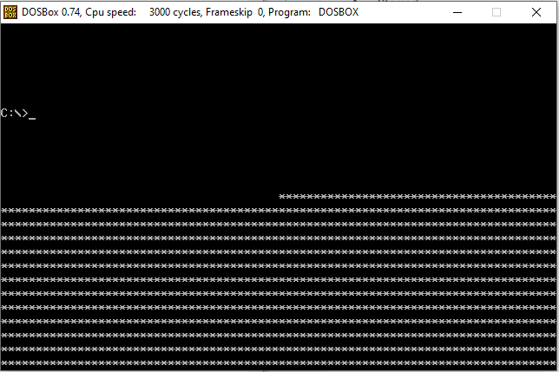

# TASK 2:

org 0x0100

jmp start

clearscreen:

push es

push ax

push cx

push di

mov ax, 0xb800

mov es, ax

xor di, di

mov ax, 0x0720

mov cx, 2000

cld

rep stosw

pop di

pop cx

pop ax

pop es

ret

print:

push es

push ax

push cx

push di

mov ax, 0xb800

mov es, ax

mov di, 3998

mov ax, 0x072a

mov cx, 1000

std

rep stosw

pop di

pop cx

pop ax

pop es

ret

start:

call clearscreen

call print

mov ax, 0x4c00

int 0x21

# OUTPUT:

# 