# TASK 1:

org 0x100

mov si, array

mov ax, 0

mov bx, 0

add_num:

lodsb

cmp al,0xFF

je done

add ax, bx

jmp add_num

done:

mov [sum], ax

mov ah, 0x4c

int 0x21

array db 1,2,3,4,5,6,7,8,9,10,0xFF

sum db 0

# TASK 2:

org 0x100

mov si, array

loop:

mov al, [si]

cmp al, [target]

je found

inc si

jmp loop

found:

mov [loc], si

mov ah, 0x4C

int 0x21

array db 69, 87, 96, 45, 105

target db 96

loc dw 0

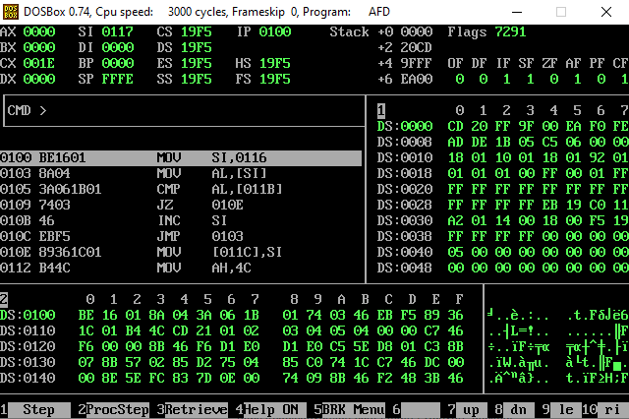

# TASK 3:

org 0x100

mov si, array

mov al, [si]

mov [highest], al

loop2:

inc si

mov al, [si]

cmp al, [highest]

jle continue_loop

mov [highest], al

mov [loc], si

continue_loop:

cmp si, array + 4

jb loop2

mov ah, 0x4C

int 0x21

array db 1, 2, 3, 4, 5

highest db 0

loc dw 0

