|  |  |  |
| --- | --- | --- |
|  | National University  of Computer and Emerging Sciences  Chiniot-Faisalabad Campus |  |

**Computer Networks lab**

**Final Project**

**Group Members**

|  |  |
| --- | --- |
| Member 1: **20F-0145 Huzaifa Muhammad Arshad** |  |

**Submitted To**

Ma’am Farwa Ahmed

**Submission Date**

12 December 2023

# **Routing**

## **Area 0**

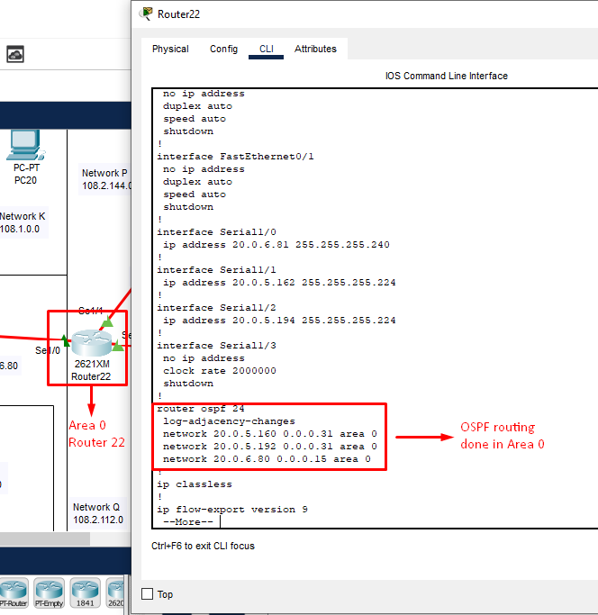

## **Area 1**

## **Area 2**

## **Area 3**

## 

## **Area 4**

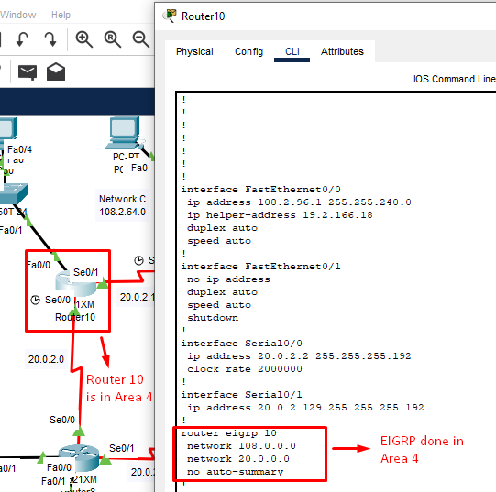

# **VLSM**

VLSM working is done in the attached pdf.

# **DHCP**

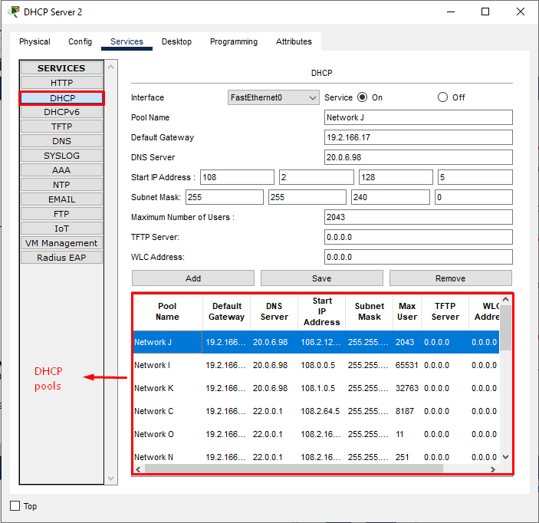

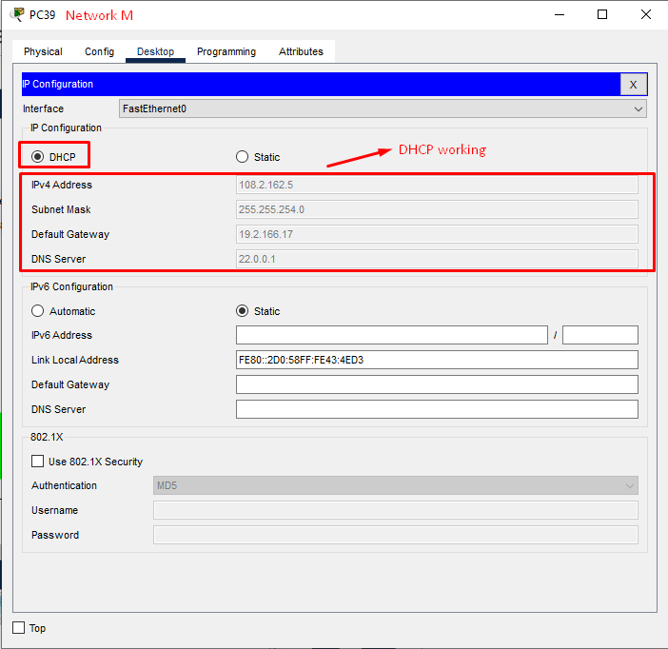

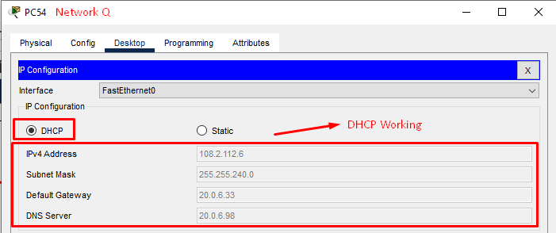

# **Redistribution**

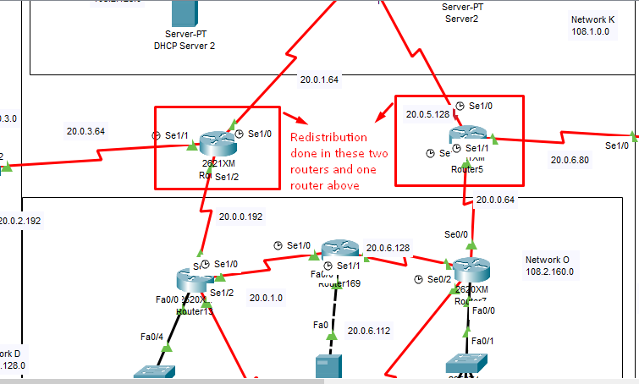

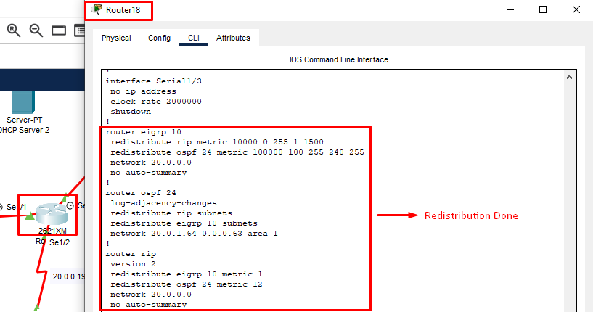

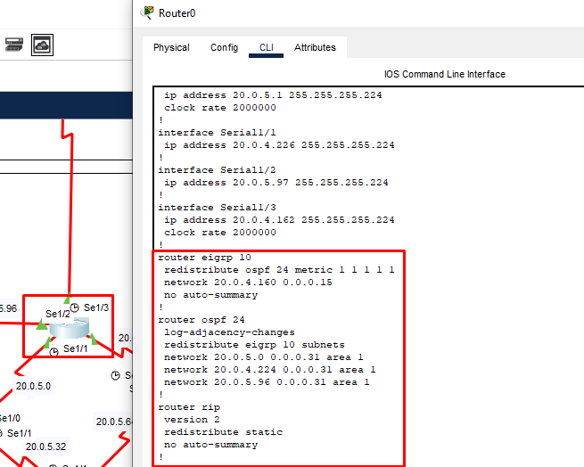

# **NAT**

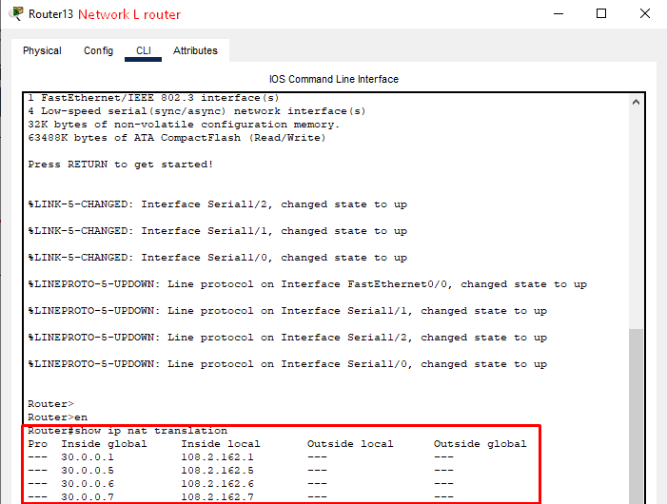

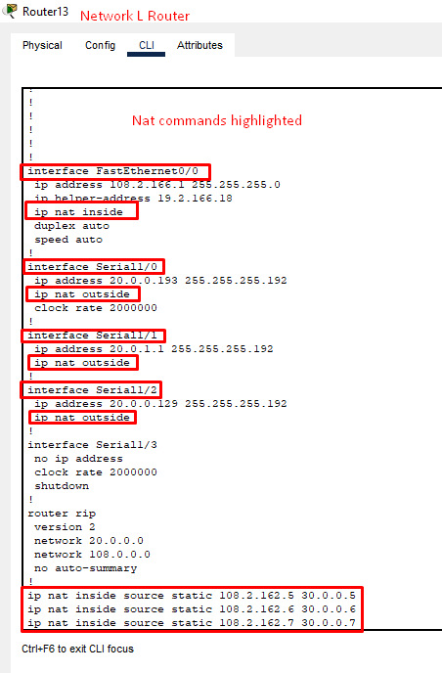

# **DNS and Web Servers**

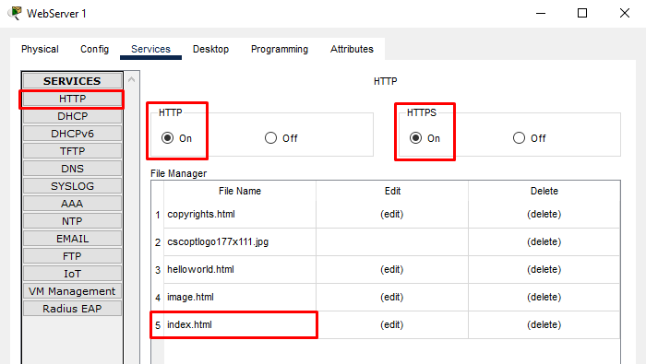

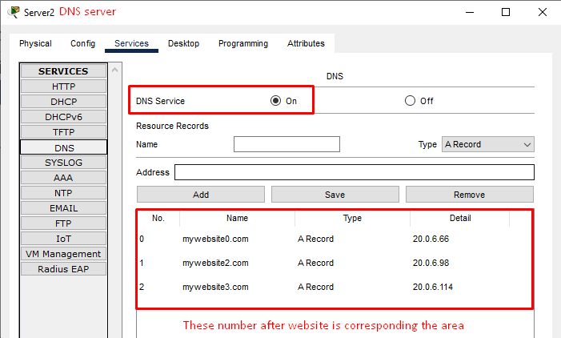

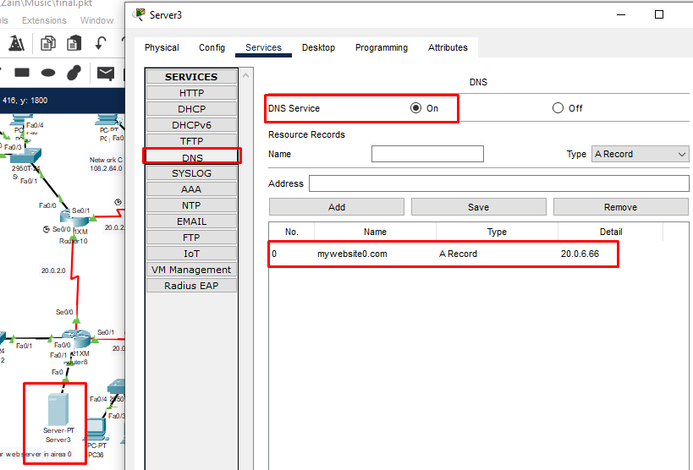

# **VLANs and INTER-VLANING:**

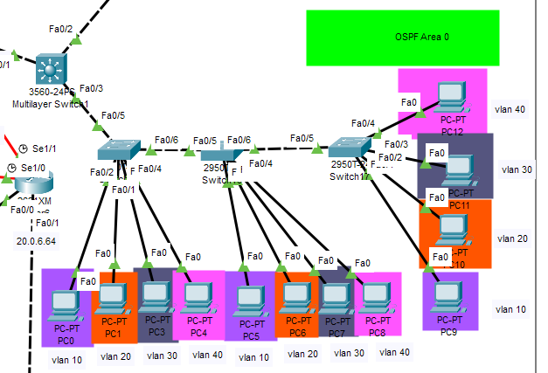

# **Multi-layered Switch:**

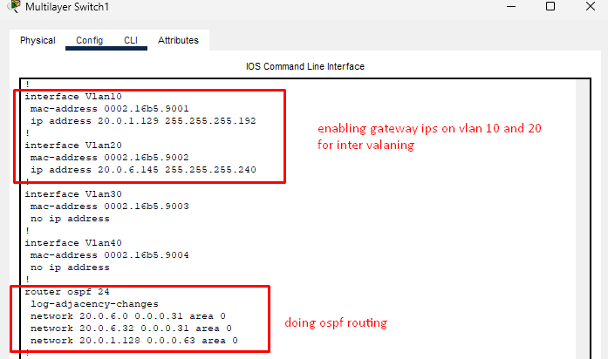

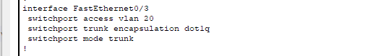

# **Simple switch configuration (same for all three)**

