TASK 1:  
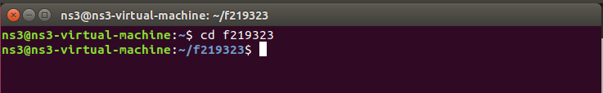

TASK 2:  
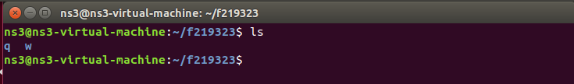

TASK 3:  
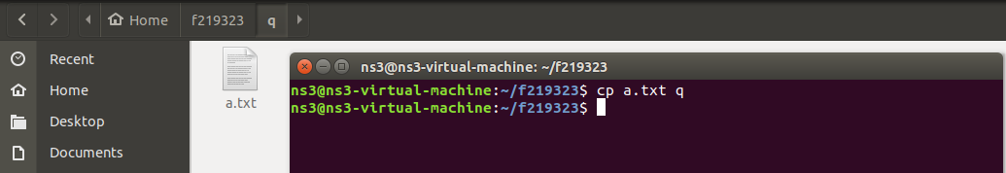

TASK 4:  
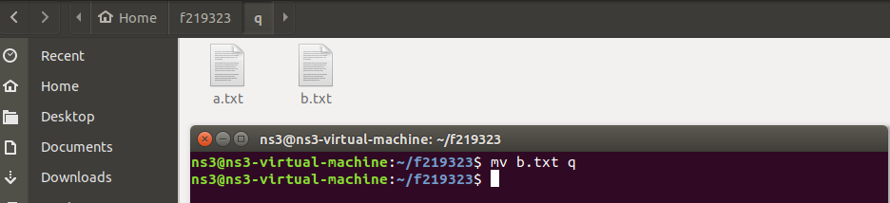

TASK 5:  
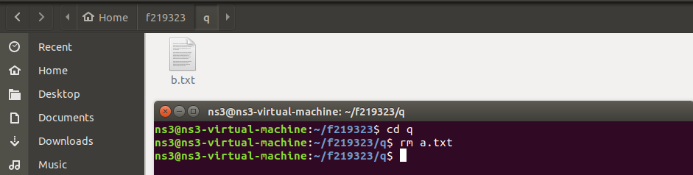

TASK 6:  
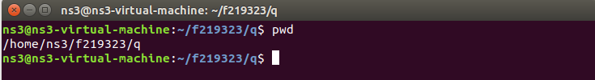

TASK 7:

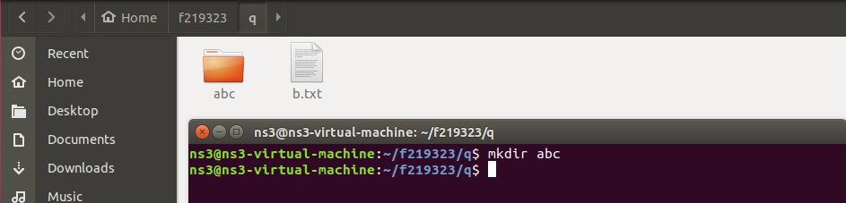

TASK 8:

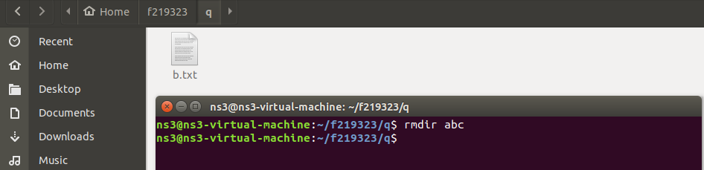

TASK 9:

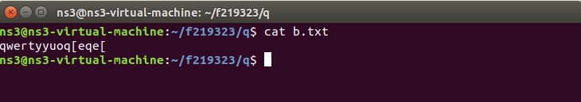

TASK 10:



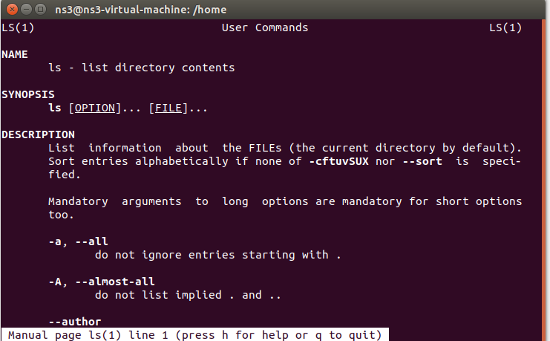

TASK 11:

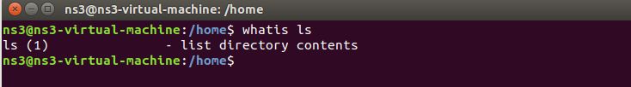

TASK 12:

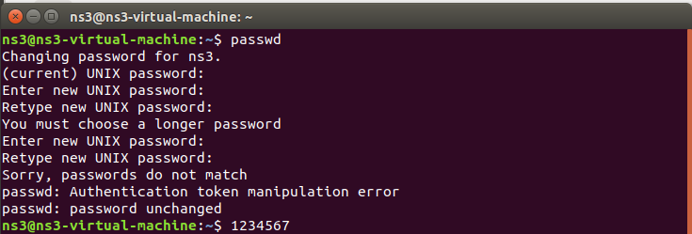

TASK 13:

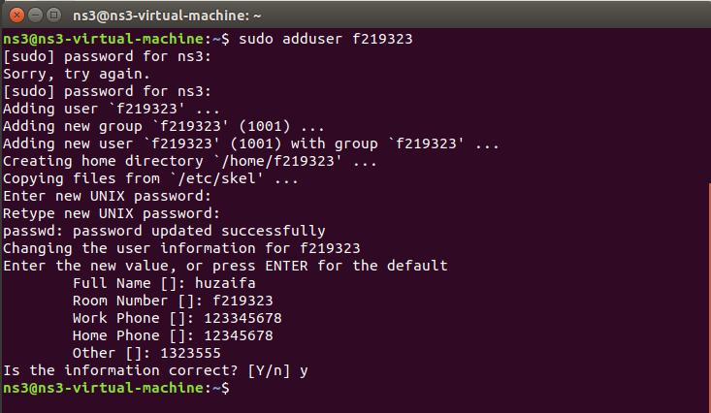

TASK 14:

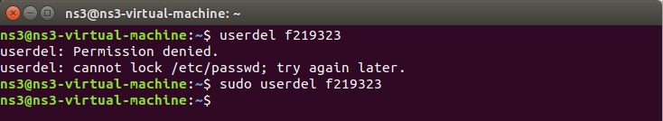

TASK 15:

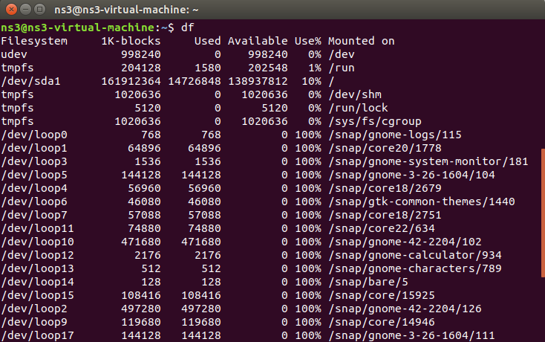

TASK 16:

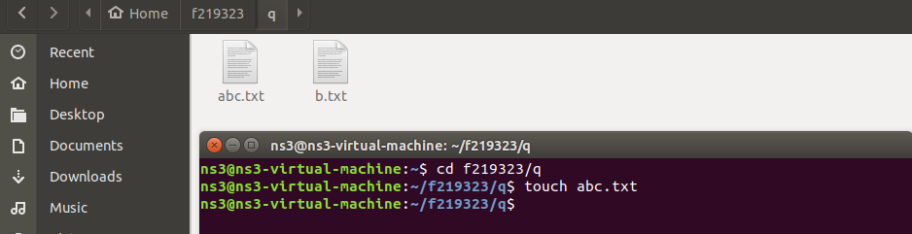

TASK 17:

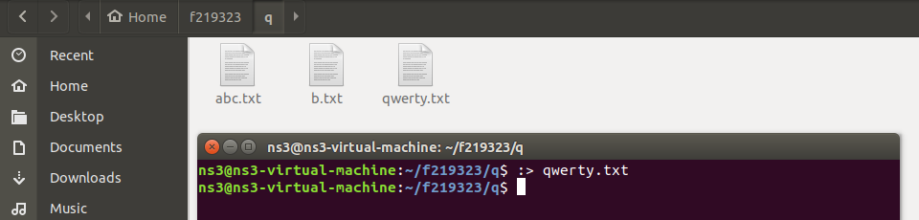

TASK 18:

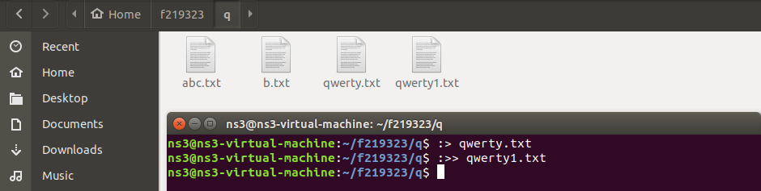

TASK 19:

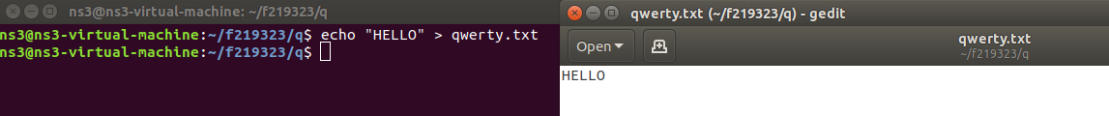

TASK 20:

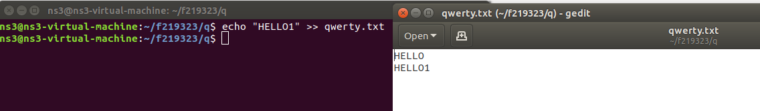

TASK 21:

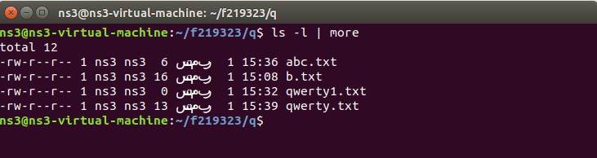

TASK 22:  
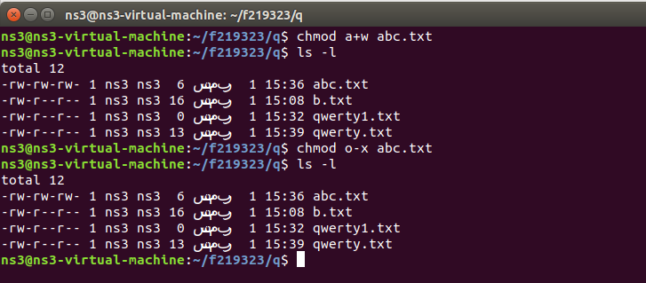

TASK 23:

