# TASK 1:

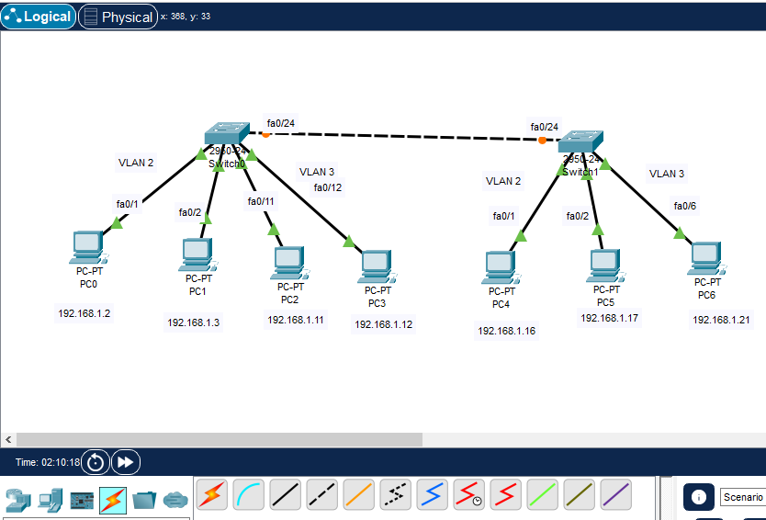

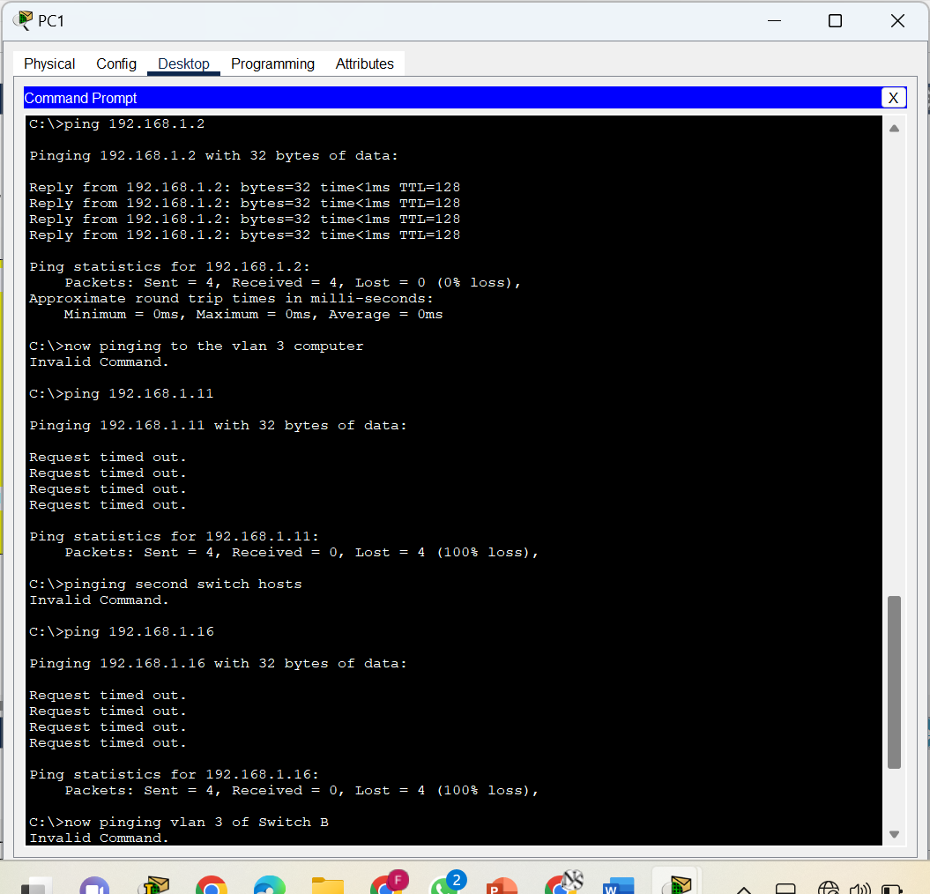

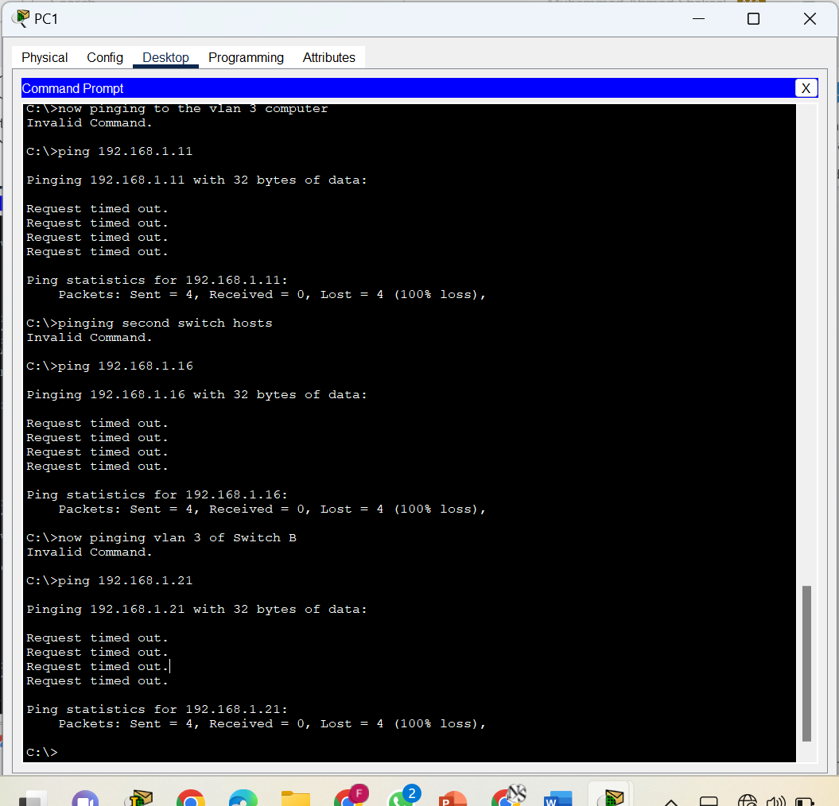

# Task 2:



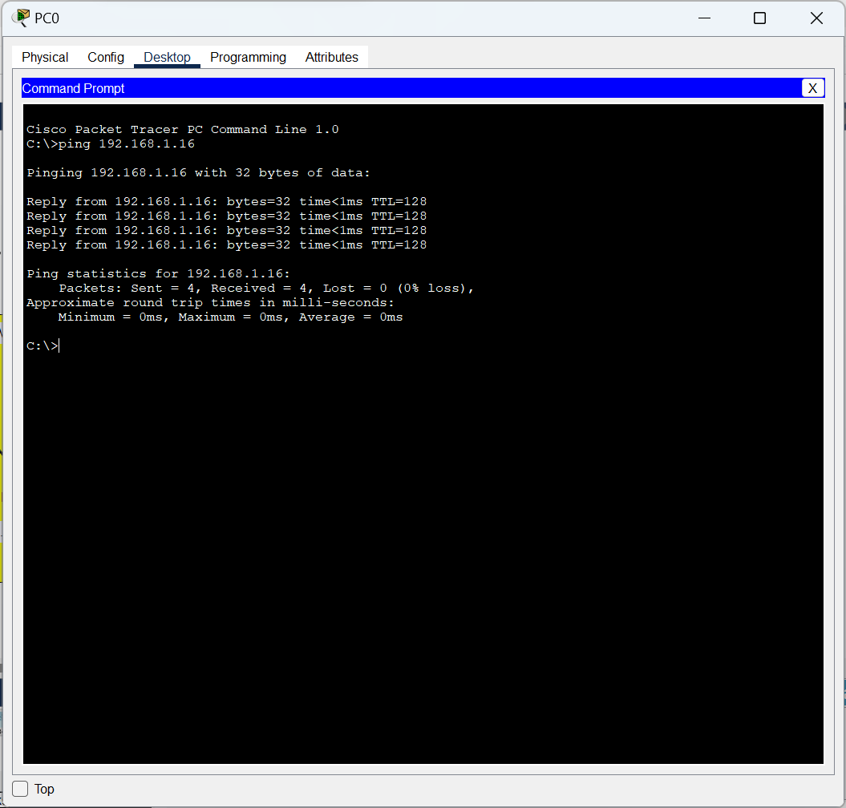

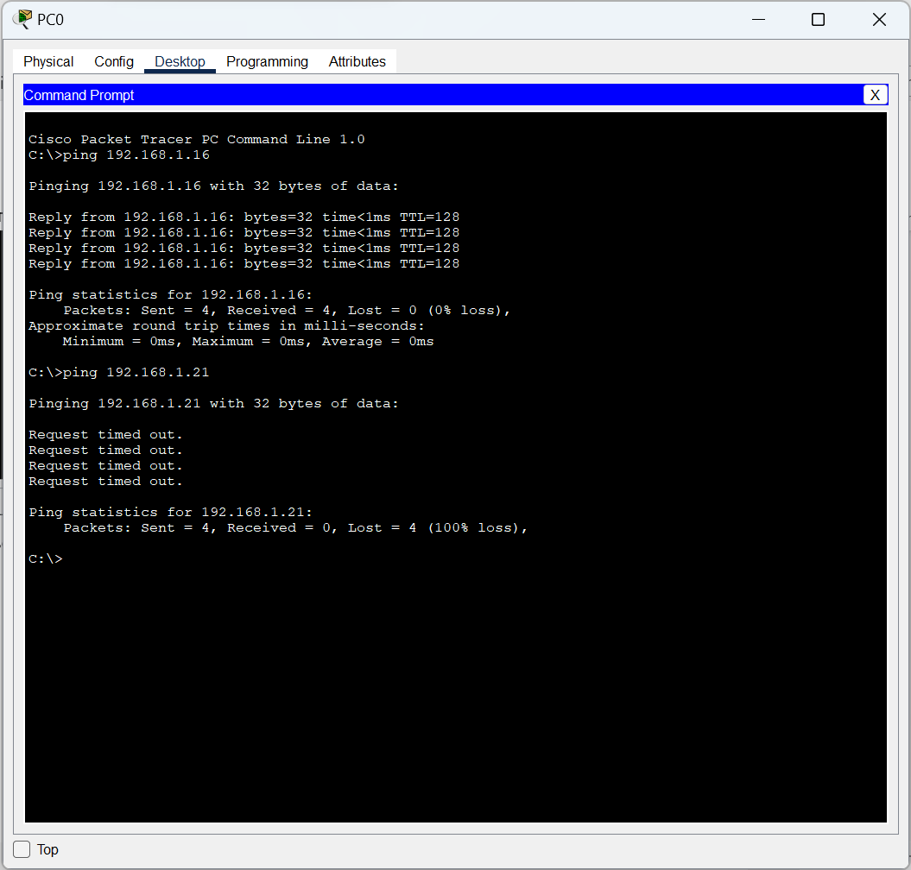



# Task 3:



