Report for Lab 4
Part A: Testing Wireshark
Name: Huzaifa M.Arsahd | RollNo:21F-9323 | Date:

1 | Is the frame an outgoing or an incoming frame?  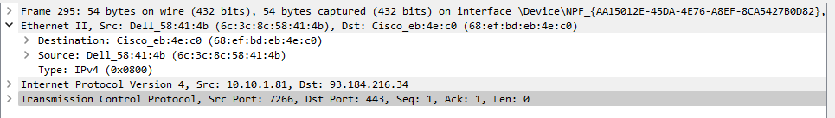  This frame is outgoing since it shows the source MAC address as "Dell_58:41:4b" and the destination MAC address as "Cisco_eb:4e:c0."
2 | Source IP address of the network-layer header in the frame:  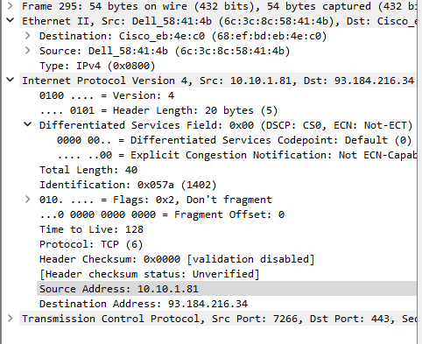  The source IP address is "10.10.1.81."
3 | Destination IP address of the network-layer header in the frame:  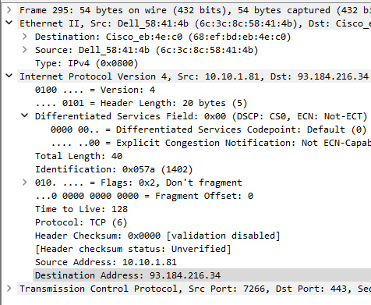  The destination IP address is "93.184.216.34."
4 | Total number of bytes in the whole frame:  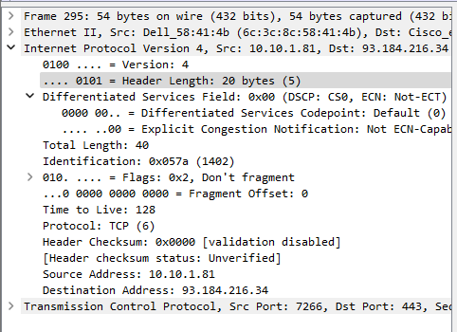  The total number of bytes in the whole frame is 54 bytes (432 bits).
5 | Number of bytes in the IP header:  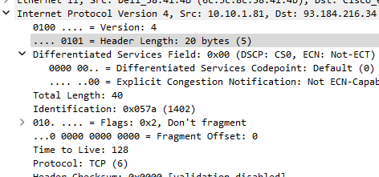  The header length is specified as 20 bytes (5 words)
6 | Number of bytes in the TCP header:  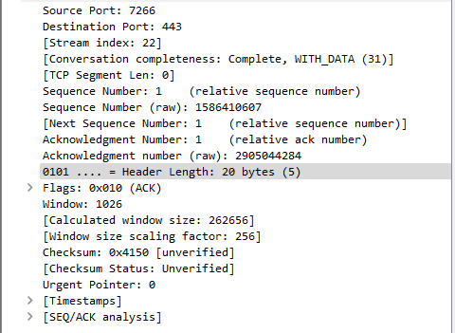  The TCP header length is also 20 bytes (5 words).
7 | Total bytes in the message (at the application layer):  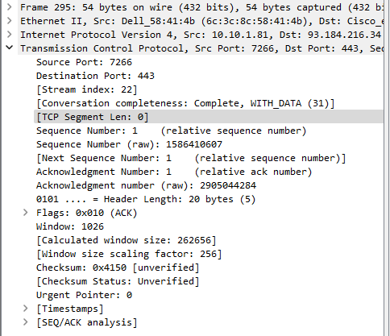  The total bytes in the message at the application layer in this frame are 0 bytes.

Part B : HTTP request packet

Open a web browser installed in your computer. Type www.slate.nu.edu.pk inside the address bar. Now locate the HTTP request message sent by your browser in order to retrieve the home page of www.slate.nu.edu.pk. While looking at that message, answer the following questions.
- What languages the browser can support?

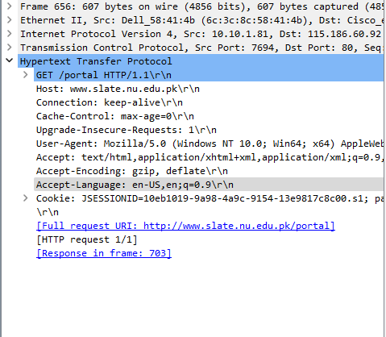

English US

- What is the type of browser that has sent this HTTP request message?
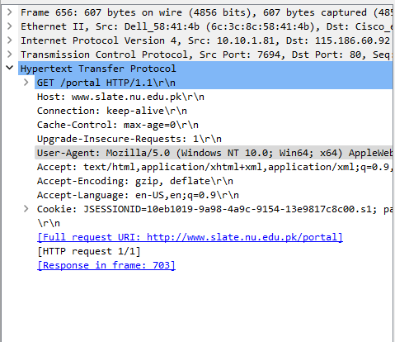
Mozilla

- What type of HTTP connection the browser has requested?

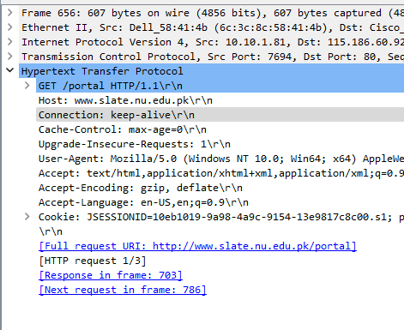
Keep Alive

- What URL is requested by the browser from the server?
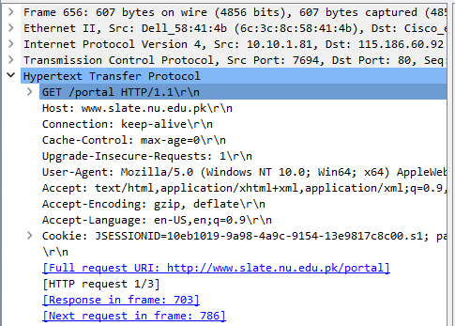
GET /portal HTTP/1.1\r/n

HTTP Response packet

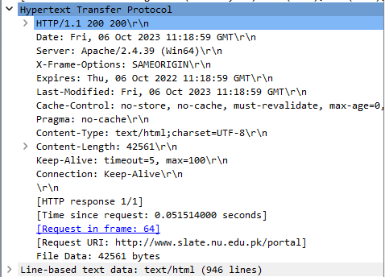
Now identify the HTTP response message sent for HTTP request message and answer the following questions.
- What is the status code sent by server?
The status code sent by the server is "200."

- What is the response phrase sent along with status code?
The response phrase is "200," which typically corresponds to "OK"

- Has the server sent a cookie ID in response message? If yes, what is the cookie ID and when does it expire according to Pakistan Standard Time?
No Cookie

- What is type of content that the sent page contains?
Content is HTML with a character encoding of UTF-8.

Part C Capturing Password

Using Wireshark to capture the FTP password
Now login slate with your own roll number. After your browser has displayed the
http://slate.nu.edu.pk/login/ page, stop Wireshark packet capture by selecting stop in the
Wireshark capture window. This will cause the Wireshark capture window to disappear and the main Wireshark window to display all packets captured since you began packet capture.

Answer these questions:
- Show all the http packets captured so far.
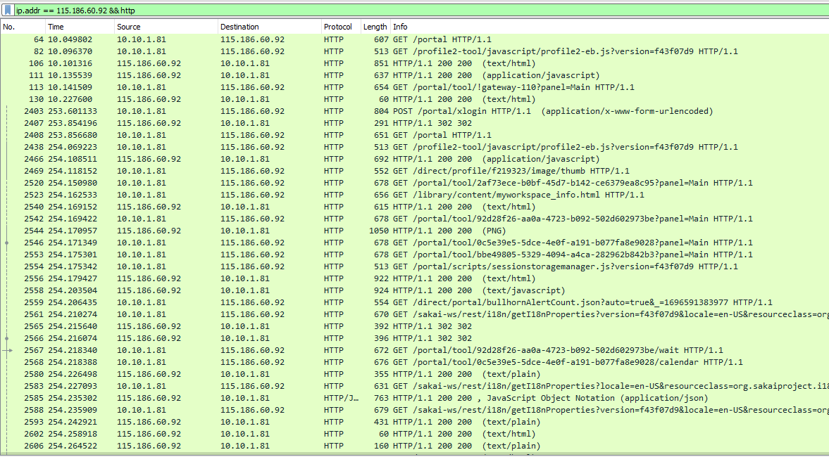

- Show the request packets of http://slate.nu.edu.pk/.
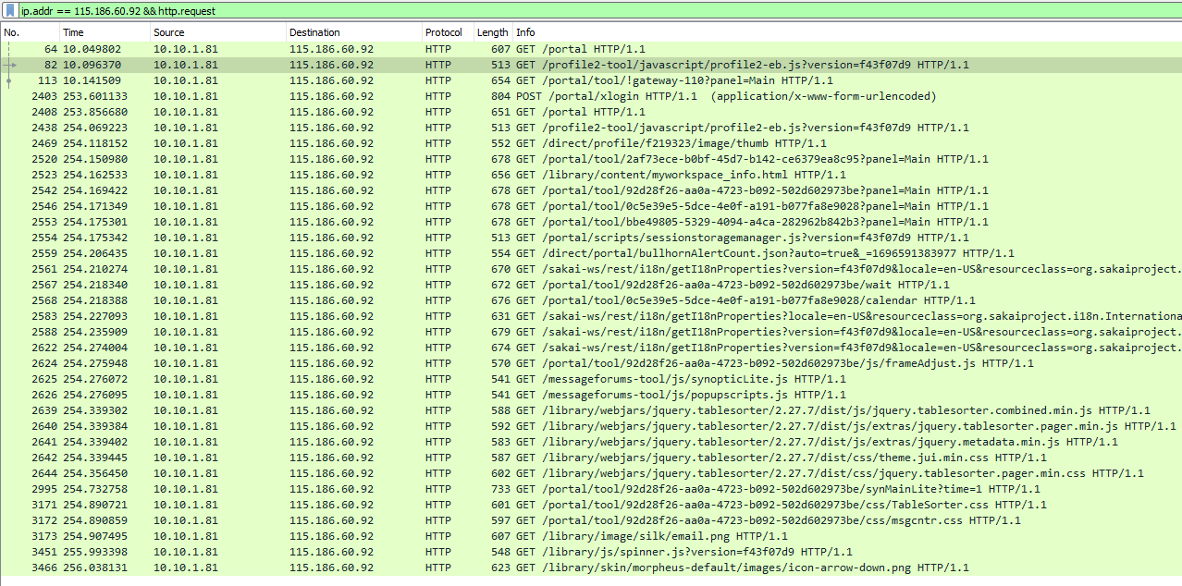

- Show all the response packets of http://slate.nu.edu.pk/.
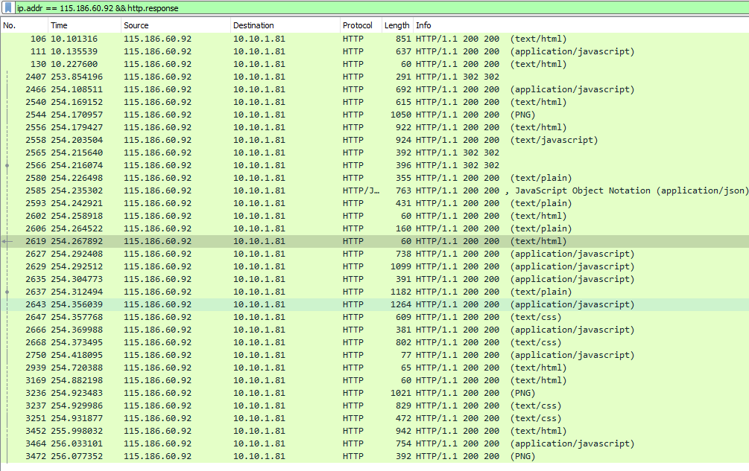

- Explore the response message and find out the password and username. Take screen shot of this and attach.
