# TASK 1:

# 

# TASK 2:

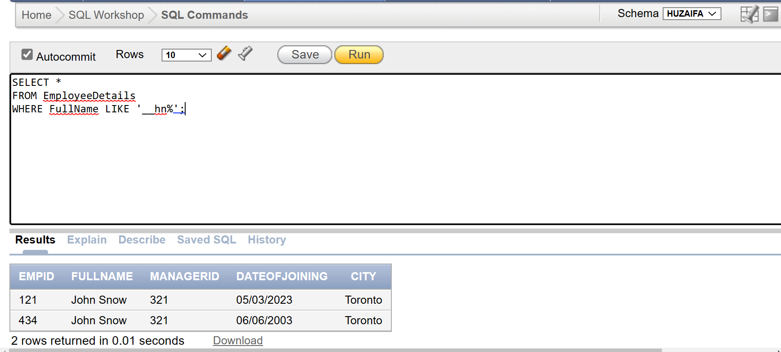

# TASK 3:

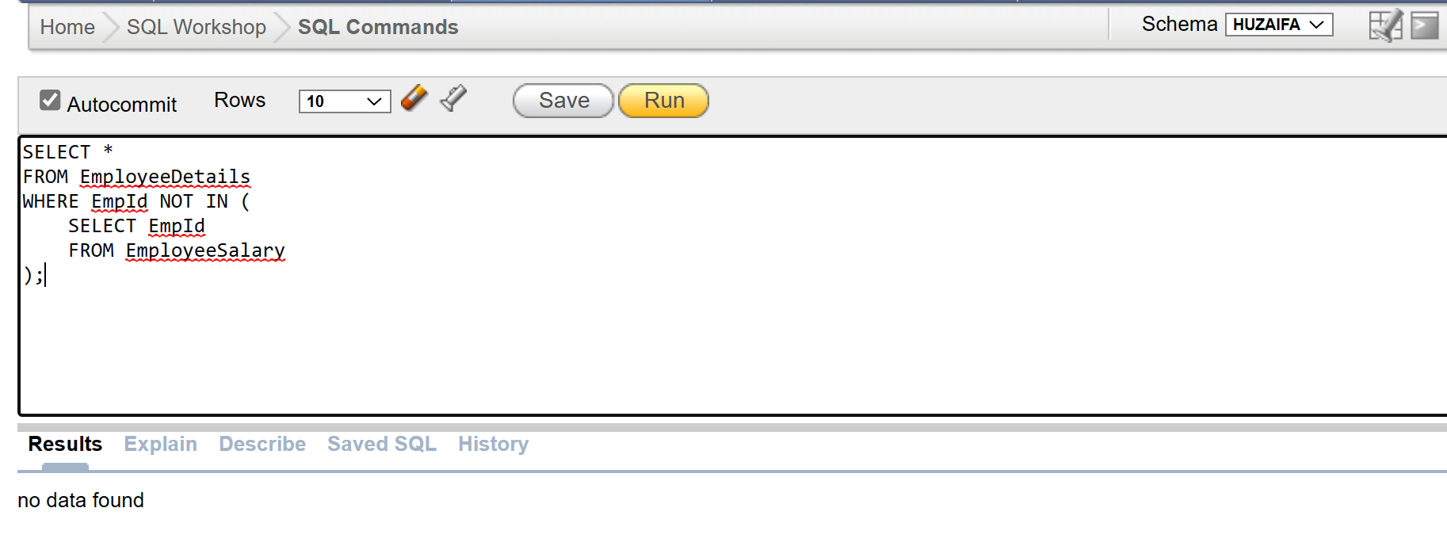

# TASK 4:

# TASK 5:

# TASK 7:

# TASK 8:

# TASK 10:

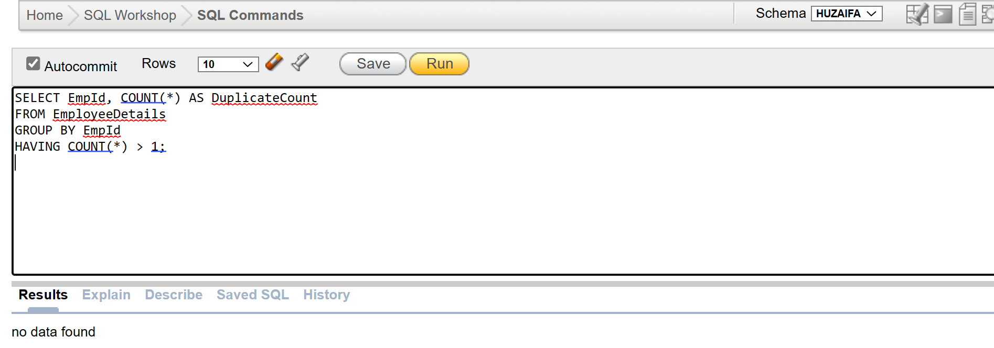

# TASK 11:

# TASK 12:

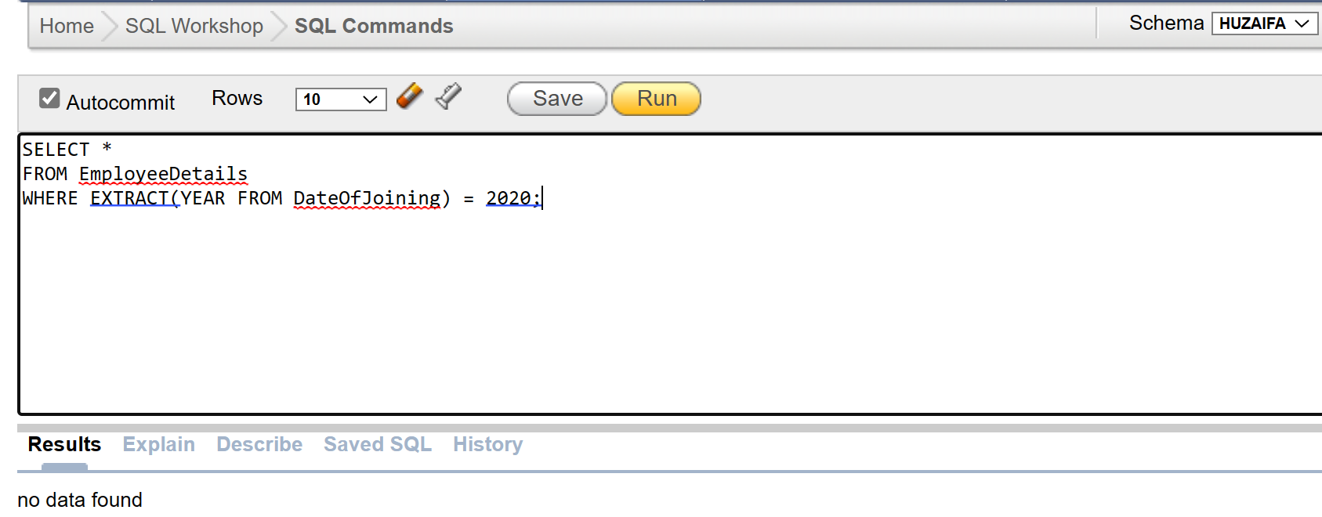

# TASK 13:

# TASK 15:

# TASK 16:

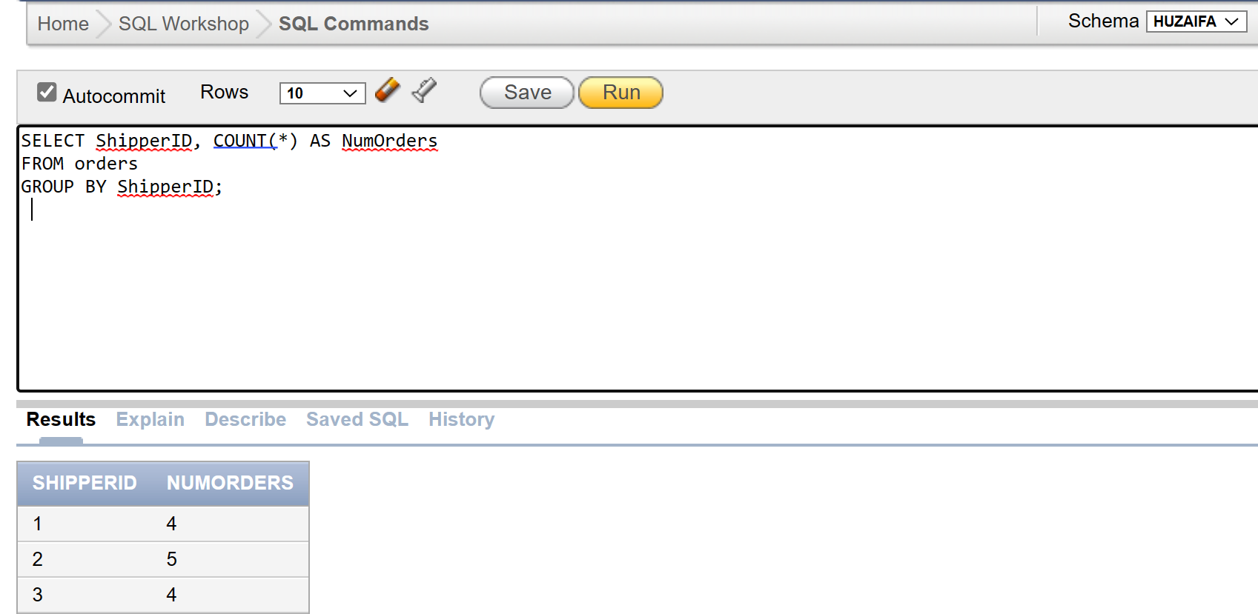

# TASK 17:

# TASK 19:

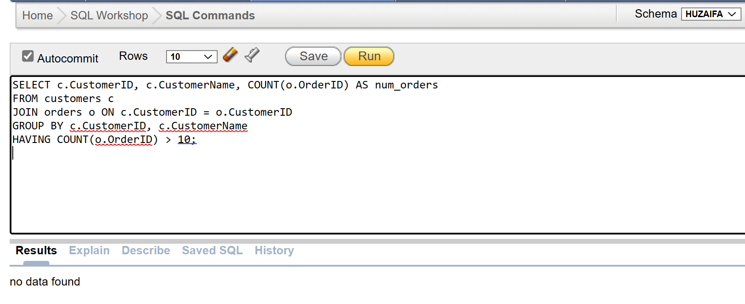

# TASK 20:

# TASK 21:

# TASK 22:

