# TASK 1:

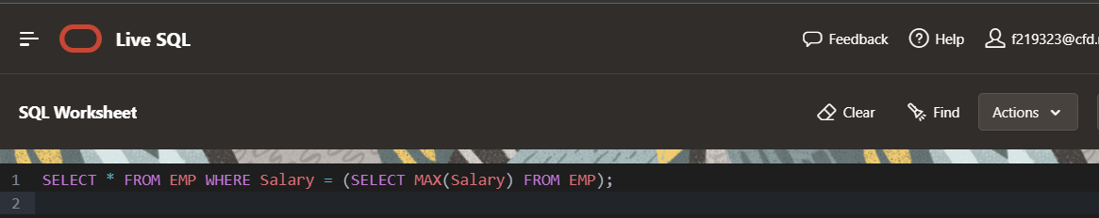

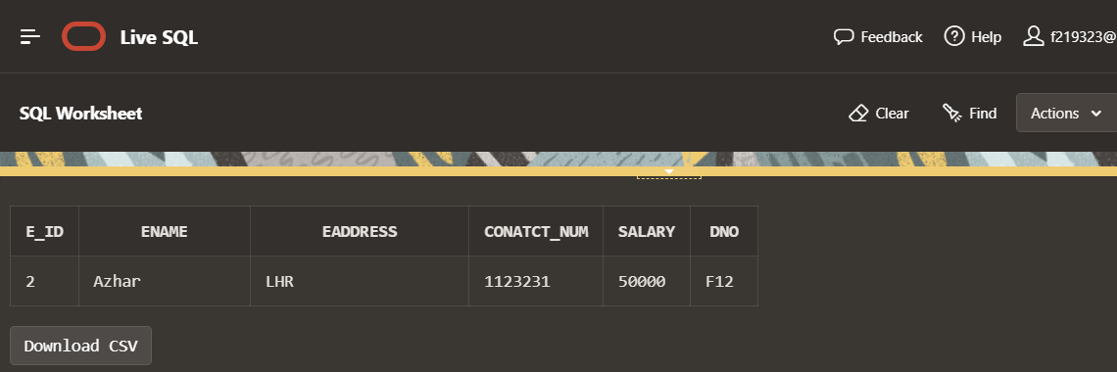

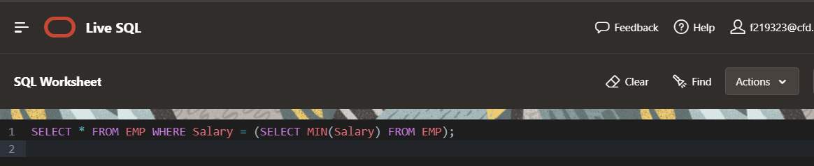

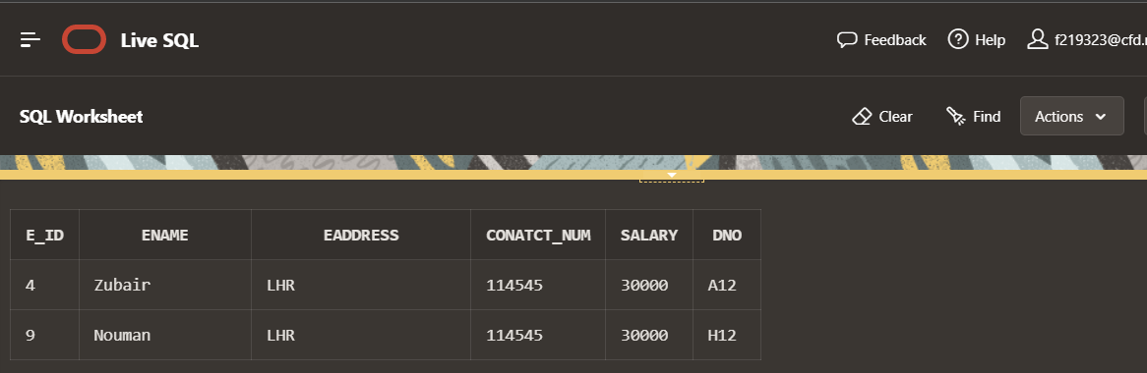

# TASK 2:

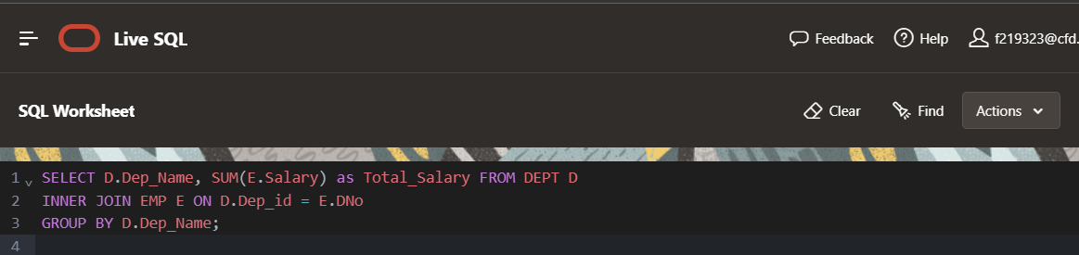

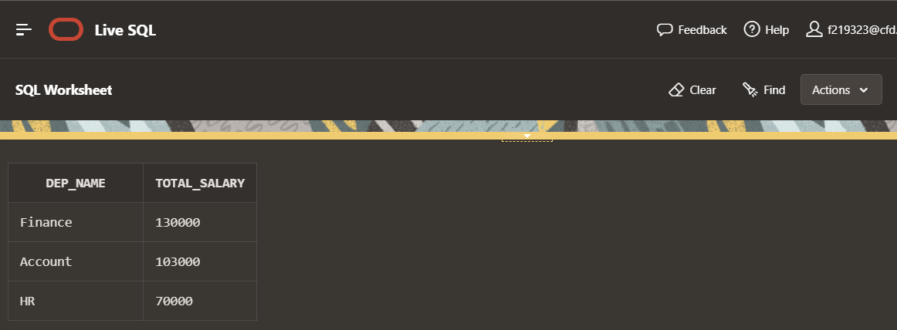

# TASK 3:

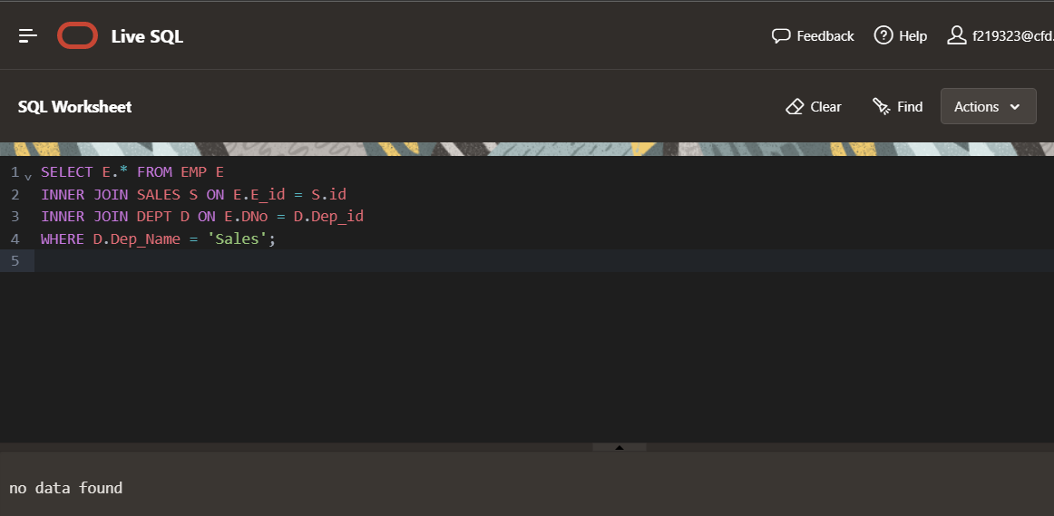

# TASK 4:

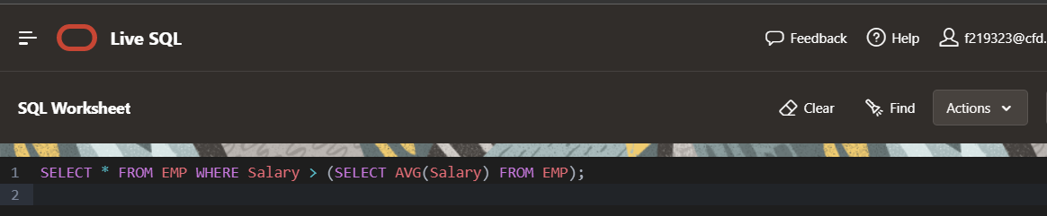

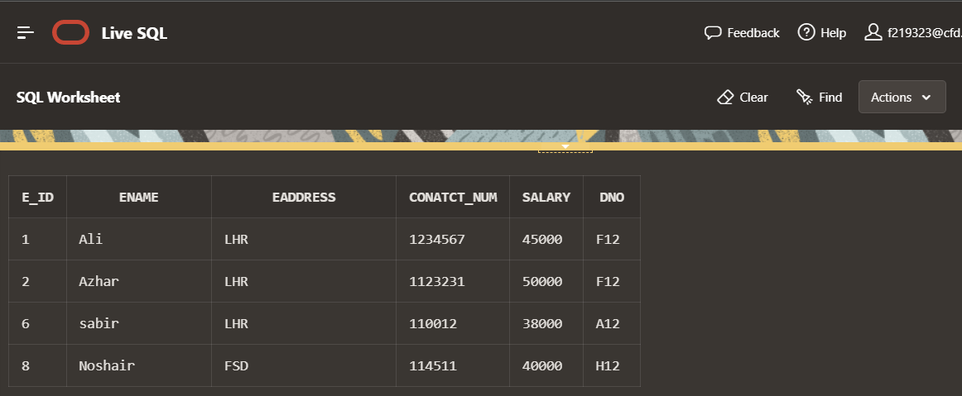

# TASK 5:

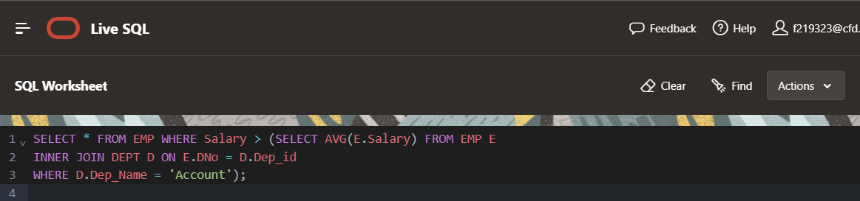

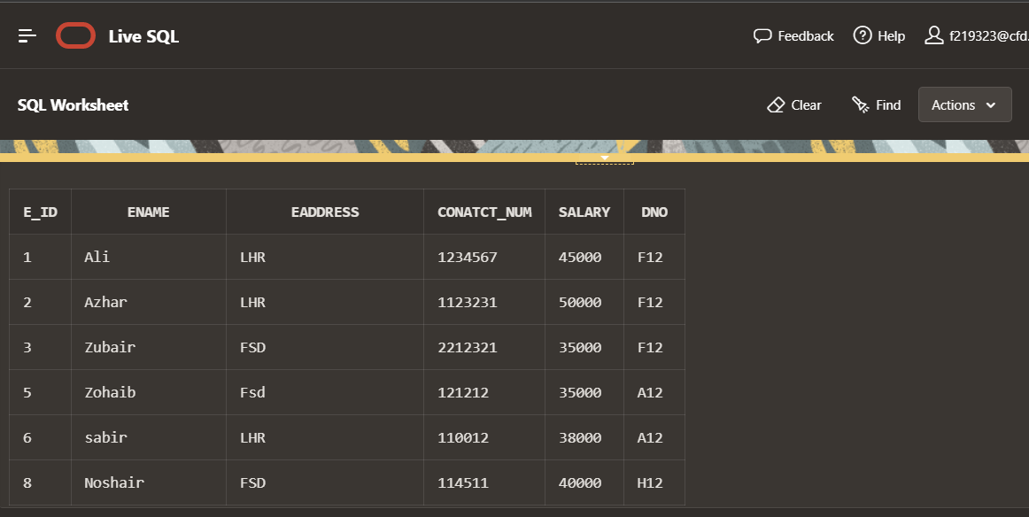

# TASK 6:

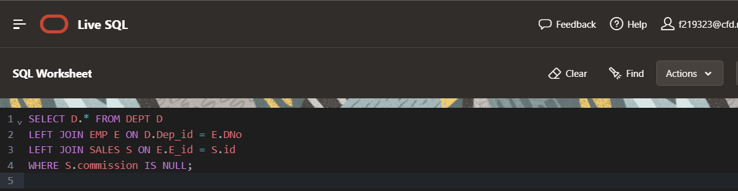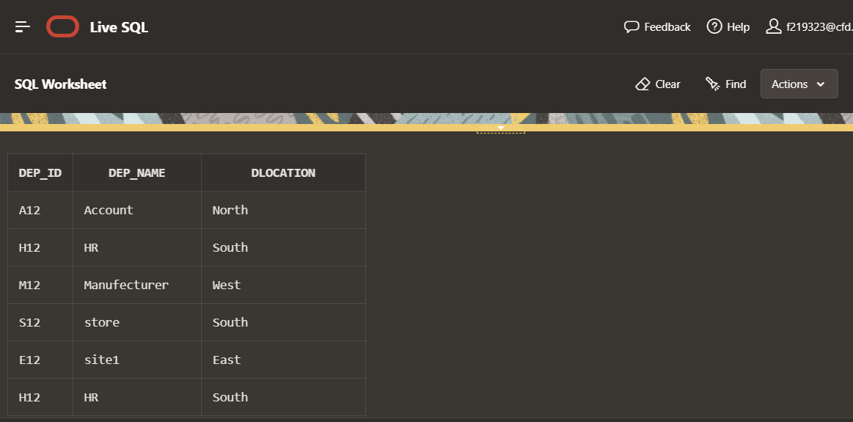

TASK 7: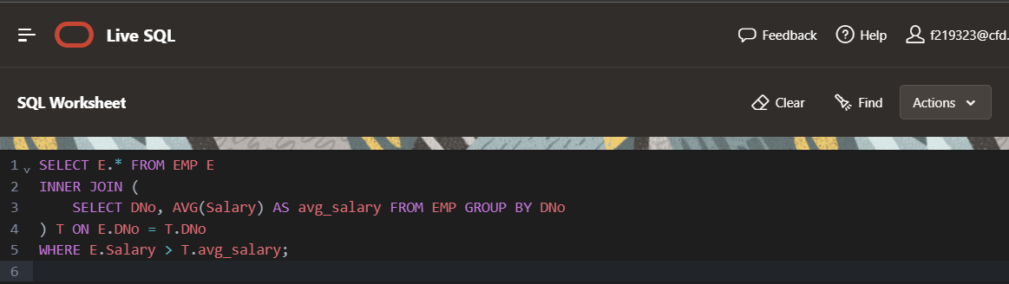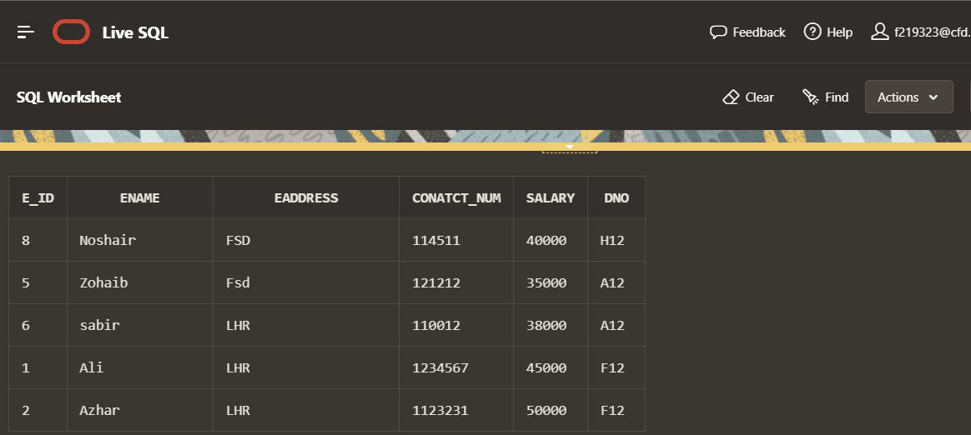

TASK 8: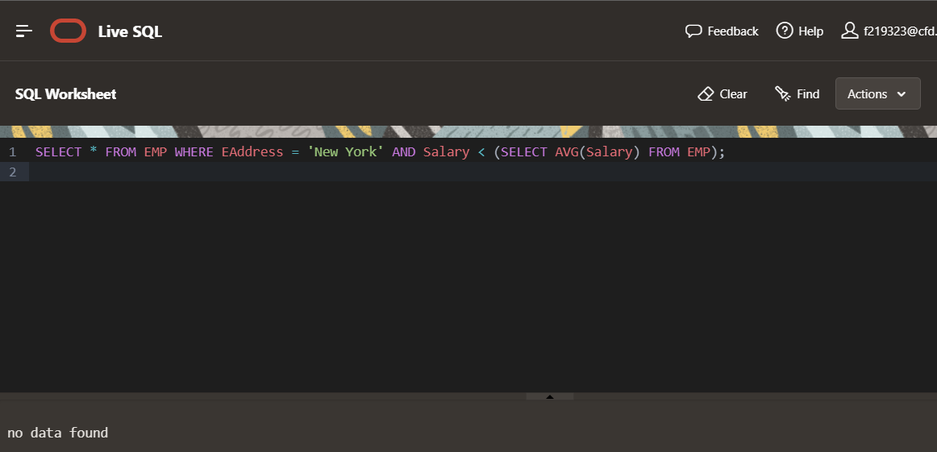

# TASK 9:

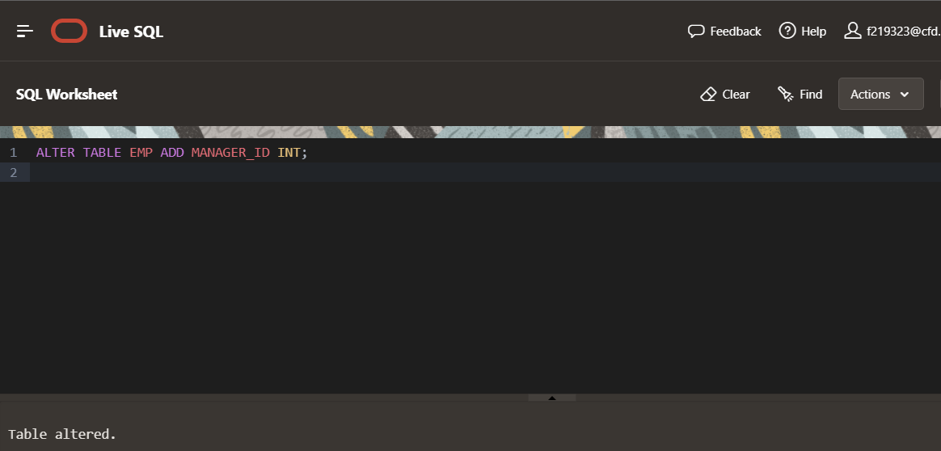

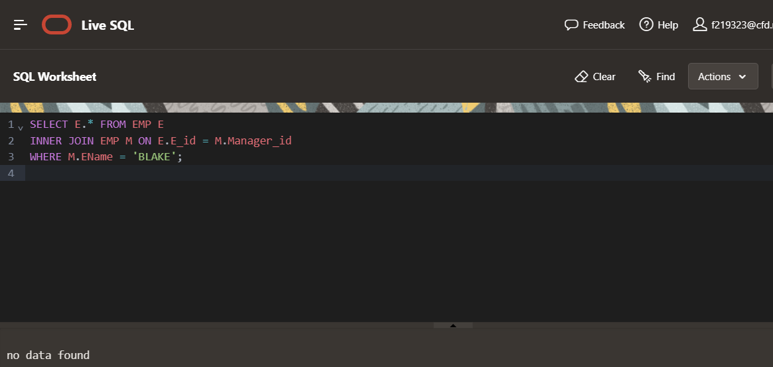

# TASK 10:

# 

# TASK 11:

# 

# 

# TASK 12:

# 

# TASK 13:

# 

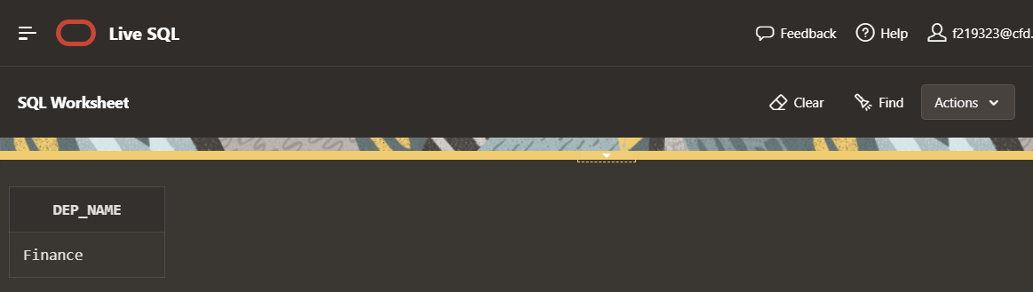

# TASK 14:

# TASK 15:

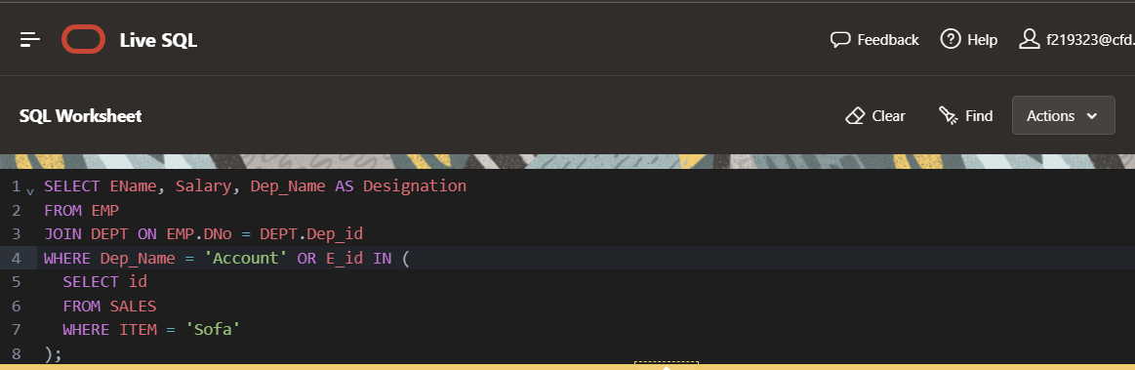

# PART 2:

# TASK 2:

# 

# TASK 3:

# 

# TASK 4:

# 

# TASK 6:

# 

# TASK 7:

# 

# TASK 8:

# 