# TASK 1:

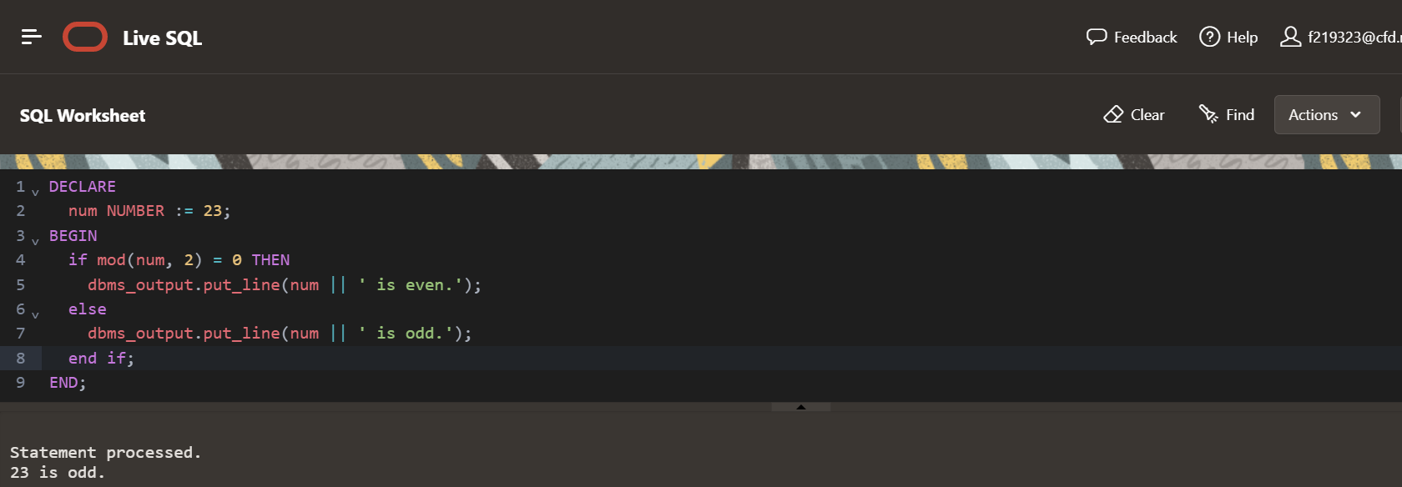

# TASK 2:

# TASK 3:

# 

# TASK 4:

# TASK 5:

# TASK 6:

# TASK 7:

# 

# TASK 8:

# TASK 9:

# TASK 10:

# TASK 11: